4-4.1 Integrating Processes: Level Process

Consider the process tank shown in Fig. 4-4.1. An input stream enters the tank freely, whereas the output stream depends on the speed of the pump. The pump speed is regulated by the signal m(t), %.  The relation between the output flow and the signal is given by:  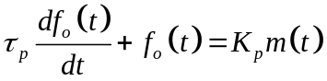 | 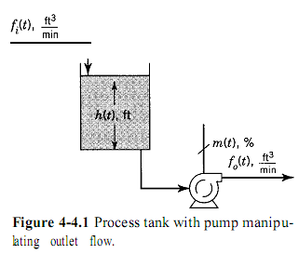
An unsteady-state mass balance around the tank provides the first equation needed:  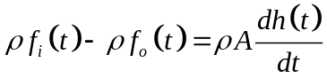  Only two equations are required to model this simple process.  Following the usual procedure, we obtain  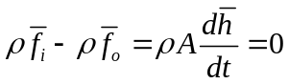  Restando:  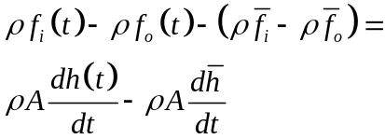  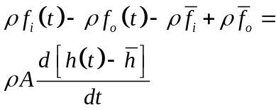  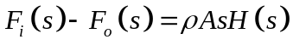  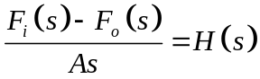  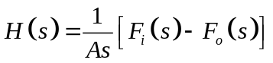  where the deviation variables are  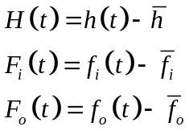 | 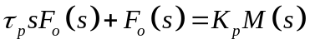  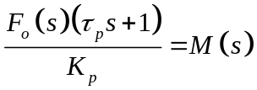  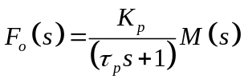  where the new deviation variable is  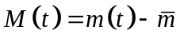  Sustituyendo:  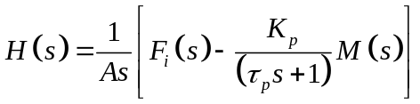  By superposition we can obtein transfer funtions desires:  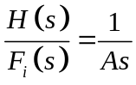  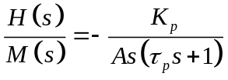  S term in denominator indicates the “integrating” nature of the process

Let us develop the response of the system to a change of -B% in the signal m(t). That is,

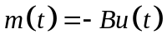
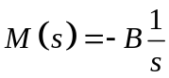

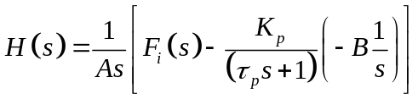
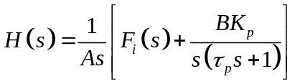
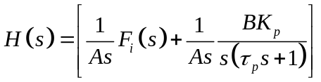
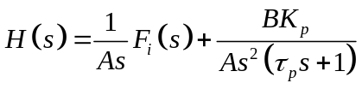

Principles and Practice of
Automatic Process Control

