Higher-order response

The response of systems represented by differential equations of order higher than two can be thought of as a combination of first-order lags and second-order underdamped responses. When all the roots of the denominator of the transfer function are real, an nth-order system becomes a combination of n first-order lags. We can easily extend the results for the second-order overdamped responses to higher-order overdamped responses. For example, consider the following nth-order overdamped system:

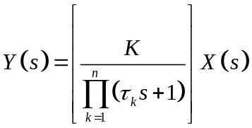

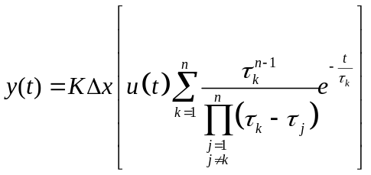

For higher-order underdamped systems, the second-order step response terms defined in this section also apply. However, the formulas presented to calculate the characteristic terms are valid only for estimating the contribution of individual pairs of complex conjugate roots to the overall response. The accuracy of the estimates of the overshoot, rise time, and decay ratio of the total response depends on how dominant is the pair of complex conjugate roots with respect to the other roots. Recall, from Section 2-3, that the dominant roots are those with the least negative real parts-that is, the terms of the response that take the longest to decay.

