5-1 SENSORS AND TRANSMITTERS

The sensor produces a phenomenon-mechanical, electrical, or the like-related to the process variable it measures. The transmitter in turn converts this phenomenon into a signal that can be transmitted. Thus the purpose of the sensor/transmitter combination is to generate a signal, the transmitter output, that is related to the process variable. Ideally this relationship should be linear; that is, the transmitter output signal should be proportional to the process variable.

Often this is the case, as for example with pressure, level, and some temperature transmitters, such as resistance temperature devices (RTDs).

In other situations, the transmitter output is a known nonlinear function of the process variable, as for example with thermocouples and orifice flowmeters.

There are three important terms related to the sensor/transmitter combination. The range of the instrument is given by the low and high values of the process variable that is measured.

Consider a pressure sensor/transmitter that has been calibrated to measure a process pressure between the values of 20 psig and 50 psig. We say that the range of this sensor/transmitter combination is 20 to 50 psig. The span of the instrument is the difference between the high and low values of the range. For the pressure instrument we have described, the span is 30 psi. The low value of the range is often referred to as the zero of the instrument. This value does not have to be zero in order to be called the zero of the instrument. For our example, the zero of the instrument is 20 psig.

Appendix C presents some of the most common industrial sensors: pressure, flow, temperature, and level. That appendix also briefly discusses the working principles of an electrical transmitter and of a pneumatic transmitter.

The transfer function of the sensor/transmitter combination relates its output signal to its input, which is the process variable; this is shown in Fig. 5-1.1. | 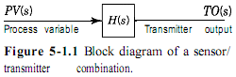
The simplest form of the transfer function is a first-order lag:  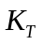: transmitter gain  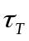: transmitter time constant | 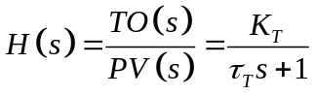

When the relationship between the transmitter output (TO) and the process variable (PV) is linear, the transmitter gain is simple to obtain once the span is known.

Consider an electronic pressure transmitter with a range of 0 to 200 psig. Figure 5-1.2  shows the output versus the process variable (input).  From the definition of gain in Chapter 3, the gain of a linear transmitter can be obtained by considering the entire change in output over the entire change in input, which is the span of the transmitter.  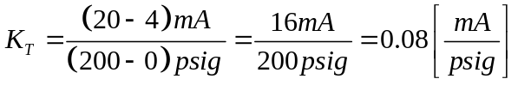 | 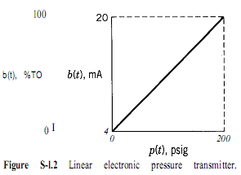
or, in percent transmitter output (%TO)

