Control valves

Control valves are the most common final control elements. They perform the action (A) function of the control system by adjusting the flows that affect the controlled variables. This section presents the most important aspects of control valves: the selection of their action and fail position, their capacity and sizing, their flow characteristics, their gain, and their transfer function. Appendix C presents different types of valves and their accessories. The reader is strongly encouraged to read Appendix C along with this section.

A control valve acts as a variable restriction in a process pipe. By changing its opening, it changes the resistance to flow and thus the flow itself. Throttling flows is what control valves are all about. The controller output signal positions the valve, determining the valve position that in turn determines the degree of restriction to flow.

Therefore, the controller output signal is the input to the valve, and the flow is the output of the valve.

The Control Valve Actuator

Figure 5-2.la shows the instrumentation schematic of a control valve.  Even with electronic instrumentation, an air pressure actuator is the most common means of adjusting the position of control valves; this is because of the high reliability and low maintenance requirements of air, or pneumatic, actuators.  When the signal from the controller is a 4- to 20-mA signal, a current-to-pressure transducer, labeled I/p in Fig. 5-2.la, is | 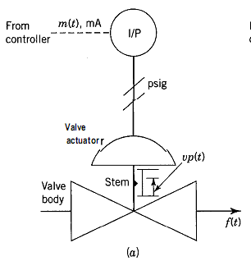
 | 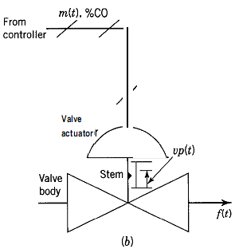

Principes and practice of automatic process control 2E

