5-3.1 Actions of controllers

The selection of the controller action is critical. If the action is not correctly selected, the controller will not control. Let us see how to select the action and what it means.

Consider the heat exchanger control loop shown in Fig. 5-3.2; the process is at steady state, and the set point is constant.  Assume that the signal from the temperature transmitter increases, indicating that the outlet temperature has increased above set point.  To return this temperature to set point, the controller must close the steam valve by some amount. Because the valve is fail-closed (FC), the controller must reduce its output signal to the valve (see the arrows in the figure).  When an increase in the process variable requires a decrease in controller output, the controller must be set to reverse action. Often the term increase/decrease (as the input signal to the controller increases, the output signal from the controller must decrease), or simply decrease, is also used. | 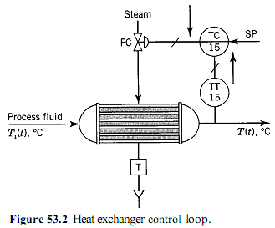
Alternatively, consider the level control loop shown in Fig. 5-3.3; the process is at steady state, and the set point is constant.  Assume that the signal from the level transmitter increases, indicating that the level has increased above the set point.  To return this level to set point, the controller must open the valve by some amount. Because the valve is fail-closed (FC), the controller must increase its output signal to the valve (see the arrows in the figure).  To make this decision, the controller must be set to direct action. Often the term increase/increase (as the input signal to the controller increases, the output signal from the controller must also increase), or simply increase, is also  used. | 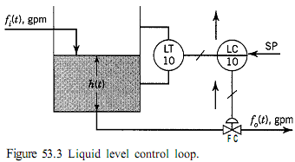

In summary, to determine the action of a controller, the engineer must know:

1. The process requirements for control.
2. The fail-safe action of the control valve or other final control element.

Both things must be taken into consideration. What should be the action of the level controller if a fail-open (FO) valve is used? And what should it be if the level is controlled with the inlet flow instead of the outlet flow? In the first case the control valve action changes, whereas in the second case the process requirements for control change.

The controller action is set by a switch or by a configuration bit on most controllers.

