6-1 Feedback control loop for temperature control of a heat exchanger

The stirred tank sketched in Fig. 6-1.5 is used to heat a process stream so that its premixed components achieve a uniform composition.
Temperature control is important because a high temperature tends to decompose the product, whereas a low temperature results in incomplete mixing.
The tank is heated by steam condensing inside a coil.
A proportional-integral-derivative (PID) controller is used to control the temperature in the tank by manipulating the steam valve position.
Derive the complete block diagram and the closed-loop transfer function from the following design data.
PROCESS.  The feed has a density ρ of 68.0 lb/ft3 and a heat capacity Cp of 0.80 Btu/lb-°F.  The volume V of liquid in the reactor is maintained constant at 120 ft³.  The coil consists of 205 ft of 4-in.  schedule 40 steel pipe that weighs 10.8 lb/ft and has a heat capacity of 0.12 Btu/lb-°F and an outside diameter of 4.500 in.  The overall heat transfer coefficient U, based on the outside area of the coil, has been estimated as 2.1 Btu/min-ft2-°F.  . | |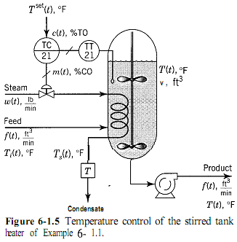  The steam available is saturated at a pressure of 30 psia; it can be assumed that its latent heat of condensation λ is constant at 966 Btu/lb. It can also be assumed that the inlet temperature T, is constant | 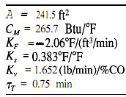  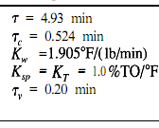  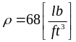  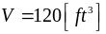  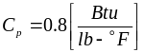  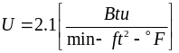
DESIGN CONDITIONS.  The feed flow f at design conditions is 15 ft3/min, and its temperature Ti is 100°F. The contents of the tank must be maintained at a temperature T of 150°F. Possible disturbances are changes in feed rate and temperature. | TEMPERATURE SENSOR AND TRANSMITTER.  The temperature sensor has a calibrated range of 100 to 200°F and a time constant thau t of 0.75 min.  CONTROL VALVE.  The control valve is to be designed for 100% overcapacity, and pressure drop variations can be neglected. The valve is an equal percentage valve with a rangeability parameter α of 50. The actuator has a time constant thou v 7, of 0.20 min.
PROCESS.  An energy balance on the liquid in the tank, assuming negligible heat losses, perfect mixing, and constant volume and physical properties, results in the equation | 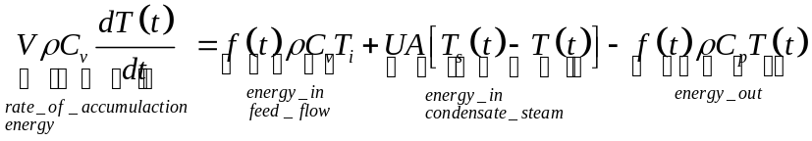  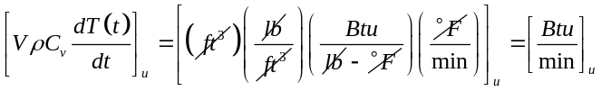  : the heat transfer area, ft2  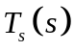: the condensing steam temperature, °F  and the other symbols have been defined in the statement of the problem. For the liquid contents of the tank, the cv, in the accumulation term is essentially equal to cP .

An energy balance on the coil, assuming that the coil metal is at the same temperature as the condensing steam, results in: | 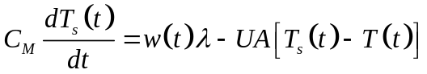  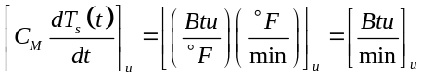  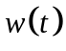: the steam rate lb/min  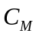: heat capacitance of the coil metal Btu/°F  Because of the steam is the output of the control valve and an input to the process, our process model is complete.
Linearization and Laplace Transformation.  By the methods presented in Section 2-6, we obtain the linearized tank model equations in terms of deviation variables. | 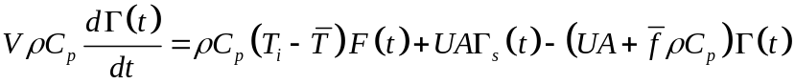  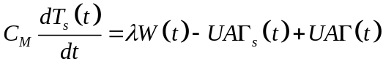
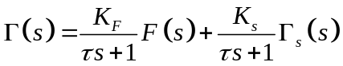
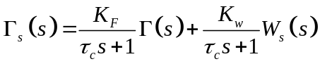

Control valve  The transfer function for an equal percentage valve with constant pressure drop is, from Section 5-2 | 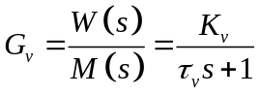  where M(s) is the controller output signal in percent controller output (%CO), and the valve gain is, from Section 5-2:  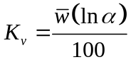
Sensor/transmitter (TT21) | The sensor transmitter can be represented by a first oder lag:  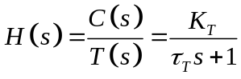  where C(s) is the Laplace transform of the transmitter output signal, %TO, and the  transmitter gain is, from Section 5-1,  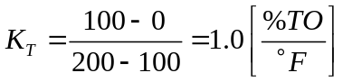
The transfer function of the PID controller is, from Section 5-3, | 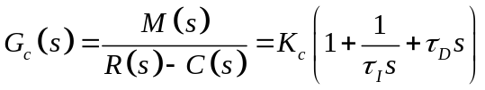

Block Diagram of the Loop. Figure 6-1.6 shows the complete block diagram for the loop. All of the transfer functions in the diagram have been derived here. Using the rules for block diagram manipulation we learned in Chapter 3, we obtain the simpler diagram of Fig. 6-1.7.
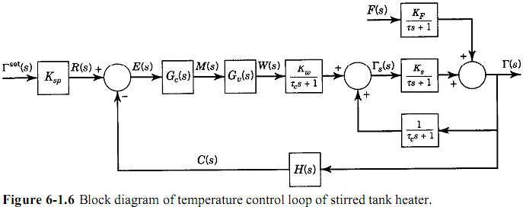
The transfer functions in the diagram are | 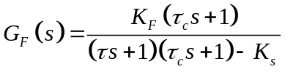  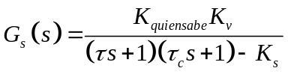
The closed-loop transfer functions to the inputs are | 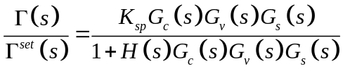  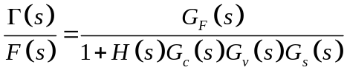
Table 6-1.1 gives the numerical values of the parameters in the transfer functions, calculated from the data given in the problem statement. The base values for the linearization are the design conditions, assumed to be the initial conditions and at steady state.
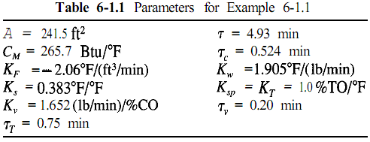
From the model equations for the tank and the coil, we compute the initial steam temperature and steam flow. At steady state, |  | 