6-1 THE FEEDBACK CONTROL LOOP

The concept of feedback control, though it is more than 2000 years old, did not find practical application in industry until James Watt applied it to control the speed of his steam engine about 200 years ago.

Since then, industrial applications have proliferated to the point where, today, almost all automatic control systems include feedback control. None of the advanced control techniques that have been developed in the last 50 years to enhance the performance of feedback control loops have been able to replace it. We will study these advanced techniques in later chapters.

To review the concept of feedback control, let us again look at the heat exchanger example of Chapter 1.  Figure 6-1.1 presents a sketch of the exchanger.  Our objective is to maintain the outlet temperature of the process fluid, T_{o}(t), at its desired value or set point, T_{o}^{set},  in the presence of variations of the process fluid flow, W(t), and inlet temperature, Ti(t). We select the steam flow, Ws(t), as the variable that can be adjusted to control the outlet temperature; the amount of energy supplied to the process fluid is proportional to the steam flow.  FEEDBACK CONTROL WORKS AS FOLLOWS:  A sensor/transmitter (TT42) measures the outlet temperature or controlled variable, T_{o}(t); generates a signal C(t) proportional to it; and sends it to the controller (TC42), where it is compared to the set point, T_{o}^{set}(t). | 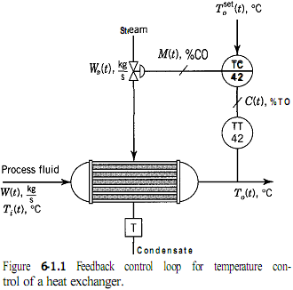  The controller then calculates an output signal or manipulated variable, M(t), on the basis of the error-that is, the difference between the measurement and the set point. This controller output signal is sent to the actuator of the steam control valve. The valve actuator positions the valve in proportion to the controller output signal. Finally, the steam flow, a function of the valve position, determines the energy rate to the exchanger and therefore the controlled outlet temperature.
The term feedback derives from the fact that the controlled variable is measured and this measurement is “fed back” to reposition the steam valve. This causes the signal variations to move around the loop as follows: | Variations in outlet temperature are sensed by the sensor/transmitter and sent to the controller, causing the controller output signal to vary. This in turn causes the control valve position and consequently the steam flow to vary. The variations in steam flow cause the outlet temperature to vary, thus completing the loop.

This loop structure is what makes feedback control simultaneously simple and effective. When properly tuned, the feedback controller can maintain the controlled variable at or near the set point in the presence of any disturbance (such as process flow and inlet temperature) without knowledge of what the disturbance is or of its magnitude. | 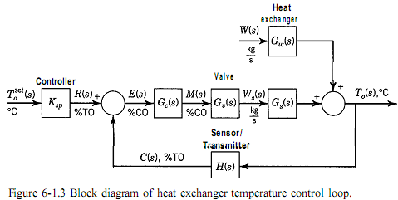
As we saw in Section 5-3, the most important requirement of the controller is the direction of its action (or simply action), direct or reverse. In the case of the temperature controller, the correct action is reverse, because an increase in temperature requires a decrease in the controller output signal to close the valve and reduce the steam flow. This assumes that the control valve is air-to-open so that the steam flow will be cut off in case of loss of electric power or instrument air pressure (fail-closed). | The performance of the control loop can best be analyzed by drawing the block diagram for the entire loop.  To do this, we first draw the block for each component and then connect the output signal from each block to the next block.  Let us start with the heat exchanger. In Chapters 3 and 4 we learned that the linear approximation to the response of the output of any process can be represented by the sum of a series of blocks, one for each input variable. | 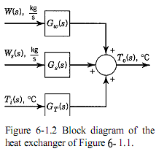  The heat exchanger consists of three blocks, one for each of its three inputs: the process flow, W(s), inlet temperature, Ti(s), and steam flow, Ws(s). The corresponding transfer functions are Gw(s), Gs(s), and G_{T}(s).
Figure 6-1.3 shows the complete block diagram for the feedback control loop.  To simplify the discussion that follows, we have purposely omitted the inlet temperature, Ti(s), as an input signal.  This effectively assumes that the inlet temperature is constant and selects the process flow, W(s), as representative of either disturbance. | 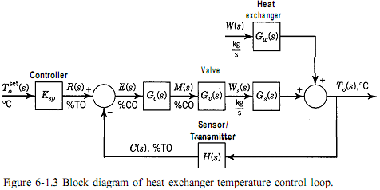
The symbols in Figure 6-1.3 are as follows: | 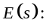the error, % transmitter output (%TO)  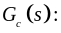the controller transfer function (%CO / %TO)  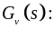the control valve transfer function ( Kg/s / %CO)  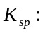 the scale factor for the temperature set point ( %TO / °C )  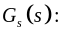transfer function 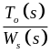
It is important at this point to note the correspondence between the blocks (or groups of blocks) in the block diagram, Fig. 6-1.3, and the components of the control loop, Fig. 6- 1.1. | This comparison is facilitated by matching the symbols used to identify the various signals. It is also important to recall from Chapter 3 that the blocks on the diagram represent linear relationships between the input and output signals and that the signals are deviations from initial steady-state values and are not absolute variable values.
The term Ksp, is a scale factor that converts the set point, usually calibrated in the same units as the controlled variable, to the same basis as the transmitter signal-that is, °C to %TO. | It can be shown that for the measurement and the set point to be on the same scale, Ksp, must be numerically equal to the transmitter gain.

The sign convention used in the block diagram of Fig. 6-1.3 agrees with the convention used in Section 5-3 for calculation of the error (set point -measurement).  This convention will be used throughout this book. Note that this makes the sign around the loop negative if the gains of all the blocks and summers in the loop are positive, as hey are in this case. A negative feedback gain is a requirement for stability.  Following his convention, a reverse-acting controller must have a positive gain, and a direct acting controller must have a negative gain, as you can verify by analyzing the controller section of the block diagram. The convention is not selected this way to confuse you, but to emphasize graphically the negative feedback gain on the block diagram (otherwise, the minus sign would be hidden in the controller gain). | 