6-1.1 Closed-Loop Transfer Function

We can see by inspection of the closed-loop block diagram of Fig. 6-1.3 that the loop has one output signal, the controlled variable To(s), and two input signals, the set point Toset(s), and the disturbance W(s).  Because the steam flow is connected to the outlet temperature through the control loop, we might expect that the “closed-loop response” of the system to the various inputs would be different from the response when the loop is “open.”  Most control loops can be opened by flipping a switch on the controller from the automatic to the manual position (see Section 5-3). | 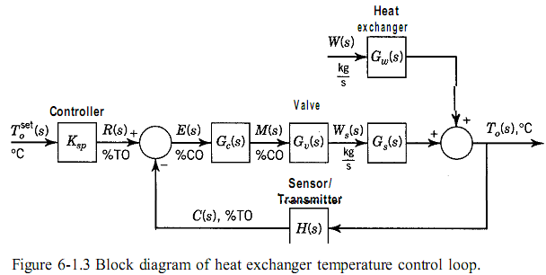  When the controller is in the manual position, its output does not respond to the error signal, so it is independent of the set point and measurement signals. In “automatic”, on the other hand, the controller output varies when the measurement signal varies.
We can determine the closed-loop transfer function of the loop output with regard to any of its inputs by applying the rules of block diagram algebra (see Chapter 3) to the diagram of the loop. To review, suppose we want to derive the response of the outlet temperature To(s) to the process flow W(s). We first write the equations for each block in the diagram, as follows: | 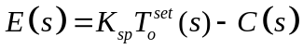  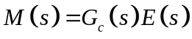  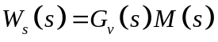  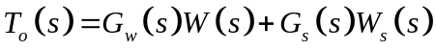  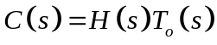
Next we assume that the set point does not vary-that is, its deviation variable is zero-  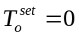  and eliminate all the intermediate variables by combining Eqs. 6- 1.1 through 6- 1.5. The result is: | 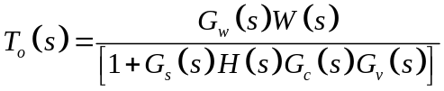  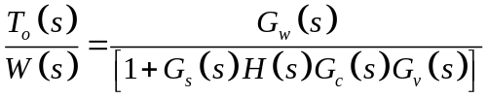

This is the closed-loop transfer function between the process flow and the outlet temperature. Similarly, if we let W(s) = 0 and combine Eqs. 6-1.1 through 6-1.5, the closed-loop transfer function between the set point and the outlet temperature results. | 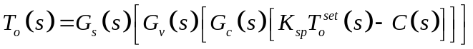  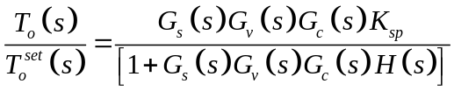
 | As we saw in Chapter 3, the denominator is the same for both inputs, whereas the numerator is different for each input. We recall further that the denominator is 1 plus the product of the transfer functions of all the blocks that are in the loop itself and that the numerator of each transfer function is the product of the blocks that are in the direct path between the specific input and the output of the loop. These results apply to any block diagram that contains a single loop.

Simplified Block Diagram  It is convenient to simplify the block diagram of Fig. 6-1.3 by combining blocks. Following the rules of block diagram algebra from Chapter 3 yields Fig. 6-1.4. The transfer functions of the simplified diagram are  FORZAMIENTO A REALIMENTACION UNITARIA  In the simplified diagram, the loop signals are in percent of range and the feedback gain is unity, which is why the loop in the diagram is sometimes called a unity feedback loop. | 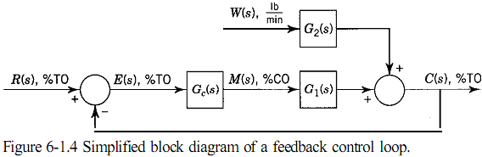  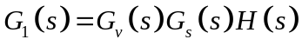  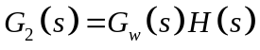
The closed-loop transfer function of the output signal, which is now the transmitter output, is | 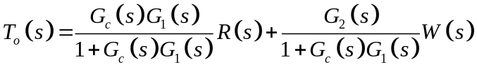
where R(s) is the reference signal (set point) in %TO. Except for the name of the flow disturbance, the block diagram of Fig. 6-1.4 can represent any feedback control loop.
The following example demonstrates how to develop the closed-loop transfer function from the principles we learned in Chapters 3, 4, and 5.

