6-1.1 Temperature control of a continuous stirred tank heater

The stirred tank sketched in Fig. 6-1.5 is used to heat a process stream so that its premixed components achieve a uniform composition. Temperature control is important because a high temperature tends to decompose the product, whereas a low temperature results in incomplete mixing. The tank is heated by steam condensing inside a coil. A proportional-integral-derivative (PID) controller is used to control the temperature in the tank by manipulating the steam valve position. Derive the complete block diagram and the closed-loop transfer function from the following design data. | 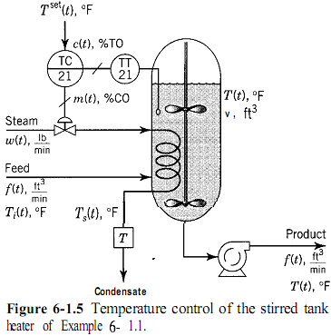
 | 