6-1.4 Flow control loop

Flow control loops are commonly used as the innermost loop in cascade, ratio, and feedforward control systems. Develop the closed-loop transfer function for a flow control loop with a proportional-integral (PI) controller.

Figure 6-1.10 shows a schematic diagram of a flow control loop and its corresponding block diagram. To concentrate on the response of the flow F(s) to its set point Fset(s), we will assume constant pressure drop across the control valve. However, one of the purposes of the flow controller is to compensate for changes in the pressure drop across the valve (disturbance). Note that the flow control loop does not have a process! This is because the controlled variable, the flow, is the output of the control valve. | 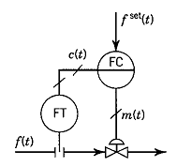
As we saw in Section 5-2, the control valve can be represented by a first-order lag.  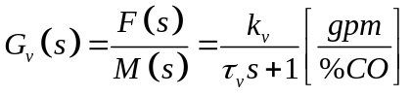 | 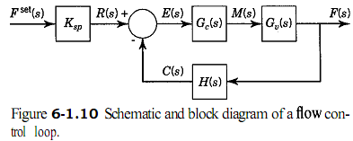
Flow transmitters are usually fast and can thus be represented by just a gain. Assuming a linear transmitter, the gain is, from Section 5-1,  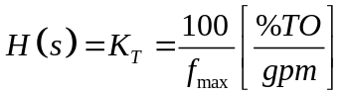 | 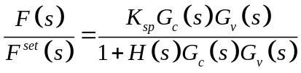  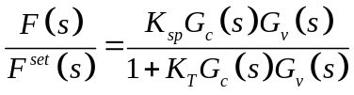  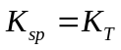  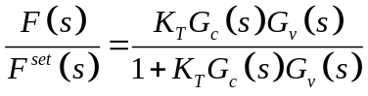
the transfer function of the PI controller is:  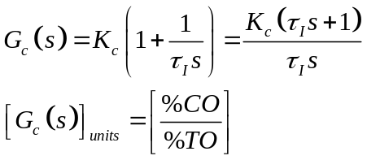 | We substitute into the closed-loop transfer function and simplify to obtain:  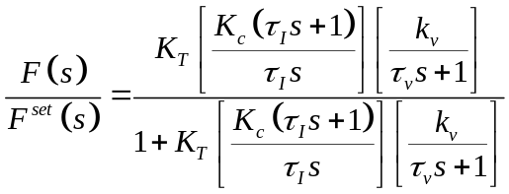
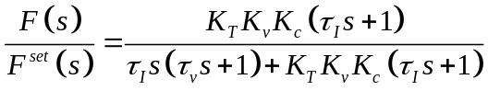 | A fast first-order response can be obtained by  setting the integral time equal to the valve time constant,  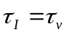  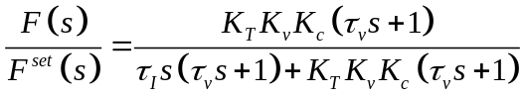  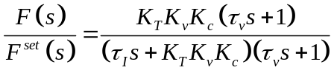

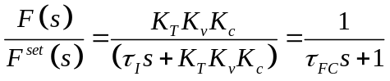  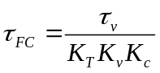 | Note that the closed-loop response is faster (shorter time constant) as the controller gain increases and that the steady-state gain is unity; that is, there is no offset.
When the flow control loop is part of a cascade control system, its set point is sometimes in percent of range instead of in engineering units (gpm). In such cases, the input to the loop is R(s) instead of Fset(s) | 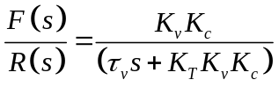  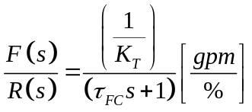  And the gain of the flow control loop is:  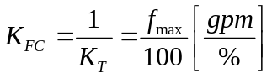
Note that this is very similar to the gain of a linear valve with constant pressure drop, except that the maximum flow here is the upper limit of the flow transmitter range (see Section 5-2). | The formulas derived in this example apply to liquid, gas, and steam valves, with the units appropriately adjusted (e.g., gpm, scfm, lb/h). They are independent of the flow characteristics of the valve and of whether the pressure drop is constant or variable

Principes and practice of automatic process control 2E

