Linearization - Jacobian Analisys

Equilibrium points

Consider a nonlinear differential equation

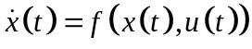

Where f is a function mapping Rn x Rm → Rn . A point 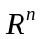 is called an equilibrium point if there is an specific 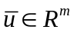 (called the equilibrium input) such that:

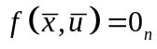

Suppose is an equilibrium point (with equilibrium input ). Consider starting the system from initial condition 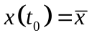, and applying the input 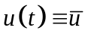for all 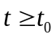. The resulting solution 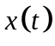 satisfies:

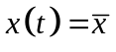
For all . That is why it is called an equilibrium point.

