Linearization of nonlinear function
Recall that only the solutions of linear systems may be found explicitly. The problem is that in general real life problems may only be modeled by nonlinear systems. In this case, we only know how to describe the solutions globally (via nullclines). What happens around an equilibrium point remains a mystery so far. Here we propose the to discuss this problem. The main idea is to approximate a nonlinear system by a linear one (around the equilibrium point). Of course, we do hope that the behavior of the solutions of the linear system will be the same as the nonlinear one. This is the case most of the time (not all the time!).
Consider de autonomous system:

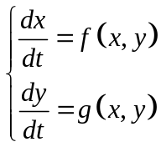

And assume that 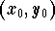is an equilibrium point. So we would like to find the closest linear system when (x,y) is close to . In order to do that we need to approximate the functions f(x,y) and g(x,y) when (x,y) is close to . This is a similar problem to approximating a real valued function by its tangent (around a point of course). From multivariable calculus, we get

