LIQUID-LEVEL PROCESS WITH CONSTANT-FLOW OUTLET

Ecuacion de balance  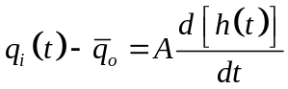  At steady state:  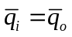  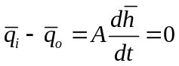  Restando a la primera ec:  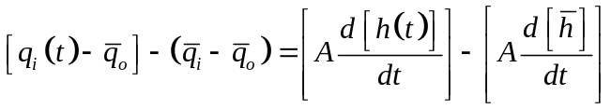 | 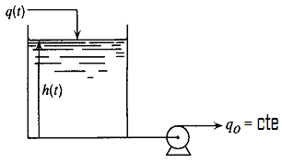  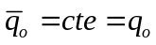
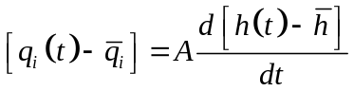  Definiendo las variables de desviacion:  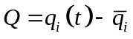  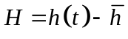 | 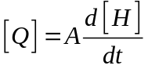  Applying laplace transform:  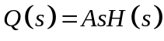  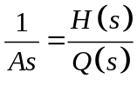  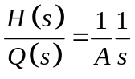
Solution is:  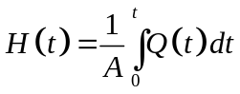  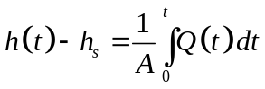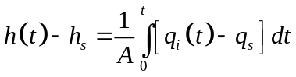  Si 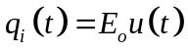  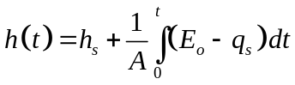  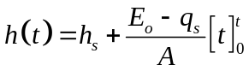  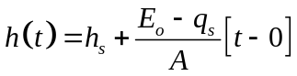  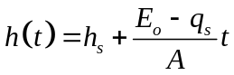 | Analizando:  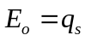 → 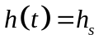  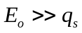 → 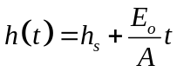  Crece indefinidamente  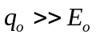→ 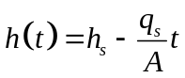  En que momento será cero ¿? 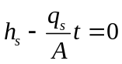  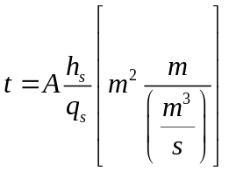  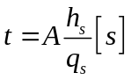

Step response is a ramp function that grows without limit. Such a system that grows without limit for a sustained change in input is said to have nonregulation. Systems that have a limited change in output for a sustained change in input are said to have regulation. An example of a system having regulation is the step response of a first-order system.

