Sensors and transmitters.

The transfer function of the sensor/transmitter combination relates its output signal to its input, which is the process variable; this is shown in Fig. 5-  1.1. The simplest form of the transfer function is a first-order lag: | 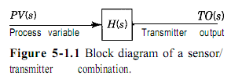
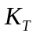 transmitter gain  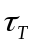 transmitter time constant | 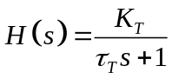
When the relationship between the transmitter output (TO) and the process variable (PV) is linear, the transmitter gain is simple to obtain once the span is known.  Consider an electronic pressure transmitter with a range of 0 to 200 psig.  Figure 5-1.2 shows the output versus the process variable (input). From the definition of gain in Chapter 3, the gain of a linear transmitter can be obtained by considering the entire change in output over the entire change in input, which is the span of the transmitter. | 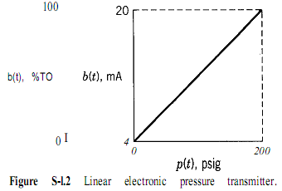  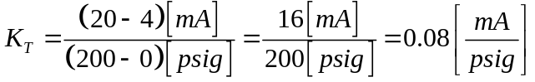
Thus the gain of a sensor/transmitter is the ratio of the span of the output signal to the span of the measured variable.

The preceding example assumed that the gain of the sensor/transmitter is constant over the complete operating range. For most sensor/transmitters this is the case, but there are some instances, such as a differential pressure sensor used to measure flow, when this is not so.

A differential pressure sensor measures the differential pressure, h, across an orifice. Ideally, this differential pressure is proportional to the square of the volumetric flow rate,J That is,

