Familias Lógicas

An Introduction to Digital Logic Familities

In the beginning (almost) there was diode logic (DL).^{reference}
See a beautiful little DL Demonstrator (local copy) from HyperPhysics
Level-Shifted Diode Logic Two-Input NAND Gate
- With either input at 0V,  V_{x}=0.7 V, D_{L} is just cut off,  and V_{OUT} = 0 V.  - With both inputs at 1 V,  V_{X}=1.7 V and V_{OUT}=1 V. | 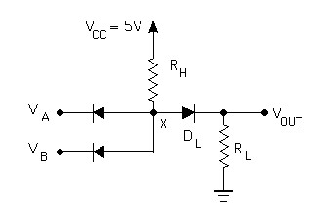

Then there was resistor-transistor logic (RTL)....
Resistor-Transistor Logia
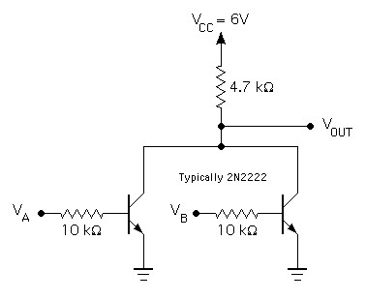 | 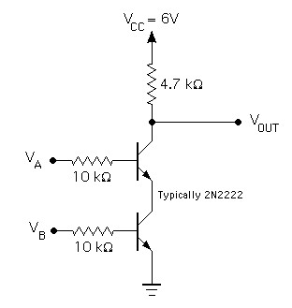
Two-Input NOR Gate | Two-Input NAND Gate

and diode-transistor logic (DTL).
A Diode-Transistor Logic (DTL) Two-Input NAND Gate
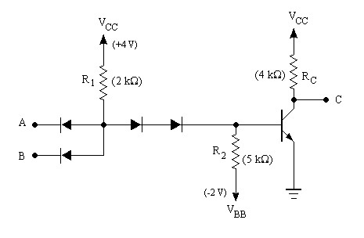 | - If all inputs are high, V_{x} = 2.2 V and  the transistor is saturated.  - If any input goes low (0.2 V), V_{x} = 0.9 V  and the transistor cuts off.  - The added resistor R₂ provides a discharge  path for stored base charge in the BJT, to  provide a reasonable L->H transition time.

930 Series Diode-Transistor Logic Three-Input NAND Gate
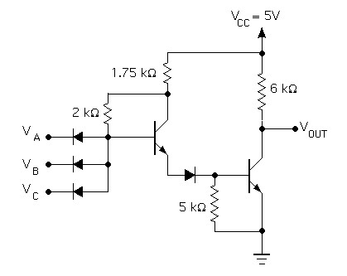

Which begat transistor-transistor logic (TTL).
Basic Transistor-Transistor Logic (TTL) Inverter
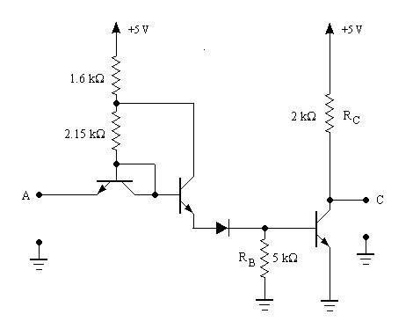

Basic Multi-emitter TTL Three-Input NAND Gate
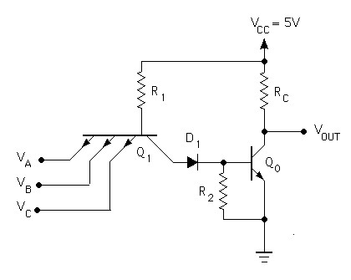 | ALL INPUTS HIGH.  ï Q₁ is reverse active.  ï Q_{O} is saturated.  ï V_{OL} = V_{CE}(sat)  ANY INPUT LOW.  ï Q₁ is saturated.  ï Q_{O} is cut off.  ï V_{OH} = V_{CC}

TTL Switching or Transistion Times
(see illustration)
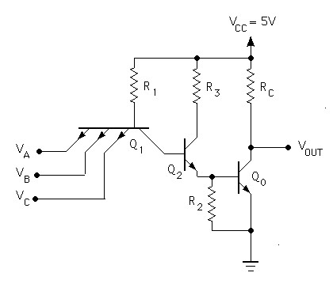
Low to High Transistion  - The time required to discharge the Q₁ depletion layers is << 1ns.  - The time required to extract the Q₂ base charge is also << 1ns:  - Q₁ becomes forward active;  - IBR becomes large for Q₂  - Removal of base charge from Q_{O} is similar to the DTL case. With R₂ = 1 kΩ, t_{s} = 10ns (typical values for 7400 series TTL). | High to Low Transistion  - The depletion capacitance of the Q₁ EB junction must discharge;  - Base charge must be removed from the saturated Q₂  - Ditto for Q_{O}  - The capactive load must be charged to V_{CC}.

Low-Power Schottky TTL (74LS Series)
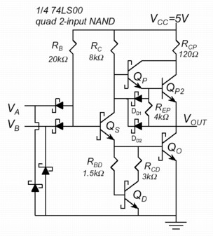  Click on image to enlarge | Why go back to DTL?  - The Schottky diodes can be made smaller than Q₁, with lower parasitic capacitances, with post 1975 technology (6mm features).  - Q_{S} can not saturate, so it is not neccessary to remove its base charge with a BJT.  (source)

CMOS and NMOS Logic
See our MOS logic page

References
See notes from Professor John Emerson Ayers course on
Digital Integrated Circuits particularly the notes on DTL/TTL (local copy).
See also Inside Logic Gates

This page was prepared and is maintained by R. Victor Jones
Comments to: mailto:%20jones.deas.harvard.edu.
Last updated December 11, 2001

Home | www.play-hookey.com | Tue, 06-01-2004
Digital | Logic Families | Digital Experiments | Analog | Analog Experiments | DC Electronic Theory | Optics | Computers | Semiconductors | Test HTML

Select the Logic Family you wish to examine:
[Diode Logic (DL)] [Resistor-Transistor Logic (RTL)] [Diode-Transistor Logic (DTL)]
[Transistor-Transistor Logic (TTL)] [Emitter-Coupled Logic (ECL)] [CMOS]
Inside Logic Gates
I have received a number of requests, asking just what goes on inside logic gates to actually perform logic functions. So, by popular demand, here are the internal schematics of various gates, as implemented by several different logic families.
I won't cover the internal operation of individual semiconductor devices in these pages, except to state the basic behavior of a given device under specific conditions. More detailed coverage of semiconductor physics and internal behavior is a job for another set of pages, which will come later.

There are several different families of logic gates. Each family has its capabilities and limitations, its advantages and disadvantages. The following list describes the main logic families and their characteristics. You can follow the links to see the circuit construction of gates of each family.
Diode Logic (DL)
Diode logic gates use diodes to perform AND and OR logic functions. Diodes have the property of easily passing an electrical current in one direction, but not the other. Thus, diodes can act as a logical switch.
Diode logic gates are very simple and inexpensive, and can be used effectively in specific situations. However, they cannot be used extensively, as they tend to degrade digital signals rapidly. In addition, they cannot perform a NOT function, so their usefulness is quite limited.

Resistor-Transistor Logic (RTL)
Resistor-transistor logic gates use Transistors to combine multiple input signals, which also amplify and invert the resulting combined signal. Often an additional transistor is included to re-invert the output signal. This combination provides clean output signals and either inversion or non-inversion as needed.
RTL gates are almost as simple as DL gates, and remain inexpensive. They also are handy because both normal and inverted signals are often available. However, they do draw a significant amount of current from the power supply for each gate. Another limitation is that RTL gates cannot switch at the high speeds used by today's computers, although they are still useful in slower applications.
Although they are not designed for linear operation, RTL integrated circuits are sometimes used as inexpensive small-signal amplifiers, or as interface devices between linear and digital circuits.

Diode-Transistor Logic (DTL)
By letting diodes perform the logical AND or OR function and then amplifying the result with a transistor, we can avoid some of the limitations of RTL. DTL takes diode logic gates and adds a transistor to the output, in order to provide logic inversion and to restore the signal to full logic levels.

Transistor-Transistor Logic (TTL)
The physical construction of integrated circuits made it more effective to replace all the input diodes in a DTL gate with a transistor, built with multiple emitters. The result is transistor-transistor logic, which became the standard logic circuit in most applications for a number of years.
As the state of the art improved, TTL integrated circuits were adapted slightly to handle a wider range of requirements, but their basic functions remained the same. These devices comprise the 7400 family of digital ICs.

Emitter-Coupled Logic (ECL)
Also known as Current Mode Logic (CML), ECL gates are specifically designed to operate at extremely high speeds, by avoiding the "lag" inherent when transistors are allowed to become saturated. Because of this, however, these gates demand substantial amounts of electrical current to operate correctly.

CMOS Logic
One factor is common to all of the logic families we have listed above: they use significant amounts of electrical power. Many applications, especially portable, battery-powered ones, require that the use of power be absolutely minimized. To accomplish this, the CMOS (Complementary Metal-Oxide-Semiconductor) logic family was developed. This family uses enhancement-mode MOSFETs as its transistors, and is so designed that it requires almost no current to operate.
CMOS gates are, however, severely limited in their speed of operation. Nevertheless, they are highly useful and effective in a wide range of battery-powered applications.
Most logic families share a common characteristic: their inputs require a certain amount of current in order to operate correctly. CMOS gates work a bit differently, but still represent a capacitance that must be charged or discharged when the input changes state. The current required to drive any input must come from the output supplying the logic signal. Therefore, we need to know how much current an input requires, and how much current an output can reliably supply, in order to determine how many inputs may be connected to a single output.
La mayoría de familias almacenan una característica común: sus entrada requieren de una cierta cantidad de corriente para operar correctamente. CMOS trabajan un poco diferente, pero aún presentan una capacitancia que debe ser cargada o descargada cuando cambian de estado las entradas. La corriente requerida para manejar alguna entrada debe llegar de la salida aplicada suministrada de la señal logica. Por lo tanto necesitamos conocer cuanta corriente requiere en la entrada y cuanta corriente puede suministrar en la salida de tal manera saber cuantas entradas se pueden conectar para una salida simple.
However, making such calculations can be tedious, and can bog down logic circuit design. Therefore, we use a different technique. Rather than working constantly with actual currents, we determine the amount of current required to drive one standard input, and designate that as a standard load on any output. Now we can define the number of standard loads a given output can drive, and identify it that way. Unfortunately, some inputs for specialized circuits require more than the usual input current, and some gates, known as buffers, are deliberately designed to be able to drive more inputs than usual. For an easy way to define input current requirements and output drive capabilities, we define two new terms:
Sin embargo, haciendo cálculos puede ser tedioso. Por lo tanto, nosotros usamos una técnica diferente.

Fan-in
The number of standard loads drawn by an input to ensure reliable operation. Most inputs have a fan-in of 1.
El número de cargas dibujadas en una entrada asegura punto de operación. La mayoría de entradas es de fan-in de 1
Fan-out
The number of standard loads that can be reliably driven by an output, without causing the output voltage to shift out of its legal range of values
El numero de cargas que pueden ser manejadas de forma buena por una entrada, sin causar que la tensión de salida cambie de su rango legal de valores
Remember, fan-in and fan-out apply directly only within a given logic family. If for any reason you need to interface between two different logic families, be careful to note and meet the drive requirements and limitations of both families, within the interface circuitry.

