 |  |  |  |  | Detener conteo | Par-impar |  | Salida hacia el MOC
 |  | C | B | A | E₁ | E₀ |  | S₀ |  | C⁺ | B⁺ | A⁺
M0 |  | 0 | 0 | 0 | 0 | 0 |  | 0 |  | 0 | 1 | 0
M1 | 0 | 0 | 0 | 0 | 0 | 1 |  | 0 |  | 1 | 1 | 1
M2 |  | 0 | 0 | 0 | 1 | 0 |  | 0 |  | 0 | 0 | 0
M3 |  | 0 | 0 | 0 | 1 | 1 |  | 0 |  | 0 | 0 | 0
M4 |  | 0 | 0 | 1 | 0 | 0 |  | 0 |  | 0 | 1 | 0
M5 | 1 | 0 | 0 | 1 | 0 | 1 |  | 0 |  | 0 | 1 | 1
M6 |  | 0 | 0 | 1 | 1 | 0 |  | 0 |  | 0 | 0 | 1
M7 |  | 0 | 0 | 1 | 1 | 1 |  | 0 |  | 0 | 0 | 1
M8 |  | 0 | 1 | 0 | 0 | 0 |  | 0 |  | 1 | 0 | 0
M9 | 2 | 0 | 1 | 0 | 0 | 1 |  | 0 |  | 0 | 1 | 1
M10 |  | 0 | 1 | 0 | 1 | 0 |  | 0 |  | 0 | 1 | 0
M11 |  | 0 | 1 | 0 | 1 | 1 |  | 0 |  | 0 | 1 | 0
M12 |  | 0 | 1 | 1 | 0 | 0 |  | 1 |  | 1 | 0 | 0
M13 | 3 | 0 | 1 | 1 | 0 | 1 |  | 1 |  | 1 | 0 | 1
M14 |  | 0 | 1 | 1 | 1 | 0 |  | 1 |  | 0 | 1 | 1
M15 |  | 0 | 1 | 1 | 1 | 1 |  | 1 |  | 0 | 1 | 1
M16 |  | 1 | 0 | 0 | 0 | 0 |  | 0 |  | 1 | 1 | 0
M17 | 4 | 1 | 0 | 0 | 0 | 1 |  | 0 |  | 1 | 0 | 1
M18 |  | 1 | 0 | 0 | 1 | 0 |  | 0 |  | 1 | 0 | 0
M19 |  | 1 | 0 | 0 | 1 | 1 |  | 0 |  | 1 | 0 | 0
M20 |  | 1 | 0 | 1 | 0 | 0 |  | 1 |  | 1 | 1 | 0
M21 | 5 | 1 | 0 | 1 | 0 | 1 |  | 1 |  | 1 | 1 | 1
M22 |  | 1 | 0 | 1 | 1 | 0 |  | 1 |  | 1 | 0 | 1
M23 |  | 1 | 0 | 1 | 1 | 1 |  | 1 |  | 1 | 0 | 1
M24 |  | 1 | 1 | 0 | 0 | 0 |  | 1 |  | 0 | 0 | 0
M25 | 6 | 1 | 1 | 0 | 0 | 1 |  | 1 |  | 1 | 1 | 1
M26 |  | 1 | 1 | 0 | 1 | 0 |  | 1 |  | 1 | 1 | 0
M27 |  | 1 | 1 | 0 | 1 | 1 |  | 1 |  | 1 | 1 | 0
M28 |  | 1 | 1 | 1 | 0 | 0 |  | 0 |  | 0 | 0 | 0
M29 | 7 | 1 | 1 | 1 | 0 | 1 |  | 0 |  | 0 | 0 | 1
M30 |  | 1 | 1 | 1 | 1 | 0 |  | 0 |  | 1 | 1 | 1
M31 |  | 1 | 1 | 1 | 1 | 1 |  | 0 |  | 1 | 1 | 1

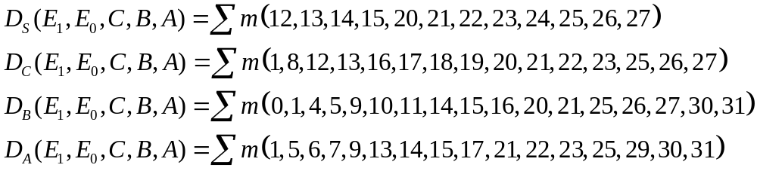
Conteo par 00
  - Conteo impar 01
  - conteo detenido 11

S:
C=0
E1E0 | 00 | 01 | 11 | 10
BA
00 | 0 | 0 | 0 | 0
01 | 0 | 0 | 0 | 0
11 | 1 | 1 | 1 | 1
10 | 0 | 0 | 0 | 0

C=1
E1E0 | 00 | 01 | 11 | 10
BA
00 | 0 | 0 | 0 | 0
01 | 1 | 1 | 1 | 1
11 | 0 | 0 | 0 | 0
10 | 1 | 1 | 1 | 1

C:
E1=0
BA | 00 | 01 | 11 | 10
E₀C
00 | 0 | 1 | 0 | 0
01 | 0 | 0 | 0 | 0
11 | 1 | 1 | 0 | 0
10 | 1 | 0 | 0 | 0

E₁=1
BA | 00 | 01 | 11 | 10
E₀C
00 | 1 | 1 | 1 | 1
01 | 1 | 1 | 1 | 1
11 | 0 | 0 | 0 | 0
10 | 0 | 1 | 1 | 1

E1=0
BA | 00 | 01 | 11 | 10
E₀C
00 | M0 | M1 | M3 | M2
01 | M4 | M5 | M7 | M6
11 | M12 | M13 | M15 | M14
10 | M8 | M9 | M11 | M10

E₁=1
BA | 00 | 01 | 11 | 10
E₀C
00 | M16 | M17 | M19 | M18
01 | M20 | M21 | M23 | M22
11 | M28 | M29 | M31 | M30
10 | M24 | M25 | M27 | M26

S:
E1=0
BA | 00 | 01 | 11 | 10
E₀C
00 | 0 | 0 | 0 | 0
01 | 0 | 0 | 0 | 0
11 | 1 | 1 | 1 | 1
10 | 0 | 0 | 0 | 0

E₁=1
BA | 00 | 01 | 11 | 10
E₀C
00 | 0 | 0 | 0 | 0
01 | 1 | 1 | 1 | 1
11 | 0 | 0 | 0 | 0
10 | 1 | 1 | 1 | 1

C:
E1=0
BA | 00 | 01 | 11 | 10
E₀C
00 | 0 | 1 | 0 | 0
01 | 0 | 0 | 0 | 0
11 | 0 | 1 | 0 | 0
10 | 1 | 0 | 0 | 0

E₁=1
BA | 00 | 01 | 11 | 10
E₀C
00 | 1 | 1 | 1 | 1
01 | 1 | 1 | 1 | 1
11 | 0 | 0 | 0 | 0
10 | 0 | 1 | 1 | 1

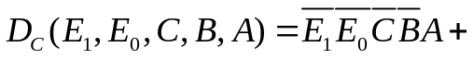

S1
001

S2
010

S3
011

S0
000

S7
111

S6
110

S5
101

S4
100

0/0
0/0
0/0
00/00
P=1
1/1
1/1
1/1
01/
P=1
P=0

P=1

E1=0
BA | 00 | 01 | 11 | 10
E₀C
00 | M0 | M1 | M3 | M2
01 | M4 | M5 | M7 | M6
11 | M12 | M13 | M15 | M14
10 | M8 | M9 | M11 | M10

E₁=1
BA | 00 | 01 | 11 | 10
E₀C
00 | M16 | M17 | M19 | M18
01 | M20 | M21 | M23 | M22
11 | M28 | M29 | M31 | M30
10 | M24 | M25 | M27 | M26

