UNIVERSIDAD NACIONAL
AUTÓNOMA DE MÉXICO


FACULTAD DE INGENIERIA

Trabajo:

EQUIPO:
SANTIAGO CRUZ CARLOS

ASIGNATURA:

GRUPO:

domingo, 08 de noviembre de 2026, Ciudad Universitaria, México, DF
Diseñe un circuito secuencial síncrono que efectúe un conteo por décadas, que realice las siguientes funciones:

- Conteo ascendente
- Conteo descendente
- Iniciar en un conteo específico
- Detener conteo

  - Conteo 00
  - ascendente completo 01
  - descendente completo 10
  - conteo detenido 11

INTRODUCCION:

FLIP FLOP D (SYNCHRONIZED FOR CLOCK)

A diferencia de los flip flops S-C y J-K, este FF sólo tiene una entrada síncrona de control, D, que significa Datos. Q pasará al mismo estado que este presente en la entrada D cuando ocurra una TPP en CLK.

En otras palabras, el nivel presente en D se almacenará en el FF en el instante en que ocurre la TTP.

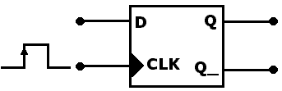

Entradas |  |  | Salidas
D | CLK |  | Q
0 | ↑ |  | 0
1 | ↑ |  | 1

Simulación en Circuit Maker incompleta:
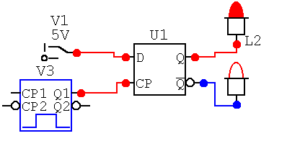
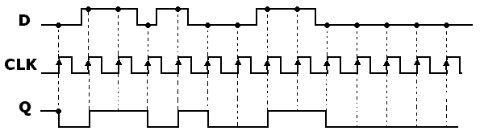

TRANSFERENCIA DE DATOS PARALELA

En este punto quizá usted se pregunte cual es la utilidad del flip flop D, puesto que según parece la salida Q es la misma que la entrada D. No del todo, recuerde Q adopta el valor de D solo en ciertos momentos, y por lo tanto no es idéntica a D.

En la mayoría de las aplicaciones del FF D la salida Q debe adoptar el valor en su entrada D sólo en instantes definidos.

Un ejemplo de esto se ilustra en la figura siguiente:

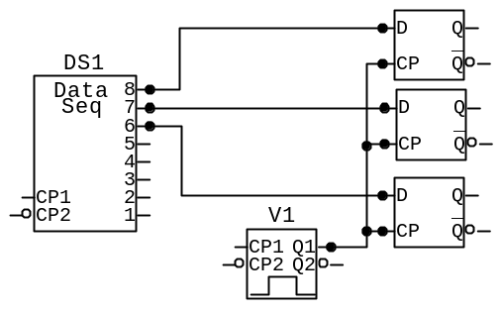

Digamos que el data seq es un circuito lógico combinacional, las salidas 8, 7, 6 se transferirían a Q1, Q2, Q3 del FF para su almacenamiento.

Usando los FF D, los niveles presentes en 8, 7, 6 se transferirán a Q1, Q2, Q3, respectivamente al aplicar un pulso de TRANSFERENCIA a las entradas comunes CLK. Los FFs pueden almacenar estos valores para su procesamiento siguiente.

Este es un ejemplo de transferencia paralela de datos binarios, los bits 8, 7, 6 se transfieren simultáneamente.

 | Var. entrada |  | Estado actual |  |  |  | salidas |  | Estado siguiente |  |  |  | Elemento de memoria
 | C₁ | C₀ | D | C | B | A | Y₁ | Y₀ | D⁺ | C⁺ | B⁺ | A⁺ | D_{D} | D_{C} | D_{B} | D_{A}
Mo | 0 | 0 | 0 | 0 | 0 | 0 | 0 | 0 | d | c | b | a | d | c | B | a
m1 | 0 | 0 | 0 | 0 | 0 | 1 | 0 | 0 | d | c | b | a | d | c | B | a
m2 | 0 | 0 | 0 | 0 | 1 | 0 | 0 | 0 | d | c | b | a | d | c | B | a
m3 | 0 | 0 | 0 | 0 | 1 | 1 | 0 | 0 | d | c | b | a | d | c | B | a
m4 | 0 | 0 | 0 | 1 | 0 | 0 | 0 | 0 | d | c | b | a | d | c | B | a
m5 | 0 | 0 | 0 | 1 | 0 | 1 | 0 | 0 | d | c | b | a | d | c | B | a
m6 | 0 | 0 | 0 | 1 | 1 | 0 | 0 | 0 | d | c | b | a | d | c | B | a
m7 | 0 | 0 | 0 | 1 | 1 | 1 | 0 | 0 | d | c | b | a | d | c | B | a
m8 | 0 | 0 | 1 | 0 | 0 | 0 | 0 | 0 | d | c | b | a | d | C | B | a
m9 | 0 | 0 | 1 | 0 | 0 | 1 | 0 | 0 | d | c | b | a | d | c | B | a
m10 | 0 | 0 | 1 | 0 | 1 | 0 | * | * | * | * | * | * | * | * | * | *
m11 | 0 | 0 | 1 | 0 | 1 | 1 | * | * | * | * | * | * | * | * | * | *
m12 | 0 | 0 | 1 | 1 | 0 | 0 | * | * | * | * | * | * | * | * | * | *
m13 | 0 | 0 | 1 | 1 | 0 | 1 | * | * | * | * | * | * | * | * | * | *
m14 | 0 | 0 | 1 | 1 | 1 | 0 | * | * | * | * | * | * | * | * | * | *
m15 | 0 | 0 | 1 | 1 | 1 | 1 | * | * | * | * | * | * | * | * | * | *

 |  |  | presente |  |  |  |  |  | siguiente |  |  |  | Elemento de memoria
 | C₁ | C₀ | D | C | B | A | Y₁ | Y₀ | D⁺ | C⁺ | B⁺ | A⁺ | D_{D} | D_{C} | D_{B} | D_{A}
m16 | 0 | 1 | 0 | 0 | 0 | 0 | 0 | 0 | 0 | 0 | 0 | 0 | 0 | 0 | 0 | 1
m17 | 0 | 1 | 0 | 0 | 0 | 1 | 0 | 0 | 0 | 0 | 0 | 1 | 0 | 0 | 1 | 0
m18 | 0 | 1 | 0 | 0 | 1 | 0 | 0 | 0 | 0 | 0 | 1 | 0 | 0 | 0 | 1 | 1
m19 | 0 | 1 | 0 | 0 | 1 | 1 | 0 | 0 | 0 | 0 | 1 | 1 | 0 | 1 | 0 | 0
m20 | 0 | 1 | 0 | 1 | 0 | 0 | 0 | 0 | 0 | 1 | 0 | 0 | 0 | 1 | 0 | 1
m21 | 0 | 1 | 0 | 1 | 0 | 1 | 0 | 0 | 0 | 1 | 0 | 1 | 0 | 1 | 1 | 0
m22 | 0 | 1 | 0 | 1 | 1 | 0 | 0 | 0 | 0 | 1 | 1 | 0 | 0 | 1 | 1 | 1
m23 | 0 | 1 | 0 | 1 | 1 | 1 | 0 | 0 | 0 | 1 | 1 | 1 | 1 | 0 | 0 | 0
m24 | 0 | 1 | 1 | 0 | 0 | 0 | 0 | 0 | 1 | 0 | 0 | 0 | 1 | 0 | 0 | 1
m25 | 0 | 1 | 1 | 0 | 0 | 1 | 0 | 1 | 1 | 0 | 0 | 1 | 0 | 0 | 0 | 0
m26 | 0 | 1 | 1 | 0 | 1 | 0 | * | * | * | * | * | * | * | * | * | *
m27 | 0 | 1 | 1 | 0 | 1 | 1 | * | * | * | * | * | * | * | * | * | *
m28 | 0 | 1 | 1 | 1 | 0 | 0 | * | * | * | * | * | * | * | * | * | *
m29 | 0 | 1 | 1 | 1 | 0 | 1 | * | * | * | * | * | * | * | * | * | *
m30 | 0 | 1 | 1 | 1 | 1 | 0 | * | * | * | * | * | * | * | * | * | *
m31 | 0 | 1 | 1 | 1 | 1 | 1 | * | * | * | * | * | * | * | * | * | *

 | Var. entrada |  | Estado actual |  |  |  | salidas |  | Estado siguiente |  |  |  | Elemento de memoria
 | C₁ | C₀ | D | C | B | A | Y₁ | Y₀ | D⁺ | C⁺ | B⁺ | A⁺ | D_{D} | D_{C} | D_{B} | D_{A}
m32 | 1 | 0 | 0 | 0 | 0 | 0 | 1 | 0 | 1 | 0 | 0 | 1 | 1 | 0 | 0 | 1
m33 | 1 | 0 | 0 | 0 | 0 | 1 | 0 | 0 | 1 | 0 | 0 | 0 | 0 | 0 | 0 | 0
m34 | 1 | 0 | 0 | 0 | 1 | 0 | 0 | 0 | 0 | 1 | 1 | 1 | 0 | 0 | 0 | 1
m35 | 1 | 0 | 0 | 0 | 1 | 1 | 0 | 0 | 0 | 1 | 1 | 0 | 0 | 0 | 1 | 0
m36 | 1 | 0 | 0 | 1 | 0 | 0 | 0 | 0 | 0 | 1 | 0 | 1 | 0 | 0 | 1 | 1
m37 | 1 | 0 | 0 | 1 | 0 | 1 | 0 | 0 | 0 | 1 | 0 | 0 | 0 | 1 | 0 | 0
m38 | 1 | 0 | 0 | 1 | 1 | 0 | 0 | 0 | 0 | 0 | 1 | 1 | 0 | 1 | 0 | 1
m39 | 1 | 0 | 0 | 1 | 1 | 1 | 0 | 0 | 0 | 0 | 1 | 0 | 0 | 1 | 1 | 0
m40 | 1 | 0 | 1 | 0 | 0 | 0 | 0 | 0 | 0 | 0 | 0 | 1 | 0 | 1 | 1 | 1
m41 | 1 | 0 | 1 | 0 | 0 | 1 | 0 | 0 | 0 | 0 | 0 | 0 | 1 | 0 | 0 | 0
m42 | 1 | 0 | 1 | 0 | 1 | 0 | * | * | * | * | * | * | * | * | * | *
m43 | 1 | 0 | 1 | 0 | 1 | 1 | * | * | * | * | * | * | * | * | * | *
m44 | 1 | 0 | 1 | 1 | 0 | 0 | * | * | * | * | * | * | * | * | * | *
m45 | 1 | 0 | 1 | 1 | 0 | 1 | * | * | * | * | * | * | * | * | * | *
m46 | 1 | 0 | 1 | 1 | 1 | 0 | * | * | * | * | * | * | * | * | * | *
m47 | 1 | 0 | 1 | 1 | 1 | 1 | * | * | * | * | * | * | * | * | * | *

 | Var. entrada |  | Estado actual |  |  |  | salidas |  | Estado siguiente |  |  |  | Elemento de memoria
 | C₁ | C₀ | D | C | B | A | Y₁ | Y₀ | D⁺ | C⁺ | B⁺ | A⁺ | D_{D} | D_{C} | D_{B} | D_{A}
m48 | 1 | 1 | 0 | 0 | 0 | 0 | 1 | 1 | 0 | 0 | 0 | 0 | 0 | 0 | 0 | 0
M49 | 1 | 1 | 0 | 0 | 0 | 1 | 1 | 1 | 0 | 0 | 0 | 1 | 0 | 0 | 0 | 1
M50 | 1 | 1 | 0 | 0 | 1 | 0 | 1 | 1 | 0 | 0 | 1 | 0 | 0 | 0 | 1 | 0
M51 | 1 | 1 | 0 | 0 | 1 | 1 | 1 | 1 | 0 | 0 | 1 | 1 | 0 | 0 | 1 | 1
M52 | 1 | 1 | 0 | 1 | 0 | 0 | 1 | 1 | 0 | 1 | 0 | 0 | 0 | 1 | 0 | 0
M53 | 1 | 1 | 0 | 1 | 0 | 1 | 1 | 1 | 0 | 1 | 0 | 1 | 0 | 1 | 0 | 1
M54 | 1 | 1 | 0 | 1 | 1 | 0 | 1 | 1 | 0 | 1 | 1 | 0 | 0 | 1 | 1 | 0
M55 | 1 | 1 | 0 | 1 | 1 | 1 | 1 | 1 | 0 | 1 | 1 | 1 | 0 | 1 | 1 | 1
M56 | 1 | 1 | 1 | 0 | 0 | 0 | 1 | 1 | 1 | 0 | 0 | 0 | 1 | 0 | 0 | 0
M57 | 1 | 1 | 1 | 0 | 0 | 1 | 1 | 1 | 1 | 0 | 0 | 1 | 1 | 0 | 0 | 1
M58 | 1 | 1 | 1 | 0 | 1 | 0 | * | * | * | * | * | * | * | * | * | *
M59 | 1 | 1 | 1 | 0 | 1 | 1 | * | * | * | * | * | * | * | * | * | *
M60 | 1 | 1 | 1 | 1 | 0 | 0 | * | * | * | * | * | * | * | * | * | *
M61 | 1 | 1 | 1 | 1 | 0 | 1 | * | * | * | * | * | * | * | * | * | *
M62 | 1 | 1 | 1 | 1 | 1 | 0 | * | * | * | * | * | * | * | * | * | *
M63 | 1 | 1 | 1 | 1 | 1 | 1 | * | * | * | * | * | * | * | * | * | *

S9
1001

S1
0001

S2
0010

S3
0011

S0
0000

S8
1000

S7
0111

S6
0110

S5
0101

S4
0100

dcba

11/11
11/11
11/11
11/11
11/11
11/11
11/11
11/11
01/00
01/00
01/00
01/00
01/00
01/00
01/00
01/00
01/00
01/00
11/11
01/10
01/10
01/10
01/10
01/10
01/10
01/10
01/10
01/10
01/10
00/00
--> Todas las flechas que van hacia abcd son el estado 00/00

tenemos dos entradas,

X₁=0 X₀=0
BA | 00 | 01 | 11 | 10
DC
00 | M0 | M1 | M3 | m2
01 | M4 | M5 | M7 | M6
11 | M12 | M13 | M15 | m14
10 | M8 | m9 | M11 | m10

X₁=0 X₀=1
BA | 00 | 01 | 11 | 10
DC
00 | M16 | M17 | M19 | M18
01 | M20 | M21 | M23 | M22
11 | M28 | M29 | M31 | M30
10 | M24 | M25 | M27 | M26

X₁=1 X₀=0
BA | 00 | 01 | 11 | 10
DC
00 | M32 | M33 | M35 | M34
01 | M36 | m37 | M39 | M38
11 | M44 | M45 | M47 | M46
10 | M40 | M41 | M43 | M42

X₁=1 X₀=1
BA | 00 | 01 | 11 | 10
DC
00 | M48 | M49 | M51 | M50
01 | M52 | M53 | M55 | M54
11 | M60 | M61 | M63 | M62
10 | M56 | M57 | M59 | M58

Para Y1:

X₁=0 X₀=0
BA | 00 | 01 | 11 | 10
DC
00
01
11 | * | * | * | *
10 |  |  | * | *

X₁=0 X₀=1
BA | 00 | 01 | 11 | 10
DC
00
01
11 | * | * | * | *
10 |  |  |  | *

X₁=1 X₀=0
BA | 00 | 01 | 11 | 10
DC
00 | 1
01
11 | * | * | * | *
10 |  |  | * | *

X₁=1 X₀=1
BA | 00 | 01 | 11 | 10
DC
00 | 1 | 1 | 1 | 1
01 | 1 | 1 | 1 | 1
11 | * | * | * | *
10 | 1 | 1 | * | *

1
2

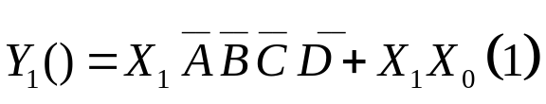

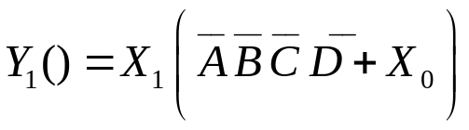

Para Y0

X₁=0 X₀=0
BA | 00 | 01 | 11 | 10
DC
00
01
11 | * | * | * | *
10 |  |  | * | *

X₁=0 X₀=1
BA | 00 | 01 | 11 | 10
DC
00
01
11 | * | * | * | *
10 |  | 1 | * | *

X₁=1 X₀=0
BA | 00 | 01 | 11 | 10
DC
00
01
11 | * | * | * | *
10 |  |  |  | *

1

X₁=1 X₀=1
BA | 00 | 01 | 11 | 10
DC
00 | 1 | 1 | 1 | 1
01 | 1 | 1 | 1 | 1
11 | * | * | * | *
10 | 1 | 1 | * | *
2

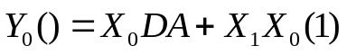

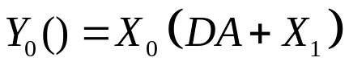

X₁=0 X₀=0
BA | 00 | 01 | 11 | 10
DC
00 | D | D | D | D
01 | D | D | D | D
11 | * | * | * | *
10 | D | D | * | *

X₁=0 X₀=1
BA | 00 | 01 | 11 | 10
DC |  |  |  | 4
00
01 |  |  | 1
11 | * | * | * | *
10 | 1 |  | * | *

X₁=1 X₀=0
BA | 00 | 01 | 11 | 10
DC
00 | 1
01
11 | * | * | * | *
10 |  | 1 | * | *
5
X₁=1 X₀=1
BA | 00 | 01 | 11 | 10
DC
00
01
11 | * | * | * | *
10 | 1 | 1 | * | *
2

1
3

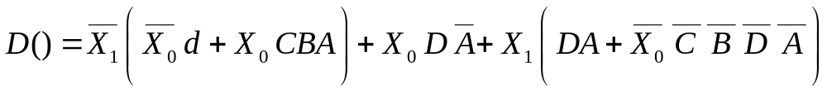

X₁=0 X₀=0
BA | 00 | 01 | 11 | 10
DC |  |  |  | 3
00 | C | C | C | C
01 | C | C | C | C
11 | * | * | * | *
10 | C | C | * | *

X₁=0 X₀=1
BA | 00 | 01 | 11 | 10  2
DC
00 |  |  | 1
01 | 1 | 1 |  | 1
11 | * | * | * | *
10 |  |  | * | *

X₁=1 X₀=0
BA | 00 | 01 | 11 | 10
DC
00
01 |  | 1 | 1 | 1
11 | * | * | * | *
10 | 1 |  | * | *
6
X₁=1 X₀=1
4
BA | 00 | 01 | 11 | 10
DC
00
01 | 1 | 1 | 1 | 1
11 | * | * | * | *
10 |  |  | * | *

1
5
7

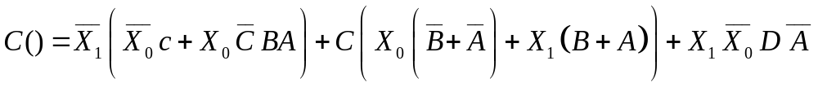

X₁=0 X₀=0
BA | 00 | 01 | 11 | 10
DC |  |  |  | 3
00 | B | B | B | B
01 | B | B | B | B
11 | * | * | * | *
10 | B | B | * | *

X₁=0 X₀=1
BA | 00 | 01 | 11 | 10
DC
00 |  | 1 |  | 1
01 |  | 1 |  | 1  2
11 | * | * | * | *
10 |  |  | * | *

X₁=1 X₀=0
BA | 00 | 01 | 11 | 10
DC
00 |  |  | 1
01 | 1 |  | 1
11 | * | * | * | *
10 | 1 |  | * | *
5
6
X₁=1 X₀=1
BA | 00 | 01 | 11 | 10
DC
00 |  |  | 1 | 1
01 |  |  | 1 | 1
11 | * | * | * | *
10 |  |  | * | *

4
1

X₁=0 X₀=0
BA | 00 | 01 | 11 | 10
DC
00 | A | A | A | A
01 | A | A | A | A
11 | * | * | * | *
10 | A | A | * | *

X₁=0 X₀=1
BA | 00 | 01 | 11 | 10
DC
00 | 1 |  |  | 1  2
01 | 1 |  |  | 1
11 | * | * | * | *
10 | 1 |  | * | *

X₁=1 X₀=0
BA | 00 | 01 | 11 | 10
DC
00 | 1 |  |  | 1
01 | 1 |  |  | 1
11 | * | * | * | *
10 | 1 |  | * | *

X₁=1 X₀=1
BA | 00 | 01 | 11 | 10
DC
00 |  | 1 | 1
01 |  | 1 | 1
11 | * | * | * | *
10 |  | 1 | * | *

1
3
4

