HOST-TO-HOST PAYMENT API
Notes flow
- Host-to-Host flow:
Merchant calls our H2H api with details, in which we process the information for making transaction.
(a.) if the transaction was non-3DS, then we'll provide success response and you'll get notification through webhook API for same.
(b.) if the transaction was 3DS, then we'll provide redirect URL in response , through which user can go to that page for entering OTP/PIN for completing 3ds feature of transaction and transaction will be completed, and you will get notification through webhook API for same .
The whole process can be completed whether configured for webhook or not, but if notification is required in real-time, then u need to follow the documentation for the same.
System webhook 3DS
- Our system sends a webhook callback upon 3DS transaction completion
- You need to configure the webhook URL on your side.
Points to Note:
- Merchant needs provide their base URL, let’s suppose this is your
Base URL: https://app.checkoutgo.top/gateway
so, you'll receive the webhook on GET: https://app.checkoutgo.top/gateway/api/finpay/p12/{checkout-id} .
In this webhook, you need to call our GET Payment Status API for details for the transaction. All details for same are provided in the documentation.
- NOTE: {checkout-id} is used for identifying the transaction.
- You can use “CAD” in currency for Canadian Dollars, “USD” for US Dollars

Example for H2H :
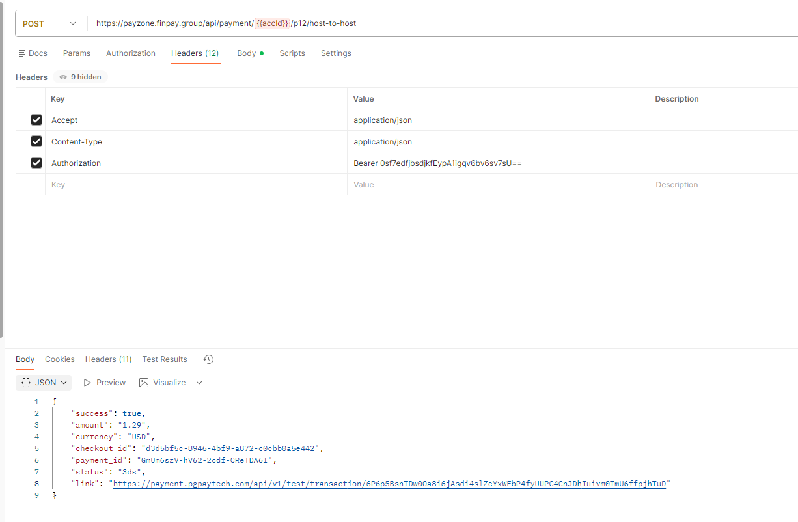
METHOD : POST
https://payzone.finpay.group/api/payment/{YOUR-ACCOUNT-ID}/p12/host-to-host

HEADERS :
Accept : “application/json”,
Content-Type: “application/json”,
Authorization: Your-Bearer-Token

RESQUEST BODY:
{
"firstName": "Veronica",
"lastName": "Verstappen",
"address": "Upside Down",
"country": "US", //2 letters
"state": "Indiana",
"city": "Hopkins",
"zip": "133147",
"ipAddress": "192.168.1.1",
"email": "adam@mail.com",
"phoneNumber": "+441234567890",
"amount": "3.99",
"currency": "USD",
"cardNumber": "5555555555554444",
"cardExpiryMonth": "12",
"cardExpiryYear": "2025",
"cardCvvNumber": "123",
"redirectUrl": "https://www.google.com/"
}

RESPONSE: 200 (SUCCESSFUL AND 3DS TRANSACTION)
{
"success": true,
"amount": 101,
"currency": "USD",
"checkout_id": "93194054",
"payment_id": 153512,
"status": "Awaiting",
"link": "https://cashier.paytoro.io/cashier/threedscheck/df6ab7fc-1023-4e61-996a-1de987404"
}

RESPONSE: 200 (SUCCESSFUL AND NON 3DS TRANSACTION)
{
"success": true,
"amount": 10,
"currency": "USD",
"checkout_id": "23533586",
"payment_id": 153537,
"status": "Captured"
}

RESPONSE: 200 (FAILED Trasanctions)
{
"success": true,
"amount": 10,
"currency": "USD",
"checkout_id": "50567649",
"payment_id": 153538,
"status": "Failed"
}

Get Payment Status API:

GET: https://payzone.finpay.group/api/payment/{accId}/p12/getPaymentStatus/{checkout_id}
Headers:
{
Authorization : Bearer Token ,
Content-Type : application/json
}

Response: 200 OK (SUCCESS)
{
"currency" => string,
"amount" => string,
"checkout_id" = > string,
"payment_id" => string,
"payment_status" => string,
"description" => string,
"created_at" => timestamp,
}

