HOST-TO-HOST PAYMENT API
Notes flow
- Host-to-Host flow:
Merchant calls our H2H api with details, in which we process the information for making transaction.
(a.) if the transaction was non-3DS, then we'll provide success response and you'll get notification through webhook API for same.
(b.) if the transaction was 3DS, then we'll provide redirect URL in response , through which user can go to that page for entering OTP/PIN for completing 3ds feature of transaction and transaction will be completed, and you will get notification through webhook API for same .
The whole process can be completed whether configured for webhook or not, but if notification is required in real-time, then u need to follow the documentation for the same.
System webhook 3DS
- Our system sends a webhook callback upon 3DS transaction completion
- You need to configure the webhook URL on your side.
Points to Note:
- Merchant needs provide their base URL, let’s suppose this is your
Base URL: https://app.checkoutgo.top/gateway
so, you'll receive the webhook on GET: https://app.checkoutgo.top/gateway/api/RyzenPay/p13/{checkout-id} .
In this webhook, you need to call our GET Payment Status API for details for the transaction. All details for same are provided in the documentation.
- NOTE: {checkout-id} is used for identifying the transaction.
- You can use “EUR” in currency for Euro, “USD” for US Dollars

Example for H2H :
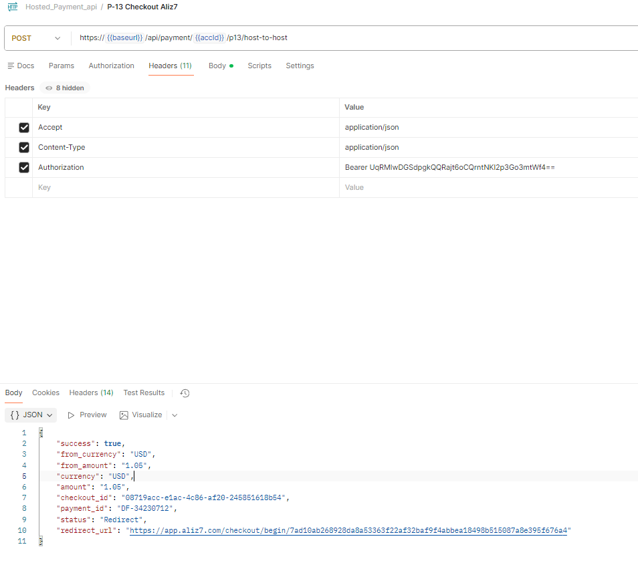
METHOD : POST
https://payment.ryzen-pay.com/api/payment/{YOUR-ACCOUNT-ID}/p13/host-to-host

HEADERS :
Accept : “application/json”,
Content-Type: “application/json”,
Authorization: Your-Bearer-Token
RESQUEST BODY:
{
"first_name": "Bobby",
"last_name": "Poonia",
"company": "Neurodamaad", // optional
"address_1": "78 Avenue",
"address_2": "Near Central Park", // optional
"city": "Oadby",
"region": "Leicester",
"postal_code": "LE2 2DB",
"country": "GB",
"email": "abc@mail.co.uk",
"phone": "+441234567890",
"ip": "203.0.113.10", // optional
"date_of_birth": "1995-07-20",
"description": " Card payment",
"currency": "USD",
"amount": 1.05,
"cardholder_name": "BOBBY SINGH POONIA",
"card_number": "4633000000099581",
"card_exp_month": 7 ,
"card_exp_year": 2059,
"card_cvv": "456",
"approval_return_url": "https://google.com",
"decline_return_url": "https://youtube.com"
}
RESPONSE: 200 (SUCCESSFUL AND 3DS TRANSACTION)
{
"success": true,
"from_currency": "USD",
"from_amount": "1.05",
"currency": "USD",
"amount": "1.05",
"checkout_id": "08719acc-e1ac-4c86-af20-245851618b54",
"payment_id": "DF-34230712",
"status": "Redirect",
"redirect_url": "https://app.aliz7.com/checkout/begin/7ad10ab268928da8a53363f22af32baf9f4abbea18498b515087a8e395f676a4"
}
RESPONSE: 200 (SUCCESSFUL AND NON 3DS TRANSACTION)
{
"success": true,
"from_currency": "USD",
"from_amount": "1.05",
"amount": 10,
"currency": "USD",
"checkout_id": "23533586",
"payment_id": 153537,
"status": "Captured"
}

RESPONSE: 200 (FAILED Trasanctions)
{
"success": true,
"amount": 10,
"currency": "USD",
"checkout_id": "50567649",
"payment_id": 153538,
"status": "Failed"
}

Get Payment Status API:
GET: https://payment.ryzen-pay.com/api/payment/{accId}/p13/getPaymentStatus/{checkout_id}
Headers:
{
Authorization : Bearer Token ,
Content-Type : application/json
}
Response: 200 OK (SUCCESS)
{
"currency" => string,
"amount" => string,
"checkout_id" = > string,
"payment_id" => string,
"payment_status" => string,
"description" => string,
"created_at" => timestamp,
}

