HOST-TO-HOST PAYMENT API
Euro Currency Default (Notes flow)
- X1 host-to-host flow:
Merchant calls our H2H api with details, in which we process the information for making transaction.
(a.) if the transaction was non-3DS, then we'll provide success response and you'll get notification through webhook API for same.
(b.) if the transaction was 3DS, then we'll provide redirect URL in response , through which user can go to that page for entering OTP/PIN for completing 3ds feature of transaction and transaction will be completed, and you will get notification through webhook API for same .
2. for our AQ payment page flow:
call our API to get checkout link , redirect to that link for payment and notification through webhook API will be sent.
The whole process can be completed whether configured for webhook or not, but if notification is required in real-time, then u need to follow the documentation for the same.
System webhook 3DS
- Our system sends a webhook callback upon 3DS transaction completion
- You need to configure the webhook URL on your side
Merchant needs provide their base URL, which suppose your case would be https://app.checkoutgo.top/gateway
so, you'll receive the webhook on GET: https://app.checkoutgo.top/gateway/api/RyzenPay/p3/{checkout-id} .
In this webhook, you need to call our GET Payment Status API for details for the transaction. All details for same are provided in the documentation.
NOTE: {checkout-id} is used for identifying the transaction.

Example for H2H – Adding Success and Error Parameters:
Once integrated to redirect after success you can add the following Parameters, success and error: calling h2h API they can add two more additional parameter, "success_url" and "error_url" for respective redirecting cases after 3ds completion
Example:
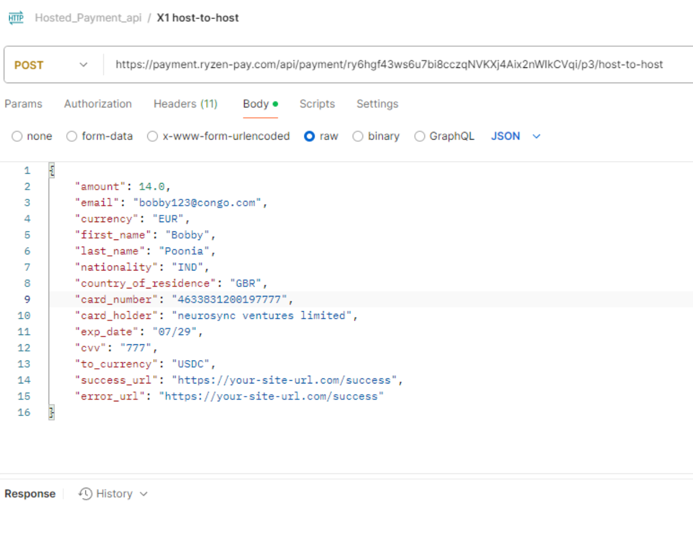
*You need to define your own success URL and error URL – in which can show whatever you want.
METHOD : POST
https://payment.ryzen-pay.com/api/payment/{YOUR-ACCOUNT-ID}/p3/host-to-host

HEADERS :
Accept : “application/json”,
Content-Type: “application/json”,
Authorization: Your-Bearer-Token
RESQUEST BODY:
{
"amount": 14.0,
"email": "your@email.com",
"currency": "EUR",
"first_name": "John",
"last_name": "Poe",
"nationality": "GBR",
"country_of_residence": "GBR",
"card_number": "422222222222222",
"card_holder": "NAME ON CARD",
"exp_date": "07/29",
"cvv": "123",
"to_currency": "USDC"
"success_url": "https://your-site-url.com/success",
"error_url": "https://your-site-url.com/error"
}
RESPONSE: 200 (SUCCESSFUL AND 3DS TRANSACTION)
{
"message": "3DS authentication required",
"checkout_id": "1fda91f1-a7f0-428d-84e0-e4011f12e48b",
"redirect_url": “https://gate.emerchantpay.net/threeds/authentication/a174077598********97d10f866d9b"
}

RESPONSE: 200 (SUCCESSFUL AND NON 3DS TRANSACTION)
{
"checkout_id": "1fda91f1-a7f0-428d-84e0-e4011f12e48b",
}

RESPONSE: 500 (UNSUCCESSFUL)
{
'error' :'An error (STRING)',
'checkout_id' : "1fda91f1-a7f0-428d-84e0-e4011f12e48b",
'message' : ’ERROR MESSAGE (string)'
}

RESPONSE: 422 (UNSUCCESSFUL)
{
'error' : 'Validation error',
'checkout_id': $checkout_id,
‘details’ : optional,
'fields' : [
{ “error_key” : “error message(string)”,
},
] ,
}

Valid Country Codes:
"ALB" "DZA" "AND" "AGO" "AIA" "ATG" "ARG" "ARM" "AUS" "AUT" "AZE" "BHS" "BHR" "BGD" "BRB" "BEL" "BLZ" "BEN" "BMU" "BTN" "BOL" "BIH" "BWA" "BVT" "BRA" "IOT" "BRN" "BGR" "KHM" "CPV" "CYM" "CHL" "CHN" "CXR" "CCK" "COL" "COK" "CRI" "HRV" "CYP" "CZE" "DNK" "DJI" "DMA" "DOM" "ECU" "EGY" "SLV" "GNQ" "EST" "ETH" "FLK" "FRO" "FJI" "FIN" "FRA" "FXX" "GUF" "ATF" "GAB" "GEO" "DEU" "GHA" "GIB" "GGY" "GRC" "GRL" "GRD" "GLP" "GTM" "GIN" "GUY" "HMD" "HND" "HKG" "HUN" "ISL" "IND" "IMN" "IDN" "IRL" "ISR" "ITA" "JEY" "JAM" "JOR" "KAZ" "KEN" "KOR" "XKX" "KWT" "KGZ" "LVA" "LSO" "LIE" "LTU" "LUX" "MAC" "MKD" "MDG" "MWI" "MYS" "MDV" "MLT" "MTQ" "MRT" "MUS" "MYT" "MEX" "MDA" "MCO" "MNG" "MNE" "MSR" "MAR" "NRU" "NPL" "NCL" "NZL" "NIC" "NIU" "NFK" "NOR" "OMN" "PAK" "PLW" "PAN" "PRY" "PER" "PHL" "PCN" "POL" "PRT" "QAT" "REU" "ROU" "RWA" "KNA" "LCA" "VCT" "WSM" "SMR" "STP" "SAU" "SEN" "SRB" "SYC" "SLE" "SGP" "SVK" "SVN" "ZAF" "SGS" "ESP" "LKA" "SHN" "SPM" "SUR" "SJM" "SWZ" "SWE" "CHE" "TWN" "TZA" "THA" "TGO" "TKL" "TON" "TTO" "TUN" "TUR" "TKM" "TCA" "UGA" "UKR" "ARE" "GBR" "URY" "UZB" "VUT" "VAT" "VNM" "VGB" "WLF" "ZMB" "CUW"

Get Payment Status API:

GET:
https://payment.ryzen-pay.com/api/payment/{accId}/p3/getPaymentStatus/{checkout_id}

Headers:
{
Authorization : Bearer Token ,
Content-Type : application/json
}

Response: 200 OK (SUCCESS)
{
"amount" => string,
"currency" => string,
"checkout_id" = > string,
"payment_id" => string,
"payment_status" => string,
"description" => string,
"created_at" => timestamp,
}

