TodoList Application

1. Introduction

Across the training, you’re required to use the studied skills to incrementally implement the back-end system described in the next slides of this document so that at the end, you will have the whole system implemented and running as described.

1. Architechture

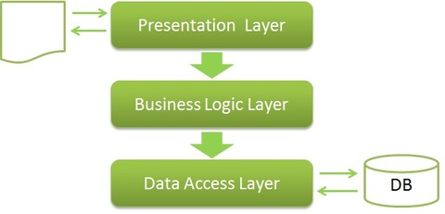

1. Design
   1. Model

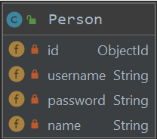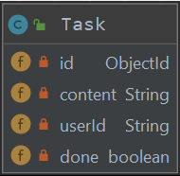

* 1. Database
  2. Event
  3. Test Case

1. Implementation
   1. API specification
   2. Test Coverage