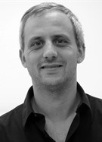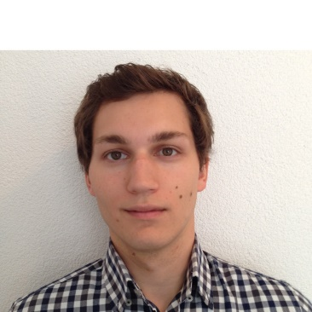Kunde/Betreuer:

Stefan Arisona

Simon Marcin

Projektteam: i4Ds15: Navigation im VR Space

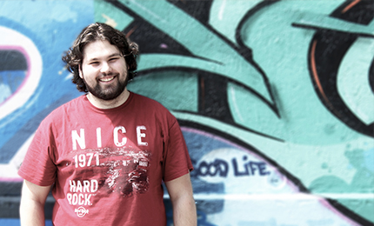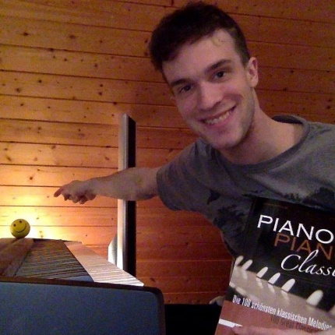

Marcel Groux

Dominic Bär

Andere Projekte in Virtual Reality:

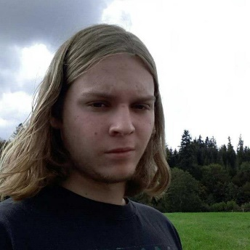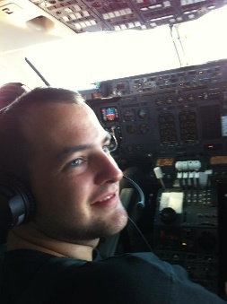Explorative Navigation/Virtual Reality:

Stefan Mettler

Michael Läuchli

(togheter with econaut, architectural construction, model from vindonissa)

how can we deal with navigation.

(smoke, animate trees)

Virtual Reality Simulation von Verkehrszenarien:

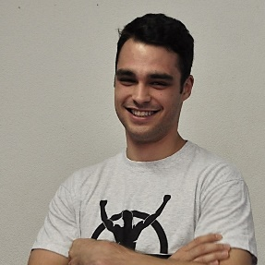

Emanuel Minstretta