Q.5

5.1.

Ubuntu install for Curl. $ sudo apt update, $ sudo apt upgrade, $ sudo apt install curl

5.2.

Using client.exec_command to submit terminal command 'mkdir -p Labs/{Lab1,Lab2}'

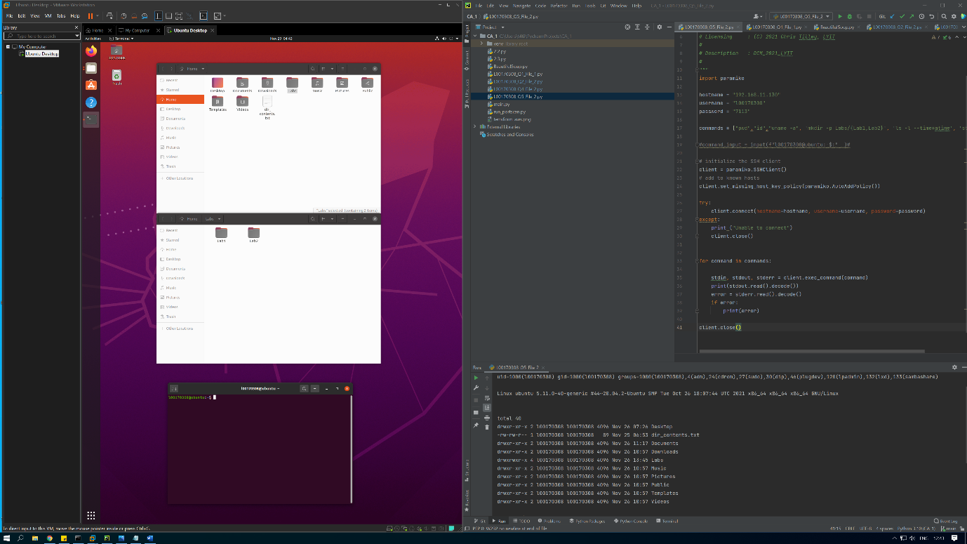

5.3.

Output for last access ‘ls -l –time=atime’. (added ‘stat /home’ as additional command in script)

Runlocally on server to confirm same results(left). Results and output in script from host(right).

