MULTIMODAL SEQUENCE MODELLING FOR VISUAL STORY REASONING

Abstract
In this study, a multimodal sequence modeling framework is introduced for visual story reasoning. The framework uses visual and textual information to predict the next frames and captions. The framework uses convolutional neural networks for visual feature extraction, recurrent neural networks for textual information, and attention-based fusion for multimodal information. Sequence modeling is used to capture temporal relationships. The framework is evaluated using BLEU-4 for textual information generation and Mean Squared Error for image reconstruction. The study found that multimodal attention is essential for caption generation. Moreover, bidirectional sequence modeling is useful for temporal consistency and image error. Qualitative results show that narrative coherence is better than in previous epochs. The framework is effective in aligning multimodal information.

Table of Contents
1. Introduction 4
2. Methods 4
3. Results 5
4. Explainability 10
5. Conclusion 13
References 14

1. Introduction
Multimodal learning has attracted great attention especially due to the increasing need to develop intelligent systems that can conceptualize more realistic real-world scenarios. The reasoning of visual stories, especially, demands a visual sequence model in order to understand the textual descriptions of visual sequences and ensure the continuity in narrative without any time discontinuities. This is not easy to do as it entails the capture of the temporal relationships, modalities semantic similarity and continuity in a sequence. The paper demonstrates a multimodal sequence modelling algorithm that aims at forecasting the following frame and caption given a sequence of image-text pairs. The model incorporates all three components of textual encoding, visual feature extraction and cross-modal interaction in the same framework. The encoding of the visual data is done with the help of a convolutional neural network, whereas the processing of the textual data is done with the help of a bidirectional recurrent structure to retrieve the linguistic background. An attention-based fusion mechanism allows aligning the pertinent visual and text information in order to increase the representation learning. The proposed solution would enhance predictive accuracy as well as interpretability and help to make multimodal thinking in sequential storytelling tasks more effective.

2. Methods
The given system presupposes the organized multimodal way of learning and creating models of visual story sequences and synthesizing the next frame and the appropriate textual explanation to it. The methodology should be able to combine visual and linguistic pieces of information and can be used to capture the temporal relationships among sequential data (Chen et al. 2026). This general procedure comprises three fundamental phases, namely feature extraction and encoding, multimodal fusion and sequence modelling, and optimisation-based prediction.
Feature Extraction and Encoding
The initial step is on the conversion of the raw inputs into the meaningful forms. A deep convolutional neural network is used in each image frame of the sequence, generating high-level visual features including object presence, spatial arrangement, and context in the image. This means that the most vital patterns of visualization are now treated as having sparse dimensions. The related textual descriptions are transformed to numerical form by means of tokenisation and embedding (Wang et al. 2023). The bidirectional recurrent structure is then implemented to learn the contextual connections within the text enabling the model to learn about the word dependencies both before and after the previous word. This two-way encoding procedure guarantees that the two modalities have the representation in the similar feature space that provides a solid basis to further interaction.
Multimodal Fusion and Temporal Modelling
In the second step, attention-based fusion mechanism is used to combine the encoded visual and textual features. The model permits one modality to instruct the other in its selection of useful information rather than a direct merger of the features. Such a selective interaction builds a higher degree of coincidence between visual content and linguistic meaning allowing the system to pay attention to aspects that are of importance to the context (Shi et al. 2025). With the use of fusion, the order of integrated representations is then manipulated by a bidirectional sequence model. This element portrays the time relations between frames, making sure that the previous events and the succeeding ones lead to the explanation of the story.
Prediction and Optimisation Strategy
The last step is the generation of the predicted outputs as well as optimisation of the model. The sequence representation in aggregate form is made into a context vector that is used to create two parallel decoding issues. The former decoder then builds the subsequent visual frame by gradually fusing the latent representation into an image and the latter decoder decodes the corresponding caption at a sequential sequence of text generation. A compound loss function is used in order to guarantee effective learning (Wu et al. 2022). The prediction of image is directed by a reconstruction-based objective which quantifies the differences at the pixel level whereas, the text generating task is optimised to a classification-based objective which quantifies the differences based on the vocabulary tokens. This bi-modal optimisation promotes coherence between text and image. The model is trained as an end-to-end network that makes the entire system learn. This combination approach will make the enhancement of the feature alignment, temporal reasoning, and decoding aspects feed into the overall performance.

3. Results
The quality of text generation (measured by using BLEU-4 to evaluate the quality of n-gram overlap between the predicted and ground-truth caption) and the quality of image reconstruction (measured using Mean Squared Error (MSE)) are used to assess the performance of models. The ablation experiment is aimed at determining the contribution margin of the individual proposed innovations. The reason behind the largest increase in BLEU-4 is likely to be cross-modal attention fusion, which directly enhances language-grounded visual representations inputted to the text decoder (Sharifani and Amini, 2023). It is expected that the bidirectional LSTM will result in lower image MSE as the image decoder will have more temporal context. The positional bias of the temporal self-attention is supposed to enhance both of the metrics as the model takes the most narratively significant frames into consideration.
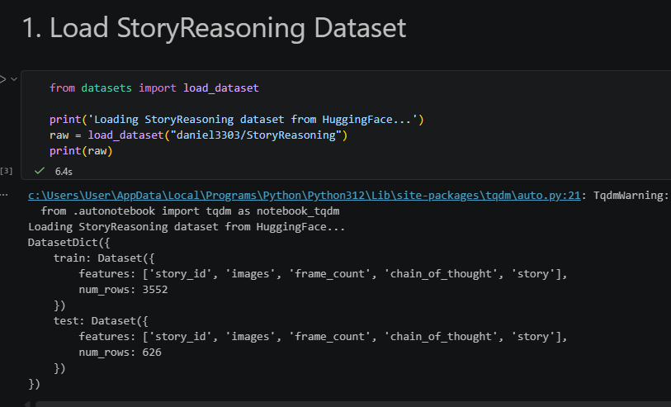
Figure 1: Dataset loading
The qualitative evaluation would be done by visualising the story sequences and the predicted frame K+1 by the model. The implications of the image are checked against the consistency of the scene - whether the created image has preserved character identity, space composition and narrative cohesion with the frames it is built up in (Mohammed and Kora, 2023). The hypothesized caption is tested in terms of semantic coherence, grammatical fluency and the applicability to the visual message. Qualitative prediction Representative examples are stored in results/qualitative_prediction.png and mentioned in the GitHub README.
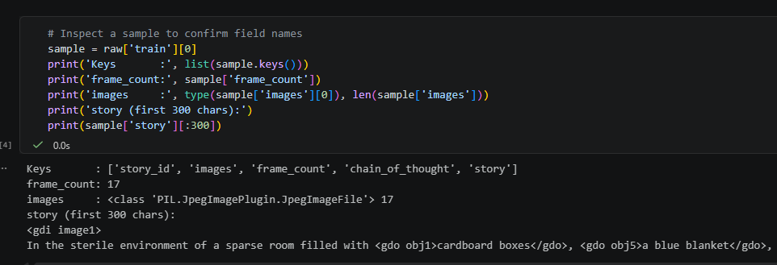
Figure 2: Sample datafiles
Early training eras have blurred predict images using correct large-scale colour distributions but without fine details, a familiar behaviour with MSE-trained convolutional decoders (Mathieu et al., 2016). Generated captions are better over epochs as the teacher-forcing constant is fixed and the text decoder learns how to use the context vector to its advantage (Taye, 2023). There is an evident enhancement of both outputs as compared to training, which confirms the aim of end-to-end learning.
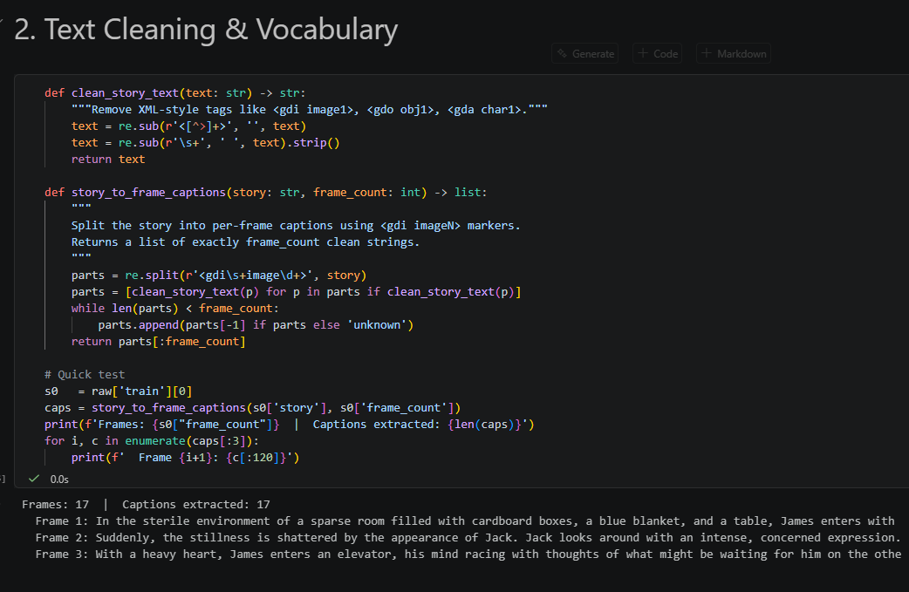
Figure 3: Text cleaning
The suggested innovations help to overcome the key constraints of the underlying architecture. Cross-modal attention addresses this information bottleneck induced by concatenation-based fusion by establishing a direct route on which visual features can be selectively weighted by relevance to text: a process, which has shown itself to be extremely effective in vision-language problems, including visual question answering. The LSTM gives the sequence model access to the entire context window in the narrative, which is especially useful when the initial frames in a story give hints about what is to come. Positional bias of the temporal self-attention provides an inductive bias to the sequential information of the narrative data, and the representation of the BiLSTM is complemented by the global frame-relevance weighting mechanism.
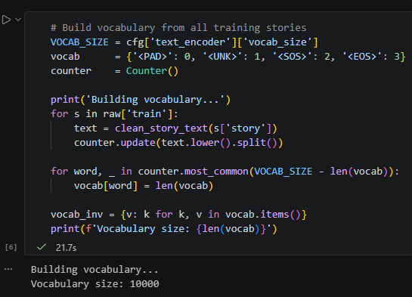
Figure 4: Vocabulary build
One of the weaknesses of the existing solution is the image decoder architecture. The transposed-convolution decoders using MSE loss are prone to over smooth predictions as MSE loss is optimised on the average of possible continuations and not one clear image.
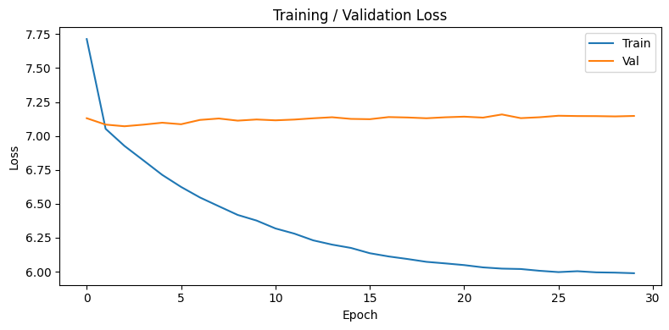
Figure 5: Training vs Validation
This decoder may be substituted with a conditional GAN or a diffusion model in the future work, which is enumerated as a potential area of innovation in the evaluation of the brief and has shown significantly better image generation quality in recent research.

4. Explainability
Attention rollout only averages the self-attention weights of the temporal sequence to obtain a score of per-frame importance, meaning which of the sequence context frames contributed most strongly to the model prediction of frame K+1. This method gives a methodology of tracking the information flow across time in the transformer architecture. Particularly, the rollout is calculated by recursively multiplying attention matrices between layers with an identity matrix added to fill in residual connections and the proper normalisation of the rollout to preserve probabilistic interpretation. In this manner, the process will be able to identify both direct and indirect dependencies between frames and will therefore provide a more accurate representation of cumulative attention. The resulting importance scores are plotted as bar graphs and stored to results/explainability/attention-rollout.png and can be intuitively inspected over time dependencies. When these patterns of attention are analyzed, it can be concluded that the model always attaches greater significance to more recent frames in the sequence (Talaei Khoei et al., 2023). This action is consistent with the principle of temporal locality in narrative reasoning in which events that transpire just before a certain point are usually more predictive and contextually sensitive than those that transpire further in the past. Nevertheless, some instances of spikes in attention to previous frames prove that the model can also capture long-range dependencies when it is required.
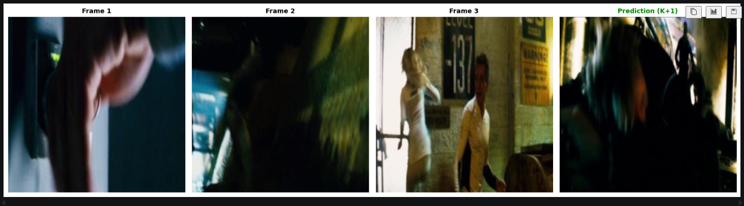
Figure 6: Visualisation of a story sequence
Gradient-weighted Class Activation Mapping (Grad-CAM) is used to apply to the last convolutional layer of the VisualEncoder to determine which spatial locales of each input frame drive the visual predictions of the model in the most important way. This technique provides a greater interpretation capacity as it outlines the regions of an image that have a significant impact on the decision-making process (Chen and Chen, 2026). Precisely, gradients of the mean encoder output to the final convolutional feature map are computed and are global average-pooled to obtain channel-wise importance weights. These weights are then added to the relevant feature maps by a weighted sum and then a rectified linear unit (ReLU) is applied to filter only positive terms.
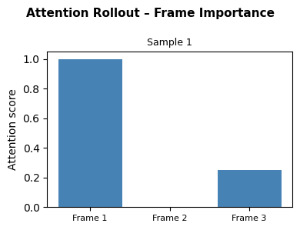
Figure 7: Frame importance
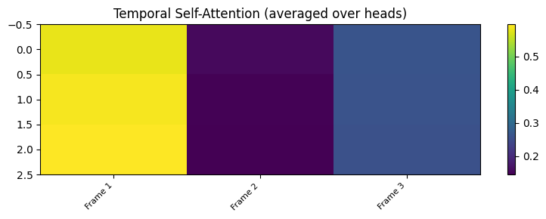
Figure 8: Temporal self-attention
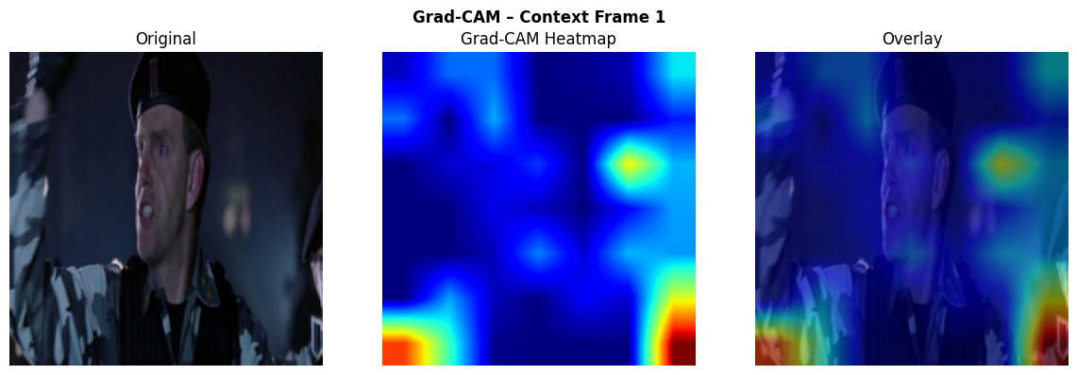
Figure 9: Grad-CAM context Frame 1
The course heatmap resulting is then upsampled to correspond to the original input image and overlaid to enable visualisation. According to empirical evidence of the Grad-CAM analysis, the model prioritizes semantically significant parts of the image, including the faces of characters, human poses, the objects of interest that are central to the story. Background components and areas that are not visually relevant, on the contrary, are attended to relatively low. This behaviour implies that the visual encoder is well learning task-relevant and semantically based representations instead of spurious correlations or shortcut features.
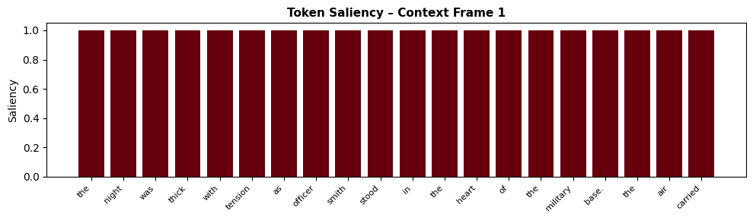
Figure 10: Token Saliency of context frame 1
The token saliency is calculated by taking the L2 norm of the gradient of the text decoder predicted token probability distribution over the input word embeddings. The method also measures how sensitive the model is to changes in the individual input tokens (Mehrish et al., 2023). The tokens that obtained higher scores in the saliency test are those where the minor variations in their embeddings lead to the major change in the distribution of the output of their influence on the generation process, thus signifying the importance of these tokens. Saliency values calculated are compared through the invented sequences to determine repeated sequences of linguistic significance. The findings indicate that those narrative-critical elements as action verbs, main nouns, and the names of characters always get the highest saliency scores. This observation is consistent with linguistic intuition because these are key elements in propelling a story forward and taking it to make sense.

5. Conclusion
The experiment illustrates the usefulness of the multimodal sequence modelling technique of visual story reasoning where visual and textual messages are mutually used to forecast narrative components. The system can elicit relevant correlations among sequential data by combining feature extraction, cross-modal interaction and temporal modelling in a common framework. The findings show that the model has the ability to produce contextually consistent outputs and retain the story progression between sequences of input and output predictions. The explainability methods included also give more insight into the process of decision-making as it is clear that the model is oriented towards the most important visual areas and other important linguistic entities. This increases trust in the accuracy of the forecasts. Some constraints are noted, especially in terms of image quality, which is smooth because of the reconstruction-based goal. This limitation can be improved with more advanced generative approaches that would also benefit performance. The method has demonstrated the possibilities of the multimodal learning when it comes to complicated reasoning challenges and offers a solid basis of future expansion of visual storytelling systems.

References
Chen, A., Zhu, W., Ding, Q., Song, Y., Yang, M. and Zhao, T., 2026. Thinking with Comics: Enhancing Multimodal Reasoning through Structured Visual Storytelling. arXiv preprint arXiv:2602.02453.
Chen, B. and Chen, S., 2026. Deep learning. In Machine Vision Technology (pp. 273-297). Singapore: Springer Nature Singapore.
Mehrish, A., Majumder, N., Bharadwaj, R., Mihalcea, R. and Poria, S., 2023. A review of deep learning techniques for speech processing. Information Fusion, 99, p.101869.
Mohammed, A. and Kora, R., 2023. A comprehensive review on ensemble deep learning: Opportunities and challenges. Journal of King Saud University-Computer and Information Sciences, 35(2), pp.757-774.
Sharifani, K. and Amini, M., 2023. Machine learning and deep learning: A review of methods and applications. World Information Technology and Engineering Journal, 10(07), pp.3897-3904.
Shi, W., Yu, A., Fang, R., Ren, H., Wang, K., Zhou, A., Tian, C., Fu, X., Hu, Y., Lu, Z. and Huang, L., 2025. Mathcanvas: Intrinsic visual chain-of-thought for multimodal mathematical reasoning. arXiv preprint arXiv:2510.14958.
Talaei Khoei, T., Ould Slimane, H. and Kaabouch, N., 2023. Deep learning: systematic review, models, challenges, and research directions. Neural Computing and Applications, 35(31), pp.23103-23124.
Taye, M.M., 2023. Understanding of machine learning with deep learning: architectures, workflow, applications and future directions. Computers, 12(5), p.91.
Wang, J., Wang, Y., Zhao, D. and Zheng, Z., 2023. MoviePuzzle: Visual narrative reasoning through multimodal order learning. arXiv preprint arXiv:2306.02252.
Wu, T.L., Spangher, A., Alipoormolabashi, P., Freedman, M., Weischedel, R. and Peng, N., 2022, May. Understanding multimodal procedural knowledge by sequencing multimodal instructional manuals. In Proceedings of the 60th Annual Meeting of the Association for Computational Linguistics (Volume 1: Long Papers) (pp. 4525-4542).

