AnchorGuy_JointOwner

Tool requirement:
- Tool to generate default joint owner record if AnchorGuy having no relation with joint owner.
- If any joint owner having relation with AnchorGuy and support structure, unrelate joint owner relation with support structure and generate new joint owner record with same JO name and relate to that support structure.

Tool Installation and Execution:
- Open ArcMap in citrix and connect to the production database and create a session, open the session, save and close the created session.
- Copy PGEElecCleanup_Setup.msi, setup.exe in to your local.
- Click on setup file “PGEElecCleanup_Setup” to install and it asks for the path to install.

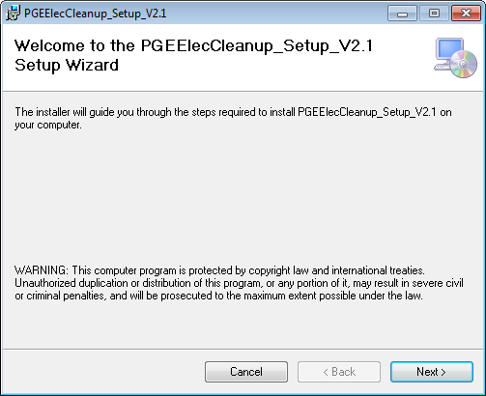

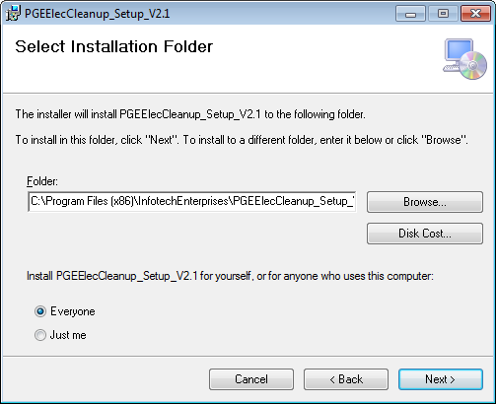

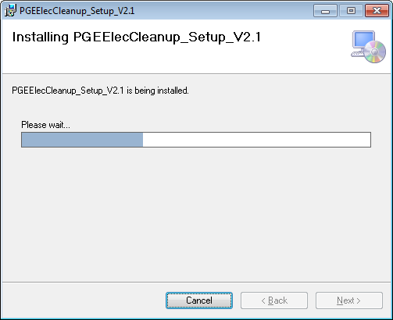

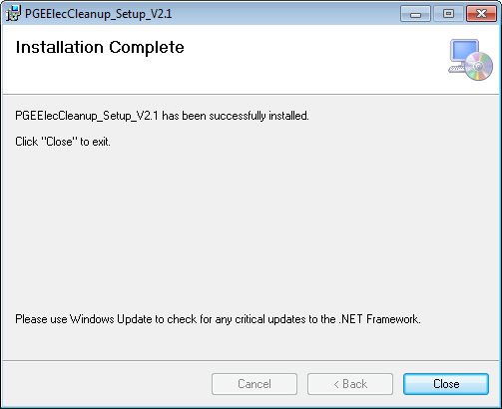

- After completion of installation click close button.

Click on PGEElecCleanup.exe from installed path. It opens below GUI.

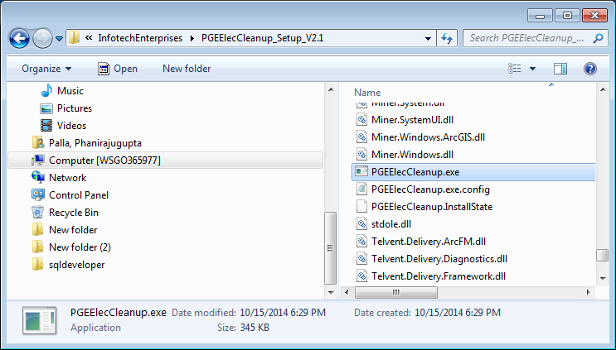

Select tab Database->Connection, following Spatial Database connection GUI form will be opened.

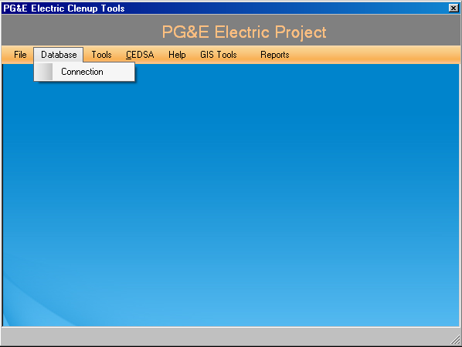

- Provide the SDE connection details (Replace production database name in place of edgism2q), username and password.
- Select the version which is created in Arc Map to run the tool.

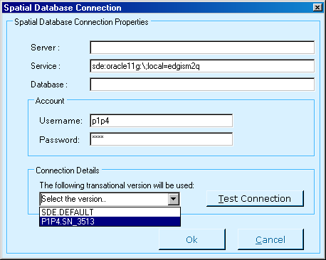

- Test connection established for a selected versioned database, Click on OK if the test succeed.
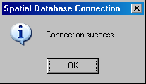
- Select tab Tools->CreateDefaultJointOwnerToAnchor, it will opens below GUI.

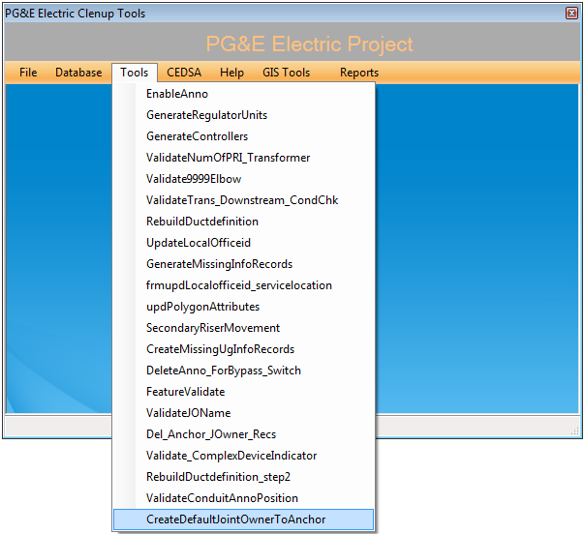
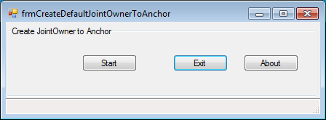

- Click start button to execute the tool.
- Bellow message box will pop up on completion of tool execution.
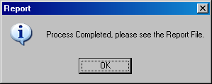
- Log files will be generated at path C:\PGE_Reports.
- After Verifying the tool results this session will need to be posted to default through GDBM.

