RebuildDuctdefinition

Overview: Some Conduits are related with more than one PGEDuctDefinition in GIS, which should never happen.
Below is the logic:
- Delete related PGEDuctDefinition records for Conduit system (subtypes ductbank and CIC).
- Delete any associated PGEDuctDefinition records and replace them with the correct records based on link field Conversionid from input PGEDuctDefinition table (This table contains the ductdefinition records of WP Deliveries of 1-8) which fall under this condition ((SUBTYPECD NOT IN ('1','3') and the conduit feature not edited/created by mapper).for these PGEDuctDefinitions, populate PGEDuctDefinition->ductcount attribute from its related parent conduitsystem->ductcount.
- Update PGEDuctdefinition->DuctCount based on grouping of DUCTSIZE, MATERIAL and AVAILABLE attributes values.
  - EX: If Conduit related with total of 2 PGEDuctdefinition records
    - RecordCount, Material, DuctSize, Available
2 3" PVC available - Result 1 pgeductdef with ductcount = 2
    - If Conduit related with total of 3 PGEDuctdefinition records
2 4" PVC available
1 5" PVC available - Result 2 pgeductdef with ductcount = 2 (4") and ductcount = 1 (5")

If any conduitsysyem not found in the input FGDB table or conduit conversionid is blank, these conditions update PGEDuctdefinition->DuctCount based on existing records and report reports same in the log report.

Open ArcMap in citrix and connect to the production database and create a session, open the session, save and close the created session.

Installing the Application:
- Copy PGEElecCleanup_Setup.msi, setup.exe, CV_Duct Definition.gdb and MappersList.txt in your local drive.

- Click on setup file “PGEElecCleanup_Setup” to install and it asks for the path to install.
- Copy the MappersList.txt files into the same directory the .exe file was installed

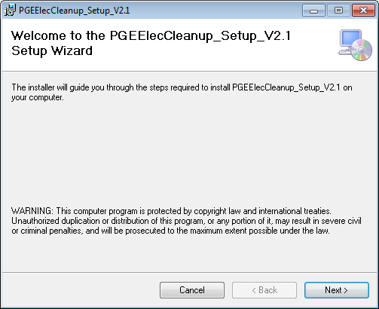

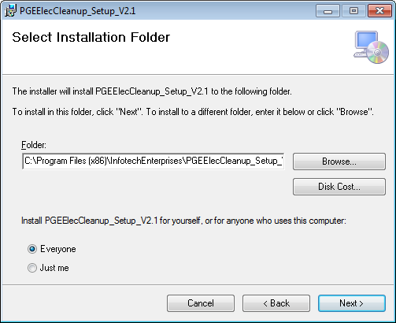

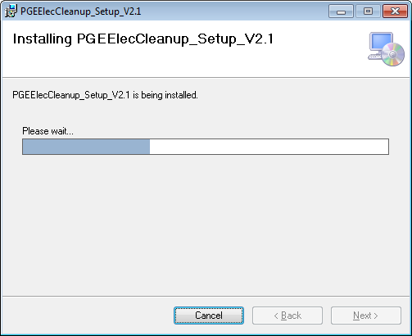

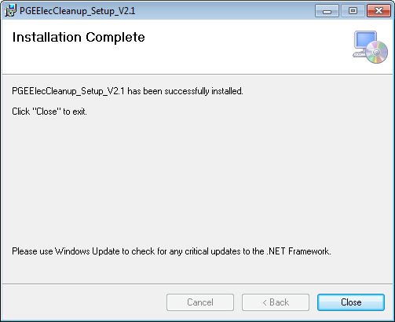

- After completion of installation click close button.

Click on PGEElecCleanup.exe from installed path. It opens below GUI.

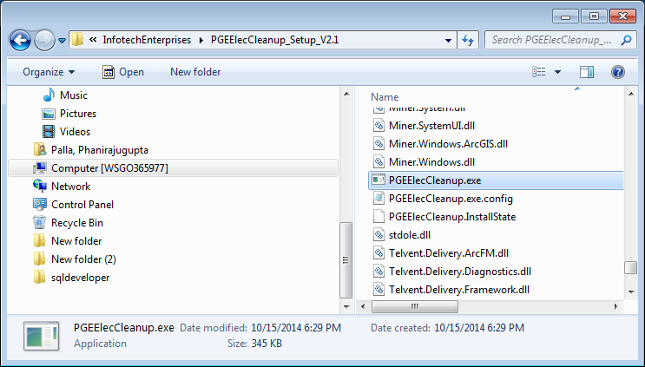

Select tab Database->Connection, following Spatial Database connection GUI form will be opened.

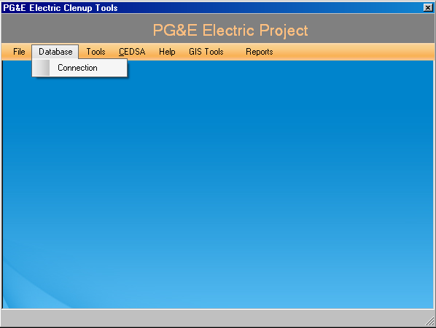

- Provide the SDE connection details (Replace production database name in place of edgism2q), username and password.
- Select the version which is created in Arc Map to run the tool.

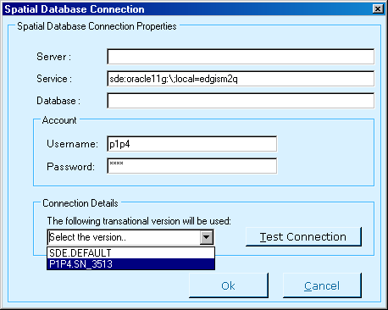

- Test connection established for a selected versioned database, Click on OK if the test succeed.
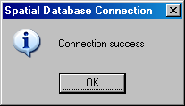
- Select tab Tools->RebuildDuctDefinition, it will opens below GUI.

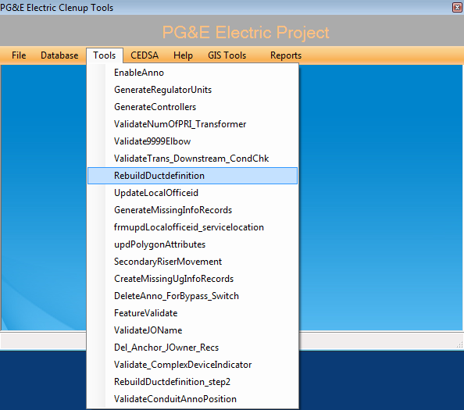
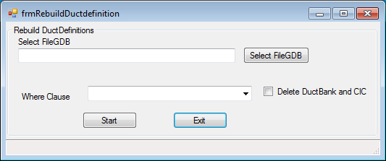

- Click on SelectFileGDB button and browse the file ‘CV_Duct Definition.gdb’ which is copied locally. It takes 1 mint to popup below interface.
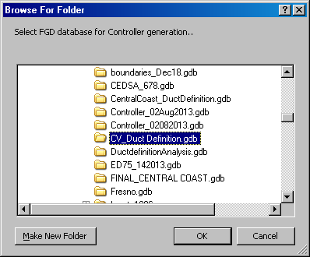
- Once browse the gdb file, based on feature count in conduitsystem featureclass it will divide into parts and added in to combo box like below.
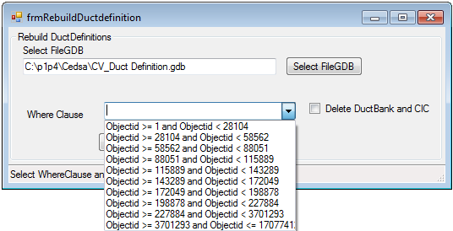
- Select where clause option and then click start button to execute the tool.
- Note: For first execution tool need to be run by selecting ‘Delete DuctBank and CIC’ option and remaining executions tool need to be run without selecting ‘Delete DuctBank and CIC’ option
- Bellow message box will pop up on completion of tool execution.
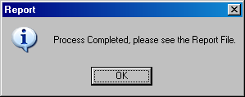
- Log files will be generated at path C:\PGE_Reports.
- After Verifying the tool results this session will need to be posted to default through GDBM.
- DeleteDuctdefinition table data: Truncate table Ductdefinition table using below script. Connect EDGIS schema through sqlplus and run below script.
TRUNCATE TABLE Ductdefinition;
COMMIT;
TRUNCATE TABLE A62;
COMMIT;

