GeoCoding_Case3

Tool Overview:
In current Production non-geocode service points captured for each service point one service location which is incorrect.
Tool to identify non-geocode service points and replace/relate them to same service location based on street name and street number field values of service point.
Tool Functionality:
Non-Geocode service location: Consider if service location related all service points placed with null APN number and it’s connected to pseudo service.
Non-Geocode service Point: Consider if service point places with null APN number.
- Process each transformer and get the related non-geocode service points having APN number is null and related service location connected to pseudo service.
- Segregate the service points based on street number and street names by ignoring " APT ", " BLDG ", " UNIT", " #", " STE ", " LOT", " FLAT ", " FLT ", " UNT ", " COUNTRY ", " REAR ", " (HSE MTR) ", " SPC "PT ", "BLDG ", "UNIT", "#", "STE ", "LOT" field values.
- If segregation count of service points matches with non-geocode service location count build the relationship to those service locations.
- If segregation count of service points is greater than non-Geocoded service locations count, create new service locations with pseudo service.
- If segregation count of service points is lesser than non-Geocoded service locations count, delete the extra non-Geocode service location and connected pseudo service by changing the service point relation.
- It is a Desktop stand alone tool, which will execute on SDE version instances.
- On successful execution the tool will generate the report.
- It generates error report of tool execution, if any errors occurred while tool execution. Manual review required these situations.

1.0) Installation setup
Copy the ServicePointValidations_Setup.msi, setup.exe, PGEReGeoCoding.ini and Transformer_Globalids.txt file to your local system.

Click on the setup file to install the tool (it asks for the path to install).

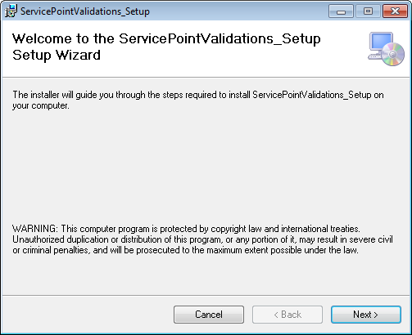

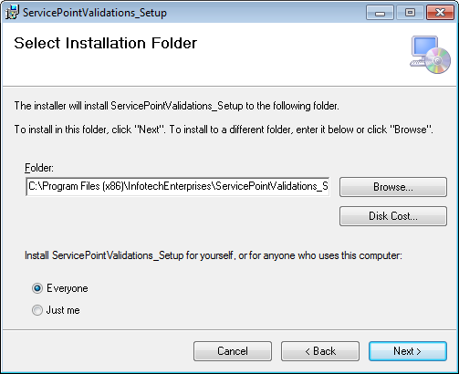
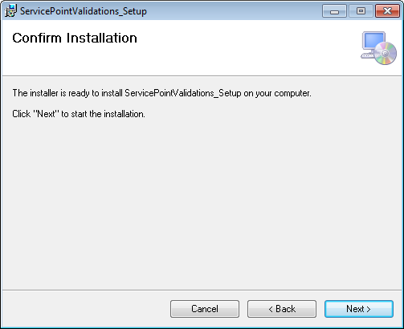

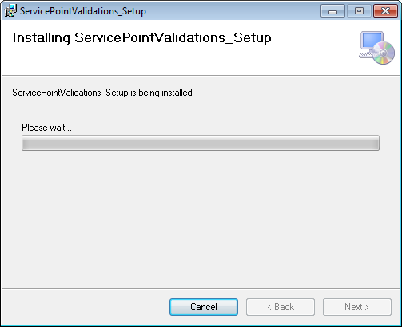
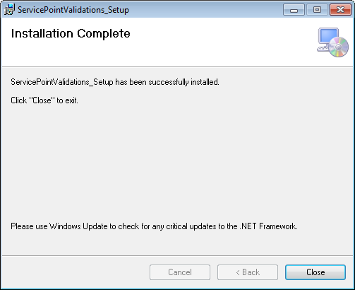
After completion of installation click close button.
Execution Process:
Copy one of the Transformer_Globalids.txt text files into the same directory the .exe file was installed into and rename the file to “Transformer_Globalids.txt” removing the number suffix.
** ensure that only one text file (i.e. Transformer_Globalids.txt) is copied into the installation path above.
2) Create a session
2.1) Open ArcMap and connect to the PRODUCTION (EDGIS1P) database and create a session, open the session, save and close the created session.
2.2) Click on the ServicePointValidations.exe from the installed path and It will open the below interface.
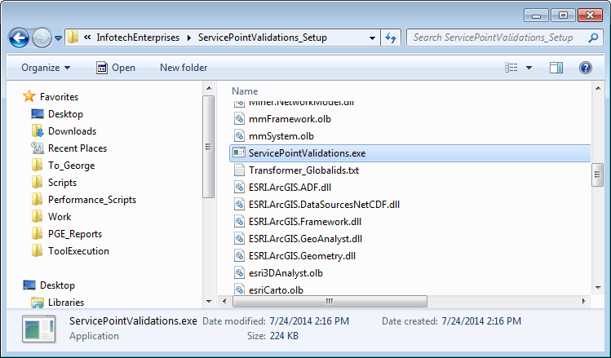
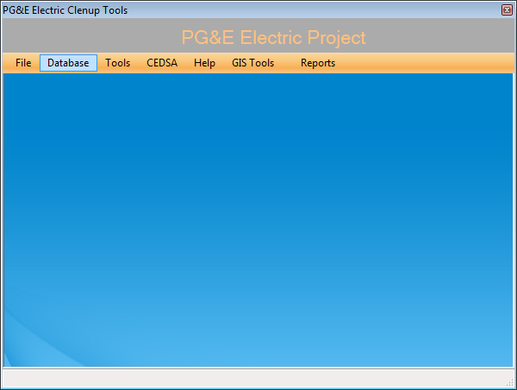
2.4) Select tab Database->Connection, following Spatial Database connection GUI form will be opened.
-Provide the SDE connection details (Replace production database name inplace of edgism2q), username and password.
-Select the version which is created in Arc Map to run the tool.

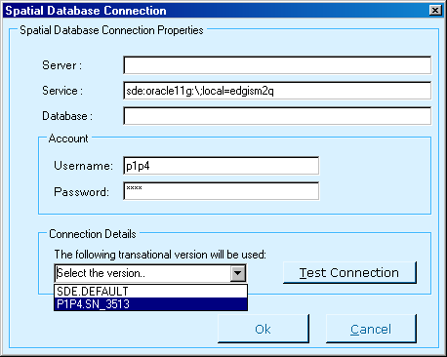

2.5) Test connection established for a selected versioned database, Click on OK if the test succeed.
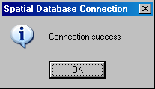

2.6) Select tab Tools->NonGeoCoded_SP_Replacement, It will opens below GUI.

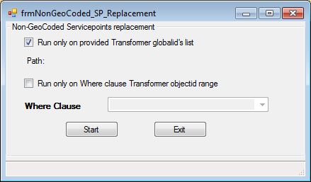

2.7) Select option “Run only provided Transformer globalid’s list” to run the tool on provided transformer globalids.
2.8) Select start button to execute the tool. After completion of execution tool generate the log reports at path C:\PGE_Reports.
2.9) After completion of the tool execution this session will need to be posted to default upon review of the results.

