|  |  |
| --- | --- |
| PGE Logo | |
| Configuration Guide | |
|  |  |

WEBR Tracing

Prepared by:

IBM, Ashish Narasimham

April 2014

|  |  |  |  |
| --- | --- | --- | --- |
| Revision History | | | |
| Document # | Date | Author | Summary of Changes |
| 1.0 | 4/15/14 | Ashish Narasimham | Initial Draft |
|  |  |  |  |

## Reference Documents

1. Location of all necessary files
   1. MXD Source Control Directory: $/EDAMGIS/Source_Development/WEBR/MXDs

# Initial System Configuration

1. Publish new Mxd as new WEBR service.
   1. From the testing ArcGIS Server machine open ArcMap.
   2. Open the following Publication.mxd from TFS source control. (Note: This mxd uses the new EDPUB and EDSCHPUB tns entries and must exist on the system)  
      $/EDAMGIS/Source_Development/WEBR/MXDs
   3. Choose File-> Share As -> Service
   4. Choose Publish a Service

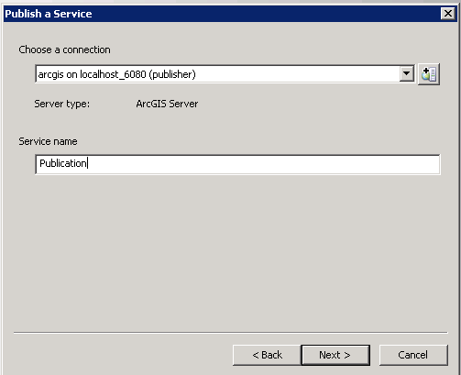

* 1. Click Next

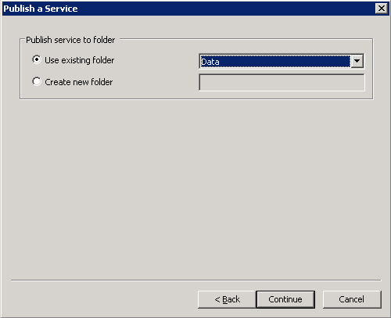

* 1. Click Continue
  2. For Maximum number of records returned by the server on the Parameters tab set the parameter to 100,000.
  3. Under the Capabilities tab, check the “ArcFMMapServer”.
  4. Publish the service.

1. Modify the Page.Config file.
   1. Modify the Tracing section. This section specifies which map servers refer to which type of trace. It also specifies the tracing tables for each tracing. (I.e. PGE_FeederFedNetwork_trace table). The LayerIDs must be derived from the service that was just published in step 1.

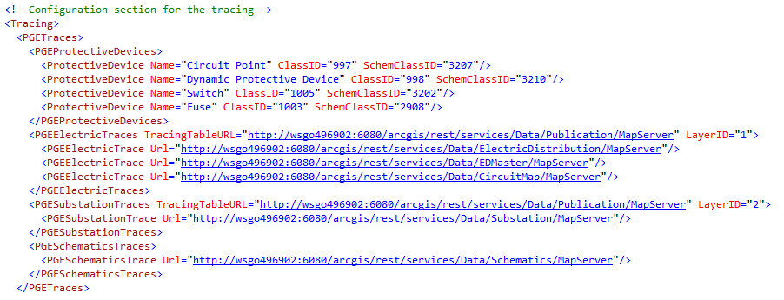

1. Modify the PGELoadingInformation. The section specifies the tracing table URL for the PGE_ElecDistNetwork_Trace table. Update the information for the appropriate Layer ID and feature class ID values
2. For this tracing functionality to work, network features must have GlobalID turned on in ESRI Properties (visible). Ensure that all layers in map services required to have PG&E Tracing functionality have GlobalID fields that are visible. The checkbox should be checked in the Properties of the layer:

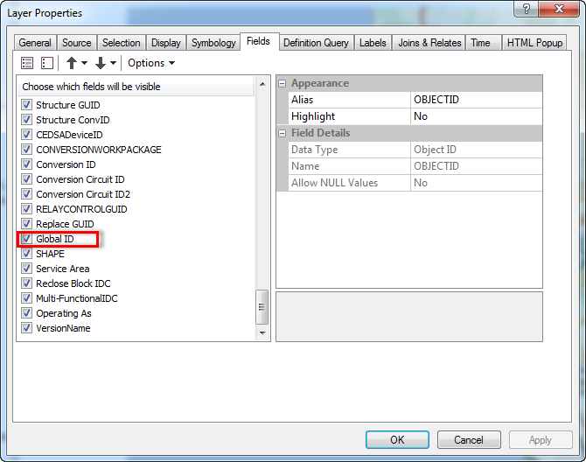

* 1. For any service required, the ArcFMMapServer extension needs to be enabled. Perform this task through the ArcGIS server manager.  
     