# Work Book SM_CIRCUITBREAKER

Revision History

|  |  |  |  |
| --- | --- | --- | --- |
| **Date** | **Version** | **Description** | **Author(s)** |
| 02/24/14 | 0.1 | Draft | Gareth Thompson |
|  |  |  |  |
|  |  |  |  |
|  |  |  |  |

Document Reviewers

|  |  |
| --- | --- |
| **Title** | **Name** |
|  | Chris Kim |
|  |  |
|  |  |
|  |  |

# Graphical User Interface

This section is used to keep track of question and answers regarding the user interface and expected functionality.

The planned UI screen is displayed below. There are no additional fields between Current and Future Settings.

**"Circuit" section:**

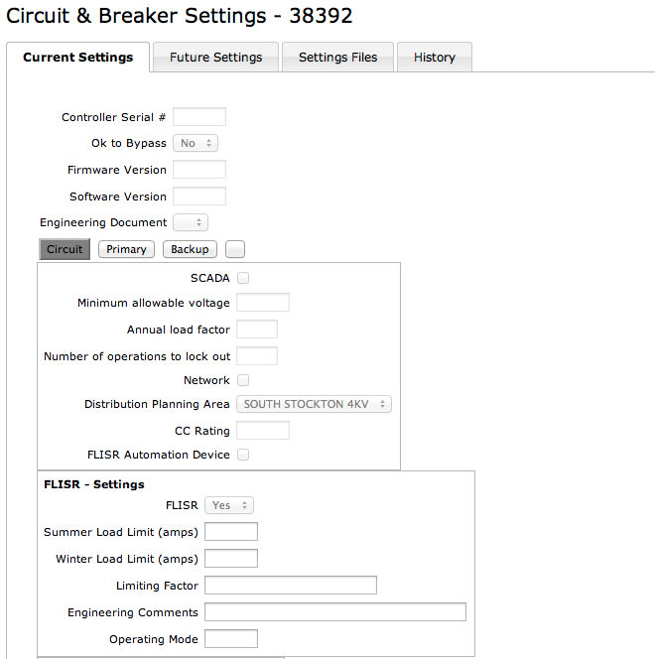

**"Primary" section:**

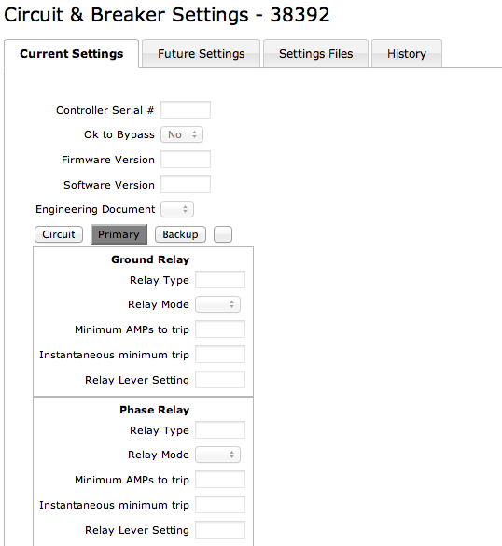

**"Backup" section:**

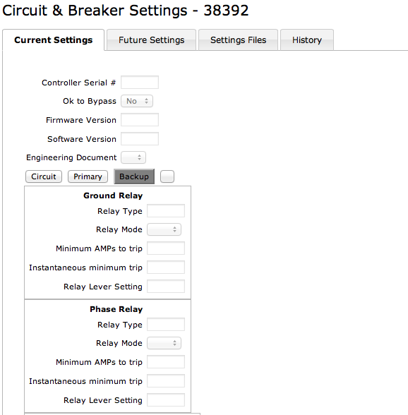

**After Circuit/Primary/Backup section:**

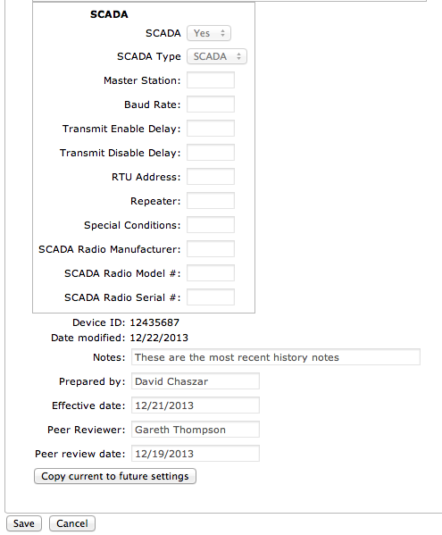

## Displayed Fields

1. *All the fields/data that is to be referenced by this GUI is captured in the SM_CIRCUITBREAKER spreadsheet.*
2. *Are there any additional data elements that are to be added? No.*

## Functionality

**Buttons by Tab**

Current Settings Tab

* Copy current to future settings
* 3 tabs as shown in the screen shots above.

Future Settings Tab

* Save
* Released Check Box
* Cancel
* 3 tabs as shown in the screen shots above.

**Released check Box**

*When the user checks the “Released” Check Box*

* *Cancel, what is the expected flow if the user clicks on Cancel?*
* *When the User chooses Save*
  + *Current setting data is archived*
  + *The Future settings are written to Current*
  + *The Future settings are set to default values or Nulls*
  + *The Released Flag box becomes unchecked*
  + *The screen is displayed as the default Switch Setting screens*
  + *The user stays on the current page.*

**Copy to Future button**

*When the user select the Copy To Future button*

* *The data values from the existing ‘Current’ record for the device are copied to the ‘Future’ record (existing values in the ‘Future’ record should be overwrtitten if the record exists, else create a new ‘Future’ record and copy the values in)*
* *The user is moved to the Future tab*

## Data Mapping

### Deprecated Attributes

The following section defines the current data mapping and attributes that will be carried over to the Setting Management application as well as those that will not. The SM_CIRCUITBREAKER spreadsheet defines the fields that are carried over.

|  |  |  |  |  |
| --- | --- | --- | --- | --- |
| **?** | **CEDSA Tab** | **Column** | **GIS** | **Comments** |
|  |  |  |  |  |

Questions referring to the above table

### Data Validations

The following table identifies the attributes that require further information regarding the validation process.

|  |  |  |  |  |
| --- | --- | --- | --- | --- |
| **Num** | **Table** | **Column** | **Validation** | **GUI Label** |
| 1 |  | GRD_PR_RELAY_TYPE | Lookup. RELAY_TYPE. [ ] Need to get this list updated. Phouc Tran. |  |
|  |  | GRD_BK_RELAY_TYPE | Lookup. RELAY_TYPE. [ ] Need to get this list updated. Phouc Tran. |  |
|  |  | PHA_PR_RELAY_TYPE | Lookup. RELAY_TYPE. [ ] Need to get this list updated. Phouc Tran. |  |
|  |  | PHA_BK_RELAY_TYPE | Lookup. RELAY_TYPE. [ ] Need to get this list updated. Phouc Tran. |  |

Questions

.

### Data Mapping Source to Settings

The following table defines the current mappings in question. The SM_CIRCUITBREAKER spreadsheet defines all of the mappings.

|  |  |  |  |  |  |
| --- | --- | --- | --- | --- | --- |
| **Source Table** | **Column Name** | **CircuitBreaker Column** | **Nulls** | **Type** | **Approved** |
|  |  |  |  |  |  |
|  |  |  |  |  |  |
|  |  |  |  |  |  |
|  |  |  |  |  |  |
|  |  |  |  |  |  |
|  |  |  |  |  |  |
|  |  |  |  |  |  |