# Work Book SM_Sectionalizer

Revision History

|  |  |  |  |
| --- | --- | --- | --- |
| **Date** | **Version** | **Description** | **Author(s)** |
| 02/18/14 | 0.1 | Draft | Gabe Mohacsi |
| 02/19/14 | 0.2 | Updated with latest table fields and questions answered | Gareth Thompson |
| 02/21/14 | 0.3 | Additional updates based on questions to PG&E | Gareth Thompson |
|  |  |  |  |

Document Reviewers

|  |  |
| --- | --- |
| **Title** | **Name** |
|  | Chris Kim |
|  |  |
|  |  |
|  |  |

# Graphical User Interface

This section is used to keep track of question and answers regarding the user interface and expected functionality.

The planned UI screen is displayed below. There are no additional fields between Current and Future Settings.

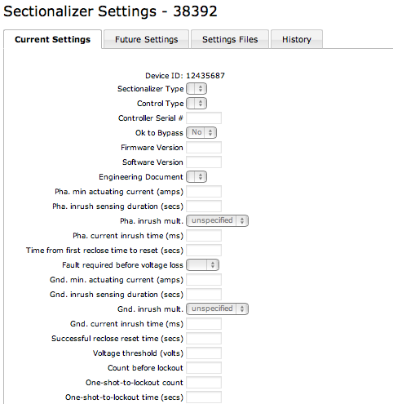

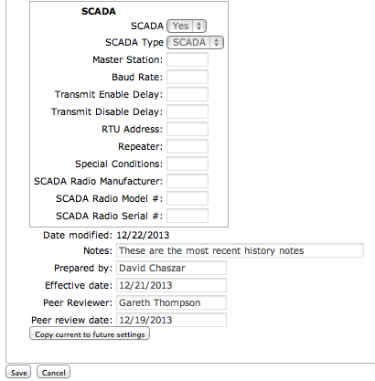

## Displayed Fields

1. *All the fields/data that is to be referenced by this GUI is captured in the SM_SECTIONALIZER spreadsheet.*
2. *Are there any additional data elements that are to be added? No.*

## Functionality

**Buttons by Tab**

Current Settings Tab

* Copy current to future settings

Future Settings Tab

* Save
* Released Check Box
* Cancel

**Released check Box**

*When the user checks the “Released” Check Box*

* *Cancel, what is the expected flow if the user clicks on Cancel?*
* *When the User chooses Save*
  + *Current setting data is archived*
  + *The Future settings are written to Current*
  + *The Future settings are set to default values or Nulls*
  + *The Released Flag box becomes unchecked*
  + *The screen is displayed as the default Switch Setting screens*
  + *The user stays on the current page.*

**Copy to Future button**

*When the user select the Copy To Future button*

* *The data values from the existing ‘Current’ record for the device are copied to the ‘Future’ record (existing values in the ‘Future’ record should be overwrtitten if the record exists, else create a new ‘Future’ record and copy the values in)*
* *The user is moved to the Future tab*

## Data Mapping

### Deprecated Attributes

The following section defines the current data mapping and attributes that will be carried over to the Setting Management application as well as those that will not. The SM_SECTIONALIZER spreadsheet defines the fields that are carried over.

|  |  |  |  |  |
| --- | --- | --- | --- | --- |
| **?** | **CEDSA Tab** | **Column** | **GIS** | **Comments** |
|  |  |  |  |  |
| 1 | SECTIONALIZER_SETTINGS | CONTACT_# | Not in GIS | no field validation, but is required when Released is checked and Prepared by, Contact #, and Effective Date are copied from future to current. This field is not needed. |
| 2 | SECTIONALIZER | SECT_TYPE | Not in GIS | SECT_TYPE Type or Model of device installed (TYPE). This field is not needed. |
| 3 | SECTIONALIZER | MS_CD | MATERIALCODE | MS_CD The PG&E material code # of this device - used by OM&C when ordering a replacement unit for overhaul or replacement. (MS CODE)  Use MANF_CD lookup today. [ ] Goes to SAP. BE CAREFUL with this. Consider restricting list based on feature class. This field is not needed. |
| 4 | SECTIONALIZER | NEXT_CLOSEUP_DATE | Not in GIS | NEXT_CLOSEUP_DATE If COAST_CORROSIVE = YES, then record the due date of then next required closeup bucket truck inspection. This field is not needed. |
| 5 | SECTIONALIZER | CONTROL_TYPE | Not in GIS | Lookup. SECT_CTL_TYPE. This field is needed and has been added to the SM_SECTIONALIZER spreadsheet. |
| 6 | SECTIONALIZER | FIRMWARE_VERSION | Not in GIS | User entered. Free form, no validation. Goes to SAP. This field is needed and has been added to the SM_SECTIONALIZER spreadsheet. |
| 7 | SECTIONALIZER | SOFTWARE_VERSION | Not in GIS | User entered. Free form, no validation. Goes to SAP. This field is needed and has been added to the SM_SECTIONALIZER spreadsheet. |

Questions referring to the above table

* 1,2,4,5 is it okay to deprecate these attributes? See table above.
* 3 going forward is this data going to be passed to SAP from the GIS system? See table above. This is in GIS already and goes to SAP from there.
* 6,7 By not mapping these attributes how is this data going to be provided to SAP. Will we need to continue to provide the data to SAP going forward? See table above. These attributes are in GIS also and go to SAP from there.

### Data Validations

The following table identifies the attributes that require further information regarding the validation process.

|  |  |  |  |  |
| --- | --- | --- | --- | --- |
| **Num** | **Table** | **Column** | **Validation** | **GUI Label** |
| 1 | SECTIONALIZER_SETTINGS | PHA_INRUSH_MULTIPLIER | Lookup. REST_MULT. | PHA Inrush Mult. |
| 2 | SECTIONALIZER_SETTINGS | REQUIRED_FAULT_CURRENT | Lookup. FAULT_CUR | Fault Required Befor Voltage Loss |
| 3 | SECTIONALIZER_SETTINGS | GRD_INRUSH_MULTIPLIER | Lookup. REST_MULT. | GND Inrush Mult |

Questions

* 1,3 Need a spread sheet with all the values that are valid for REST_MULT and an explanations of how validations are to take place in the context of the Sectionalizer data and any chosen values. These values are in the CEDSA CODES lookup table and found via the REST_MULT code indicated in the table.
* 2 Need a spread sheet with all the values that are valid for FAULT_CUR and an explanation of how validations are to take place in the context of the Sectionalizer and any chosen values data.

These values are in the CEDSA CODES lookup table and found via the FAULT_CUR code indicated in the table.

### Data Mapping Source to Settings

The following table defines the current mappings in question. The SM_SECTIONALIZER spreadsheet defines all of the mappings.

|  |  |  |  |  |  |
| --- | --- | --- | --- | --- | --- |
| **Source Table** | **Column Name** | **Sectionalizer Column** | **Nulls** | **Type** | **Approved** |
| GIS | Via the Change Detection process | GLOBAL_ID | NOT NULL | CHAR(38) | Y |
| SM | Application Defined | ROW_TYPE | NOT NULL | NVARCHAR2 (2) |  |
| GIS | Via the Change Detection process | FEATURE_CLASS_ID | NOT NULL | NUMBER(38) | Y |
| GIS | Via the Change Detection process | OPERATING_NUM |  | NVARCHAR(2)9 | Y |
| GIS | Via the Change Detection process | DIVISION | NOT NULL | NVARCHAR(50) | Y |
| GIS | Via the Change Detection process | DISTRICT | NOT NULL | NVARCHAR(50) | Y |

*We need to validate the NOT NULLABILITY and define correctly as well as the mapping to the source system. We also have a second look to insure that no attributes may have been over looked.*

As discussed we decided to define all ‘settings’ fields as nullable.