# Work Book SM_Switch

Revision History

|  |  |  |  |
| --- | --- | --- | --- |
| **Date** | **Version** | **Description** | **Author(s)** |
| 02/18/14 | 0.1 | Draft | Gabe Mohacsi |
| 02/19/14 | 0.2 | Updated with latest table fields and questions answered | Gareth Thompson |
| 02/21/14 | 0.3 | Additional updates based on questions to PG&E | Gareth Thompson |
| 02/24/14 | 0.4 | Updated switch screens | Gareth Thompson |

Document Reviewers

|  |  |
| --- | --- |
| **Title** | **Name** |
|  | Chris Kim |
|  |  |
|  |  |
|  |  |

# Graphical User Interface

This section is used to keep track of question and answers regarding the user interface and expected functionality.

The planned UI screens are displayed below. There are no additional fields between Current and Future Settings

The field visibility changes based on Controller Type. The SM_SWITCH spreadsheet identifies fields that are visible or hidden based on the SWITCH_TYPE and ATS_CAPABLE attributes.

The following is the layout for the Switch specific device settings fields (for SCADAMate switches).

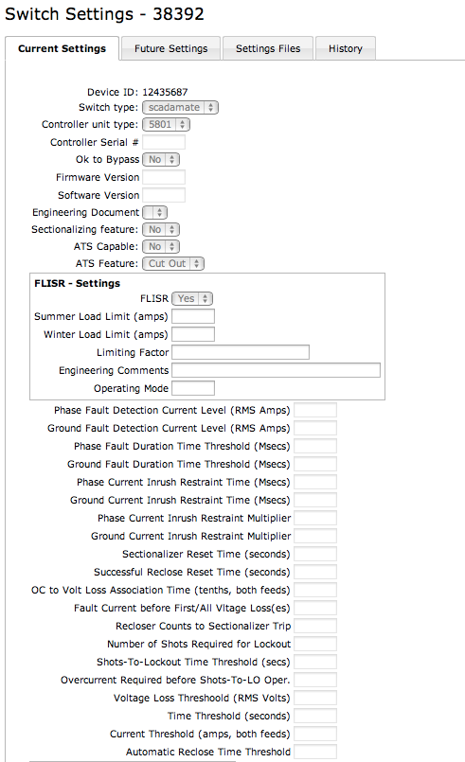

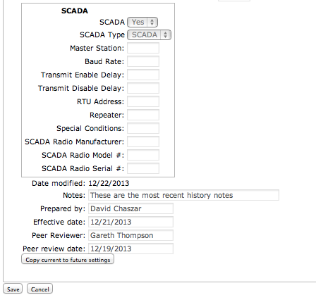

The following is the layout for the Switch specific device settings fields (for MSO switches operating as ATS and ATS switches operating as ATS).

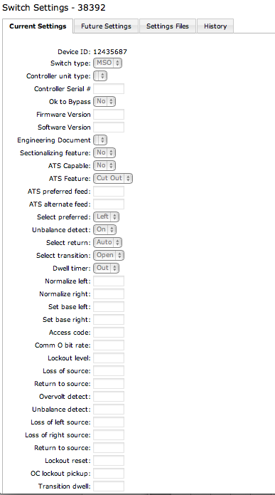

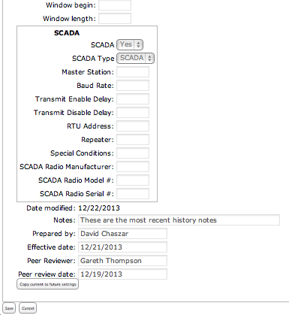

The following is the layout for the Switch specific device settings fields (for MSO switches operating as non-ATS and ATS switches operating as non-ATS).

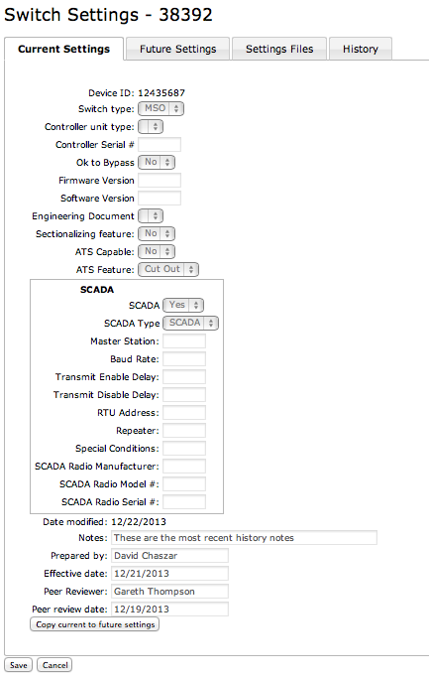

## Displayed Fields

1. *All the fields/data that is to be referenced by this GUI is captured in the SM_SWITCH spreadsheet.*
2. *Are there any additional data elements that are to be added? No.*

## Functionality

**Buttons by Tab**

Current Settings Tab

* Copy current to future settings
* For SCADAMate switches: If the FLISR value = Yes then enable the FLISR fields, else disable them

Future Settings Tab

* Save
* Released Check Box
* Cancel

**Released check Box**

*When the user checks the “Released” Check Box*

* *Cancel, what is the expected flow if the user clicks on Cancel?*
* *When the User chooses Save* 
  + *Current setting data is archived*
  + *The Future settings are written to Current*
  + *The Future settings are set to default values or Nulls*
  + *The Released Flag box becomes unchecked*
  + *The screen is displayed as the default Switch Setting screens*
  + *The user stays on the current page.*

**Copy to Future button**

*When the user select the Copy To Future button*

* *The data values from the existing ‘Current’ record for the device are copied to the ‘Future’ record (existing values in the ‘Future’ record should be overwrtitten if the record exists, else create a new ‘Future’ record and copy the values in)*
* *The user is moved to the Future tab*

## Data Mapping

### Deprecated Attributes

The following section defines the current data mapping and attributes that will be carried over to the Setting Management application as well as those that will not. The SM_SWITCH spreadsheet defines the fields that are carried over.

|  |  |  |  |  |
| --- | --- | --- | --- | --- |
| **Mapped** | **CEDSA Tab** | **Column** | **GIS** | **Comments** |
|  |  |  |  |  |
|  | SWITCH | JOB_# | INSTALLJOBNUMBER | This field is not needed. |
|  | SWITCH | CONTROL_SERIAL_# | Not in GIS | This field is needed and is listed in the spreadsheet. |
|  | SWITCH | FIRMWARE_VERSION | Not in GIS | This field is needed and is listed in the spreadsheet. |
|  | SWITCH | SOFTWARE_VERSION | Not in GIS | This field is needed and is listed in the spreadsheet. |

*Yellow highlights*

* *These values will no longer be stored*

*Red highlights*

* *This attribute is defined as required.*

### Data Definitions

The following list of attributes that have been identified as being part of Setting Maintenance Applications but do not have data types and sizes quantified.

|  |  |  |  |
| --- | --- | --- | --- |
| **GUI Label** | **Data Type** | **Size** | **Validation Rule** |
| Example | Number | 4,1 | 0 -> 999 |
| Phase Fault Detection Current Level (RMS Amps) | NUMBER (10) |  |  |
| Ground Fault Detection Current Level (RMS Amps) | NUMBER (10) |  |  |
| Phase Fault Duration Time Threshold (Msecs) | NUMBER (10) |  |  |
| Ground Fault Duration Time Threshold (Msecs) | NUMBER (10) |  |  |
| Phase Current Inrush Restraint Time (Msecs) | NUMBER (10) |  |  |
| Ground Current Inrush Restraint Time (Msecs) | NUMBER (10) |  |  |
| Phase Current Inrush Restraint Multiplier | NUMBER (10,2) |  |  |
| Ground Current Inrush Restraint Multiplier | NUMBER (10,2) |  |  |
| Sectionalizer Reset Time (seconds) | NUMBER (10) |  |  |
| Successful Reclose Reset Time (seconds) | NUMBER (10) |  |  |
| OC to Volt Loss Association Time (tenths, both feeds) | NUMBER (10,2) |  |  |
| Fault Current before First/All Vltage Loss(es) | NUMBER (10) |  |  |
| Recloser Counts to Sectionalizer Trip | NUMBER (10) |  |  |
| Number of Shots Required for Lockout | NUMBER (10) |  |  |
| Shots-To-Lockout Time Threshold (secs) | NUMBER (10) |  |  |
| Overcurrent Required before Shots-To-LO Oper. | NUMBER (10) |  |  |
| Voltage Loss Threshoold (RMS Volts) | NUMBER (10) |  |  |
| Time Threshold (seconds) | NUMBER (10) |  |  |
| Current Threshold (amps, both feeds) | NUMBER (10) |  |  |
| Automatic Reclose Time Threshold | NUMBER (10) |  |  |

*We need to populate the table with values for the following columns Data Type, Size and Validation Rules.*

### Data Mapping Source to Settings

The following table defines the current mappings in question. The SM_SWITCH spreadsheet defines all of the mappings.

|  |  |  |  |  |  |
| --- | --- | --- | --- | --- | --- |
| **Source Table** | **Column Name** | **Switch Column** | **Nulls** | **Type** | **Approved** |
| GIS | Via the Change Detection process | GLOBAL_ID | NOT NULL | CHAR(38) |  |
| GIS | Via the Change Detection process | FEATURE_CLASS_ID | NOT NULL | NUMBER(38) |  |
| GIS | Via the Change Detection process | OPERATING_NUM |  | NVARCHAR(2)9 |  |
| GIS | Via the Change Detection process | DIVISION | NOT NULL | NVARCHAR(50) |  |
| GIS | Via the Change Detection process | DISTRICT | NOT NULL | NVARCHAR(50) |  |
| UI | UI | DATE_MODIFIED | NOT NULL | DATE |  |

*Need mappings for the highlighted sections.*