JSC «International Information Technology University»
Faculty of Business, Media and Management · Department of Information Systems
REPORT
on Laboratory Work No. 10
The security subsystem: Spring Security, a login form, users in the database, BCrypt password hashing, role-based access restriction, CSRF protection
Course: RWPSF 3305 — Web Application Development with Spring Framework
Student: Askarkhan Baipanuly
Group: 2411
Variant: 1 — a custom login page
Lecturer: Yestay Mergengali, Senior Lector
Almaty, 2026

1. Aim of the work
To close the book catalogue application: it must ask who the visitor is, load users from a database table instead of configuration, store passwords only as BCrypt hashes, keep ordinary users out of the administrator pages (at URL level and at method level), and show CSRF protection working and failing on purpose.
Repository, branch lab10: https://github.com/c5shtv4cnh-ux/spring-lab-01/tree/lab10

Environment
Component | Version / value
Spring Boot / Spring Security | 4.1.1 / 7.1.1 (Thymeleaf, WebMVC, Data JPA, Flyway)
JDK | OpenJDK 21.0.12 (Microsoft build)
Database | PostgreSQL 16.15 (Homebrew), database springlab
Base of the branch | lab05 (book catalogue: /books, /api/books, Thymeleaf)
HTTP client / browser | curl 8, Google Chrome

Note on the migration number. The project in this repository goes from lab 5 straight to lab 10: the books are still kept in memory and there were no earlier Flyway migrations. Flyway and PostgreSQL were therefore added in this work, and the security migration is the first one, V1__security.sql. Its content is exactly the V5__security.sql of the assignment; on a project that already has V1–V4 it would be added as V5 without any change.

2. Task 1 — Spring Security and the login form
The branch lab10 was created and two dependencies were added to pom.xml: spring-boot-starter-security and thymeleaf-extras-springsecurity6. The application was started without any configuration.

2.1 What the application did before any configuration (table 1.2)
What to check | What I observed
What happens when you open /books? | The browser is redirected (302, Location: /login) to the generated page «Please sign in». A request without Accept: text/html (plain curl) gets 401 with WWW-Authenticate: Basic instead. Everything is closed by default.
What is the username, and where is the password? | Username: user. The password is generated randomly at every start and printed in the application log (UserDetailsServiceAutoConfiguration).
What does curl -i localhost:8080/api/books return now? | HTTP/1.1 401, WWW-Authenticate: Basic realm="Realm", empty body. With -u user:<generated password> it returns 200 and the JSON list of 3 books.
What is in the log line beginning «Using generated security password»? | Using generated security password: 4e084fe0-90f6-45da-8cec-963213a5a477  This generated password is for development use only. Your security configuration must be updated before running your application in production.
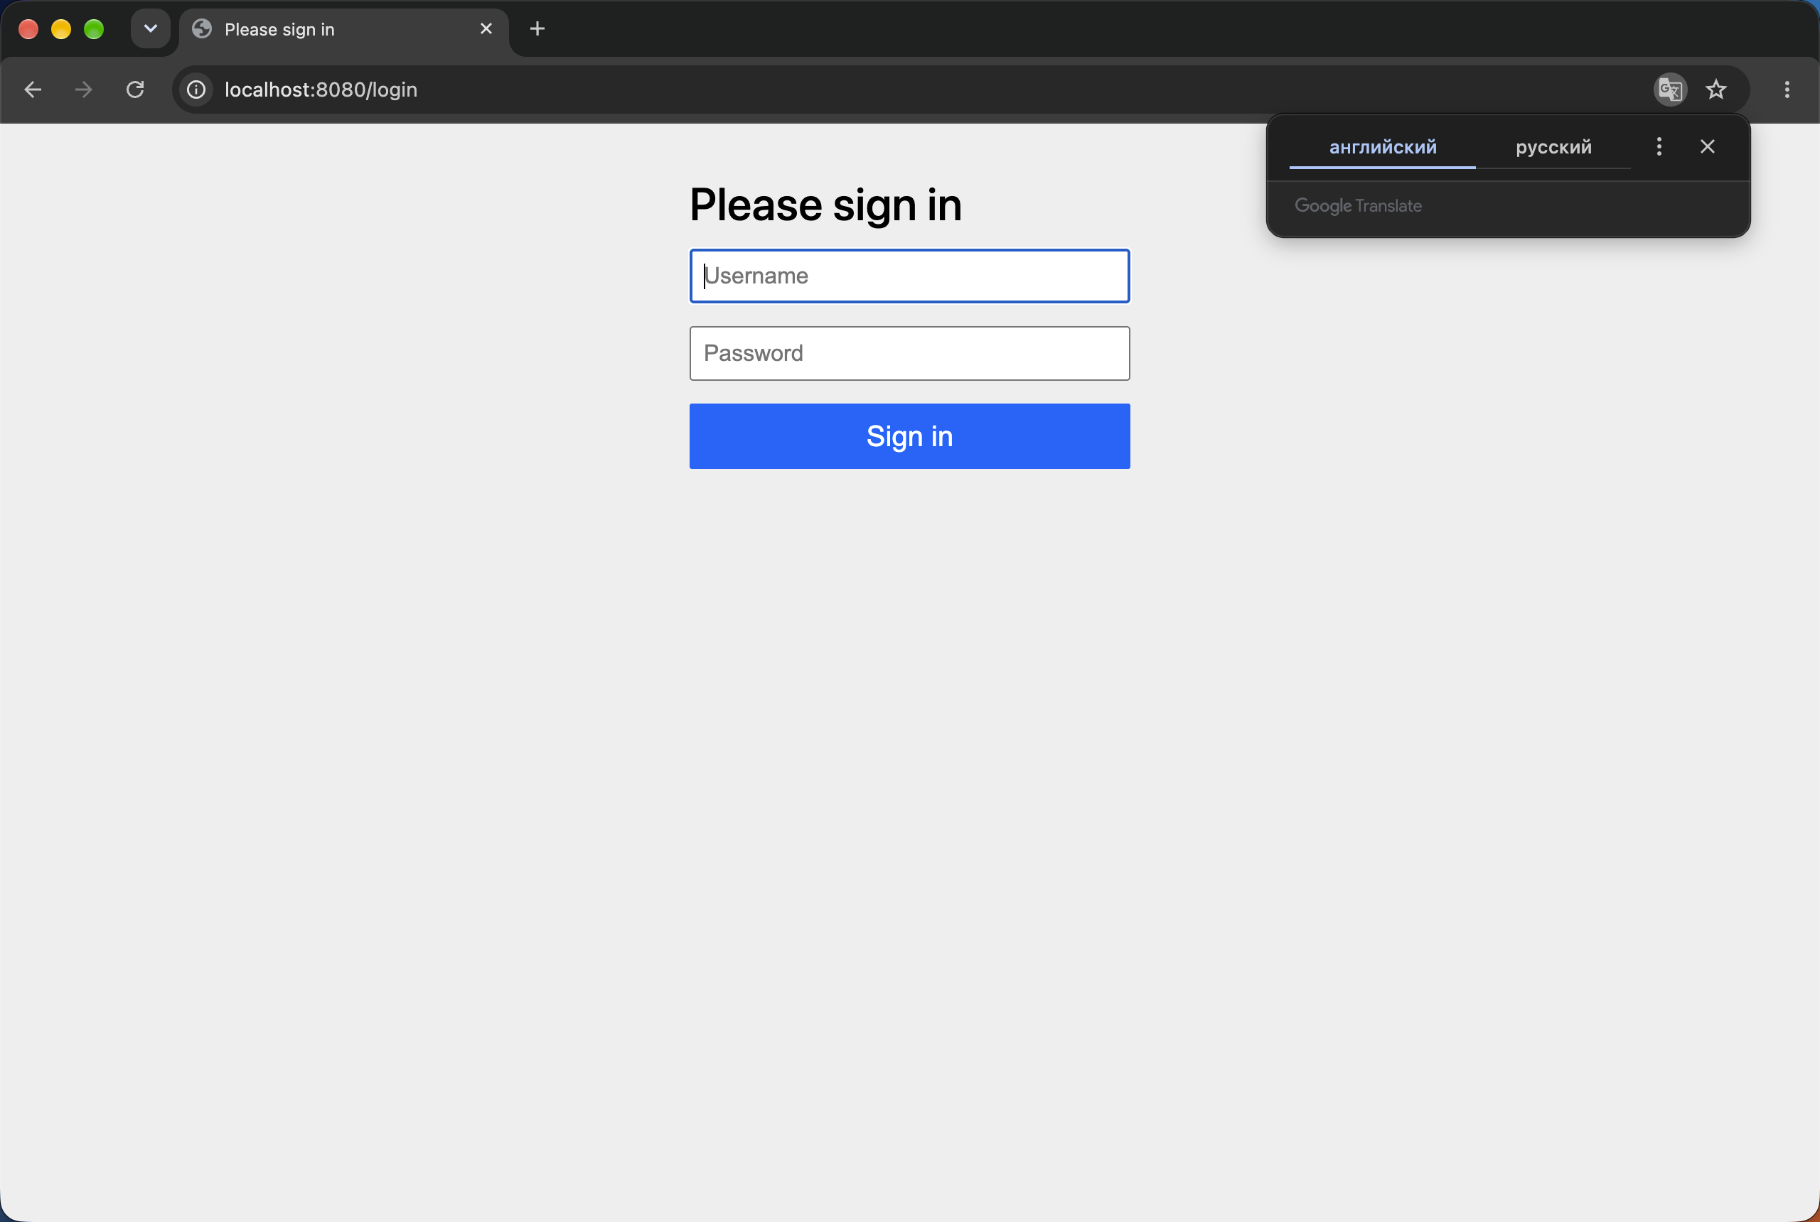
Figure 1. /books opened with no configuration: the browser lands on the generated login page

2.2 Own SecurityFilterChain (listing 2)
Listing 1. SecurityConfiguration at the end of task 1
@Configuration
@EnableWebSecurity
public class SecurityConfiguration {

@Bean
SecurityFilterChain filterChain(HttpSecurity http) throws Exception {
http
.authorizeHttpRequests(auth -> auth
.requestMatchers("/", "/login", "/css/**").permitAll()
.requestMatchers("/books/**").authenticated()
.anyRequest().denyAll())
.formLogin(form -> form.permitAll())
.logout(logout -> logout.logoutSuccessUrl("/?logout"));
return http.build();
}

@Bean // TEMPORARY — removed in task 2
UserDetailsService users() {
return new InMemoryUserDetailsManager(
User.withUsername("user")
.password("{noop}user123").roles("USER").build());
}
}

A HomeController with a home.html template was added for "/" (the static index.html from lab 5 was removed, because a forward to /index.html would be caught by denyAll()).

2.3 Checks (1.4)
Request | Result | Why
GET /books, anonymous | 302 → /login | rule authenticated(); not logged in
GET /, anonymous | 200 | permitAll()
POST /login user / user123 (with _csrf) | 302 → / | in-memory user found, {noop} password matches
GET /books as user | 200, the catalogue | authenticated
GET /nowhere as user | 403 | no rule mentions it → anyRequest().denyAll()
GET /nowhere, anonymous | 302 → /login | denyAll for an anonymous user starts authentication
GET /api/books as user | 403 | /api/** is not mentioned → denyAll()
POST /logout (with _csrf) | 302 → /?logout | logoutSuccessUrl("/?logout")
GET /books after logout | 302 → /login | session invalidated
POST /login user / wrong | 302 → /login?error | bad credentials

An unmentioned URL. GET /nowhere returns 403 to a logged-in user. No rule matches it, so the last rule anyRequest().denyAll() applies: an endpoint that somebody forgets to secure is closed, not open. An anonymous user is sent to the login page instead, because for an anonymous request ExceptionTranslationFilter first asks for authentication.

3. Task 2 — Users in the database and BCrypt

3.1 Generating the hashes (2.2)
Listing 2. PasswordHashGenerator (src/test/java)
package kz.iitu.spring_lab_01;

import org.springframework.security.crypto.bcrypt.BCryptPasswordEncoder;

/** Lab 10, task 2.2: prints BCrypt hashes for the two teaching passwords. */
public class PasswordHashGenerator {

public static void main(String[] args) {
var encoder = new BCryptPasswordEncoder();
System.out.println(encoder.encode("user123"));
System.out.println(encoder.encode("admin123"));
}
}

Password | Run 1 | Run 2
user123 | $2a$10$Gq99tc3/EEqaXFQ7tPSVMuV3jNezSwDoMbZKjuau7cQ1vljMmTTWe | $2a$10$8MuYOrPfMhvCo8IIX7ocguQJ//ihMZtGhzsI5erNDSkSyVEc3SWxa
admin123 | $2a$10$iTylasHuwX.Qcs6zo6Gur.ou7hfd9QtUJnnmwXPxCTcXNA3OQWcSC | $2a$10$Hol4qIbadO5FfJE0JCjJ1.5InondO5b/dY1nnlgnwlUPT0u0tgVY.

The same password gives a different hash on every run: BCrypt generates a new random 16-byte salt each time and stores it inside the hash. Run 1 was pasted into the migration.

3.2 The migration
Listing 3. src/main/resources/db/migration/V1__security.sql (= V5__security.sql of the assignment)
-- Lab 10, task 2: users and roles. Passwords are stored only as BCrypt hashes.
create table app_user (
id bigserial primary key,
username varchar(60) not null unique,
password_hash varchar(100) not null, -- BCrypt is 60 characters
enabled boolean not null default true
);

create table user_role (
user_id bigint not null references app_user (id),
role varchar(20) not null,
primary key (user_id, role)
);

-- two users; the hashes are of user123 and admin123 (PasswordHashGenerator, run 1)
insert into app_user (username, password_hash) values
('user', '$2a$10$Gq99tc3/EEqaXFQ7tPSVMuV3jNezSwDoMbZKjuau7cQ1vljMmTTWe'),
('admin', '$2a$10$iTylasHuwX.Qcs6zo6Gur.ou7hfd9QtUJnnmwXPxCTcXNA3OQWcSC');

insert into user_role (user_id, role)
select id, 'USER' from app_user;
insert into user_role (user_id, role)
select id, 'ADMIN' from app_user where username = 'admin';

Flyway log at start-up: Migrating schema "public" to version "1 - security" … Successfully applied 1 migration. The log line with a generated password is gone: with our own UserDetailsService bean the auto-configured user is not created.

3.3 Entity, repository, UserDetailsService, PasswordEncoder
Listing 4. AppUser — roles from user_role via @ElementCollection (EAGER)
package kz.iitu.spring_lab_01.user;

import jakarta.persistence.*;

import java.util.HashSet;
import java.util.Set;

@Entity
@Table(name = "app_user")
public class AppUser {

@Id
@GeneratedValue(strategy = GenerationType.IDENTITY)
private Long id;

@Column(nullable = false, unique = true, length = 60)
private String username;

@Column(name = "password_hash", nullable = false, length = 100)
private String passwordHash;

@Column(nullable = false)
private boolean enabled = true;

@ElementCollection(fetch = FetchType.EAGER)
@CollectionTable(name = "user_role", joinColumns = @JoinColumn(name = "user_id"))
@Column(name = "role", length = 20)
private Set<String> roles = new HashSet<>();

protected AppUser() { }

public Long getId() { return id; }
public String getUsername() { return username; }
public String getPasswordHash() { return passwordHash; }
public boolean isEnabled() { return enabled; }
public Set<String> getRoles() { return roles; }
}

Listing 5. AppUserRepository
package kz.iitu.spring_lab_01.user;

import org.springframework.data.jpa.repository.JpaRepository;

import java.util.List;
import java.util.Optional;

public interface AppUserRepository extends JpaRepository<AppUser, Long> {

Optional<AppUser> findByUsername(String username);

List<AppUser> findAllByOrderByIdAsc();
}

Listing 6. DatabaseUserDetailsService
package kz.iitu.spring_lab_01.user;

import org.springframework.security.core.userdetails.User;
import org.springframework.security.core.userdetails.UserDetails;
import org.springframework.security.core.userdetails.UserDetailsService;
import org.springframework.security.core.userdetails.UsernameNotFoundException;
import org.springframework.stereotype.Service;

@Service
public class DatabaseUserDetailsService implements UserDetailsService {

private final AppUserRepository users;

public DatabaseUserDetailsService(AppUserRepository users) {
this.users = users;
}

@Override
public UserDetails loadUserByUsername(String username) {
AppUser u = users.findByUsername(username)
.orElseThrow(() -> new UsernameNotFoundException(username));

return User.withUsername(u.getUsername())
.password(u.getPasswordHash())
.authorities(u.getRoles().stream()
.map(r -> "ROLE_" + r)
.toArray(String[]::new))
.disabled(!u.isEnabled())
.build();
}
}

Listing 7. The PasswordEncoder bean in SecurityConfiguration (the in-memory manager was deleted)
@Bean
PasswordEncoder passwordEncoder() {
return new BCryptPasswordEncoder();
}

application.properties: datasource jdbc:postgresql://localhost:5432/springlab, spring.jpa.hibernate.ddl-auto=validate (Flyway owns the schema, Hibernate only validates it).

3.4 Evidence (table 2.4)
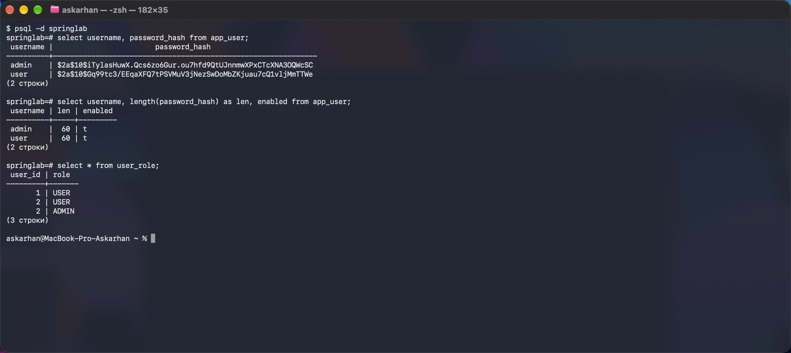
Figure 2. select username, password_hash from app_user; — hashes, not passwords
Question | Answer | How I checked it
select username, password_hash from app_user; | user | $2a$10$Gq99tc3/EEqaXFQ7tPSVMuV3jNezSwDoMbZKjuau7cQ1vljMmTTWe  admin | $2a$10$iTylasHuwX.Qcs6zo6Gur.ou7hfd9QtUJnnmwXPxCTcXNA3OQWcSC | psql -d springlab (figure 2)
Are the two hashes of the same password identical? | No. user123 → $2a$10$Gq99tc3/EEqaX… and $2a$10$8MuYOrPfMhvCo… | Ran PasswordHashGenerator twice (table above)
How long is a BCrypt hash, and what is the $2a$10$ prefix? | 60 characters. $2a$ = BCrypt algorithm version, 10 = cost factor (2^10 = 1024 rounds of key expansion), then 22 characters of salt and 31 of hash. | select length(password_hash) → 60 for both
What happens if you set enabled = false for one user? | Login with the correct password is refused: 302 → /login?error, the session stays anonymous and /books redirects to /login again. After enabled = true the same login works (302, then /books 200). The page shows the same generic message as for a wrong password (DisabledException is not revealed). | update app_user set enabled = false where username = 'user'; then curl login; then set back to true

Login (curl, form + _csrf) | Result
user / user123 | 302 → /, then GET /books 200
admin / admin123 | 302 → /, then GET /books 200
user / user124 (wrong password) | 302 → /login?error
nobody / user123 (unknown user) | 302 → /login?error (same answer)

4. Task 3 — Roles

4.1 URL rules
Listing 8. Final SecurityConfiguration (with the variant 1 settings of formLogin)
package kz.iitu.spring_lab_01.config;

import org.springframework.context.annotation.Bean;
import org.springframework.context.annotation.Configuration;
import org.springframework.http.HttpMethod;
import org.springframework.security.config.annotation.web.builders.HttpSecurity;
import org.springframework.security.config.annotation.web.configuration.EnableWebSecurity;
import org.springframework.security.crypto.bcrypt.BCryptPasswordEncoder;
import org.springframework.security.crypto.password.PasswordEncoder;
import org.springframework.security.web.SecurityFilterChain;

@Configuration
@EnableWebSecurity
public class SecurityConfiguration {

@Bean
SecurityFilterChain filterChain(HttpSecurity http) throws Exception {
http
.authorizeHttpRequests(auth -> auth
.requestMatchers("/", "/login", "/css/**", "/error").permitAll()
.requestMatchers(HttpMethod.GET, "/books/**").hasAnyRole("USER", "ADMIN")
.requestMatchers("/books/**").hasRole("ADMIN") // create, edit, delete
.requestMatchers("/admin/**").hasRole("ADMIN")
.anyRequest().denyAll())
.formLogin(form -> form
.loginPage("/login") // variant 1: our own template
.defaultSuccessUrl("/books")
.permitAll())
.logout(logout -> logout.logoutSuccessUrl("/login?logout"));
return http.build();
}

@Bean
PasswordEncoder passwordEncoder() {
return new BCryptPasswordEncoder();
}
}

4.2 Method security
Listing 9. @EnableMethodSecurity and the protected BookService methods
package kz.iitu.spring_lab_01.config;

import org.springframework.context.annotation.Configuration;
import org.springframework.security.config.annotation.method.configuration.EnableMethodSecurity;

@Configuration
@EnableMethodSecurity
public class MethodSecurityConfiguration { }

// BookService
@PreAuthorize("hasRole('ADMIN')")
public Book create(Book book) {
@PreAuthorize("hasRole('ADMIN')")
public Optional<Book> update(long id, Book book) {
@PreAuthorize("hasRole('ADMIN')")
public boolean delete(long id) {

The rule travels with the method. BookService is also used by BookRestController (/api/books) and could be called by any future controller, a scheduled job or a message listener; a URL rule only protects one path. This is shown by BookServiceMethodSecurityTests (calls the service directly, no HTTP at all):
Listing 10. BookServiceMethodSecurityTests
/**
* Lab 10, task 3.2: the service is protected even when it is called without
* going through a URL (another controller, a scheduled job, a message listener).
*/
@SpringBootTest
class BookServiceMethodSecurityTests {

@Autowired
BookService books;

@Test
void anonymousCallerCannotDelete() {
assertThatThrownBy(() -> books.delete(1))
.isInstanceOf(AuthenticationCredentialsNotFoundException.class);
}

@Test
@WithMockUser(username = "user", roles = "USER")
void userCannotDeleteOrCreate() {
assertThatThrownBy(() -> books.delete(1)).isInstanceOf(AccessDeniedException.class);
assertThatThrownBy(() -> books.create(new Book(null, "T", "A", 2020)))
.isInstanceOf(AccessDeniedException.class);
}

@Test
@WithMockUser(username = "admin", roles = {"USER", "ADMIN"})
void adminCanCreateAndDelete() {
Book saved = books.create(new Book(null, "Temp", "Admin", 2026));
assertThat(books.delete(saved.id())).isTrue();
}

@Test
@WithMockUser(username = "user", roles = "USER")
void readingIsNotRestricted() {
assertThat(books.findAll(null)).isNotEmpty();
}
}

Result of ./mvnw test: Tests run: 5, Failures: 0, Errors: 0 — BUILD SUCCESS. Anonymous → AuthenticationCredentialsNotFoundException, user → AccessDeniedException, admin → allowed.

4.3 The view
Listing 11. templates/fragments/header.html — included in every page
<!DOCTYPE html>
<html xmlns:th="http://www.thymeleaf.org"
xmlns:sec="http://www.thymeleaf.org/extras/spring-security">
<body>
<header th:fragment="header" class="topbar">
<a th:href="@{/}">Home</a>
<a th:href="@{/books}">Catalogue</a>
<a sec:authorize="hasRole('ADMIN')" th:href="@{/admin}">Administration</a>

<span class="who" sec:authorize="isAuthenticated()">
Logged in as <b sec:authentication="name">anonymous</b>,
roles <code sec:authentication="principal.authorities">[ROLE_USER]</code>
<form th:action="@{/logout}" method="post" class="inline">
<button type="submit">Log out</button>
</form>
</span>
<span class="who" sec:authorize="isAnonymous()">
Not logged in · <a th:href="@{/login}">Log in</a>
</span>
</header>
</body>
</html>

In books/list.html the «Add» form and the «Delete» buttons are wrapped in sec:authorize="hasRole('ADMIN')", and the form uses th:action="@{/books}" (in lab 5 it was a plain action="/books", which gets no CSRF token). Hiding is a courtesy: the URL rule and @PreAuthorize are the controls.
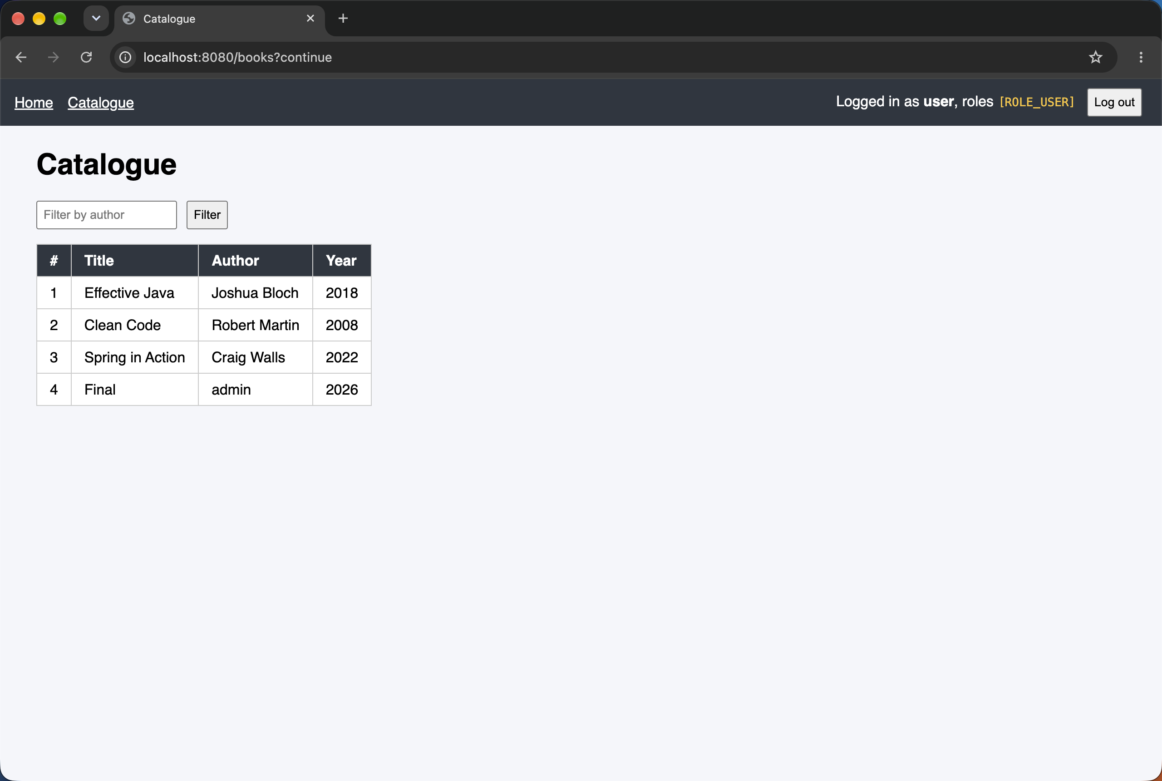
Figure 3. /books as user: the name and [ROLE_USER] are shown; no «Add» form, no Administration link
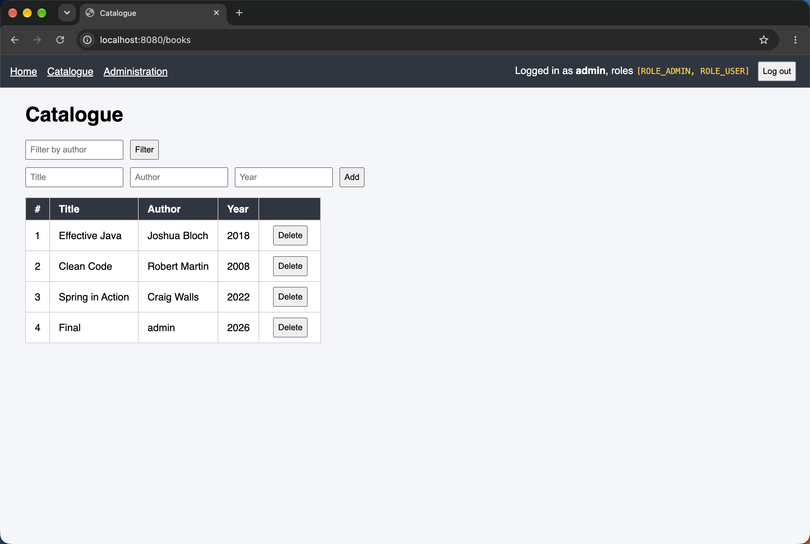
Figure 4. /books as admin: [ROLE_ADMIN, ROLE_USER], the Administration link, the «Add» form and «Delete» buttons
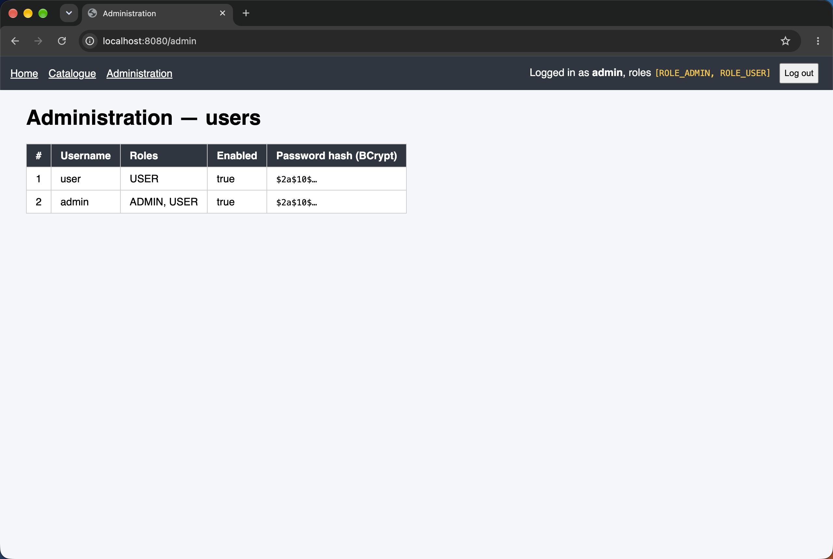
Figure 5. GET /admin as admin — AdminController lists the users from app_user

4.4 The access matrix (3.4)
Measured with curl, one cookie jar (session) per actor; every POST carried a valid _csrf token of that session, so the result shows authorisation, not CSRF.
Request | Anonymous | user | admin
GET / | 200 | 200 | 200
GET /books | 302 → /login | 200 | 200
POST /books (create) | 302 → /login | 403 | 302 → /books (created)
GET /admin | 302 → /login | 403 | 200
GET /nowhere (no rule) | 302 → /login | 403 | 403

Extra: POST /books/1/delete — user 403, admin 302 → /books (deleted).
Login redirect vs 403. Both come from ExceptionTranslationFilter, which catches the AccessDeniedException thrown by the AuthorizationFilter. If the current Authentication is anonymous, it starts authentication through the AuthenticationEntryPoint (LoginUrlAuthenticationEntryPoint → 302 /login, the original request is saved — hence /books?continue after login). If the user is already authenticated but lacks the role, it calls the AccessDeniedHandler → 403.
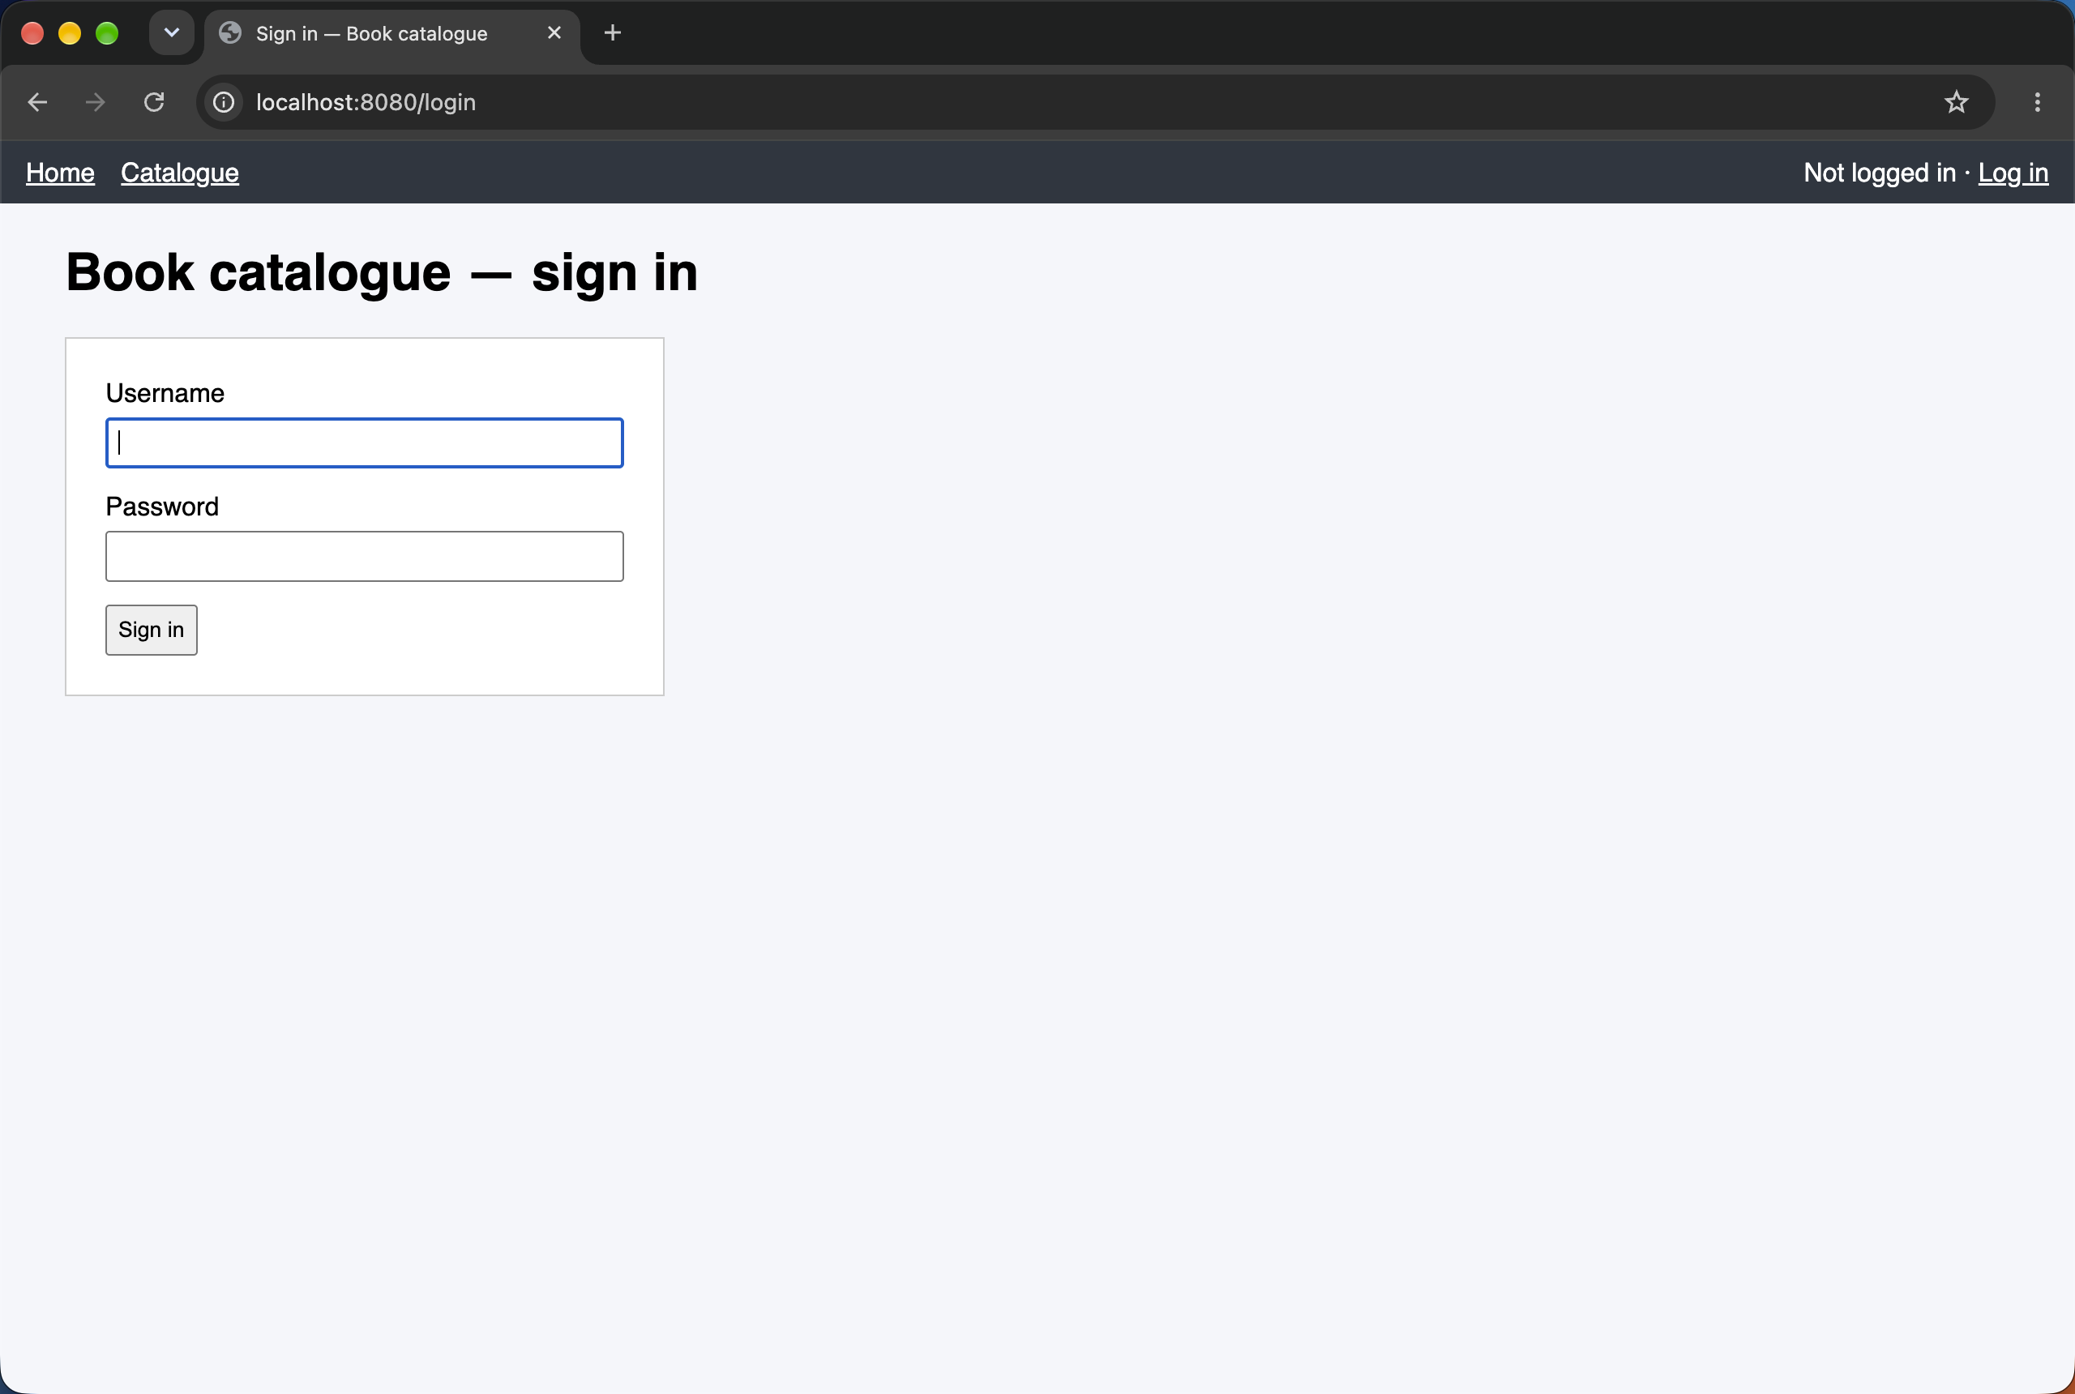
Figure 6. Anonymous GET /books → redirected to the login page (URL bar: localhost:8080/login)
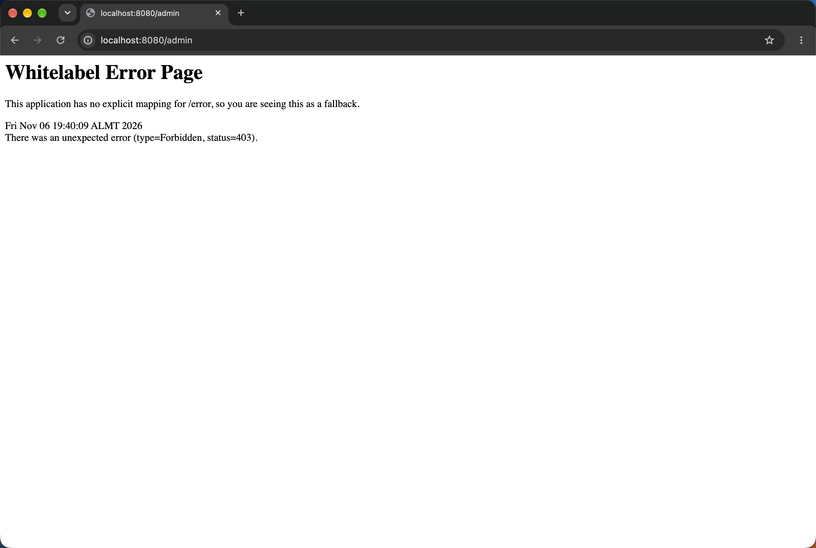
Figure 7. user requests /admin → 403 Forbidden (rule .requestMatchers("/admin/**").hasRole("ADMIN"))

5. Task 4 — CSRF

5.1 The hidden field
Listing 12. The «Add» form on /books as rendered for admin (view-source)
<form method="post" action="/books"><input type="hidden" name="_csrf" value="UgS2nReDi2mMqPZDCGly8qV5Kj1n5gd4z0ZW-c8Z…"/>

Name: _csrf; first eight characters of the value: UgS2nReD. It was inserted by Thymeleaf (Spring's CsrfRequestDataValueProcessor) because the form is a POST with th:action. The matching value is stored server-side in the HTTP session (HttpSessionCsrfTokenRepository). The value printed changes on every page load, because Spring Security 7 masks the same session token with fresh random bytes (BREACH protection).
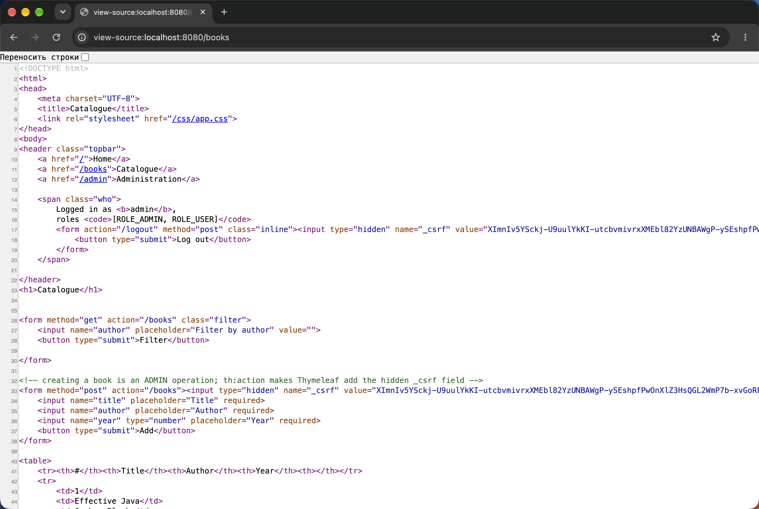
Figure 8. Page source of /books: the hidden _csrf input in the logout form and in the «Add» form

5.2 The three calls
The book form has the fields title, author, year (there is no genre field in this project), so these names were used. Call 1 exactly as in listing 8 fails: the login form is a POST too and is CSRF-protected, so a token must first be taken from GET /login with the same cookie jar.
Call | Command | Response
1a. Login without a token (as in listing 8) | curl -i -c cookies.txt -X POST localhost:8080/login -d "username=admin&password=admin123" | 403 Forbidden — not logged in
1b. Login with the token from GET /login | curl -s -c cookies.txt -b cookies.txt localhost:8080/login (take _csrf)  curl -i -c cookies.txt -b cookies.txt -X POST localhost:8080/login -d "username=admin&password=admin123&_csrf=<token>" | 302 Location: /books, new JSESSIONID (session fixation protection)
2. POST /books with the session, WITHOUT the token | curl -i -b cookies.txt -X POST localhost:8080/books -d "title=Forged&author=Mallory&year=2020" | 403 {"status":403,"error":"Forbidden","path":"/books"} — book not created
3. The same POST WITH the token from the page | curl -i -b cookies.txt -X POST localhost:8080/books -d "title=Genuine&author=Admin&year=2020&_csrf=<token>" | 302 Location: /books — «Genuine» is in the catalogue
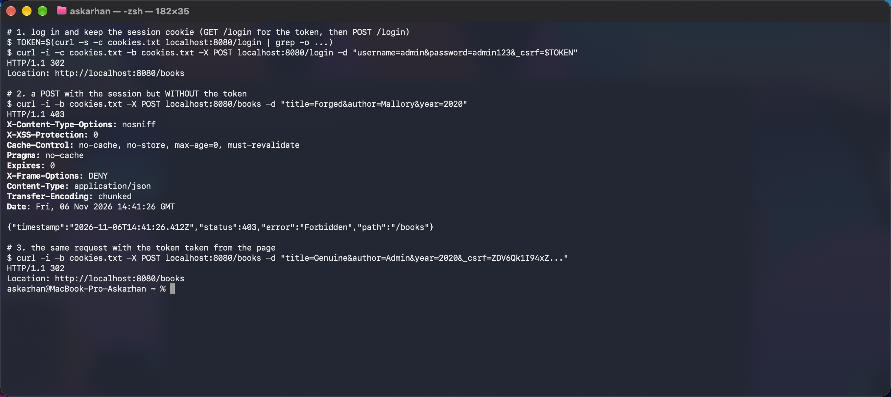
Figure 9. The three calls in the terminal
Also checked: a tampered token → 403; a GET with the session and no token → 200 (GET, HEAD, TRACE, OPTIONS are not CSRF-checked because they must not change state).
Why the cookie alone is not enough. In call 2 the browser-like client had a valid session cookie, but CsrfFilter compared the _csrf parameter with the token stored in the session, found none, threw InvalidCsrfTokenException (MissingCsrfTokenException) and AccessDeniedHandlerImpl answered 403 before the request reached the controller.
Why a page on another site cannot read the token (4.3). The same-origin policy lets the other site send a request to our server, and the browser attaches our cookie, but it does not let that site read our page's response, so it never learns the token that has to be in the form.

6. Individual assignment — variant 1: a custom login page
Requirement: own template at /login, with an error message and a logout message. formLogin(...).loginPage("/login") switches off the generated page; the GET /login is served by our controller, the POST /login is still processed by UsernamePasswordAuthenticationFilter.
Listing 13. Changes in SecurityConfiguration
.formLogin(form -> form
.loginPage("/login") // variant 1: our own template
.defaultSuccessUrl("/books")
.permitAll())
.logout(logout -> logout.logoutSuccessUrl("/login?logout"));

Listing 14. LoginController
package kz.iitu.spring_lab_01.web;

import org.springframework.stereotype.Controller;
import org.springframework.web.bind.annotation.GetMapping;

/** Individual variant 1: our own login page instead of the generated one. */
@Controller
public class LoginController {

@GetMapping("/login")
public String login() {
return "login";
}
}

Listing 15. templates/login.html
<!DOCTYPE html>
<html xmlns:th="http://www.thymeleaf.org">
<head>
<meta charset="UTF-8">
<title>Sign in — Book catalogue</title>
<link rel="stylesheet" th:href="@{/css/app.css}">
</head>
<body>
<header th:replace="~{fragments/header :: header}"></header>
<h1>Book catalogue — sign in</h1>

<!-- ?error: set by the failure handler of formLogin; one message for a wrong name AND a wrong password -->
<p th:if="${param.error}" class="error">Invalid username or password.</p>
<!-- ?logout: we arrive here after POST /logout (logoutSuccessUrl("/login?logout")) -->
<p th:if="${param.logout}" class="flash">You have been logged out.</p>

<!-- th:action makes Thymeleaf add the hidden _csrf field: the login POST is CSRF-protected too -->
<form th:action="@{/login}" method="post" class="login">
<label for="username">Username</label>
<input id="username" name="username" autofocus required>
<label for="password">Password</label>
<input id="password" name="password" type="password" required>
<button type="submit">Sign in</button>
</form>
</body>
</html>

Check | Result
Anonymous GET /books | 302 → /login, our template «Book catalogue — sign in» (figure 6)
Wrong password | 302 → /login?error, «Invalid username or password.» (figure 10)
Unknown username | the same message — no hint which part was wrong
Correct login admin / admin123 | 302 → /books
POST /logout with _csrf | 302 → /login?logout, «You have been logged out.» (figure 11)
Hidden _csrf in the login form | present (th:action), so the login POST is CSRF-protected
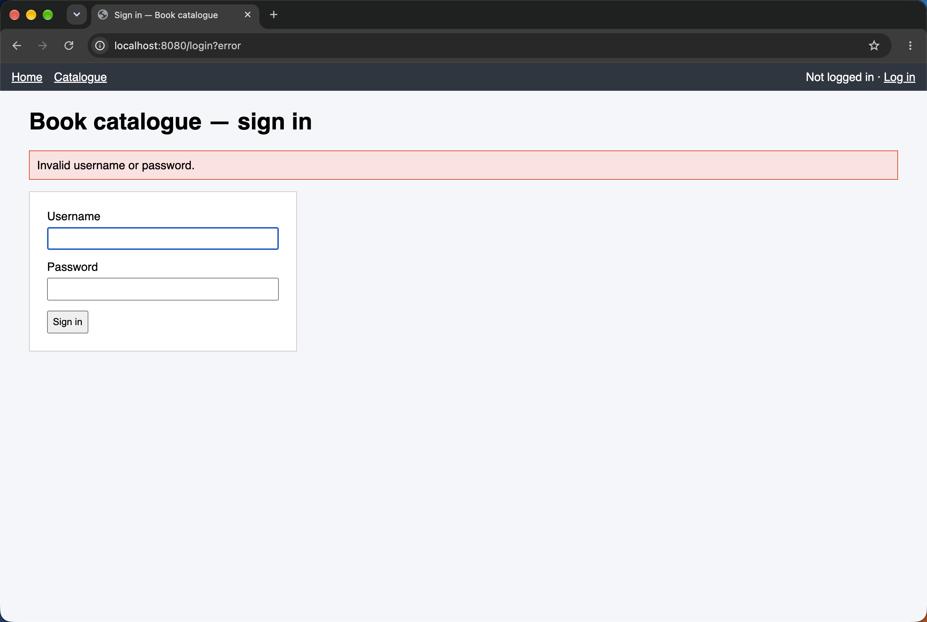
Figure 10. Custom login page with the error message (/login?error)
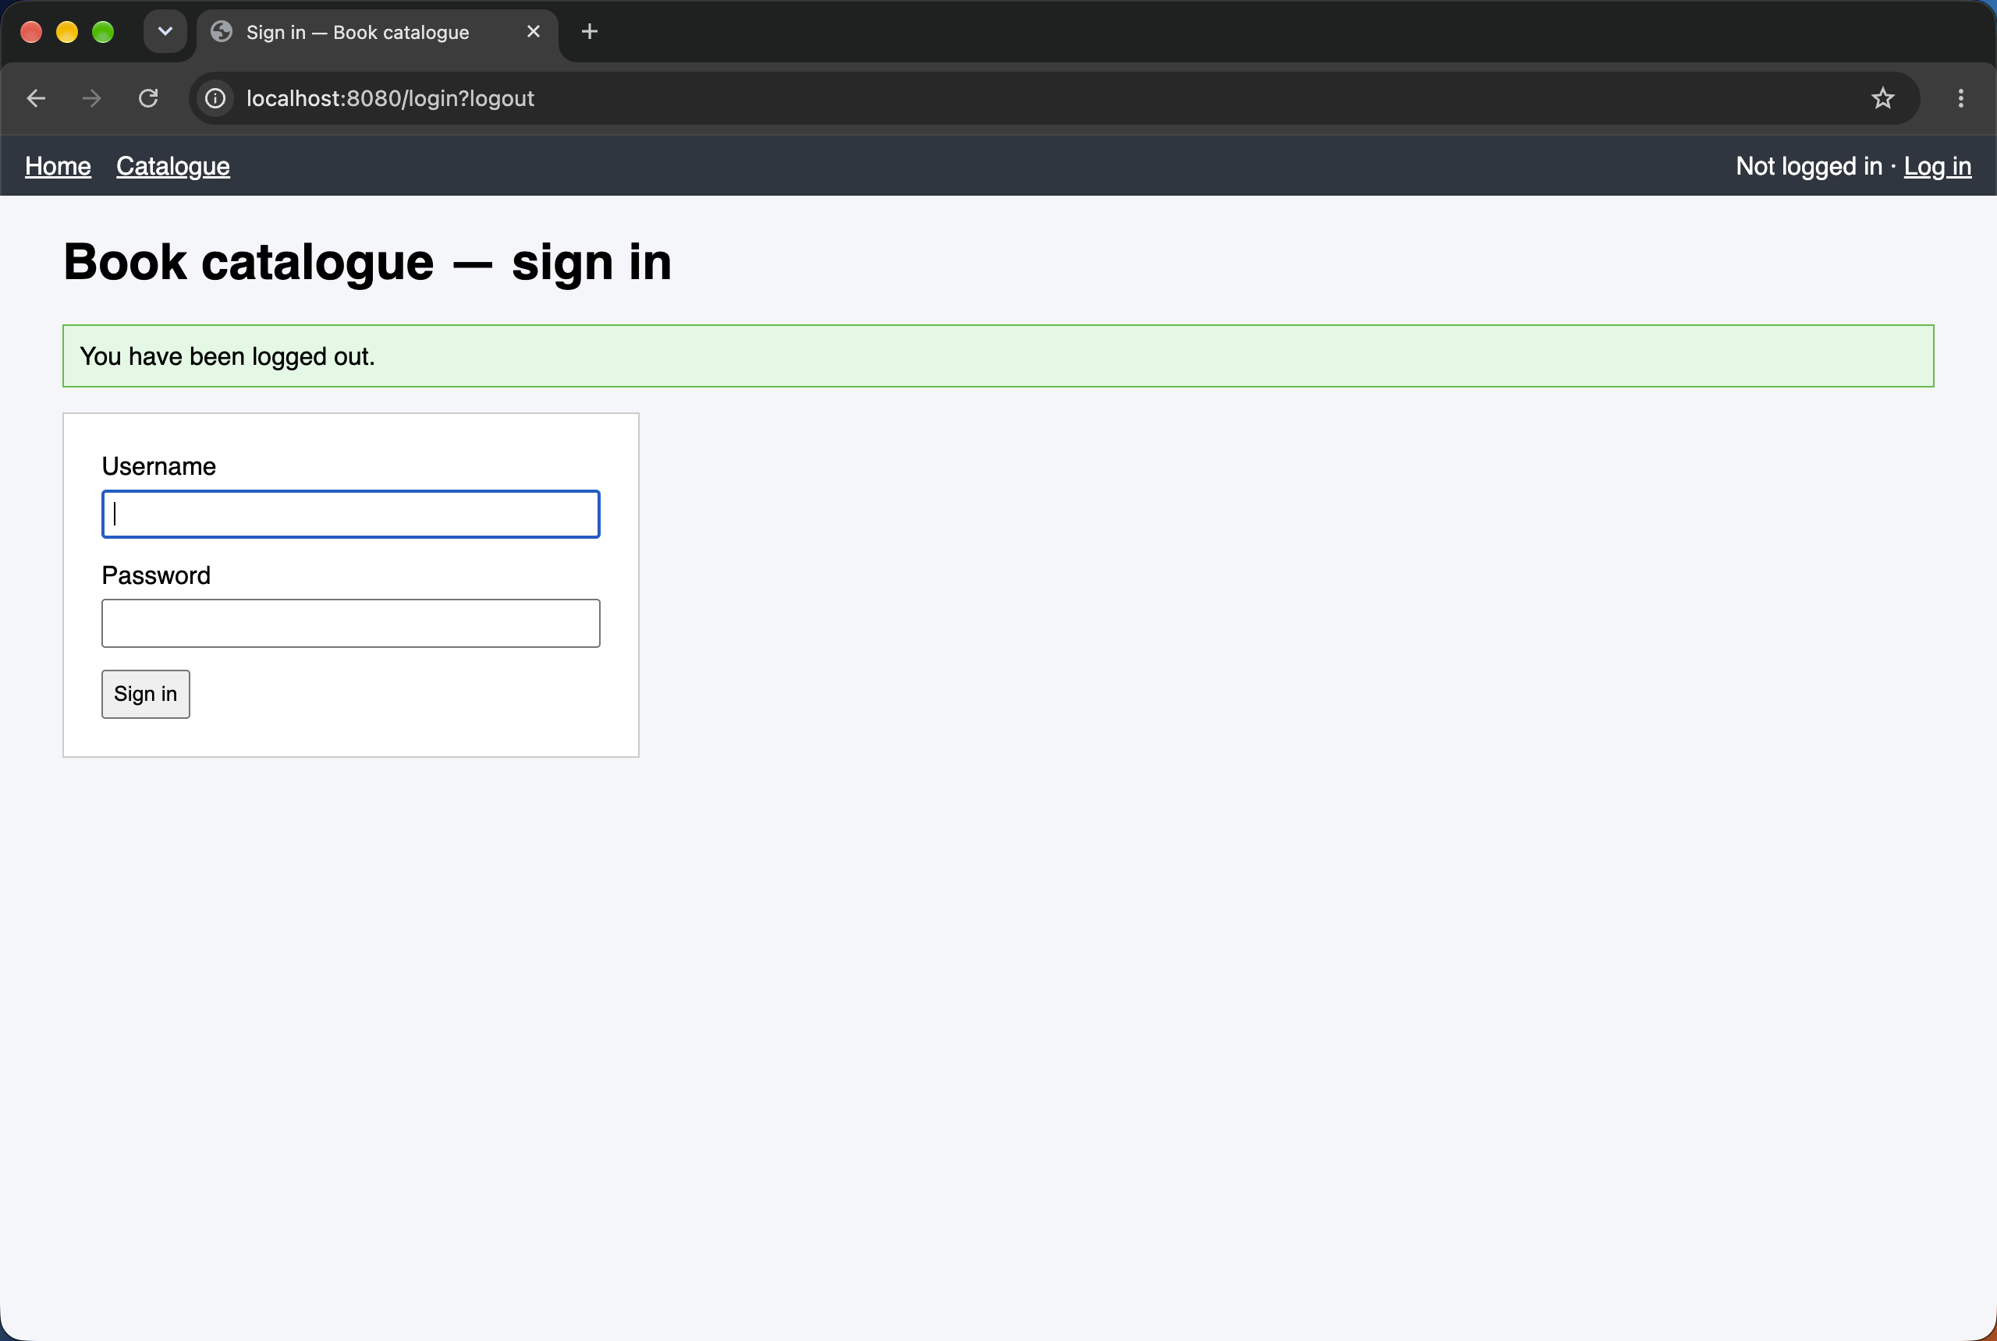
Figure 11. Custom login page after logout (/login?logout)

7. Conclusions
Adding the starter alone closed the whole application, and replacing the defaults with an explicit SecurityFilterChain made every access decision readable in one place, ending with denyAll(). Users now come from PostgreSQL through a UserDetailsService, and the table holds only 60-character BCrypt hashes with a per-user salt, so two equal passwords never look alike. Roles are enforced twice — by URL rules and by @PreAuthorize on BookService — and the matrix shows the difference between a login redirect for an anonymous visitor and a 403 for a logged-in user without the role. CSRF protection was observed both ways: the same POST with the session cookie is refused without the token and accepted with it.
In somebody else's security configuration I would check first: (1) that the last rule is anyRequest().denyAll() and the specific matchers come before the general ones; (2) that csrf is not disabled for browser forms and every POST form uses th:action; (3) which PasswordEncoder is used and that no {noop} or plaintext passwords are left in code, migrations or Git; (4) that service methods that change data also carry @PreAuthorize instead of relying only on URL rules or on hiding buttons in the template.

Appendix. Short answers for the defence (section 10)
Question | Answer
Where does Spring Security run relative to the controllers? | In servlet filters (DelegatingFilterProxy → FilterChainProxy → SecurityFilterChain) before the DispatcherServlet. A refused request never reaches a controller, so @ControllerAdvice does not see these 401/403s.
What did the application do before any configuration? | Spring Boot auto-configuration secured every URL, created user with a random password printed in the log, and enabled form login + HTTP Basic + CSRF.
Which rule matches GET /books/42? | The second one: requestMatchers(HttpMethod.GET, "/books/**").hasAnyRole("USER","ADMIN"). First match wins.
Why denyAll() last, not permitAll()? | A forgotten endpoint is closed by default (fail-safe); /nowhere and /api/** prove it.
hasRole("ADMIN") vs hasAuthority("ADMIN")? | hasRole adds the ROLE_ prefix and checks ROLE_ADMIN; hasAuthority checks the string as it is. I use hasRole and add ROLE_ in the UserDetailsService.
Which two beans for database login? | UserDetailsService — "who is this?" (username, hash, authorities, enabled); PasswordEncoder — "is this the right password?" (BCrypt matches).
What is in password_hash and what is not? | Algorithm version, cost, salt and the hash. The password itself is not there and cannot be computed back.
Why do equal passwords have different hashes? | A random salt is generated per hash and stored inside it.
What does the 10 in $2a$10$ mean? | The cost factor, 2^10 iterations. Choose the largest value that keeps one login check around 0.25–1 s on the production server, and raise it as hardware gets faster.
Why is SHA-256 a bad choice? | It is designed to be fast (billions per second on a GPU) and is unsalted by itself, so brute force and rainbow tables work. Password hashing must be slow and salted.
Why the same answer for wrong username and wrong password? | Otherwise an attacker can enumerate which usernames exist.
Redirect vs 403 — which filter? | ExceptionTranslationFilter: anonymous → AuthenticationEntryPoint (redirect to /login); authenticated without the role → AccessDeniedHandler (403).
A case the URL rule would miss? | Another controller (e.g. DELETE /api/books/{id}, or a new /import endpoint) or a scheduled job calling BookService.delete — @PreAuthorize still refuses it.
Is sec:authorize a security control? | No, it only hides markup. The endpoint is still reachable with curl; the server rules protect it.
Who put the _csrf field there and where is the pair? | Thymeleaf via CsrfRequestDataValueProcessor; the expected value is in the HTTP session (HttpSessionCsrfTokenRepository).
What happened to the POST without the token? | CsrfFilter → MissingCsrfTokenException (an AccessDeniedException) → AccessDeniedHandlerImpl → 403.
Which methods are CSRF-checked? | All except GET, HEAD, TRACE, OPTIONS, which must be safe (no state change).
When may CSRF be disabled? | Only when the browser does not send credentials automatically, e.g. a stateless API authenticated by an Authorization: Bearer header. "It is a REST API" is not enough if it uses session cookies.
Two other things that must never reach Git | Database passwords / datasource credentials, API keys and tokens (and .env files, private keys).
OWASP Top 10:2025 categories addressed | A01 Broken Access Control (roles, denyAll, @PreAuthorize), A04 Cryptographic Failures (BCrypt), A07 Authentication Failures (form login, disabled accounts, generic errors), A02 Security Misconfiguration (own chain instead of defaults). Not addressed: e.g. A03 Software Supply Chain Failures (dependency scanning) or A09 Logging & Alerting Failures.

