JSC «International Information Technology University»
Faculty of Business, Media and Management · Department of Information Systems
REPORT
on the Laboratory Work
Spring Transaction Management and Database Schema Versioning
Declarative transactions • Propagation • Isolation • Optimistic locking • Flyway
Course: RWPSF 3305 — Web Application Development with Spring Framework
Student: Askarkhan Baipanuly
Group: 2411
Lecturer: Yestay Mergengali, Senior Lector
Almaty, 2026

1. Aim
To implement and test transaction management in a Spring application, observe rollback and concurrency behaviour, and practise database schema versioning with Flyway.
Repository, branch lab-transactions: https://github.com/c5shtv4cnh-ux/spring-lab-01/tree/lab-transactions

Environment
Component | Version / value
Java, build tool | OpenJDK 21.0.12, Maven wrapper
Spring Boot | 4.1.1 (Spring Framework 7.0.9, Hibernate ORM 7.4.5) — the assignment allows 3.x; the project was already on 4.x
Database | PostgreSQL 16.15 (Homebrew), database txlab
Migration tool | Flyway 12.4.0 (only Flyway; Liquibase is not used)
Project | spring-lab-01, branch lab-transactions created from main

2. Project setup and database migrations
Dependencies added to pom.xml: spring-boot-starter-data-jpa, spring-boot-starter-flyway, flyway-database-postgresql, postgresql (runtime), spring-boot-starter-data-jpa-test (test). Spring Web and Spring Boot Test were already in the project.
Listing 1. application.properties
spring.application.name=spring-lab-01

# PostgreSQL 16 (Homebrew), database txlab; local teaching setup only
spring.datasource.url=jdbc:postgresql://localhost:5432/txlab
spring.datasource.username=askarhan
spring.datasource.password=

# Flyway owns the schema, Hibernate only validates it
spring.jpa.hibernate.ddl-auto=validate
spring.jpa.show-sql=true
spring.jpa.open-in-view=false

# make transaction boundaries visible in the log
logging.level.org.springframework.orm.jpa.JpaTransactionManager=DEBUG

PostgreSQL was used instead of H2 so that the isolation experiment shows the behaviour of a real server database. JpaTransactionManager logs at DEBUG level so that every transaction boundary is visible in the log.
Listing 2. V1__create_accounts.sql
CREATE TABLE accounts (
id BIGINT GENERATED BY DEFAULT AS IDENTITY PRIMARY KEY,
owner_name VARCHAR(120) NOT NULL,
balance DECIMAL(19, 2) NOT NULL,
version BIGINT NOT NULL DEFAULT 0
);

INSERT INTO accounts (owner_name, balance) VALUES ('Alice', 1000.00), ('Bob', 500.00);

Listing 3. V2__add_status.sql
ALTER TABLE accounts
ADD COLUMN status VARCHAR(20) NOT NULL DEFAULT 'ACTIVE';

Listing 4. V3__create_audit_log.sql — the audit table needed for task B
-- Task B: audit records written by AuditService (REQUIRED / REQUIRES_NEW)
CREATE TABLE audit_log (
id BIGINT GENERATED BY DEFAULT AS IDENTITY PRIMARY KEY,
message VARCHAR(255) NOT NULL,
created_at TIMESTAMP NOT NULL DEFAULT CURRENT_TIMESTAMP
);

Listing 5. V4__index_owner_name.sql — added later, in task E
-- Task E: a new versioned migration added after V1-V3 were already applied
CREATE INDEX idx_accounts_owner_name ON accounts (owner_name);

3. Entity and repository
Listing 6. Account — @Version enables optimistic locking
package kz.iitu.spring_lab_01.bank;

import jakarta.persistence.*;

import java.math.BigDecimal;

@Entity
@Table(name = "accounts")
public class Account {

@Id
@GeneratedValue(strategy = GenerationType.IDENTITY)
private Long id;

@Column(name = "owner_name", nullable = false)
private String ownerName;

@Column(nullable = false, precision = 19, scale = 2)
private BigDecimal balance;

@Column(nullable = false, length = 20)
private String status = "ACTIVE";

@Version
private Long version;

protected Account() { }

public Account(String ownerName, BigDecimal balance) {
this.ownerName = ownerName;
this.balance = balance;
}

public void debit(BigDecimal amount) {
if (amount.signum() <= 0) throw new IllegalArgumentException("Amount must be positive");
if (balance.compareTo(amount) < 0) throw new IllegalStateException("Insufficient funds");
balance = balance.subtract(amount);
}

public void credit(BigDecimal amount) {
if (amount.signum() <= 0) throw new IllegalArgumentException("Amount must be positive");
balance = balance.add(amount);
}

public Long getId() { return id; }
public String getOwnerName() { return ownerName; }
public BigDecimal getBalance() { return balance; }
public String getStatus() { return status; }
public Long getVersion() { return version; }

@Override
public String toString() {
return "Account{id=" + id + ", owner=" + ownerName + ", balance=" + balance + ", version=" + version + "}";
}
}

Listing 7. AccountRepository
package kz.iitu.spring_lab_01.bank;

import org.springframework.data.jpa.repository.JpaRepository;

import java.util.Optional;

public interface AccountRepository extends JpaRepository<Account, Long> {

Optional<Account> findByOwnerName(String ownerName);
}

spring.jpa.hibernate.ddl-auto=validate checks at start-up that the entity matches the schema created by Flyway; the application started, so the mapping (including the status column from V2) is correct.

4. Task A — Declarative transactions and rollback
Listing 8. TransferService.transfer
@Transactional
public void transfer(Long fromId, Long toId, BigDecimal amount) {
Account from = repository.findById(fromId).orElseThrow();
Account to = repository.findById(toId).orElseThrow();

from.debit(amount);
to.credit(amount);
repository.save(from);
repository.save(to);
}

Listing 9. Failure variants used in the experiment
/** Same as transfer, but fails with an unchecked exception after the debit and before the credit. */
@Transactional
public void transferFailingAfterDebit(Long fromId, Long toId, BigDecimal amount) {
Account from = repository.findById(fromId).orElseThrow();
Account to = repository.findById(toId).orElseThrow();

from.debit(amount);
repository.saveAndFlush(from); // the UPDATE really reaches the database
if (true) {
throw new RuntimeException("Simulated failure after debit, before credit");
}
to.credit(amount);
repository.save(to);
}

/** A checked exception: by default Spring does NOT roll back, the debit is committed. */
@Transactional
public void transferFailingWithChecked(Long fromId, Long toId, BigDecimal amount) throws TransferException {
Account from = repository.findById(fromId).orElseThrow();
from.debit(amount);
repository.save(from);
throw new TransferException("Checked failure after debit, before credit");
}

/** The same checked exception, but rollbackFor makes Spring roll back. */
@Transactional(rollbackFor = TransferException.class)
public void transferFailingWithCheckedRollbackFor(Long fromId, Long toId, BigDecimal amount) throws TransferException {
Account from = repository.findById(fromId).orElseThrow();
from.debit(amount);
repository.save(from);
throw new TransferException("Checked failure after debit, before credit (rollbackFor)");
}

Every case is an integration test (TaskATransactionTests, @SpringBootTest against PostgreSQL). Before each test the balances are reset to Alice 1000.00 / Bob 500.00; balances are read with plain SQL, past any persistence context.
Case | Exception | Balances after  (Alice / Bob) | Transaction
A1. transfer 100.00 Alice → Bob | — | 900.00 / 600.00 | committed
A2. transfer 5000.00 (more than the balance) | IllegalStateException: Insufficient funds | 1000.00 / 500.00 | rolled back, nothing changed
A3. unchecked exception after the debit, before the credit (the debit UPDATE was flushed) | RuntimeException | 1000.00 / 500.00 | rolled back — the executed UPDATE is undone
A4. checked exception after the debit | TransferException (checked) | 900.00 / 500.00 | COMMITTED — 100.00 disappeared
A5. the same checked exception, rollbackFor = TransferException.class | TransferException | 1000.00 / 500.00 | rolled back

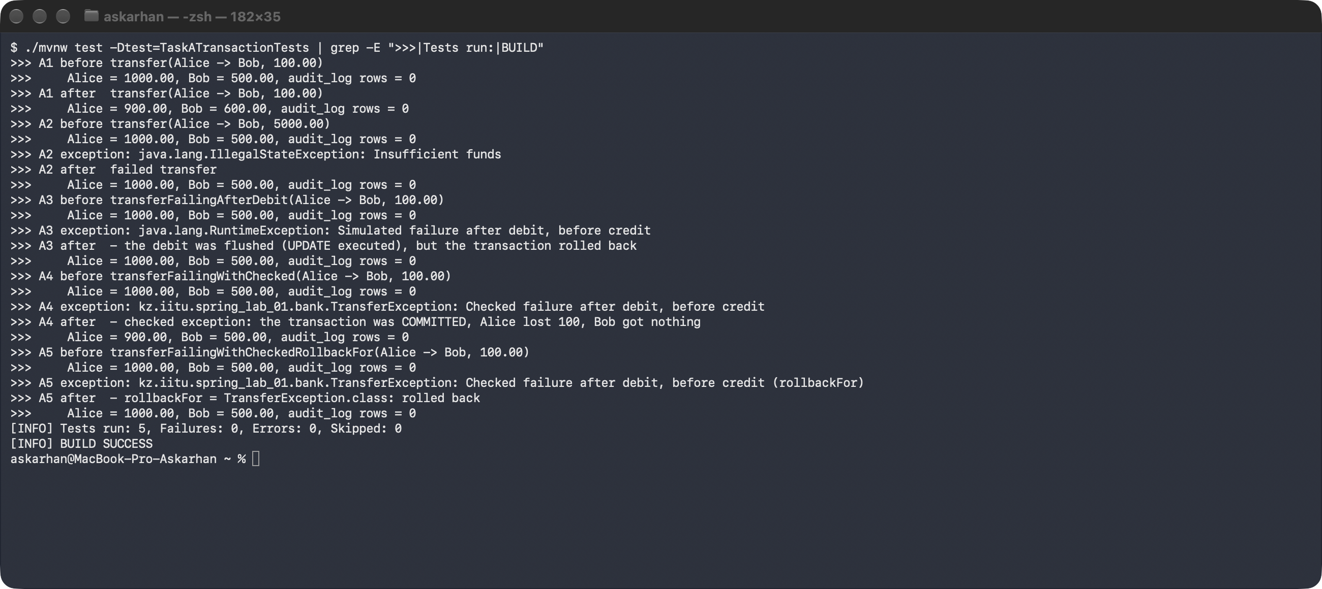
Figure 1. Task A — the successful transfer and the four failure cases (./mvnw test -Dtest=TaskATransactionTests)
Listing 10. Log of A3 and A4: transaction decisions ([tx]) and SQL ([sql])
>>> A3 before transferFailingAfterDebit(Alice -> Bob, 100.00)
>>> Alice = 1000.00, Bob = 500.00, audit_log rows = 0
[tx main] Creating new transaction with name [kz.iitu.spring_lab_01.bank.TransferService.transferFailingAfterDebit]: PROPAGATION_REQUIRED,ISOLATION_DEFAULT
[tx main] Participating in existing transaction
[sql] select a1_0.id,a1_0.balance,a1_0.owner_name,a1_0.status,a1_0.version from accounts a1_0 where a1_0.id=?
[tx main] Participating in existing transaction
[sql] select a1_0.id,a1_0.balance,a1_0.owner_name,a1_0.status,a1_0.version from accounts a1_0 where a1_0.id=?
[tx main] Participating in existing transaction
[sql] update accounts set balance=?,owner_name=?,status=?,version=? where id=? and version=?
[tx main] Initiating transaction rollback
[tx main] Rolling back JPA transaction on EntityManager
>>> A3 exception: java.lang.RuntimeException: Simulated failure after debit, before credit
>>> A3 after - the debit was flushed (UPDATE executed), but the transaction rolled back
>>> Alice = 1000.00, Bob = 500.00, audit_log rows = 0
>>> A4 before transferFailingWithChecked(Alice -> Bob, 100.00)
>>> Alice = 1000.00, Bob = 500.00, audit_log rows = 0
[tx main] Creating new transaction with name [kz.iitu.spring_lab_01.bank.TransferService.transferFailingWithChecked]: PROPAGATION_REQUIRED,ISOLATION_DEFAULT
[tx main] Participating in existing transaction
[sql] select a1_0.id,a1_0.balance,a1_0.owner_name,a1_0.status,a1_0.version from accounts a1_0 where a1_0.id=?
[tx main] Participating in existing transaction
[tx main] Initiating transaction commit
[tx main] Committing JPA transaction on EntityManager
[sql] update accounts set balance=?,owner_name=?,status=?,version=? where id=? and version=?
>>> A4 exception: kz.iitu.spring_lab_01.bank.TransferException: Checked failure after debit, before credit
>>> A4 after - checked exception: the transaction was COMMITTED, Alice lost 100, Bob got nothing
>>> Alice = 900.00, Bob = 500.00, audit_log rows = 0

Checked exceptions and rollbackFor. By default Spring rolls back only on RuntimeException and Error. A checked exception is treated as a business outcome that the caller is expected to handle, so the transaction is committed: in A4 the log shows «Initiating transaction commit», and the money left Alice without reaching Bob. rollbackFor = TransferException.class (or rollbackFor = Exception.class) adds the checked type to the rollback rules, and A5 shows «Initiating transaction rollback». noRollbackFor does the opposite for unchecked exceptions.

5. Task B — Propagation
Listing 11. AuditService — the inner method, in a separate bean
package kz.iitu.spring_lab_01.bank;

import org.springframework.stereotype.Service;
import org.springframework.transaction.annotation.Propagation;
import org.springframework.transaction.annotation.Transactional;

/** Task B: the inner method. A separate bean, so the call goes through the transactional proxy. */
@Service
public class AuditService {

private final AuditRepository audit;

public AuditService(AuditRepository audit) {
this.audit = audit;
}

/** Joins the caller's transaction: commits or rolls back together with it. */
@Transactional(propagation = Propagation.REQUIRED)
public void logRequired(String message) {
audit.save(new AuditRecord(message));
}

/** Suspends the caller's transaction and runs in its own, committed when this method returns. */
@Transactional(propagation = Propagation.REQUIRES_NEW)
public void logRequiresNew(String message) {
audit.save(new AuditRecord(message));
}
}

Listing 12. The outer methods in TransferService
/** Outer transaction; the audit joins it (REQUIRED); then the outer method fails. */
@Transactional
public void transferWithAuditRequiredThenFail(Long fromId, Long toId, BigDecimal amount, String auditMessage) {
transferInternal(fromId, toId, amount);
auditService.logRequired(auditMessage);
throw new IllegalStateException("Outer transaction fails after the audit returned");
}

/** Outer transaction; the audit runs in its own transaction (REQUIRES_NEW); then the outer method fails. */
@Transactional
public void transferWithAuditRequiresNewThenFail(Long fromId, Long toId, BigDecimal amount, String auditMessage) {
transferInternal(fromId, toId, amount);
auditService.logRequiresNew(auditMessage);
throw new IllegalStateException("Outer transaction fails after the audit returned");
}

The inner method is in a different bean on purpose: @Transactional works through a proxy, and a self-call inside the same class would bypass it, so the propagation setting would be ignored.
Inner propagation | Outer transaction | Audit record after the test | Balances
REQUIRED | fails after the inner method returned → rollback | absent (audit_log rows = 0) | 1000.00 / 500.00
REQUIRES_NEW | fails after the inner method returned → rollback | PRESENT (audit_log rows = 1) | 1000.00 / 500.00

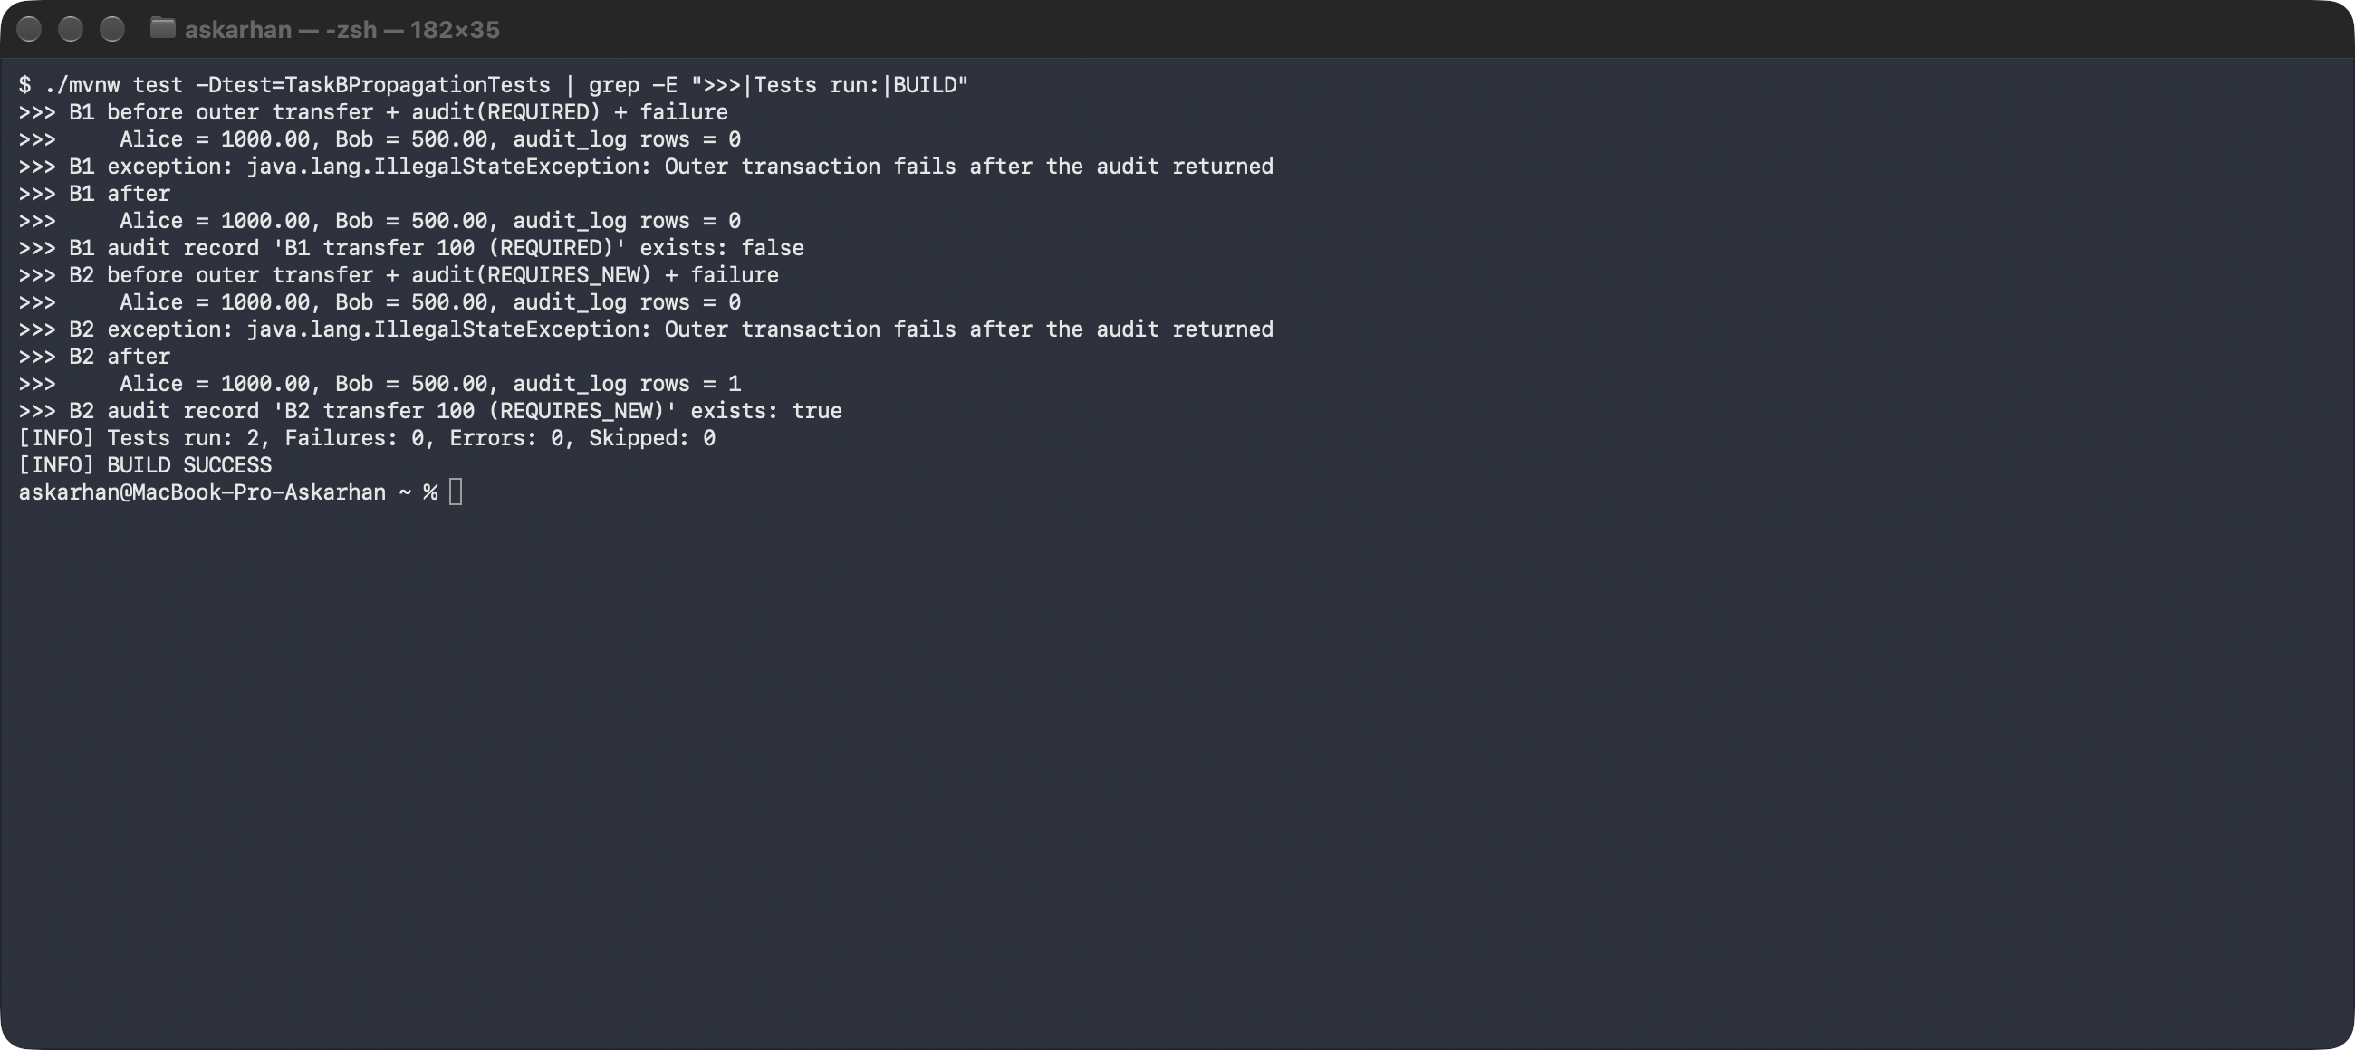
Figure 2. Task B — REQUIRED vs REQUIRES_NEW
Listing 13. Log of B2: the outer transaction is suspended, the inner one commits, the outer one rolls back
>>> B2 before outer transfer + audit(REQUIRES_NEW) + failure
>>> Alice = 1000.00, Bob = 500.00, audit_log rows = 0
[tx main] Creating new transaction with name [kz.iitu.spring_lab_01.bank.TransferService.transferWithAuditRequiresNewThenFail]: PROPAGATION_REQUIRED,ISOLATION_DEFAULT
[tx main] Participating in existing transaction
[sql] select a1_0.id,a1_0.balance,a1_0.owner_name,a1_0.status,a1_0.version from accounts a1_0 where a1_0.id=?
[tx main] Participating in existing transaction
[sql] select a1_0.id,a1_0.balance,a1_0.owner_name,a1_0.status,a1_0.version from accounts a1_0 where a1_0.id=?
[tx main] Suspending current transaction, creating new transaction with name [kz.iitu.spring_lab_01.bank.AuditService.logRequiresNew]
[tx main] Participating in existing transaction
[sql] insert into audit_log (created_at,message) values (?,?)
[tx main] Initiating transaction commit
[tx main] Committing JPA transaction on EntityManager
[tx main] Resuming suspended transaction after completion of inner transaction
[tx main] Initiating transaction rollback
[tx main] Rolling back JPA transaction on EntityManager

Why. With REQUIRED the inner method finds an active transaction and joins it («Participating in existing transaction»): there is one physical transaction, so the INSERT into audit_log is rolled back together with the transfer. With REQUIRES_NEW the transaction manager suspends the outer transaction, opens a new one on another connection and commits it when logRequiresNew returns («Committing JPA transaction … Resuming suspended transaction»); only then does the outer one roll back. The audit row is already committed and stays — exactly what an audit log of failed attempts needs.
Propagation | When it is appropriate (optional extension)
SUPPORTS | Read-only helpers that may run with or without a transaction (a lookup used both from transactional and plain code).
MANDATORY | Steps that are correct only inside a caller's unit of work and must never start their own transaction; fails fast if called without one.
NOT_SUPPORTED | Slow or external work (a remote call, sending e-mail, building a report) that should not keep a database transaction and its locks open.
NEVER | Code that must not be called inside a transaction at all, e.g. a method that manages its own batches or connections.
NESTED | A savepoint inside the outer transaction: the inner part (one item of a batch) can roll back alone while the outer work continues; needs JDBC savepoints.

6. Task C — Isolation and concurrent access (PostgreSQL 16.15)
T1 runs in the test thread with a TransactionTemplate whose isolation level is set explicitly; T2 runs in another thread (another connection, its own transaction), adds 50.00 to Alice and commits between T1's two reads. Reads use plain SQL (JdbcTemplate inside the same JPA transaction), so the Hibernate first-level cache cannot hide the database behaviour; «show transaction_isolation» confirms the level PostgreSQL actually applied.
Listing 14. TaskCIsolationTests — the concurrent writer T2 and test C1 (C2–C4 differ only in the isolation level and the final UPDATE)
/** T2: a separate thread, therefore a separate connection and transaction; it commits before returning. */
private void concurrentDepositOf50() {
CompletableFuture.runAsync(() -> tx(TransactionDefinition.ISOLATION_READ_COMMITTED).executeWithoutResult(s ->
jdbc.update("update accounts set balance = balance + 50.00 where owner_name = 'Alice'"))).join();
say(" T2: added 50.00 to Alice and COMMITTED");
}

@Test @Order(1)
void c1_readCommitted_secondReadSeesTheCommittedChange() {
BigDecimal[] reads = tx(TransactionDefinition.ISOLATION_READ_COMMITTED).execute(s -> {
say("C1 READ_COMMITTED, T1 isolation in the database: " + jdbc.queryForObject("show transaction_isolation", String.class));
BigDecimal first = readAlice();
say(" T1 first read : " + first);
concurrentDepositOf50();
BigDecimal second = readAlice();
say(" T1 second read: " + second + " -> non-repeatable read: T1 sees T2's committed change");
return new BigDecimal[]{first, second};
});
assertThat(reads[0]).isEqualByComparingTo("1000.00");
assertThat(reads[1]).isEqualByComparingTo("1050.00");
}

Test | Scenario | Observed | Conclusion
C1 READ_COMMITTED | T1 reads, T2 +50 commits, T1 reads again | 1000.00, then 1050.00 | non-repeatable read: each statement sees the latest committed data
C2 REPEATABLE_READ | the same | 1000.00, then 1000.00 (the database already holds 1050.00) | the second read is repeatable: T1 works on the snapshot taken at its first query
C3 REPEATABLE_READ | T1 reads, T2 +50 commits, T1 updates the same row −10 | T1 fails: «could not serialize access due to concurrent update» (Spring: CannotAcquireLockException, a ConcurrencyFailureException); database 1050.00 | PostgreSQL refuses to let T1 overwrite a row changed after its snapshot; T1 must retry
C4 READ_COMMITTED | the same as C3 | T1 succeeds; database 1040.00 | the UPDATE re-reads the latest committed row; both changes are kept

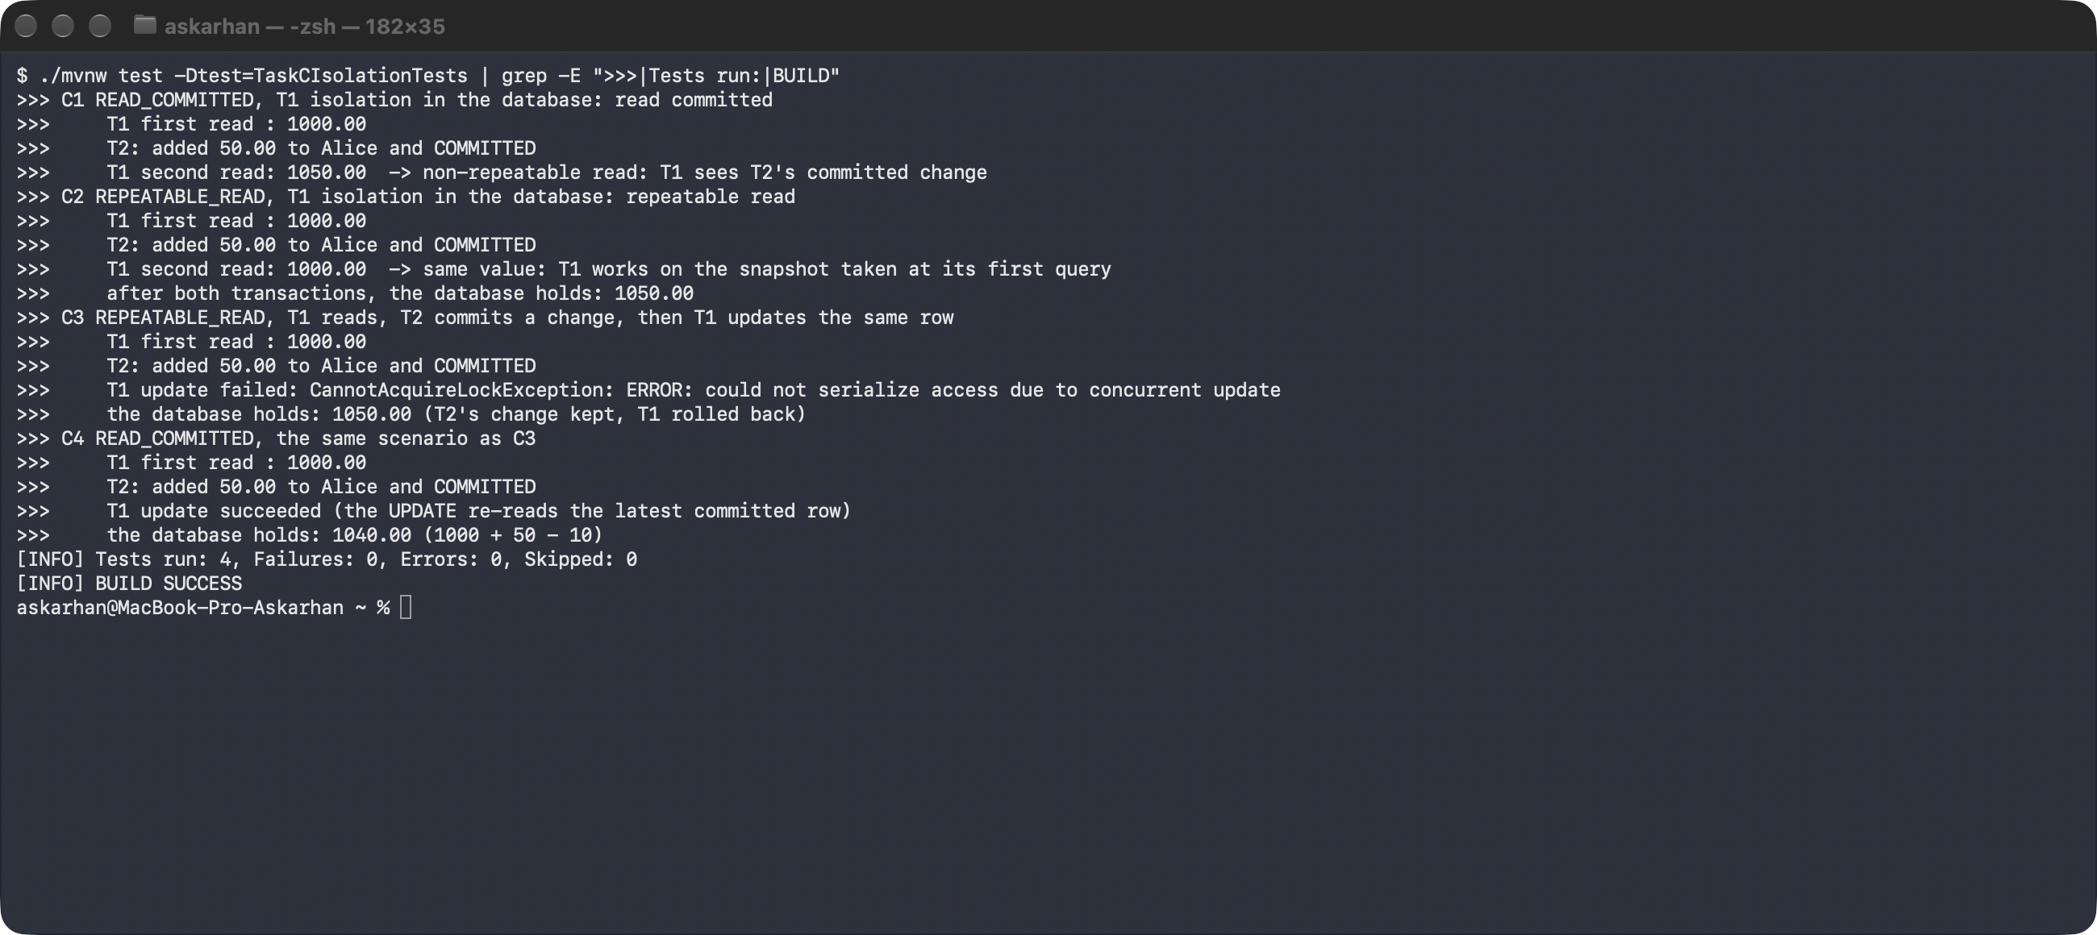
Figure 3. Task C on PostgreSQL 16.15
Database specifics. This is PostgreSQL's MVCC: READ COMMITTED takes a new snapshot for every statement; REPEATABLE READ takes one snapshot per transaction, also prevents phantoms, and instead of blocking aborts the second writer with a serialization error. Other engines differ: MySQL InnoDB at REPEATABLE READ (its default) lets the later UPDATE proceed on the newest row without an error; Oracle has no REPEATABLE READ (only READ COMMITTED and SERIALIZABLE); SQL Server implements REPEATABLE READ with shared locks, so T2 would be blocked instead of T1 failing; H2 has its own MVCC rules. The results above are valid for PostgreSQL only, which is why the experiment was run on it and not on H2.

7. Task D — Optimistic locking
Listing 15. D1 — two independent persistence contexts
@Test @Order(1)
void d1_staleCopyCannotOverwriteTheFirstUpdate() {
// two independent persistence contexts: every findById outside a transaction gets its own
Account copy1 = accounts.findById(alice).orElseThrow();
Account copy2 = accounts.findById(alice).orElseThrow();
say("D1 copy1 = " + copy1);
say(" copy2 = " + copy2);

copy1.credit(new BigDecimal("10.00"));
accounts.save(copy1); // commit #1
say(" copy1: credit 10.00 committed -> database balance " + balance(alice) + ", version " + version(alice));

copy2.debit(new BigDecimal("20.00")); // based on the stale balance and version
assertThatThrownBy(() -> accounts.save(copy2))
.isInstanceOf(ObjectOptimisticLockingFailureException.class)
.satisfies(e -> say(" copy2: debit 20.00 REJECTED: " + e.getClass().getSimpleName() + ": "
+ e.getMessage().lines().findFirst().orElse("")));

say(" database after the conflict: balance " + balance(alice) + ", version " + version(alice)
+ " (the first update was not overwritten)");
assertThat(balance(alice)).isEqualByComparingTo("1010.00");
}

Listing 16. Output of TaskDOptimisticLockingTests (first full test run)
>>> D1 copy1 = Account{id=1, owner=Alice, balance=1000.00, version=2}
>>> copy2 = Account{id=1, owner=Alice, balance=1000.00, version=2}
>>> copy1: credit 10.00 committed -> database balance 1010.00, version 3
>>> copy2: debit 20.00 REJECTED: ObjectOptimisticLockingFailureException: Row was already updated or deleted by another transaction for entity [kz.iitu.spring_lab_01.bank.Account with id '1']
>>> database after the conflict: balance 1010.00, version 3 (the first update was not overwritten)
>>> D2 T1 loaded Account{id=1, owner=Alice, balance=1000.00, version=3}
>>> T2 credited 5.00 and committed -> version 4
>>> T1 debits 30.00 and commits ...
>>> T1 commit REJECTED: ObjectOptimisticLockingFailureException
>>> database: balance 1005.00 (1000 + 5; T1's debit was rolled back)
>>> D3 someone else changed Alice meanwhile -> version 5
>>> conflict detected -> reload the current state and re-apply the operation (a credit is safe to repeat once it was NOT applied)
>>> database: balance 1101.00, version 6

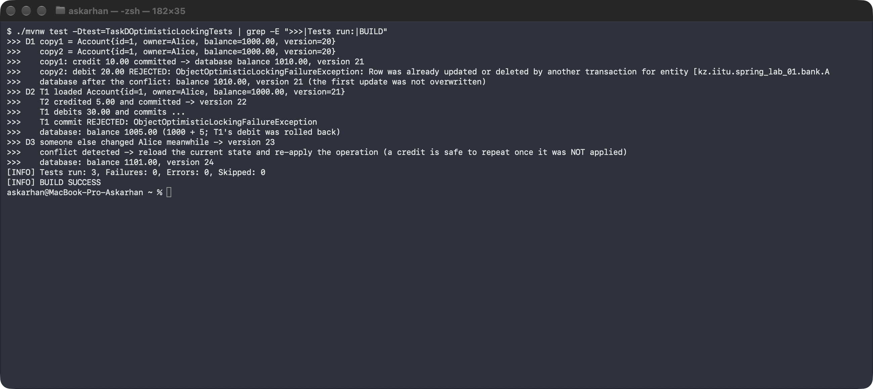
Figure 4. Task D — the stale copy is rejected (a later run, so the version numbers are higher)
Test | What happened
D1 | Two copies of Alice loaded with version 2. Copy 1 credited 10.00 and committed (UPDATE … where id=? and version=2) → balance 1010.00, version 3. Copy 2, still at version 2, debited 20.00: Hibernate found the row at version 3 → ObjectOptimisticLockingFailureException; the database stays 1010.00 / version 3.
D2 | T1 loaded version 3; T2 (another thread) credited 5.00 and committed (version 4); T1 debited 30.00 and tried to commit: the versioned UPDATE matched no row → ObjectOptimisticLockingFailureException, T1 rolled back; database 1005.00.
D3 | Safe response: on the conflict the operation is re-applied once to a freshly loaded copy (reload, re-check, save) → 1101.00.

Why the second update must not silently overwrite the first. Copy 2 computed its new balance from data that is no longer true. Writing it would be a lost update: the 10.00 committed by copy 1 would vanish without anyone noticing, and the balance would no longer match the history of operations.
A safe response. Report the conflict and show the current data (typical for an edit made in a form), or reload the entity and re-apply the operation. Automatic retry is safe only when the operation is re-validated against the fresh state (the debit is checked again against the new balance) or is idempotent, and when it has not already caused an external effect such as an e-mail or a payment call.

8. Task E — Verify schema versioning
Listing 17. First start on an empty database: V1–V3 applied; flyway_schema_history
# Flyway lines from the application log (logs/start1.log):
jdbc:postgresql://localhost:5432/txlab (PostgreSQL 16.15)
Schema history table "public"."flyway_schema_history" does not exist yet
Successfully validated 3 migrations (execution time 00:00.009s)
Creating Schema History table "public"."flyway_schema_history" ...
Migrating schema "public" to version "1 - create accounts"
Migrating schema "public" to version "2 - add status"
Migrating schema "public" to version "3 - create audit log"
Successfully applied 3 migrations to schema "public", now at version v3 (execution time 00:00.015s)
Started SpringLab01Application in 1.969 seconds (process running for 2.184)

$ psql -d txlab -c "select installed_rank, version, description, script, checksum, installed_on, execution_time, success from flyway_schema_history order by installed_rank;"
installed_rank | version | description | script | checksum | installed_on | execution_time | success
----------------+---------+------------------+--------------------------+-------------+----------------------------+----------------+---------
1 | 1 | create accounts | V1__create_accounts.sql | -657740213 | 2026-11-06 21:57:38.752641 | 9 | t
2 | 2 | add status | V2__add_status.sql | 1086204173 | 2026-11-06 21:57:38.77309 | 2 | t
3 | 3 | create audit log | V3__create_audit_log.sql | -1535137811 | 2026-11-06 21:57:38.780855 | 4 | t
(3 строки)

Listing 18. Restart: nothing is executed again
### TASK E.2 — restart: already-applied migrations are not executed again
Successfully validated 3 migrations (execution time 00:00.014s)
Schema "public" is up to date. No migration necessary.
Started SpringLab01Application in 1.845 seconds (process running for 2.036)

Listing 19. The new migration V4 is applied on the next start
### TASK E.3 — new migration V4__index_owner_name.sql
-- Task E: a new versioned migration added after V1-V3 were already applied
CREATE INDEX idx_accounts_owner_name ON accounts (owner_name);
Successfully validated 4 migrations (execution time 00:00.012s)
Migrating schema "public" to version "4 - index owner name"
Successfully applied 1 migration to schema "public", now at version v4 (execution time 00:00.007s)
Started SpringLab01Application in 1.88 seconds (process running for 2.077)
$ psql -d txlab -c "select installed_rank, version, description, script, success from flyway_schema_history order by installed_rank;"
installed_rank | version | description | script | success
----------------+---------+------------------+--------------------------+---------
1 | 1 | create accounts | V1__create_accounts.sql | t
2 | 2 | add status | V2__add_status.sql | t
3 | 3 | create audit log | V3__create_audit_log.sql | t
4 | 4 | index owner name | V4__index_owner_name.sql | t
(4 строки)

$ psql -d txlab -c "\di accounts*|idx*"
indexname | indexdef
-------------------------+----------------------------------------------------------------------------------
idx_accounts_owner_name | CREATE INDEX idx_accounts_owner_name ON public.accounts USING btree (owner_name)
accounts_pkey | CREATE UNIQUE INDEX accounts_pkey ON public.accounts USING btree (id)
(2 строки)

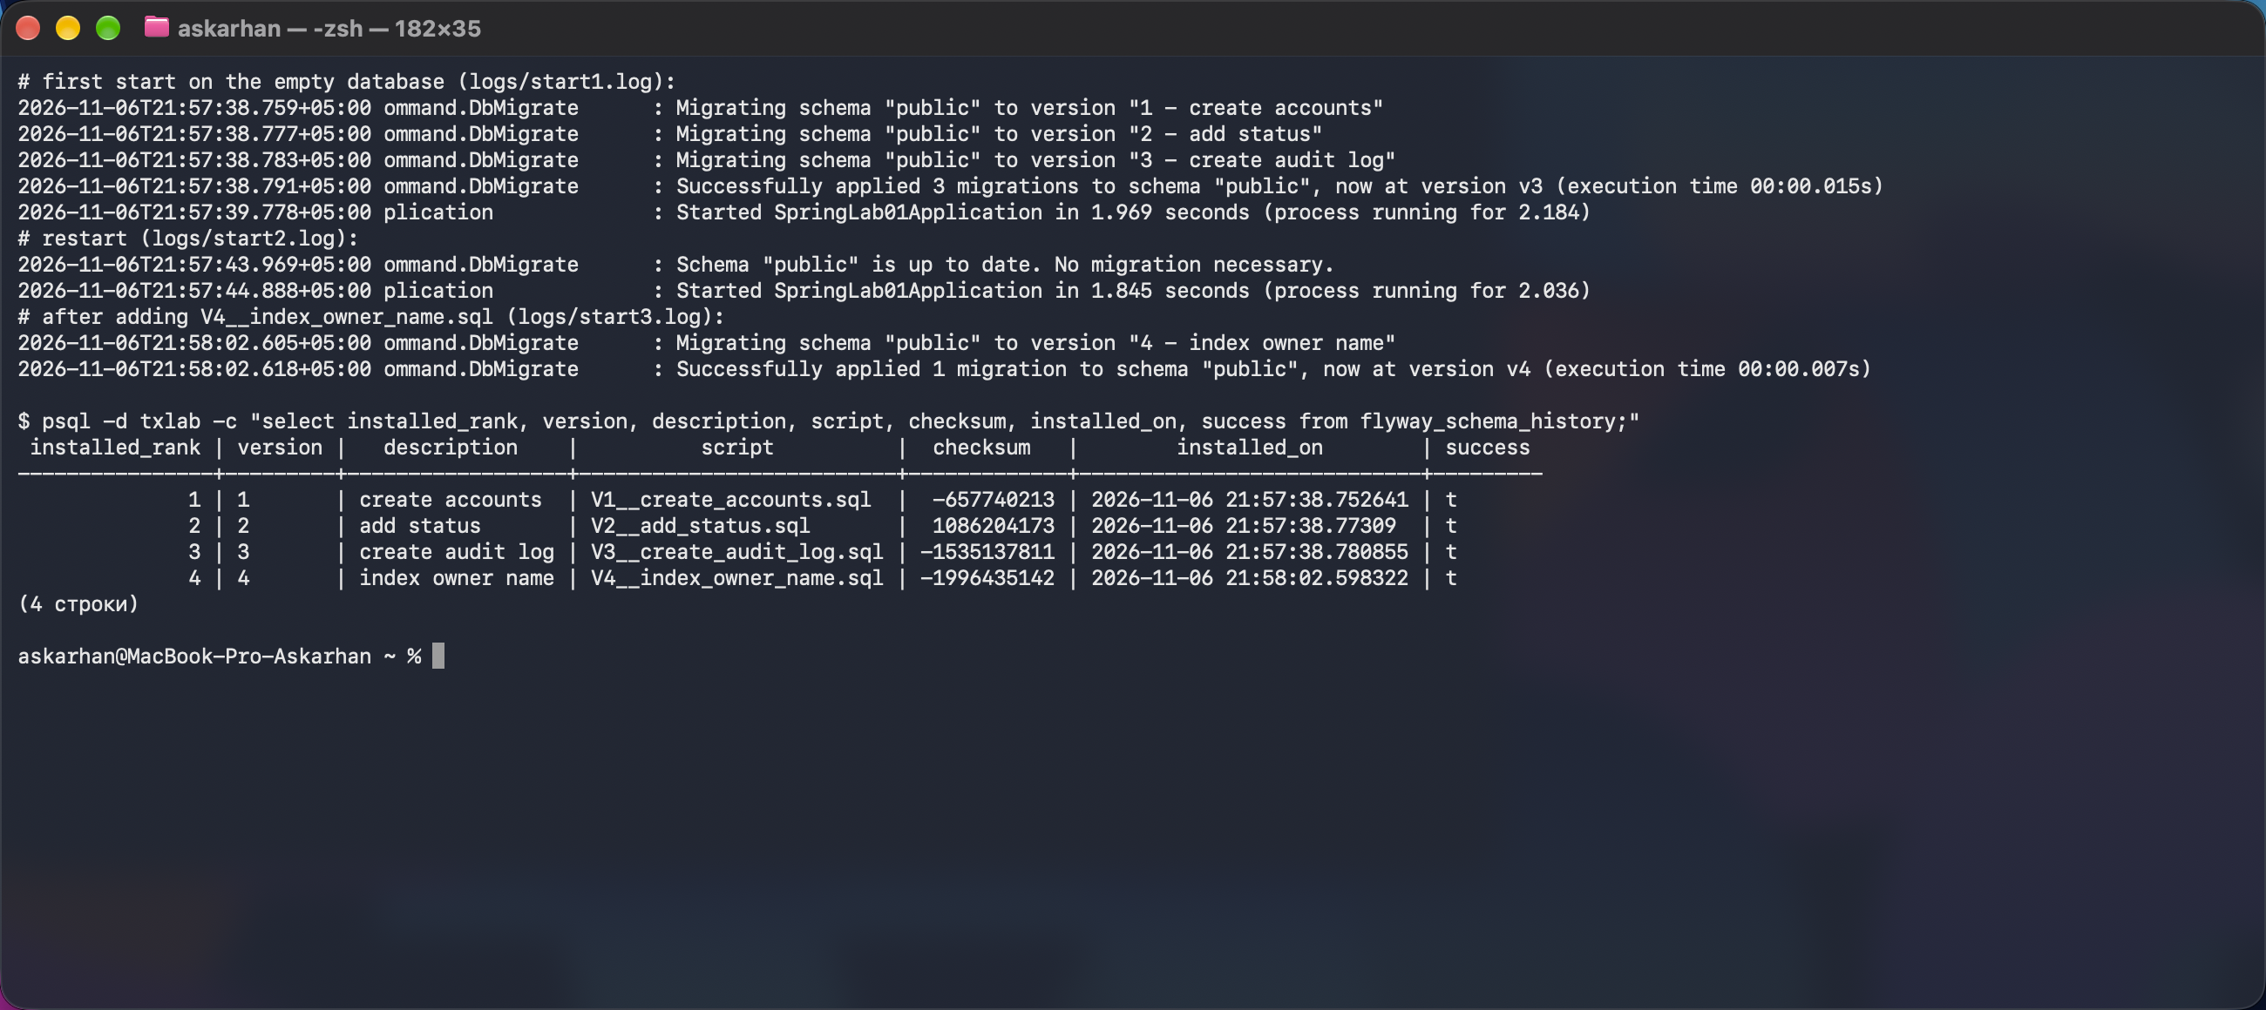
Figure 5. Migrations applied on the first start, «up to date» on restart, V4 applied later; flyway_schema_history
Listing 20. Experiment: editing the already-applied V2 (then reverted)
### TASK E.4 — what happens if an already-applied migration is edited (experiment, then reverted)
# V2__add_status.sql edited: VARCHAR(20) -> VARCHAR(30), application restarted
# result: the application does not start — "ERROR ... SpringApplication : Application run failed" (logs/start4.log):
Validate failed: Migrations have failed validation
Migration checksum mismatch for migration version 2
-> Applied to database : 1086204173
-> Resolved locally : 2094975493
Either revert the changes to the migration, or run repair to update the schema history.

# V2 reverted to the original text
Successfully validated 4 migrations (execution time 00:00.014s)
Schema "public" is up to date. No migration necessary.
Started SpringLab01Application in 1.862 seconds (process running for 2.061)

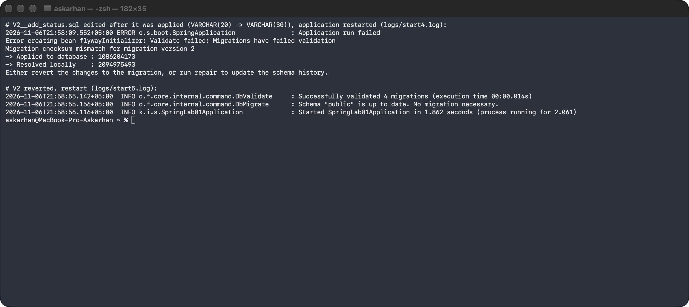
Figure 6. The application does not start after V2 was edited (checksum mismatch)
Why an applied migration must not be edited. Flyway stores the checksum of every applied script in flyway_schema_history and validates it at every start. The edited V2 no longer matched (1086204173 applied, 2094975493 local), so the application did not start. Even without this check the edit would never run on databases that had already applied V2, so environments would silently diverge. The correct way is a new migration (e.g. V5 with ALTER COLUMN); flyway repair only fixes the history after a mistake and is not a way to change an applied schema.

9. Test run
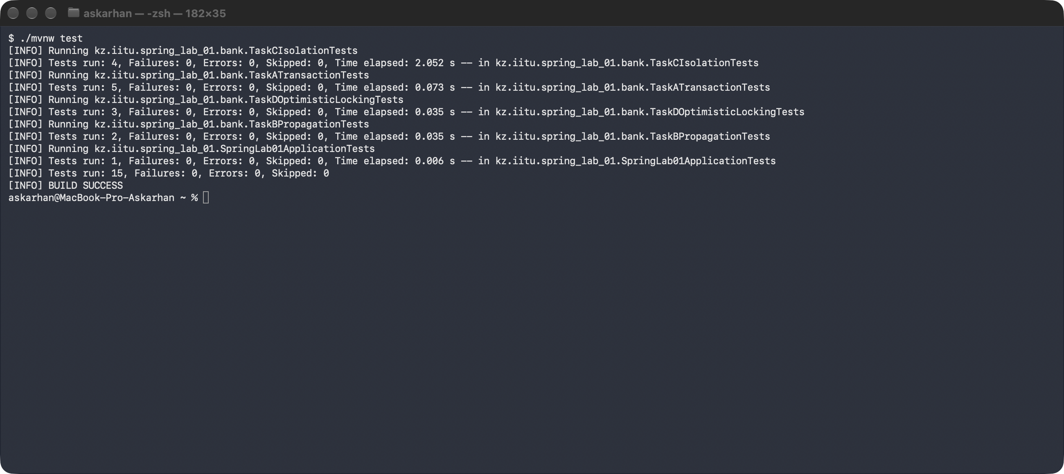
Figure 7. ./mvnw test — 15 tests, 0 failures, BUILD SUCCESS
Sources: bank/Account, AccountRepository, AuditRecord, AuditRepository, AuditService, TransferService, TransferException; tests: BankTestSupport, TaskATransactionTests, TaskBPropagationTests, TaskCIsolationTests, TaskDOptimisticLockingTests; migrations V1–V4 — all in the branch lab-transactions.

10. Answers to the questions
Question | Answer
What does @Transactional do, and where should transaction boundaries normally be placed? | It makes Spring wrap the method in a proxy that begins a transaction before the call and commits it afterwards, or rolls it back on a RuntimeException or Error (by default). All repository calls inside share one connection and one persistence context, so a multi-step operation becomes atomic. Boundaries belong on the service layer — one business operation (a transfer) is one transaction — not on controllers (too wide, the connection is held during web work) and not on single repository calls (too narrow, the debit and the credit would commit separately). The method must be public and called through the proxy, not via this.
What is the difference between REQUIRED and REQUIRES_NEW? | REQUIRED (the default) joins the current transaction or starts one if there is none, so the inner work commits or rolls back together with the outer work. REQUIRES_NEW always suspends the current transaction and runs in a new, independent one that commits when the inner method returns, so it survives a later rollback of the outer transaction (task B: the audit row stayed). It needs a second connection and can deadlock with the outer transaction if both touch the same rows.
Which anomalies are prevented by READ_COMMITTED and REPEATABLE_READ? Does behaviour vary by database? | READ_COMMITTED prevents dirty reads; non-repeatable reads and phantoms remain possible (C1: 1000 → 1050). REPEATABLE_READ also prevents non-repeatable reads (C2: 1000 → 1000); the SQL standard still allows phantoms there, but PostgreSQL's snapshot prevents them as well and reports a lost-update conflict as a serialization error (C3). Yes, it varies: MySQL InnoDB, Oracle, SQL Server and H2 implement these levels differently (section 6), so results must be measured on the target database.
How does @Version detect concurrent updates? | Hibernate remembers the version read with the entity and issues UPDATE … SET …, version = version + 1 WHERE id = ? AND version = <old value>. If another transaction has committed in the meantime, the row has a newer version, the UPDATE matches no row (or merge finds the newer version) and Hibernate throws an OptimisticLockException, which Spring translates to ObjectOptimisticLockingFailureException. No database lock is held between the read and the write.
Why should migrations be version-controlled and immutable after deployment? | The migration scripts are the history of the schema: every environment (developer machine, test, production) must reach the same schema by applying the same ordered scripts, and reviews and rollbacks need this history in Git. Once a script has run somewhere, editing it changes nothing there (it is not run again) but changes what new databases get, so environments diverge; Flyway detects this through checksums and refuses to start (section 8). Changes go into a new versioned migration.
When would you choose Flyway over Liquibase, or Liquibase over Flyway? | Flyway: plain SQL files ordered by version, minimal configuration, a team comfortable with SQL for one database — a good default for a typical Spring Boot service. Liquibase: database-independent changelogs (XML/YAML/JSON) when one schema must run on several DBMS; built-in rollback definitions, preconditions, contexts and labels; generating a changelog from an existing database (diff); or when the organisation has already standardised on it.

11. Conclusion
In this laboratory work, I implemented a money-transfer service on Spring Data JPA and PostgreSQL with declarative transactions, an audit service with different propagation settings, isolation and optimistic-locking experiments, and a Flyway-managed schema (V1–V4). I observed that a RuntimeException rolls the whole transfer back even after the debit UPDATE has been executed, while a checked exception commits it unless rollbackFor is set. The propagation experiment showed that an audit record written with REQUIRED disappears with the outer rollback, whereas with REQUIRES_NEW it is committed in its own transaction and stays. The isolation test on the PostgreSQL 16 database showed a non-repeatable read under READ_COMMITTED, a stable snapshot under REPEATABLE_READ, and a serialization error when a REPEATABLE_READ transaction tried to update a row changed by another transaction. Optimistic locking prevented a lost update: the stale copy with an old @Version was rejected and the first committed change was kept. The migration tool applied V1–V3 to the empty database, skipped them on restart, applied the new V4, and refused to start when an applied migration was edited. The main lesson learned was that transaction boundaries, rollback rules and isolation levels are part of the business logic and must be tested against the real database rather than assumed.

