Automatic report for a Randomized Complete Block Design (RCBD)

International Potato Center

June 09, 2016

Table of Contents

# 1. Model specification and data description

There are data from 27 genotypes evaluated using a randomize complete block design with 3 blocks. The statistical model is

$$y_{ij}=μ+τ_{i}+β_{j}+ϵ_{ij}$$

where

* $y_{ij}$ is the observed response with genotype $i$ and block $j$.
* $μ$ is the mean response over all genotypes and blocks.
* $τ_{i}$ is the effect for genotype $i$.
* $β_{j}$ is the effect for block $j$.
* $ϵ_{ij}$ is the error term.

In this model we assume that the errors are independent and have a normal distribution with common variance, that is, $ϵ_{ij}∼N(0,σ_{ϵ}^{2})$.

# 2. Analysis for trait Harvest index computing percent

## 2.1. ANOVA

You have fitted a linear model for a RCBD. The ANOVA table for your model is:

## Analysis of Variance Table  
##   
## Response: "Harvest index computing percent"  
## Df Sum Sq Mean Sq F value Pr(>F)   
## germplasmName 26 16327.0 627.96 5.1695 2.466e-07 ***  
## REP 2 101.5 50.73 0.4176 0.6608   
## Residuals 52 6316.6 121.47   
## ---  
## Signif. codes: 0 '***' 0.001 '**' 0.01 '*' 0.05 '.' 0.1 ' ' 1

The coefficient of variation for this experiment is 27.28%. The p-value for genotypes is 2.466e-07 which is significant at the 5% level.

## 2.2. Assumptions

Don't forget the assumptions of the model. It is supposed that the errors are independent with a normal distribution and with the same variance for all the genotypes. The following plots must help you evaluate this:

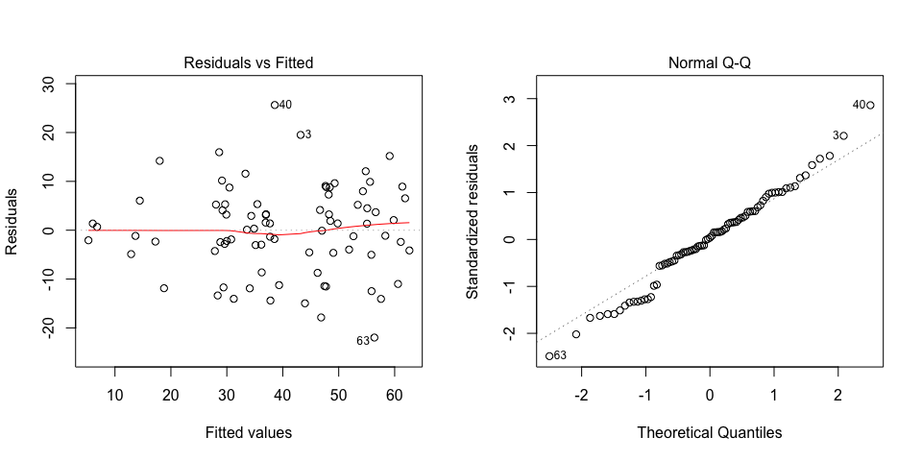

Any trend in the residuals in the left plot would violate the assumption of independence while a trend in the variability of the residuals --for instance a funnel shape-- suggests heterogeneity of variances. Departures from the theoretical normal line on the right plot are symptoms of lack of normality.

## 2.3. Genotype means

Below are the sorted means for each genotype with letters indicating if there are significant differences using the multiple comparisons method of Tukey at the 5% level.

## trt means M  
## 1 MGSG 1001-7 61.866667 a  
## 2 MGSG 1001-36 60.600000 a  
## 3 MGSG 1009-3 58.333333 a  
## 4 MGSG 1010-4 55.833333 a  
## 5 MGSG 1004-27 55.600000 a  
## 6 MGSG 1061-3 55.100000 a  
## 7 MGSG 1002-49 52.633333 ab  
## 8 MGSG 1010-10 49.033333 ab  
## 9 MGSG 1011-5 48.500000 abc  
## 10 MGSG 1007-13 47.633333 abc  
## 11 MGSG 1004-2 47.433333 abc  
## 12 MGSG 1006-7 47.000000 abc  
## 13 MGSG 1012-9 43.966667 abc  
## 14 MGSG 1015-2 38.566667 abcd  
## 15 MGSG 1065-4 37.733333 abcd  
## 16 Jonathan 36.933333 abcd  
## 17 Resisto 36.233333 abcd  
## 18 MGSG 1005-17 34.366667 abcd  
## 19 MGSG 1006-9 34.100000 abcd  
## 20 Chingova 30.466667 abcd  
## 21 MGSG 1003-27 30.000000 abcd  
## 22 MGSG 1051-1 29.133333 abcd  
## 23 MGSG 1015-17 28.833333 abcd  
## 24 MGSG 1008-8 28.633333 abcd  
## 25 MGSG 1068-1 18.000000 bcd  
## 26 MGSG 1007-9 13.666667 cd  
## 27 MGSG 1032-3 6.033333 d

## 2.4. Variance components

Below are the variance components for this model, under the assumption that genotypes and blocks are random. Here the model is fitted using REML and missing values are not estimated.

## Variance Std.Dev.  
## germplasmName 169.7025 13.02699  
## REP 0.0000 0.00000  
## Residual 118.8535 10.90199

# 3. Analysis for trait Number of commercial storage roots counting number per plot

## 3.1. ANOVA

You have fitted a linear model for a RCBD. The ANOVA table for your model is:

## Analysis of Variance Table  
##   
## Response: "Number of commercial storage roots counting number per plot"  
## Df Sum Sq Mean Sq F value Pr(>F)   
## germplasmName 26 10759.6 413.83 2.3027 0.005248 **  
## REP 2 2150.9 1075.44 5.9842 0.004581 **  
## Residuals 52 9345.1 179.71   
## ---  
## Signif. codes: 0 '***' 0.001 '**' 0.01 '*' 0.05 '.' 0.1 ' ' 1

The coefficient of variation for this experiment is 62.32%. The p-value for genotypes is 0.005248 which is significant at the 5% level.

## 3.2. Assumptions

Don't forget the assumptions of the model. It is supposed that the errors are independent with a normal distribution and with the same variance for all the genotypes. The following plots must help you evaluate this:

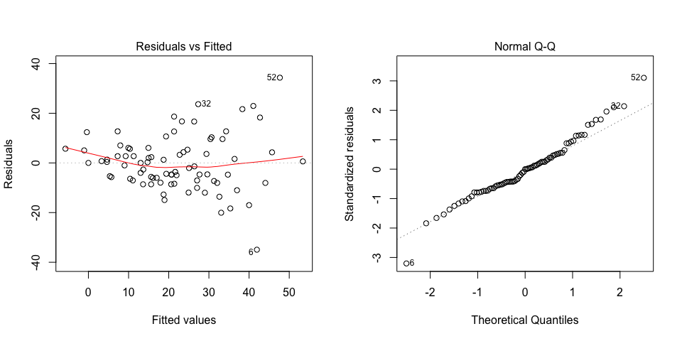

Any trend in the residuals in the left plot would violate the assumption of independence while a trend in the variability of the residuals --for instance a funnel shape-- suggests heterogeneity of variances. Departures from the theoretical normal line on the right plot are symptoms of lack of normality.

## 3.3. Genotype means

Below are the sorted means for each genotype with letters indicating if there are significant differences using the multiple comparisons method of Tukey at the 5% level.

## trt means M  
## 1 MGSG 1051-1 47.666667 a  
## 2 MGSG 1010-4 40.000000 ab  
## 3 MGSG 1065-4 38.333333 ab  
## 4 MGSG 1015-2 37.000000 ab  
## 5 MGSG 1061-3 35.333333 ab  
## 6 MGSG 1009-3 30.666667 ab  
## 7 MGSG 1006-7 29.000000 ab  
## 8 MGSG 1010-10 27.666667 ab  
## 9 MGSG 1005-17 27.333333 ab  
## 10 MGSG 1004-27 26.333333 ab  
## 11 MGSG 1006-9 24.666667 ab  
## 12 MGSG 1001-7 23.666667 ab  
## 13 MGSG 1004-2 21.333333 ab  
## 14 MGSG 1011-5 21.333333 ab  
## 15 MGSG 1002-49 20.666667 ab  
## 16 MGSG 1007-13 19.333333 ab  
## 17 MGSG 1012-9 17.000000 ab  
## 18 Chingova 15.666667 ab  
## 19 MGSG 1001-36 15.000000 ab  
## 20 MGSG 1015-17 13.666667 ab  
## 21 MGSG 1003-27 13.000000 ab  
## 22 Resisto 13.000000 ab  
## 23 MGSG 1008-8 10.333333 ab  
## 24 MGSG 1007-9 9.000000 ab  
## 25 Jonathan 5.333333 ab  
## 26 MGSG 1068-1 4.666667 b  
## 27 MGSG 1032-3 0.000000 b

## 3.4. Variance components

Below are the variance components for this model, under the assumption that genotypes and blocks are random. Here the model is fitted using REML and missing values are not estimated.

## Variance Std.Dev.  
## germplasmName 78.03846 8.833938  
## REP 33.17522 5.759793  
## Residual 179.71367 13.405733