NEA

Table of Contents
Analysis: 3
Problem: 3
Research: 3
Research of the end user: 4
Requirements: 4
Objectives: 4
Documented design: 5
Objectives: 5
Hierarchy diagrams: 5
System flowcharts: 6
Object-oriented design: 10
Database design: 10
Algorithms: 12
Data structures: 13
HCI (Human-computer interaction) / Front end design: 13
Technical solution: 14
Git: 14
Libraries: 15
Source tree: 15
Testing: 18
Signup router 19
Login router 20
Logout router 20
Create router 21
Search router 21
Attempt router 22
Appendix: 22

Analysis:

Problem:
Despite regex being the most efficient and cleanest tool for pattern matching and text manipulation, there are little resources to improve being able to solve regex problems. Being experienced in reading technical documentation and indulging in programming resources, regular expressions are surprisingly ignored. However, the issue lies beyond learning the basic theory of regex, and instead in being able to piece together a solution that arises from an array of requirements.

The end user, Patrick, is passionate about software that abstracts the complexity from the user above such as compilers/interpreters and parsers. The problem is that once the abstract overview of these programs is understood, the data processing modules are heavily undocumented since with regular expressions, they can be simply read from the source code rather than explained. After finding this out through my own knowledge and primary research, and trying my best to learn about the topic, it was obvious that the skill curve was too large, it would lead to one of two consequences. A regex guide would be utilised each time you had to solve a problem with regex, or you’d have to learn it whole, also dedicating time to create the resources and data needed for practice.

Therefore, on the hunt to find a project idea, it was settled that I’d make a regex practice site for him.

Research:
For programming itself, the best resources are the most practical oriented, with written documentation and books only being used when needed to learn how to implement ideas (e.g. writing drivers for the Linux kernel). The reason for this is because the ability to make trade-offs and solve problems is more generalisable to different types of problems.
As a result, individuals who simply read more material won’t become better engineers, and instead, the deficit in practical progress may lead to “tutorial hell”, where one is too accustomed to reading/watching tutorials and guides, leading to a halt in skill acquisition.

The closest computational topic to regular expressions are algorithms, where they both fulfil different aims, but are created in similar ways. The most popular website for learning algorithms – more specifically tailored to job interview questions (but hold up for practising algorithms)– is Leetcode. The site is characterised by how it hands over a precise instruction and examples that are then utilised to create an end product, which can be submitted in the browser using any mainstream language (python, c, c++, java, rust etc). Once a question has been answered, and it meets the criteria for three examples (that are shown alongside the instruction), the user’s solution goes through extensive testing with the use of test cases (thousands of them) to ensure that the answer holds up in every possible scenario. Once complete, it gives you statistics; such as memory footprint and the efficiency of the algorithm in terms of speed (ms).

Research of the end user:

Requirements:
- To make it easier to practice regex compared to alternative methods,
- To make problem creation quick and simple so that you can quickly get to solving existing problems,
- For the interface to be minimalistic yet graphical and expressing everything that it must,
- To motivate users to carry on using the website: leader-boards, elo, being able to compare against other users.

Objectives:
The problem will be solved with a website, which is a lot more simpler on the user’s end, and it will allow for more reach (using the browser is the simplest it can get). In theory, making a compiled program wouldn’t be troublesome since the packaging and hosting of the project could be done with GitHub actions, and considering that the project wouldn’t be massive, statically linking could be done without an egregious size. However, creating a frontend in a non web way would be a lot more challenging and less documented.

Documented design:

Objectives:
The first objective for the project was to set up the base layers. Just like the concept of abstraction layers, I believed that the same approach would suit the development of this project. Starting off, my biggest worry was struggling to find all the information I need for my project, and potentially having to stretch out development. I know that the web has a lot of small annoying things you have to consider, so to counter this, I decided that figuring out the bare bones would be best suited as a first step.

Hierarchy diagrams:
The hierarchy below displays all GET endpoints, with levels assigned by navigability (hence why the navigation bar is included).
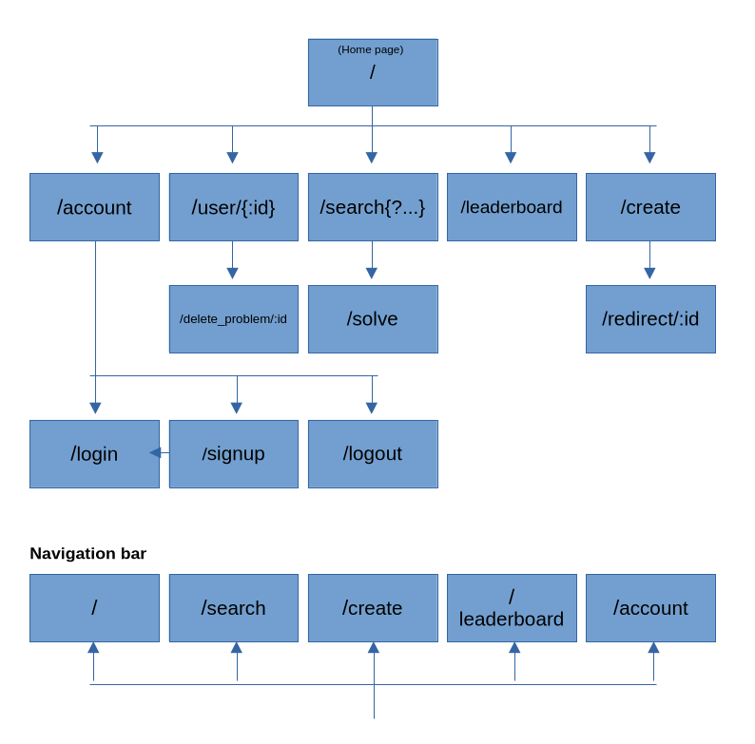

System flowcharts:
The flowcharts below show the design for the search router. Some of the detail has been abstracted, and some conditions in practice represent multiple.

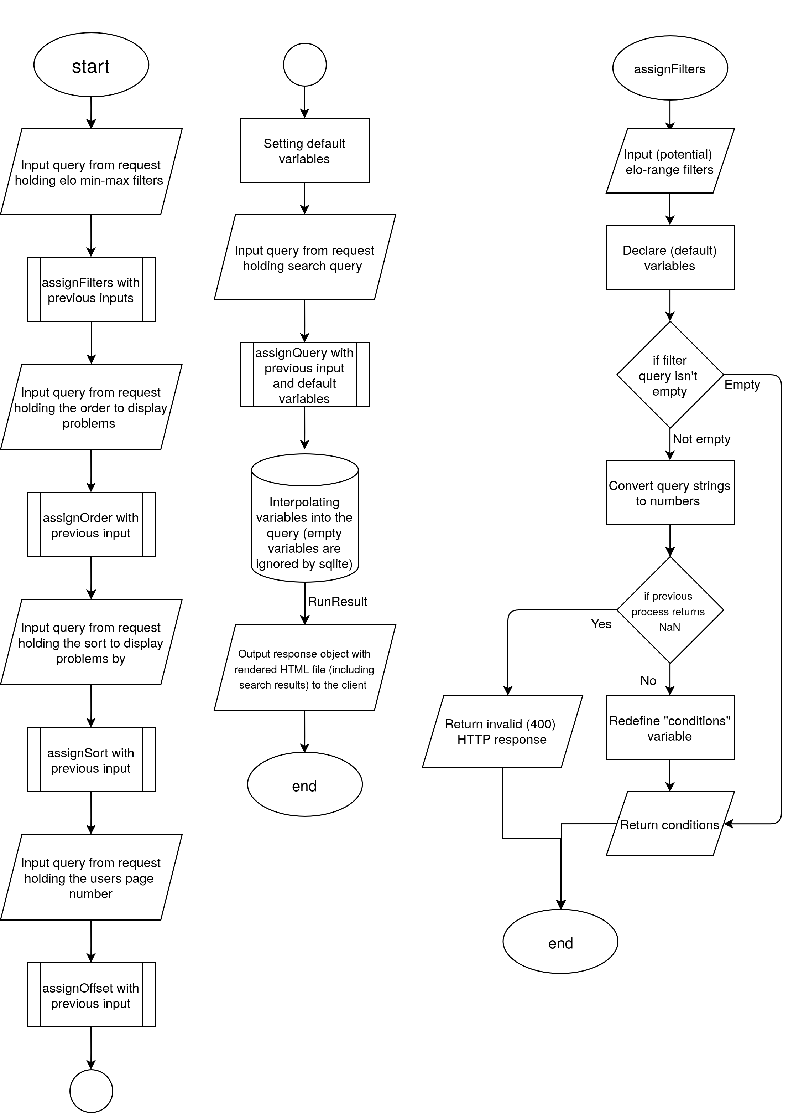
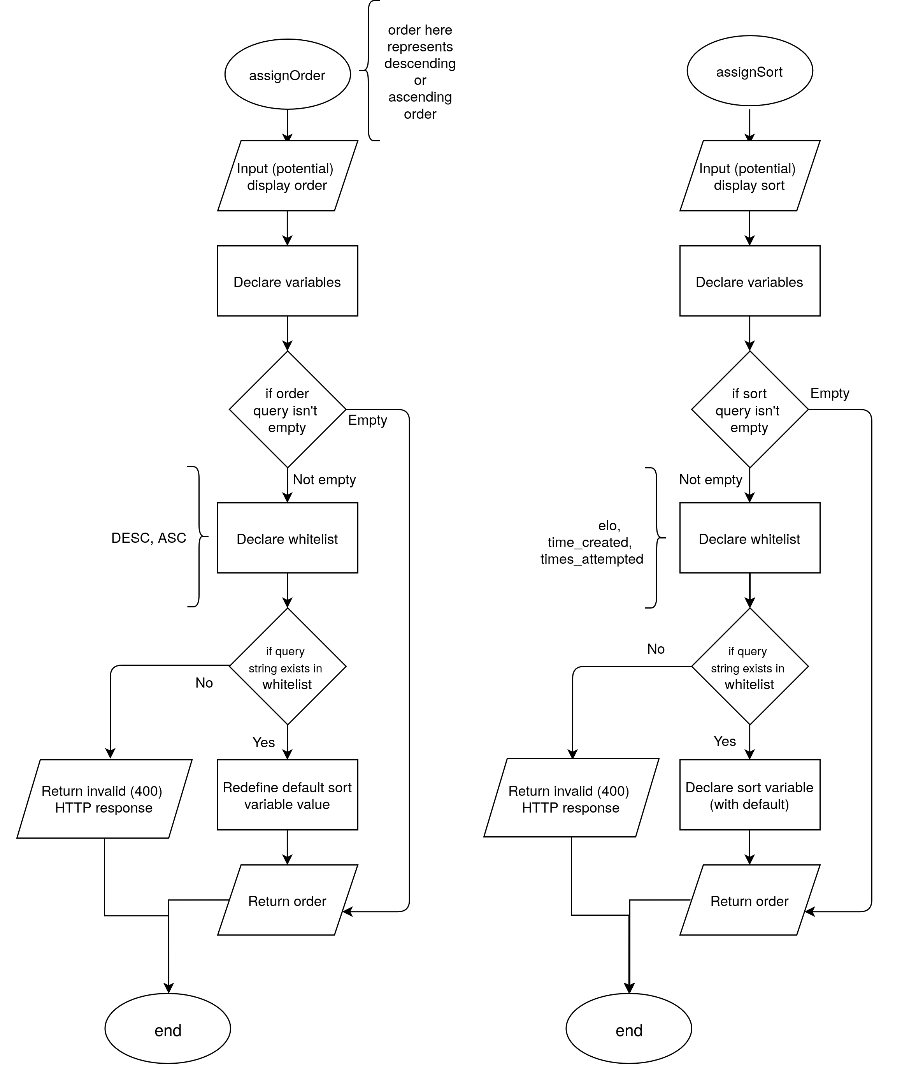

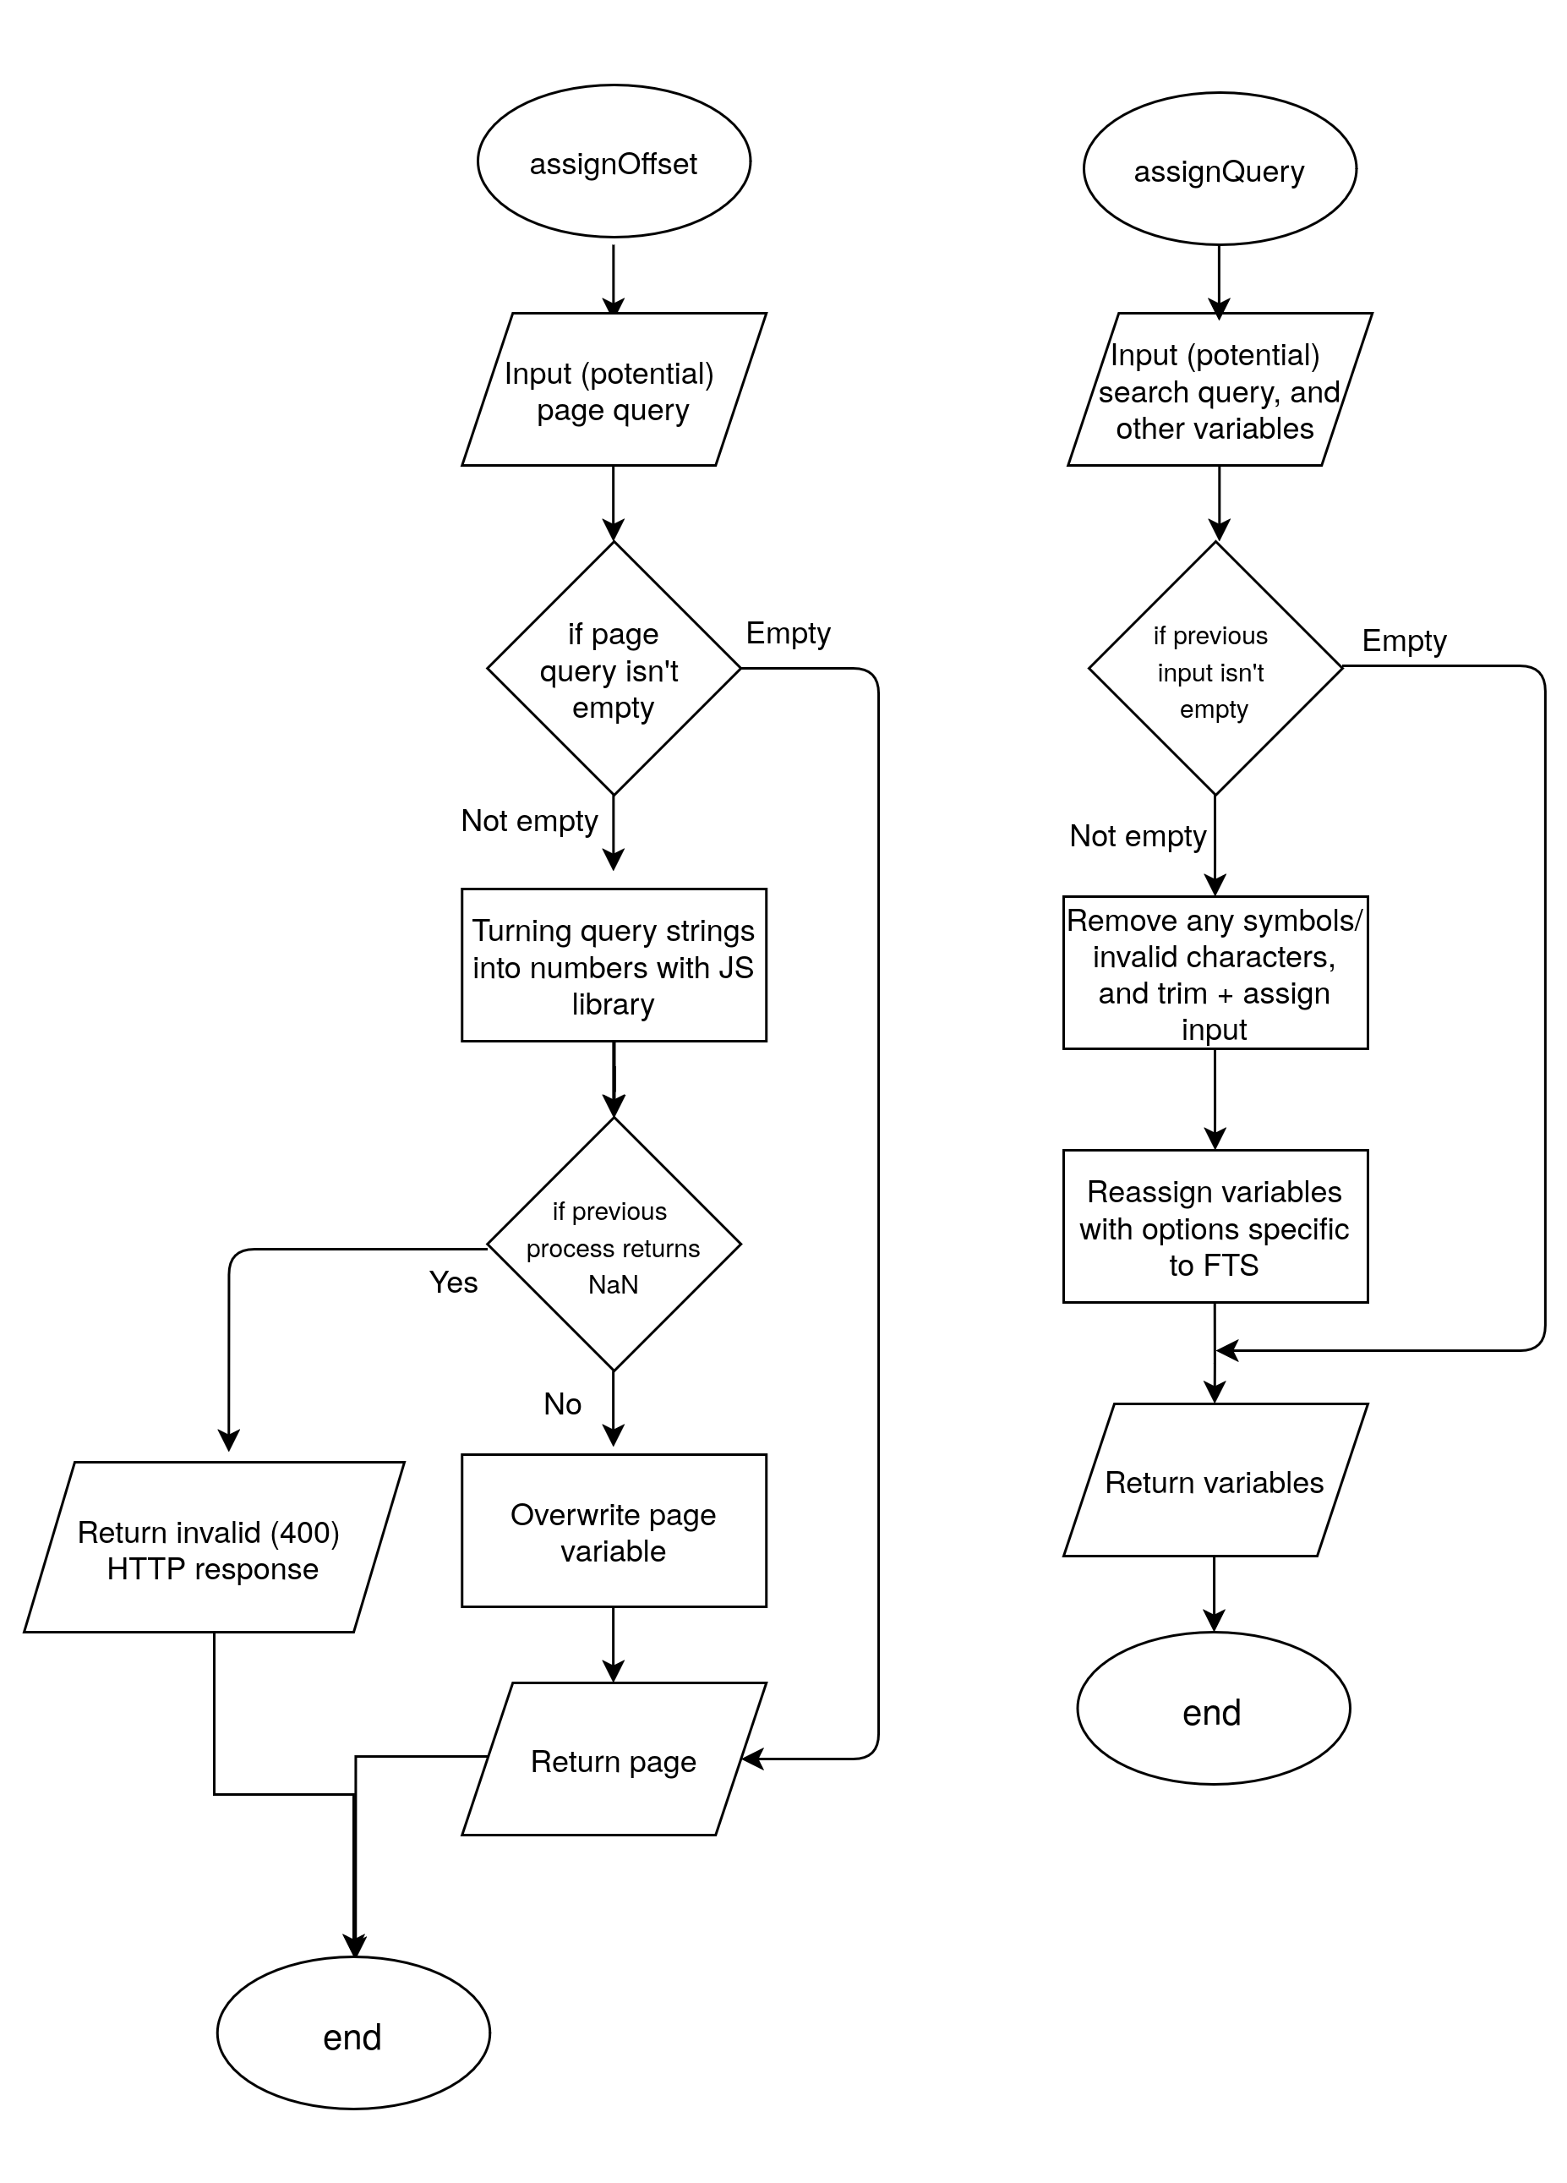

Object-oriented design:
The project is mostly based around an imperative approach/paradigm because I couldn’t find any practical use of complex object-oriented design. But object-oriented features have been used throughout.
The whole project works around the idea that each code module computes it’s own complex job with input before passing the results to another side of the model (client/server/database). An advantage of this approach is that each module simply doesn’t manage much data on its own, this ensures that data flow occurs in a structured and meaningful manner. However, this makes it difficult to have enough relationships between data/code at any one location for a complex OOP model to be beneficial.
I recognise that If I was to do complex DOM tasks (on the client side), then complex OOP would suit it more than a functional paradigm, especially if I was to (create|edit|display|remove) a more-than-small amount of HTML elements.
I’ve been able to incorporate some simple classes across my project - especially for my elo algorithm – with some benefits including encapsulation, composition and abstraction of constant/intermediary values used in the algorithm.
Despite that, my programming is widespread with composition, most functions being made up of even smaller functions with clear relationships to the super-function. Interfaces are essential to my code, more specifically to the fetching of objects (e.g. from database) that contain values within. By doing so, the code can show what is only necessary by hiding details regarding types (the “type” of variable that is used: number, string etc.).

Database design:
The database is the key component of the extended client server model I’ll be implementing (DB ↔ Server ↔ Client), so it’s critical that I get it right. For starters, the data I’ll have to store is: User information, Problems, Attempts. This isn’t data to warrant multiple databases, so those three will be tables within one general purpose database.

I decided to use SQLite3 over any other relational database system since it’s server-less, and so I don’t have to set up more networking besides the HTTP server. Having a database server wouldn’t provide any benefit for this project, and the “better-sqlite3” library fixes any problem that would have made it less viable.

I also need to implement a search function, but there is one big limitation: SQL’s “WHERE … LIKE ‘…’;” is precise. This poses multiple steep issues. First of all, if you misspell or incorrectly capitalise the search, you won’t get receive the expected problem. Using the LIKE operator will also lead to efficiency problems, since it will look through every row to find the pattern. Efficiency isn’t the biggest issue with the stock method, but it does mean that the project won’t be able to scale up if required.

So to implement a search function, Full Text Search (FTS) will be utilised, which is included with SQLite. It includes fast text matching, a reversed index and the ability to rank by relevance/rank. The biggest trade off comes in the form of complexity and setup, with the only relevant sources of information being Wikipedia (for the abstract) and the SQLite documentation. To set this up, a virtual FTS table has to be created:

CREATE VIRTUAL TABLE IF NOT EXISTS Problems_fts USING fts5(
title,
creator,
content='Problems', -- Points to the table it's based on,
content_rowid='problem_id' -- and the primary key of that table.
);

The below triggers are self explanatory, they will conditionally execute additional queries whenever insertions/deletions to the Problems table have been made to mimic the it.

CREATE TRIGGER IF NOT EXISTS fts_insert AFTER INSERT ON Problems BEGIN
INSERT INTO Problems_fts(rowid, title, creator)
VALUES (new.problem_id, new.title, new.creator);
END;

The deletion method below marks the contents unavailable rather than traditionally deleting them.

CREATE TRIGGER IF NOT EXISTS fts_delete AFTER DELETE ON Problems BEGIN
INSERT INTO Problems_fts(Problems_fts, rowid, title, creator)
VALUES ('delete', old.problem_id, old.title, old.creator);
END;

This is the recommended method, however, it will require rebuilding the FTS table if storage becomes a problem:

INSERT INTO Problems_fts(Problems_fts) VALUES('rebuild');

This can simply be ran using the SQLite CLI program alongside updating the system.

Algorithms:
The key algorithm for this project is going to be the elo algorithm. The elo rating system is a method of calculating the relative skill of players. It’s commonly used in zero-sum games (where somebody’s win is another’s loss) such as sports, competitive video games, and most notably chess. This is going to be used to determine both the difficulty of user created problems as well as user skill. A rating system will also allow users to search for problems around their skill level. I’ll be using the standard Elo system over the Glicko, otherwise I’d be over engineering a problem that requires a more simple solution.
The theory of the elo algorithm is as follows:
- The current ratings of the user and problem are fetched from the database.
- The estimated ability (probability of winning) is calculated using the below formula where: Ea is the estimated ability of player A, and Ra + Rb are ratings for player A + B.
$$Ea\text{=}\frac{1}{1\text{+}{10}^{\left({\left(Rb−Ra\right)}/{400}\right)}}$$

- Calculate new ratings using two separate formulas (since the previous could be generalisable to either player).
$${Ra}^{1}\text{=}Ra\text{+}Kx\left(Sa−Ea\right)$$
$${Rb}^{1}\text{=}Rb\text{+}Kx\left(1−Sa−Eb\right)$$

- Remove (truncate) any decimals from the elo calculation results.
- Return and insert values into the database.

Another key algorithm is my custom validation algorithm. It works

Data structures:
I used a variety of data structures, but with the focus of only using those where necessary:
- (JavaScript) Objects: Variables that lets you store multiple variables or functions. All SQLite SELECT statements return an object. Objects are usually interfaced.
- Arrays: These were used for validation, more specifically comparing values against. Lists weren’t used since arrays have a fixed size set during runtime.
- JSON: Although not a data structure, it’s sent between the client and server as a means of communication. Two most notable uses are for: sending data to the server, and sending error messages to the client.

HCI (Human-computer interaction) / Front end design:
Since I am creating a website, the frontend has to be adequate for repetitive use. For this to be achieved I need to consider the following:
- Intractability
- Quantity of information displayed
- Navigation (the user shouldn’t have to use the URL bar)
- Presentation of information
  - Conditional presentation/interactivity
To fulfil these aims I will be using EJS and BootstrapJS. Embedded JavaScript (EJS) is a templating language that will allow me to change HTML with JavaScript, as well as render the HTML on the server side with appended data before sending the it to the user. This saves time by not having repeated client side code appending data onto the HTML when unnecessary.
BootstrapJS is a library that implements many frontend elements like buttons or inputs, and it’s the second most used JavaScript library (w3techs 2026). I won’t need to use much of it, but it’s going to prove useful for quickly spinning parts of the HCI at no cost.

Technical solution:

Git:
Git is an open source version control tool originally created for the development of the Linux kernel (one of the most sophisticated software projects) that tracks differences in code between snapshots (formally called commits). I learnt to use git through this project, and it serves multiple benefits.
The most important reason is how it doubles as a safety net. I can freely edit my code without setting any changes in stone. If I want the current directory to reflect a previous commit, all I have use is `git reflog` and `git reset –soft (commit hash)` in the terminal. It’s also easier to find new bugs with `git show (commit hash)`, and using the output – which is based on the `diff` command – to find what change caused it.
The tool also serves as documentation, since you can browse through all changes that you have made.
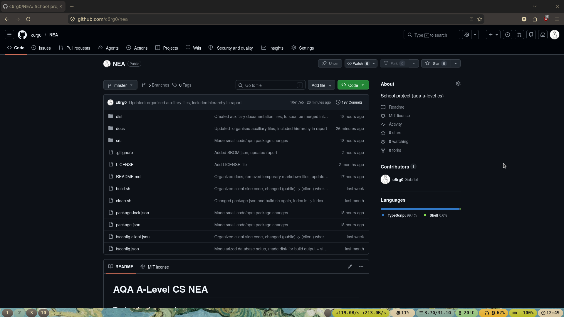
In this project, git was additionally paired with GitHub. I did so because GitHub lets me backup my source code (and other small-ish files) for free. There is a size limit of 500mb for a private repository, so I decided to make it public since any images/videos might weigh more than expected. I additionally included an MIT license so anyone can use my code, without a license it’s under CC, which shouldn’t be used for code.
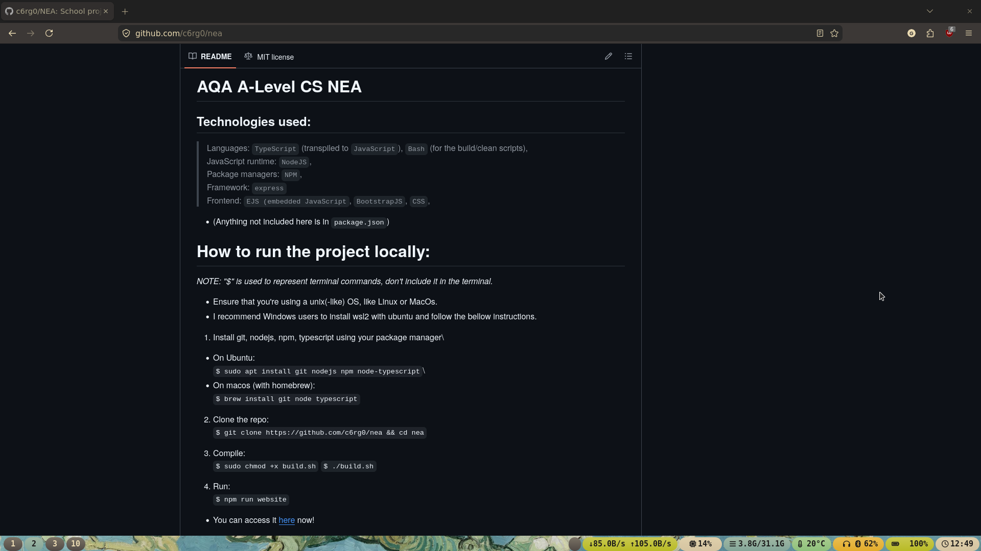

Libraries:
A lot of libraries were utilised in this project, but generally, most have been used for 1-2 features. Before I list them, I used the Node Package Manager (NPM). A package manager is a program that simplifies software installation (especially in the form of dependency management) and management (e.g. deletion).
An important note is that the bellow isn’t the complete curation of libraries used. A lot are dependencies and NodeJS modules (the standard library), even if they haven’t been used. I included a docs/SBOM.json file generated by GitHub for every single package used.

Library packages to run the website:
typescript: The language used in the project, package (library) for transpiling,
express: The web framework used, used for HTTP routing and helpers (e.g. redirecting),
body-parser: Allows parsing HTTP request bodies (in the name),
better-sqlite3: JavaScript implementation of SQLite3,
ejs: Embedded JavaScript, explained in the HCI section of documented design,
bcrypt: Password hashing function meant to protect against rainbow table/brute force attacks with the use of salts,
express-session: For allowing users to stay logged while they’re on the site.

Development packages; pre-made types for some of the packages above:
@types/express
@types/better-sqlite3
@types/bcrypt
@types/express-session

Source tree:
(“$” specifies a terminal command)
$ tree
.
├── LICENSE
├── README.md
├── build.sh
├── clean.sh
├── dist
│ ├── db
│ │ ├── db.db
│ │ ├── db.db-shm
│ │ └── db.db-wal
│ ├── public
│ │ ├── css
│ │ │ └── style.css
│ │ ├── fonts
│ │ │ ├── Ubuntu-Light.woff2
│ │ │ ├── Ubuntu-Medium.woff2
│ │ │ ├── Ubuntu-Regular.woff2
│ │ │ └── Ubuntu-font-license.txt
│ │ └── js
│ ├── routes
│ └── views
│ ├── account.ejs
│ ├── create.ejs
│ ├── create_success.ejs
│ ├── delete.ejs
│ ├── index.ejs
│ ├── leaderboard.ejs
│ ├── login.ejs
│ ├── search.ejs
│ ├── signup.ejs
│ ├── solve.ejs
│ └── user.ejs
├── docs
│ ├── ...
├── package-lock.json
├── package.json
├── src
│ ├── client
│ │ ├── create.ts
│ │ ├── delete.ts
│ │ ├── login.ts
│ │ ├── search.ts
│ │ ├── signup.ts
│ │ └── solve.ts
│ ├── db
│ │ └── db.ts
│ ├── routes
│ │ ├── account.route.ts
│ │ ├── attempt.route.ts
│ │ ├── create.route.ts
│ │ ├── delete.route.ts
│ │ ├── else.route.ts
│ │ ├── index.route.ts
│ │ ├── leaderboard.route.ts
│ │ ├── login.route.ts
│ │ ├── logout.route.ts
│ │ ├── redirect.route.ts
│ │ ├── search.route.ts
│ │ ├── signup.route.ts
│ │ ├── solution.route.ts
│ │ ├── solve.route.ts
│ │ └── user.route.ts
│ └── server.ts
├── tsconfig.client.json
└── tsconfig.json

14 directories, 62 files

Note that before I ran the tree command, all compiled code (including the node_modules directory) was removed with a bash script. The reason being is that those files aren’t representative of the work I have done.
Dist is short for “distribution”, and it’s the directory from where you would start the website. It contains compiled output, frontend files (.ejs + .css) and the SQLite database. I’ve split the project directory like this to ensure that compiled output remain distinct from the source code.
The tsconfig* files are compiler configurations. They specify compiler input/output, project root, and whether certain compiler/code features should be enabled or not.
Package.json is a configuration file made by the package manager, it includes what packages you want to install and other miscellaneous information (like project creator, version number, or description). The package lock file enumerates all dependencies and the version installed, this improves reproducibility.

Testing:
For my project, the most efficient and reproducible method of testing will involve a networking tool called CURL. It’ll allow me to send HTTP requests from the terminal, and it’s going to be used to represent client side code. The reason being is that it’s significantly easier to represent the frontend with a single command, anyone can use this tool, so it’s essential that I also run server side validation.
Another thing worth mentioning is the use of HTTP status codes. Since the project uses HTTP, status codes are given by the server and represented by the client side (e.g. the client side will display an error if the server gives an error). A list brief summary:
- 1xx: Informational responses (not used)
- 2xx: Successful responses
- 3xx: Redirection messages
- 4xx: Client error responses
- 5xx: Server error messages
The MDN web docs has all status codes documented.

How CURL is being used:
- “curl” is the command,
- “-s” is for silent mode (just shows what I specifically want),
- “-o /dev/null” writes output and discards it using /dev/null (purely displaying the output),
- “-w %{http_code}” outputs the HTTP status code,
- “-X … ” specifies request type,
- “-H … ” specifies HTTP header type,
- “-d … ” specifies data to append, usually JSON or URLSearchParams,
- “-c” for specifying and creating a cookie,
- “-b” for specifying and using a cookie.
- “\” for allowing the command span multiple lines (rather than stay a singular line)

Signup router
Test num-ber | Test type | Test command | Expected outcome | Actual outcome | Pass/Fail
1 | Valid | curl -s -o /dev/null -w "%{http_code}" -X POST http://localhost:8000/signup \  -H "Content-Type: application/json" \  -d '{"username": "TEST_USER", "password": "Password123!"}' | 200 | 200 | Pass
2 | Invalid | curl -s -o /dev/null -w "%{http_code}" -X POST http://localhost:8000/signup \  -H "Content-Type: application/json" \  -d '{"username": "TEST_USER", "password": "Password123!"}' | 409 | 409 | Pass
3 | Erroneous | curl -s -o /dev/null -w "%{http_code}" -X POST http://localhost:8000/signup \  -H "Content-Type: application/json" \  -d '{}' | 412 | 412 | Pass
4 | Boundary | curl -s -o /dev/null -w "%{http_code}" -X POST http://localhost:8000/signup \  -H "Content-Type: application/json" \  -d '{"username": "TEST_USER_123456", "password": "Password123!345678901234"}' | 200 | 200 | Pass
5 | Boundary | curl -s -o /dev/null -w "%{http_code}" -X POST http://localhost:8000/signup \  -H "Content-Type: application/json" \  -d '{"username": "T", "password": "aB345!"}' | 200 | 200 | Pass
6 | Exceptional | curl -s -o /dev/null -w "%{http_code}" -X POST http://localhost:8000/signup \  -H "Content-Type: application/json" \  -d '{"username": "TEST_USER_1234567", "password": "Password123!3456789012345"}' | 412 | 412 | Pass
7 | Exceptional | curl -s -o /dev/null -w "%{http_code}" -X POST http://localhost:8000/signup \  -H "Content-Type: application/json" \  -d '{"username": "", "password": "aB34!"}' | 412 | 412 | Pass

Login router
Test num-ber | Test type | Test command | Expected outcome | Actual outcome | Pass/Fail
8 | Valid | curl -s -o /dev/null -w "%{http_code}" -X POST http://localhost:8000/login \  -H "Content-Type: application/json" \  -d '{"username": "TEST_USER", "password": "Password123!"}' \  -c cookies.txt | 200 | 200 | Pass
9 | Invalid | curl -s -o /dev/null -w "%{http_code}" -X POST http://localhost:8000/login \  -H "Content-Type: application/json" \  -d '{"username": "TEST_USER", "password": "Pasword123!"}' | 401 | 401 | Pass
10 | Erroneous | curl -s -o /dev/null -w "%{http_code}" -X POST http://localhost:8000/login \  -H "Content-Type: application/json" \  -d '{}' | 412 | 412 | Pass

Logout router
Test num-ber | Test type | Test command | Expected outcome | Actual outcome | Pass/Fail
11 | Valid | curl -s -o /dev/null -w "%{http_code}" -X POST http://localhost:8000/logout | 200 | 200 | Pass

Create router
Test num-ber | Test type | Test command | Expected outcome | Actual outcome | Pass/Fail
12 | Valid | curl -s -o /dev/null -w "%{http_code}" -X POST http://localhost:8000/create \  -H "Content-Type: application/json" \  -d '{"title": "TEST", "instruction": "TEST", "answer": "^[a-z]+$", "test_data": "hello"}' \  -b cookies.txt | 200 | 200 | Pass
13 | Erroneous | curl -s -o /dev/null -w "%{http_code}" -X POST http://localhost:8000/create \  -H "Content-Type: application/json" \  -d '{"title": "TEST", "instruction": "TEST", "answer": "^[0-9]+$", "test_data": "hello"}' \  -b cookies.txt | 412 | 412 | Pass
14 | Erroneous | curl -s -o /dev/null -w "%{http_code}" -X POST http://localhost:8000/create \  -H "Content-Type: application/json" \  -d '{"title": "TEST", "instruction": "TEST", "answer": "[invalid", "test_data": "hello"}' \  -b cookies.txt | 412 | 412 | Pass

Search router
Unlike the other routes, this uses a defaulting system (described in the algorithm section of documented design). This means that incorrect URLSearchParam queries will be ignored, however, incorrect values within valid URLSearchParam queries will send a 4xx error.

Test num-ber | Test type | Test command | Expected outcome | Actual outcome | Pass/Fail
15 | Valid | curl -s -o /dev/null -w "%{http_code}" -X GET "http://localhost:8000/search" | 200 | 200 | Pass
16 | Valid | curl -s -o /dev/null -w "%{http_code}" -X GET "http://localhost:8000/search?order=ASC&fl=100&fu=1000&sort=time_created&q=title+more_title" | 200 | 200 | Pass
17 | Invalid | curl -s -o /dev/null -w "%{http_code}" -X GET "http://localhost:8000/search?order=ACC&fl=hundred&fu=thousand&sort=timeCreated&q=$*&$*" | 412 | 412 | Pass
18 | Erroneous | curl -s -o /dev/null -w "%{http_code}" -X GET "http://localhost:8000/search?random=random" | 200 | 200 | Pass

Attempt router

Test num-ber | Test type | Test command | Expected outcome | Actual outcome | Pass/Fail
19 | Valid | curl -s -o /dev/null -w "%{http_code}" -X POST http://localhost:8000/attempt \  -H "Content-Type: application/json" \  -d '{"correct": "false", "problemId": "1"}' | 200 | 200 | Pass
20 | Valid | curl -s -o /dev/null -w "%{http_code}" -X POST http://localhost:8000/attempt \  -H "Content-Type: application/json" \  -d '{"correct": "false", "problemId": "1"}' \  -b cookies.txt | 200 | 200 | Pass
21 | Invalid | curl -s -o /dev/null -w "%{http_code}" -X POST http://localhost:8000/attempt \  -H "Content-Type: application/json" \  -d '{"correct": "false", "problemId": "17"}' | 404 | 404 | Pass
22 | Erroneous | curl -s -o /dev/null -w "%{http_code}" -X POST http://localhost:8000/attempt \  -H "Content-Type: application/json" \  -d '{"correct": "false", "problemId": "one"}' | 404 | 404 | Pass

Appendix:

