Databricks FAST start

# 1 How to create a Databricks Community Edition account

1. Go to <https://databricks.com/try-databricks>

2. Fill out the “Please tell us about yourself” form on the right side of the screen:

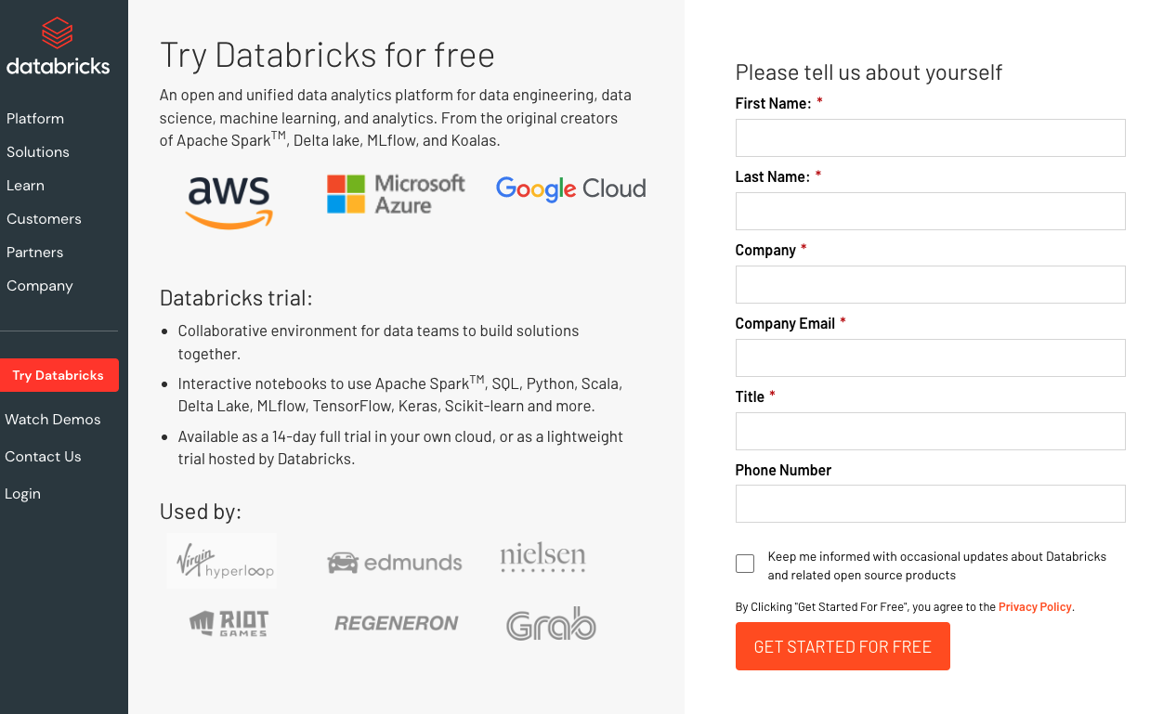

3. On the next screen, **click on the “Get started with Community Edition”** at the bottom (circled in red below):

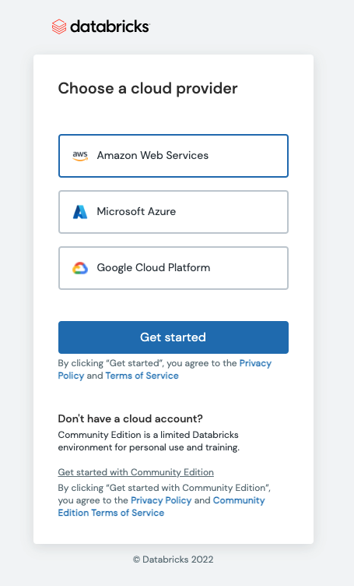

# 2 Read the Databrick Community edition FAQ

Read: [FAQ](https://databricks.com/product/faq/community-edition) for the free version of Databricks, Databricks Community Edition

# 3 Quick Start tutorial

Complete: [10 minute getting started tutorial](https://docs.databricks.com/getting-started/quick-start.html) - great for getting to know Databricks for new users