訓練環境部屬流程
(以RTX3090顯示卡為例)

部屬環境版本
Ubuntu : 18.04.5
Python : 3.6.9
NVIDIA Driver : 455.32.00
CUDA : 11.1
cuDNN : 8.0.5.39-1
Pytorch : 1.7.1
TensorFlow : 2.4.0

安裝Python
sudo apt install python3
sudo apt install python3-pip

安裝NVIDIA Driver
https://www.nvidia.com/zh-tw/geforce/drivers/

sudo bash NVIDIA-Linux-x86_64-455.45.01.run

安裝CUDA
https://developer.nvidia.com/cuda-downloads?target_os=Linux&target_arch=x86_64&target_distro=Ubuntu&target_version=1804&target_type=deblocal

wget https://developer.download.nvidia.com/compute/cuda/repos/ubuntu1804/x86_64/cuda-ubuntu1804.pin

sudo mv cuda-ubuntu1804.pin /etc/apt/preferences.d/cuda-repository-pin-600

wget https://developer.download.nvidia.com/compute/cuda/11.1.1/local_installers/cuda-repo-ubuntu1804-11-1-local_11.1.1-455.32.00-1_amd64.deb

sudo dpkg -i cuda-repo-ubuntu1804-11-1-local_11.1.1-455.32.00-1_amd64.deb

sudo apt-key add /var/cuda-repo-ubuntu1804-11-1-local/7fa2af80.pub

sudo apt-get update

sudo apt-get -y install cuda

安裝cuDNN
https://developer.nvidia.com/rdp/cudnn-download

先下載三個deb檔
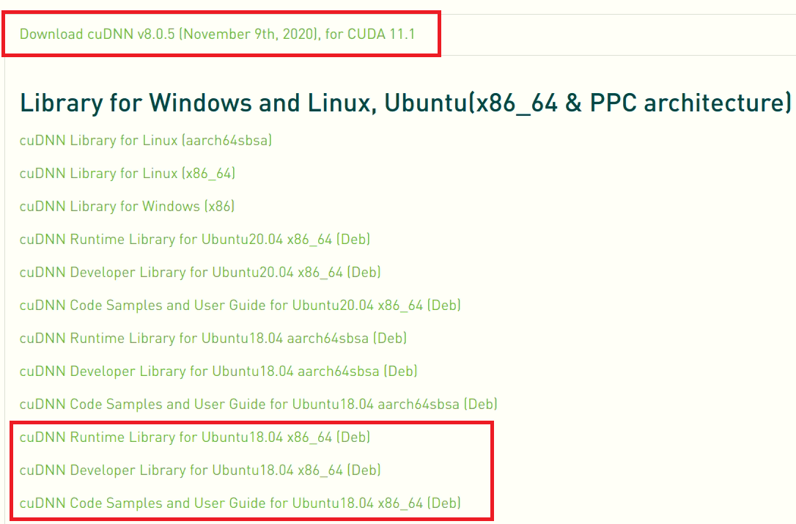

再依照安裝教學下指令
https://docs.nvidia.com/deeplearning/cudnn/install-guide/index.html

sudo dpkg -i libcudnn8_8.0.5.39-1+cuda11.1_amd64.deb
sudo dpkg -i libcudnn8-dev_8.0.5.39-1+cuda11.1_amd64.deb
sudo dpkg -i libcudnn8-samples_8.0.5.39-1+cuda11.1_amd64.deb

安裝TensorRT
https://docs.nvidia.com/deeplearning/tensorrt/install-guide/index.html
https://blog.csdn.net/shwan_ma/article/details/103637739
https://forums.developer.nvidia.com/t/tensorrt-backend-for-onnx-on-jetson-nano/74980/26

安裝Pytorch & TensorFlow
pip3 install torch==1.7.1+cu110 torchvision==0.8.2+cu110 torchaudio===0.7.2 -f https://download.pytorch.org/whl/torch_stable.html

pip3 install tensorflow==2.4.0

執行測試並修改錯誤
Run訓練時會抓不到GPU，請下這兩個指令新增檔案來解決缺檔的問題，並可成功訓練

sudo ln -s /usr/local/cuda-11.1/targets/x86_64-linux/lib/libcusolver.so.11 /usr/local/cuda-11.1/targets/x86_64-linux/lib/libcusolver.so.10

sudo ln -s /usr/local/cuda-11.1/targets/x86_64-linux/lib/libcusolver.so.11 /usr/lib/x86_64-linux-gnu/libcusolver.so.10

參考連結
Windows的RTX3090環境部屬範例
https://ai-edu-for-everyone.medium.com/win10-%E7%92%B0%E5%A2%83-%E4%BD%BF%E7%94%A8-anaconda-%E5%BB%BA%E7%BD%AE-rtx-3000-%E7%B3%BB%E5%88%97%E7%9A%84-tensorflow-%E6%B7%B1%E5%BA%A6%E5%AD%B8%E7%BF%92%E7%92%B0%E5%A2%83-9929e2a7c313?source=social.linkedin

Tensorflow避掉不支援RTX3090的支援，補上缺檔的錯誤方法
https://github.com/tensorflow/tensorflow/issues/43947?fbclid=IwAR11_NW1KU_PfkIQrQAUt0EMbp0bh0VXcoxbBSBrBaFbBldtAPJd0Rt_z9s#issuecomment-715295153

完整移除舊顯卡驅動和CUDA和CUDNN的方法
https://stackoverflow.com/questions/56431461/how-to-remove-cuda-completely-from-ubuntu

Could not load Qt platform plugin xcb
https://forum.qt.io/topic/119109/using-pyqt5-with-opencv-python-cv2-causes-error-could-not-load-qt-platform-plugin-xcb-even-though-it-was-found

