ROS

# Reference

ROS

<https://hackmd.io/@hanmon/ryfaHoezK>

# 查看ROS_MENU Config

vim ros_menu/config.yaml

# Disable ros_menu ros_menu_disable

# Enable ros_menu ros_menu_enable

# 查看ROS_MENU環境

ros_menu_env

# Get the coordinate for navigation

<https://github.com/Adlink-ROS/BT_ros1#note>

# Using Localhost Open Rviz

PC

1. ssh -X ros@ip address

ROS AGV

2. roslaunch neuronbot2_bringup bringup.launch

3. roslaunch neuronbot2_nav bringup.launch local_planner:=dwa

4. roslaunch neuronbot2_nav navigation.launch

5. rosrun teleop_twist_keyboard teleop_twist_keyboard.py

6. roslaunch realsense2_camera rs_camera.launch

PC

7. rviz open .rviz config

# 懶人包

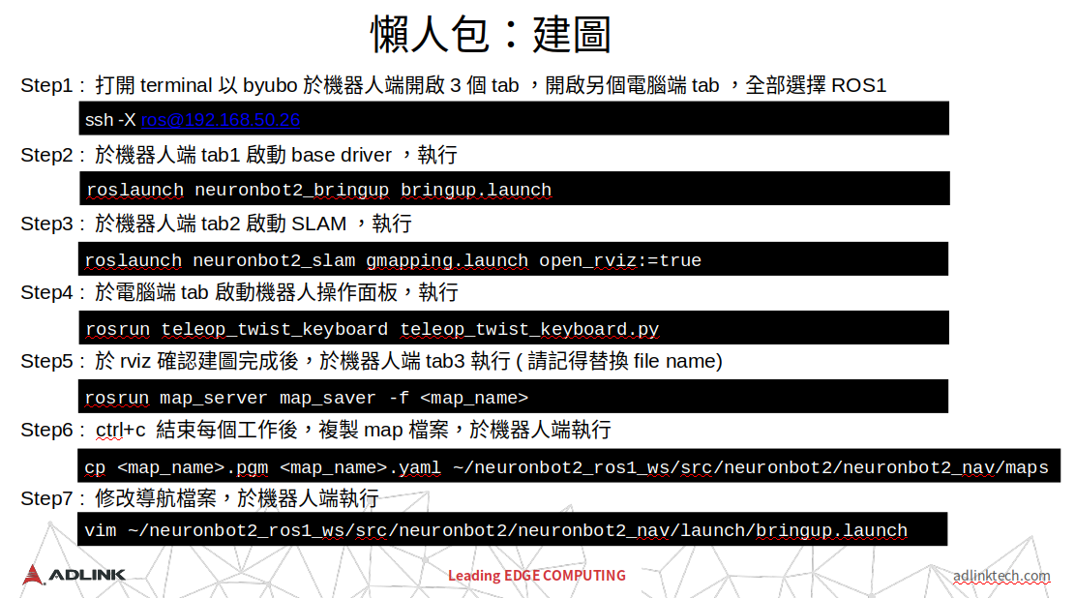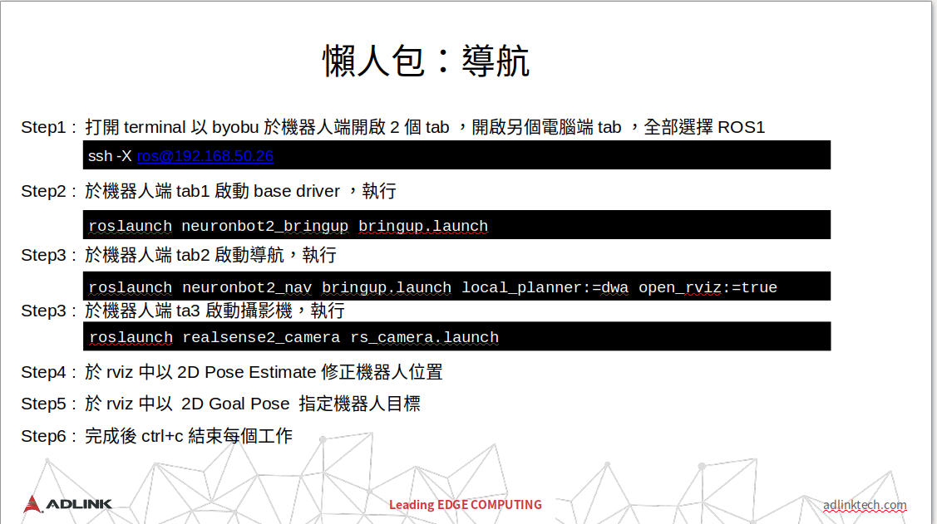

# Follower

<http://wiki.ros.org/turtlebot_follower>

# Issue

* 1. Build ROS Tutorials

<https://blog.csdn.net/qq_31511955/article/details/111278684>

* 1. TF practice(Two Turtles)

<https://blog.csdn.net/m0_50945459/article/details/118915339>

* 1. [REST.cc:205] Error in REST request

<https://blog.csdn.net/ZhangRelay/article/details/102953429>

* 1. 在 Gazebo 模擬運行時啟動 Navigation 和 Rviz

roslaunch neuronbot2_nav bringup.launch open_rviz:=true local_planner:=dwa map:=map_name.yaml

* + 1. 在bringup.launch檔案改掉預設yaml，之後指令移除map部份。
    2. 或是map指令部份使用絕對路徑。
  1. When ever I run roscore, this error prompts. How can I fix this issue ? Please provide a solution.

<https://answers.ros.org/question/372612/when-ever-i-run-roscore-this-error-prompts-how-can-i-fix-this-issue-please-provide-a-solution/>

* 1. ModuleNotFoundError: No module named 'rospkg'

<https://blog.csdn.net/qq_39779233/article/details/109922706>

* 1. ModuleNotFoundError: No module named 'netifaces'

<https://stackoverflow.com/questions/19332554/importerror-no-module-named-netifaces>

* 1. ModuleNotFoundError: No module named 'PyQt5'

<https://blog.csdn.net/qq_33485434/article/details/80606359>

* 1. change python2 / 3

move anaconda folder to other location

* 1. Error while loading gazebo

<https://answers.gazebosim.org//question/9170/error-while-loading-gazebo/>

* 1. RLException: [xx.launch] is neither a launch file in package [x] nor is [x] a launch file name

<https://blog.csdn.net/weixin_44436677/article/details/106442240>