DoConnect - Q&A Platform

📋 Table of Contents
- Project Overview
- Technology Stack
- System Architecture
- Database Design
- Features
- Sprint Implementation
- Setup and Installation
- API Documentation
- User Interface
- Admin Panel
- Testing
- Deployment
- Future Enhancements
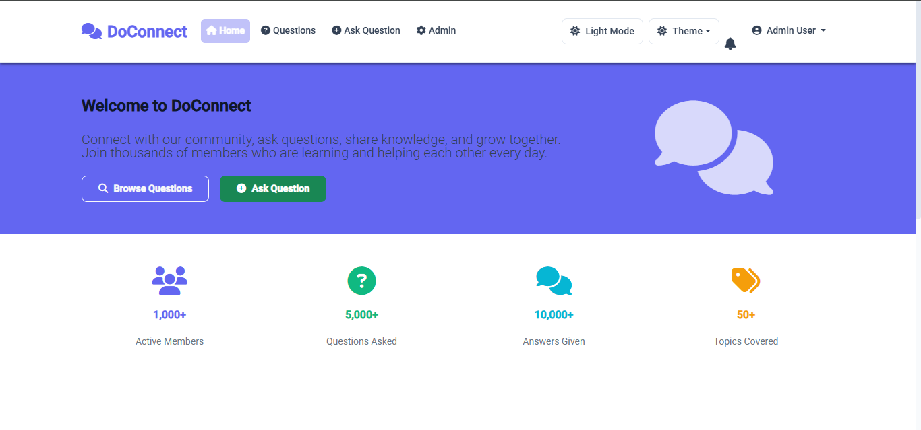
Project Overview
DoConnect is a comprehensive Q&A platform that allows users to ask and answer technical questions while providing administrators with powerful content moderation capabilities. The platform features real-time notifications, image upload functionality, and a robust approval workflow.

Problem Statement
In today's fast-paced technical environment, developers and tech enthusiasts need a reliable platform to share knowledge, ask questions, and get expert answers. DoConnect bridges this gap by providing a structured, moderated environment for technical discussions.

Project Objectives
- Create an intuitive Q&A platform for technical discussions
- Implement role-based access control (User/Admin)
- Provide real-time notifications for administrators
- Enable content moderation and approval workflows
- Support multimedia content through image uploads
- Ensure scalable and secure architecture

🛠 Technology Stack
Frontend
- Framework: Angular 14+
- UI Library: Tailwind css
- State Management: Angular Services with RxJS
- Routing: Angular Router
- HTTP Client: Angular HttpClient
- Authentication: JWT Token-based
- Real-time: SignalR Client


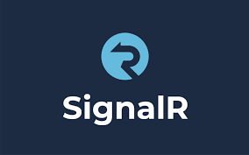

Backend
- Framework: ASP.NET Core 8 Web API
- ORM: Entity Framework Core
- Database: SQL Server
- Authentication: JWT Bearer Authentication
- Real-time: SignalR
- File Upload: IFormFile
- API Documentation: Swagger / OpenAPI
Development Tools
- IDE: VS Code
- Version Control: Git/GitHub
- Package Manager: NuGet (Backend), npm (Frontend)
- Testing: xUnit (Backend), Jasmine/Karma (Frontend)
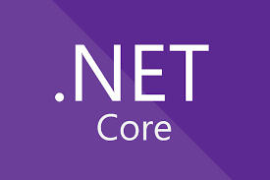


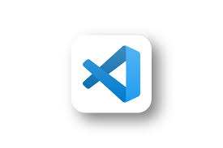
System Architecture
Architecture Components
- Client Layer (Angular)
  - User Interface Components
  - Authentication Guards
  - Service Layer for API Communication
  - State Management
- API Layer (ASP.NET Core)
  - Controllers for handling requests
  - JWT Authentication Middleware
  - SignalR Hubs for real-time communication
  - File Upload Services
- Business Logic Layer
  - User Management Services
  - Question/Answer Processing
  - Content Moderation Logic
  - Notification Services
- Data Access Layer
  - Entity Framework Core
  - Repository Pattern
  - Database Context
- Database Layer
  - SQL Server Database
  - Stored Procedures (if needed)
  - Indexes for Performance

🗄 Database Design:
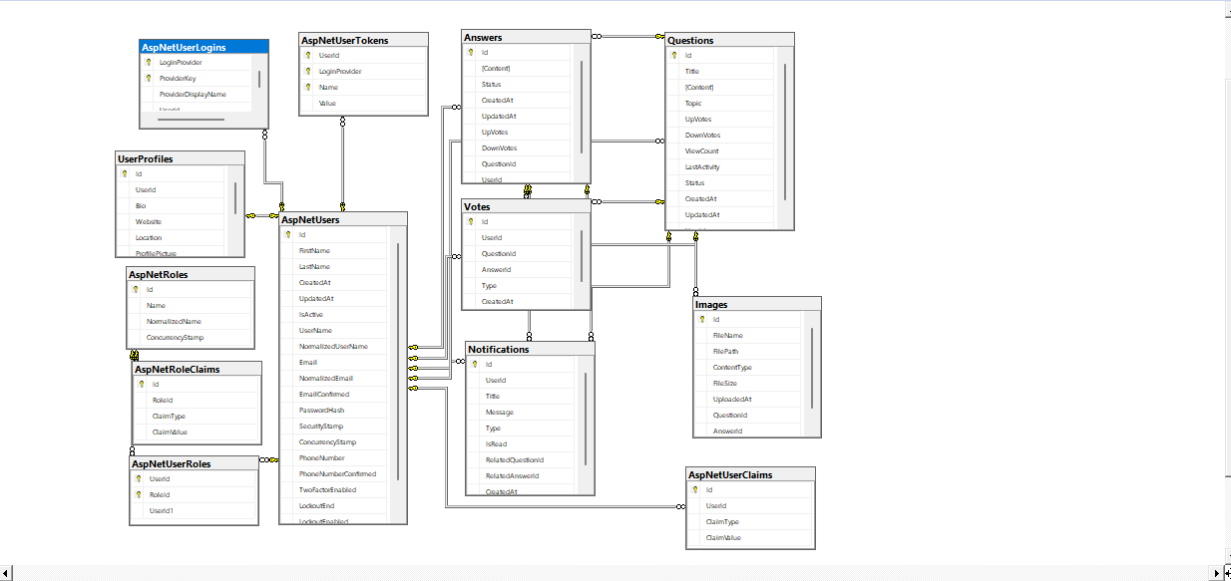
Core Tables
Table | Columns | Details
Users | Id (PK, int), FirstName, LastName, Email (Unique), UserName (Unique), PasswordHash, IsActive, CreatedAt, UpdatedAt | Stores user information
Questions | Id (PK), Title, Content, Topic, Status (0=Pending,1=Approved,2=Rejected), UserId (FK), CreatedAt, UpdatedAt | User questions
Answers | Id (PK), Content, Status, QuestionId (FK), UserId (FK), CreatedAt, UpdatedAt | Answers to questions
Images | Id (PK), FileName, FilePath, ContentType, FileSize, QuestionId (nullable FK), AnswerId (nullable FK), UploadedAt | Image metadata

Entity Relationships
- Users → Questions (One-to-Many)
- Users → Answers (One-to-Many)
- Questions → Answers (One-to-Many)
- Questions → Images (One-to-Many)
Features
User Features
- User Registration and Authentication
- Ask Questions with Rich Text Editor
- Answer Questions
- Upload Images with Questions/Answers
- Search Questions by Keywords
- View Question Details
- User Profile Management
- Dark/Light Theme Toggle

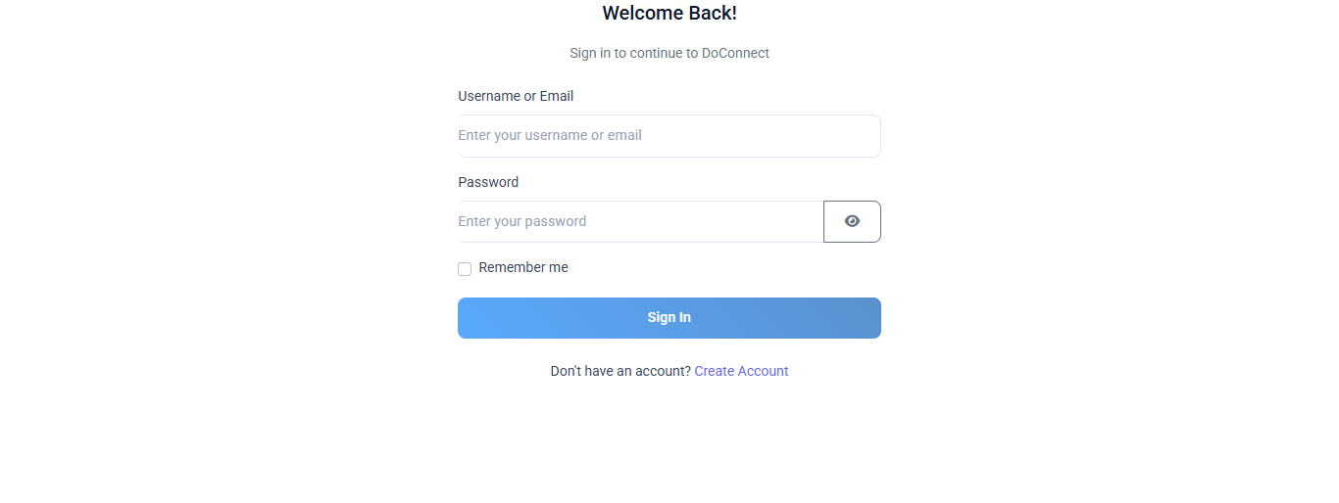
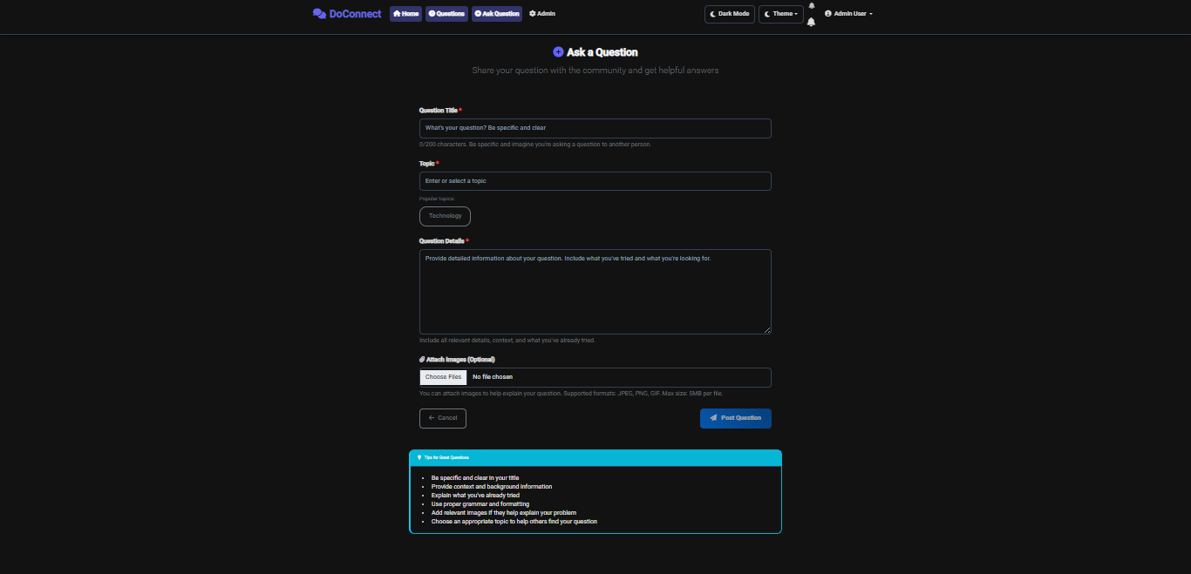
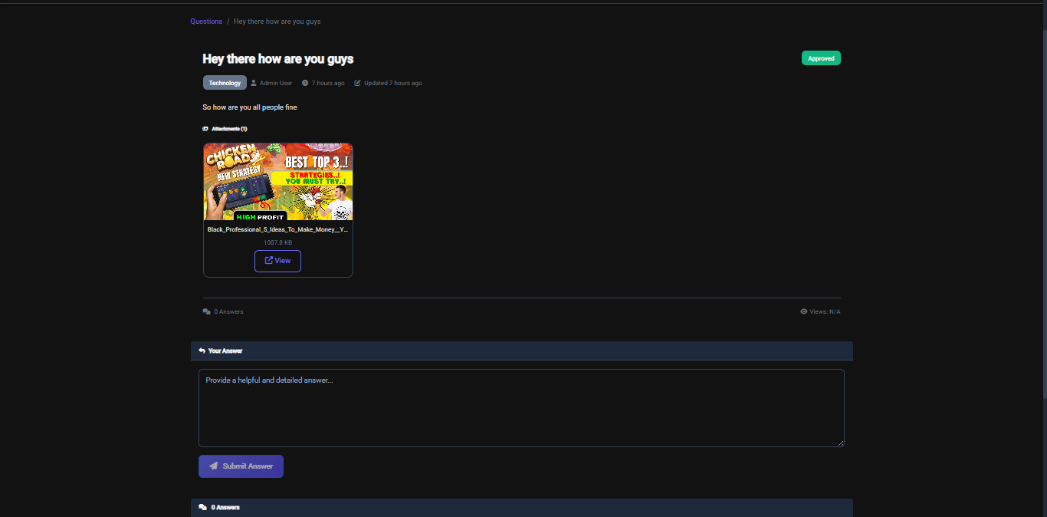
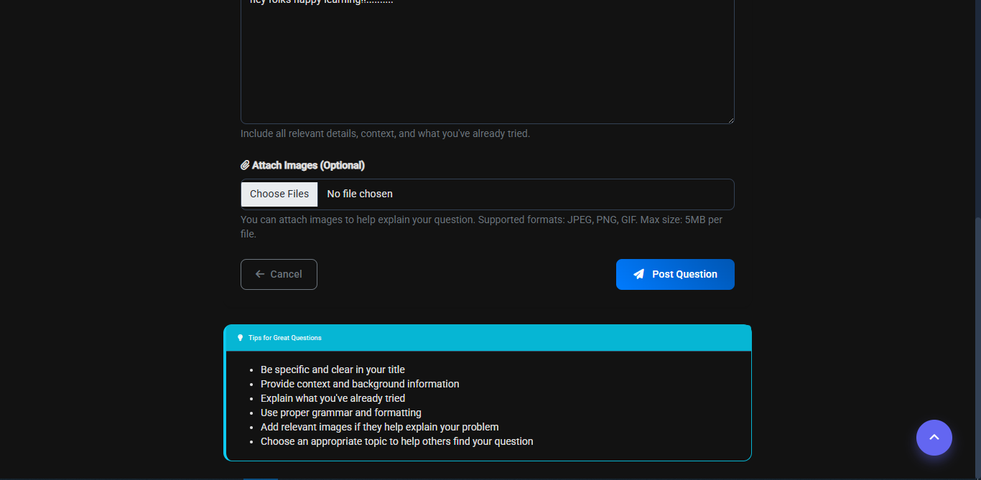
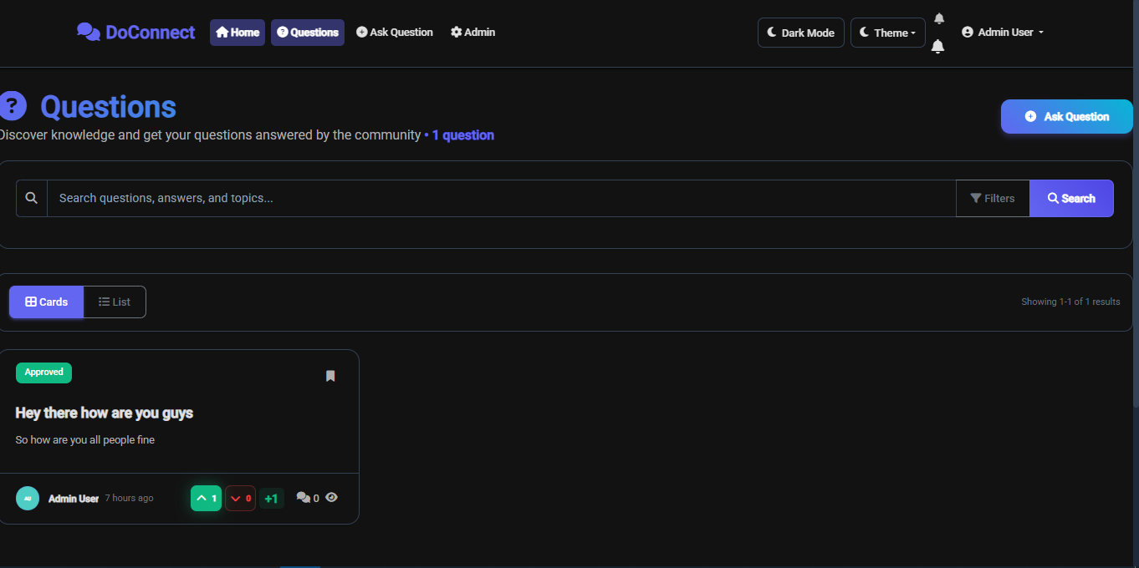
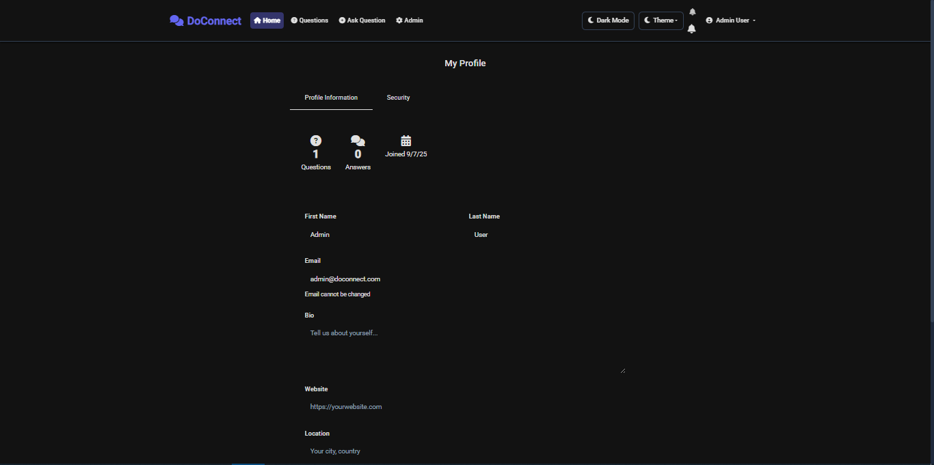
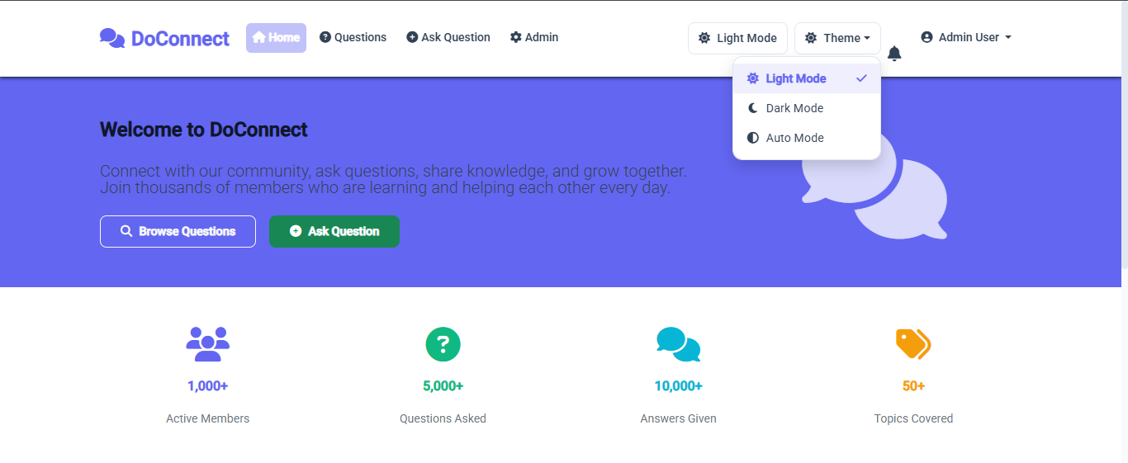
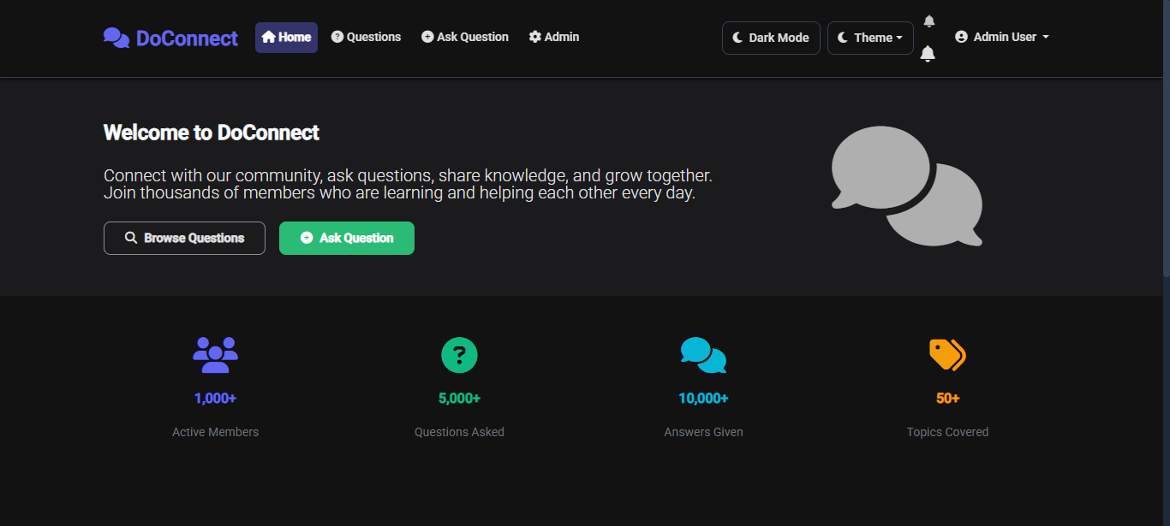
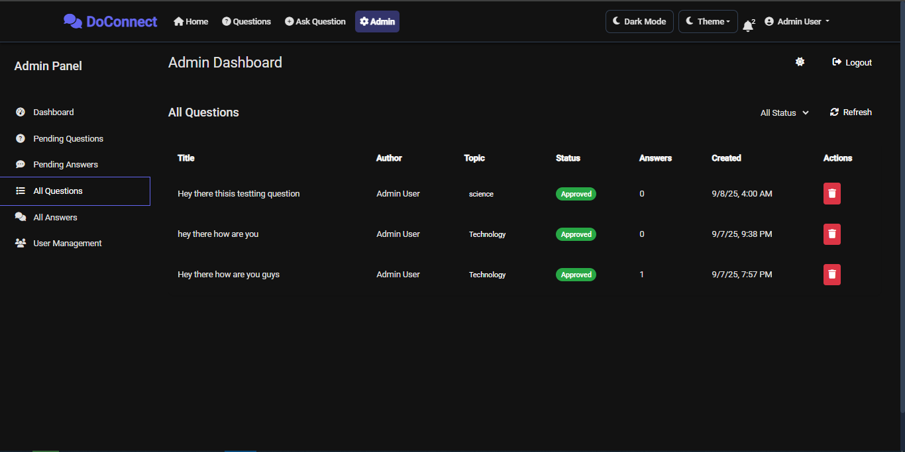
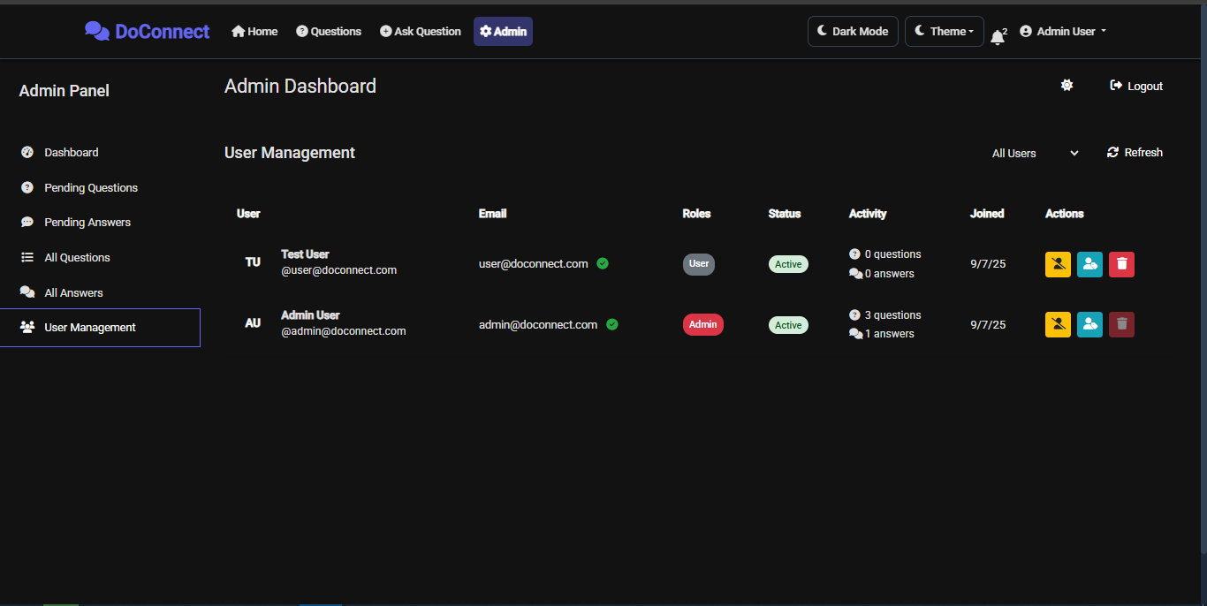

Admin Features
- Admin Dashboard with Statistics
- Content Moderation (Approve/Reject)
- User Management
- Real-time Notifications
- Content Deletion
- Role Management
- System Analytics
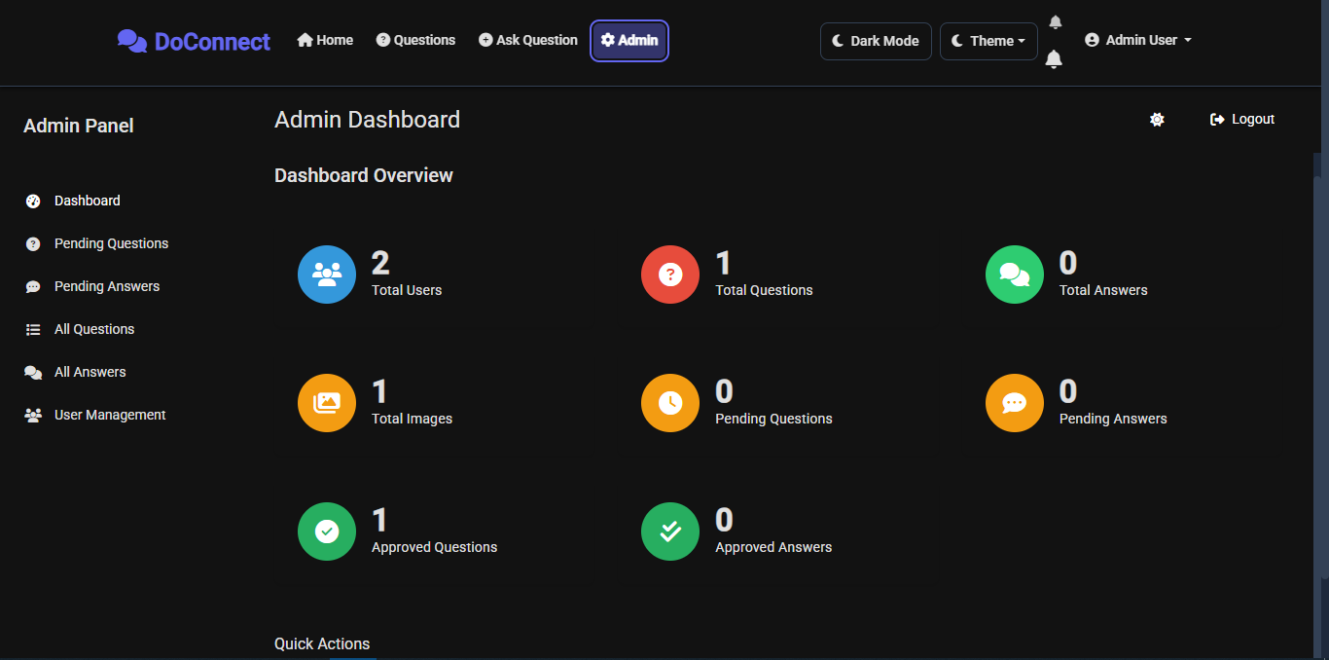
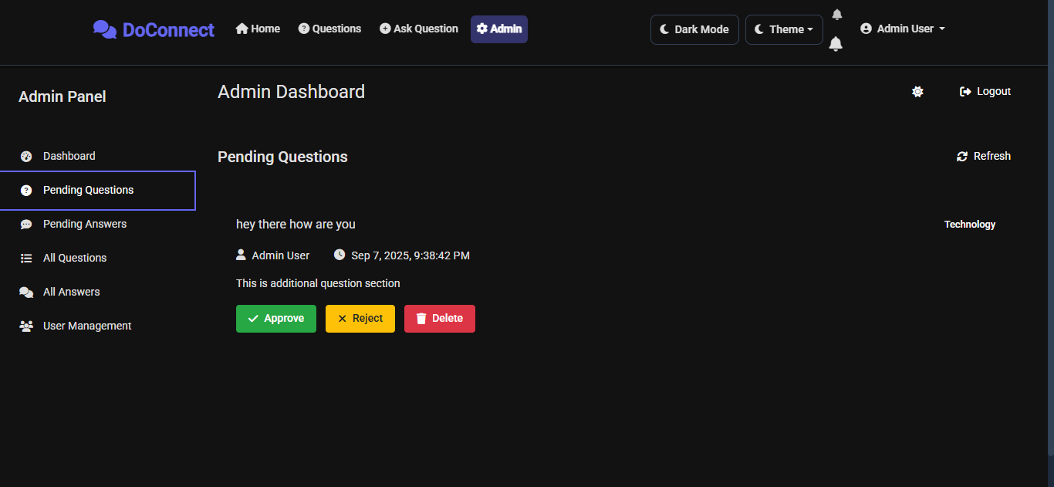
Sprint Implementation
Sprint I: Foundation and Planning
Objectives
- Use Case Documentation
- Database Schema Design
- Technology Stack Selection
- Project Setup
Deliverables
- Use case document
- Entity Relationship Diagram
- Database schema scripts
- Backend project structure
- Frontend project initialization

Sprint II: Core Functionality
Objectives
- User Authentication System
- Question & Answer CRUD Operations
- Image Upload Functionality
- Basic UI Components
Deliverables
- JWT Authentication
- User registration and login
- Question creation and viewing
- Answer submission
- Image upload API and UI
- Responsive Angular components

User registration page
User login interface
Ask question form with image upload
Questions listing page
Question detail view with answers
Sprint III: Advanced Features and Admin Panel (3 weeks)
Objectives
- Search Functionality
- Admin Dashboard
- Content Moderation
- Real-time Notifications
- Final Integration and Testing

Deliverables
- Advanced search with filters
- Complete admin panel
- Approval workflow
- SignalR notifications
- Swagger API documentation
- Comprehensive testing

Search functionality with filters
Admin dashboard with statistics
Admin pending questions management
Admin user management interface
SignalR real-time notifications

Setup and Installation
Prerequisites
- .NET 8 SDK
- Node.js 18+ and npm
- SQL Server 2019+
- Visual Studio 2022 or VS Code
- Git
Backend Setup
git clone https://github.com/yourusername/doconnect.git
cd doconnect/Backend
dotnet restore
dotnet ef database update
dotnet run
Backend API will be available at https://localhost:5001

Frontend Setup
cd ../Frontend
npm install
ng serve
Frontend app will be available at http://localhost:4200
Default Admin Credentials
Role | Email | Password
Admin | admin@doconnect.com | Admin@123
User | user@doconnect.com | User@123

📚 API Documentation
Authentication Endpoints
POST /api/auth/login
Request body example:
{
"email": "user@example.com",
"password": "password123"
}
Response example:
{
"success": true,
"token": "jwt_token_here",
"user": {
"id": 1,
"firstName": "John",
"lastName": "Doe",
"email": "user@example.com",
"roles": ["User"]
}
}

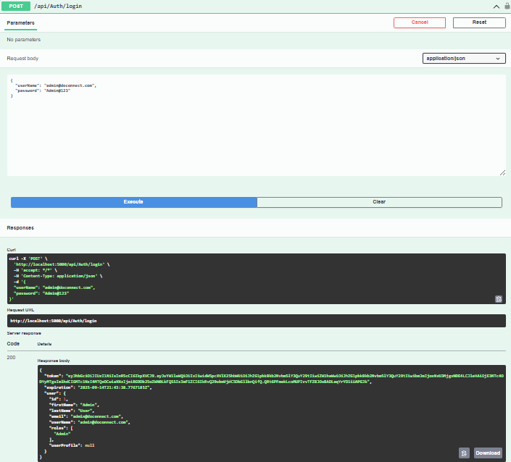

POST /api/auth/register
Request body example:
{
"firstName": "John",
"lastName": "Doe",
"email": "user@example.com",
"password": "password123",
"confirmPassword": "password123"
}
Questions Endpoints
GET /api/questions
Retrieve paginated question list with optional filters.
Query parameters:
- page (int): page number
- pageSize (int): number of items per page
- search (string): keyword search
- topic (string): topic filter
POST /api/questions
Create a new question (authorization required). Submit as multipart/form-data with fields:
- title
- content
- topic
- files (optional images)

🎨 User Interface
Screenshots included for:
- Home Page
- User Dashboard
- Question Creation Form
- Question Detail View
- Search Results
- User Profile
- Responsive Mobile View

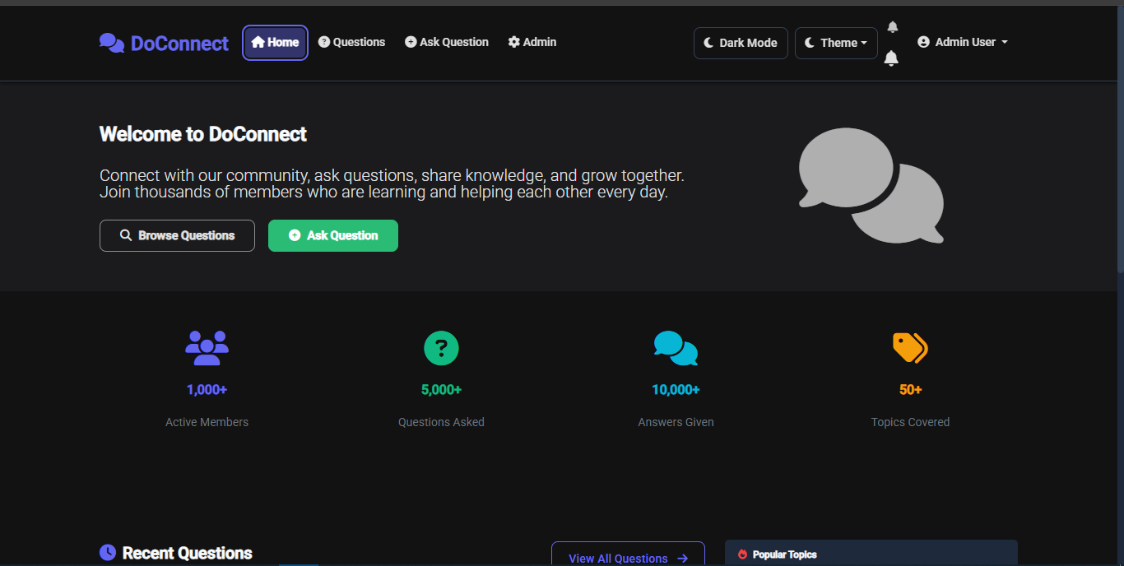
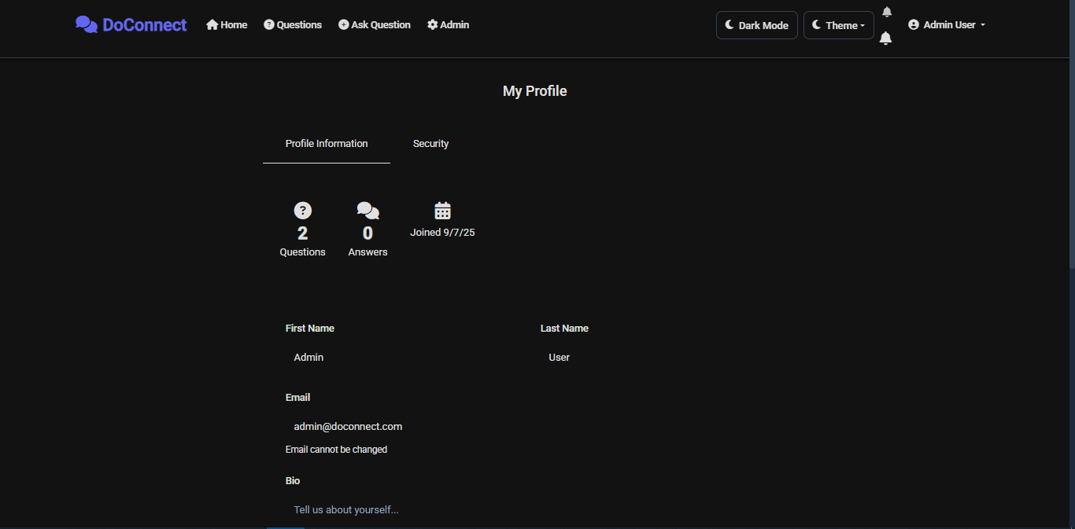

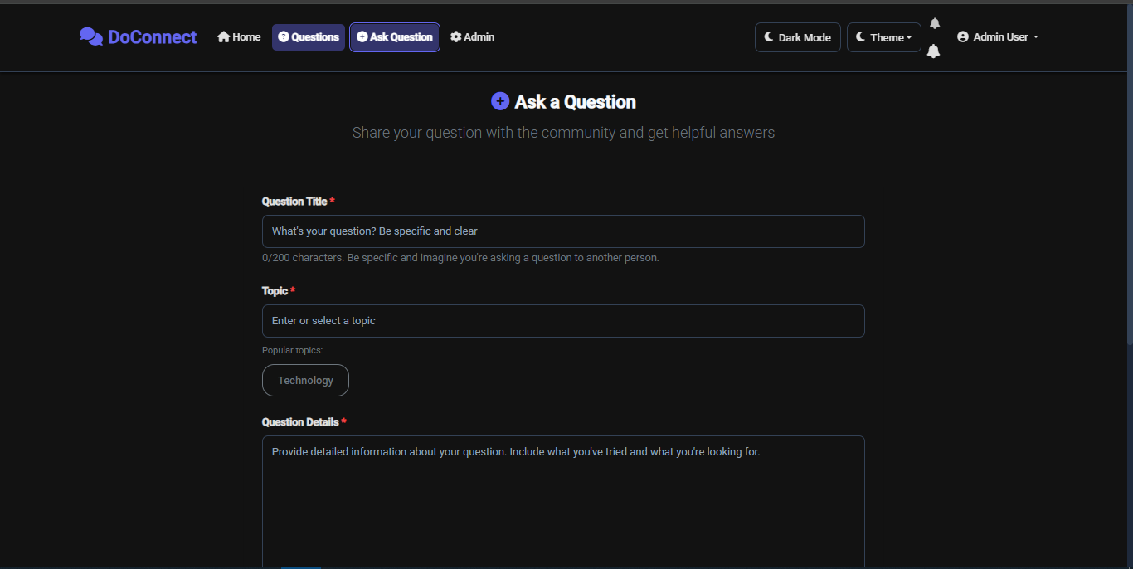

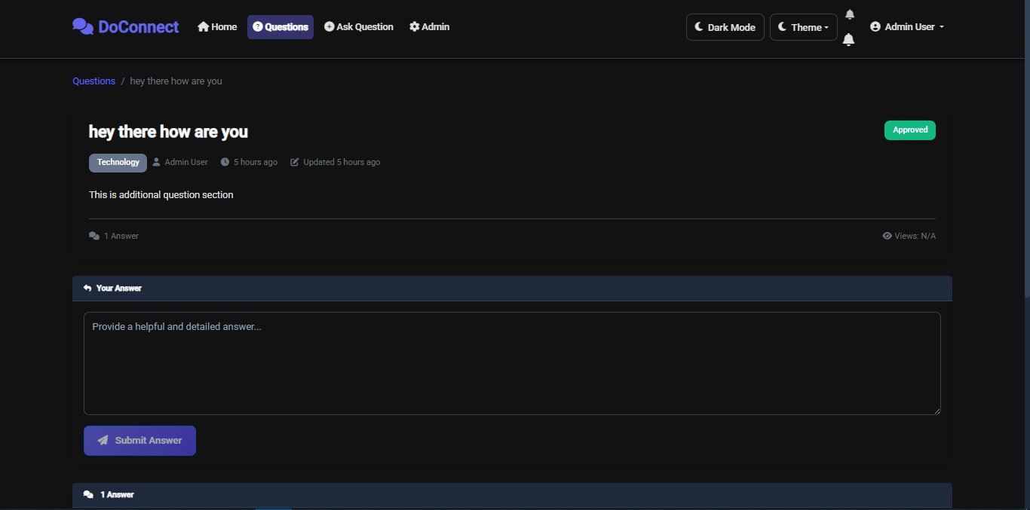

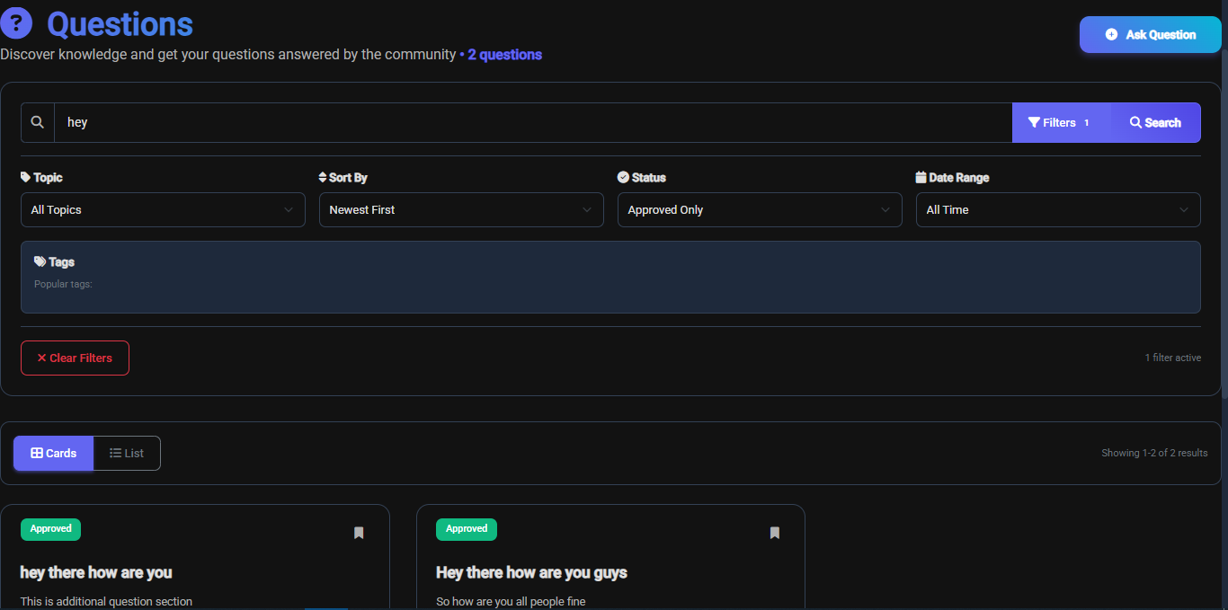

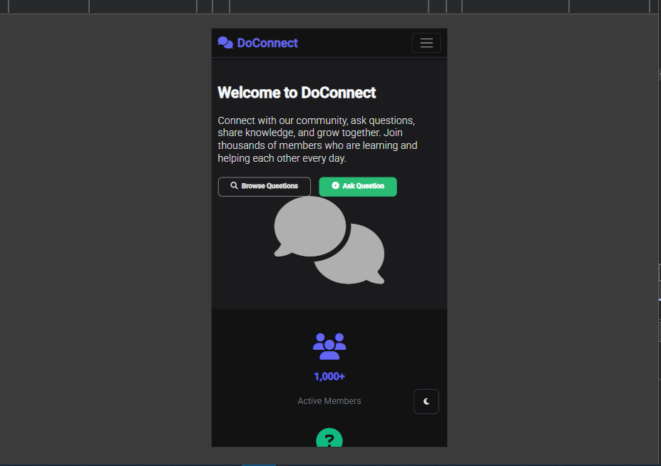

Admin Panel
Includes:
- Dashboard overview
- Content moderation interface
- User management
- Analytics
- Real-time notifications
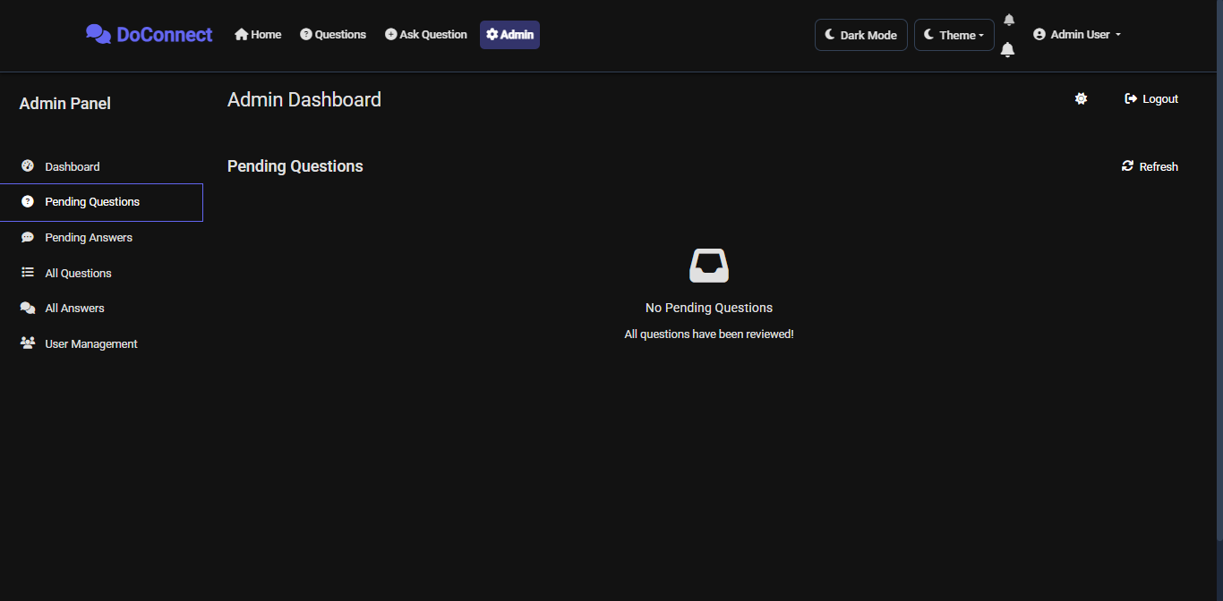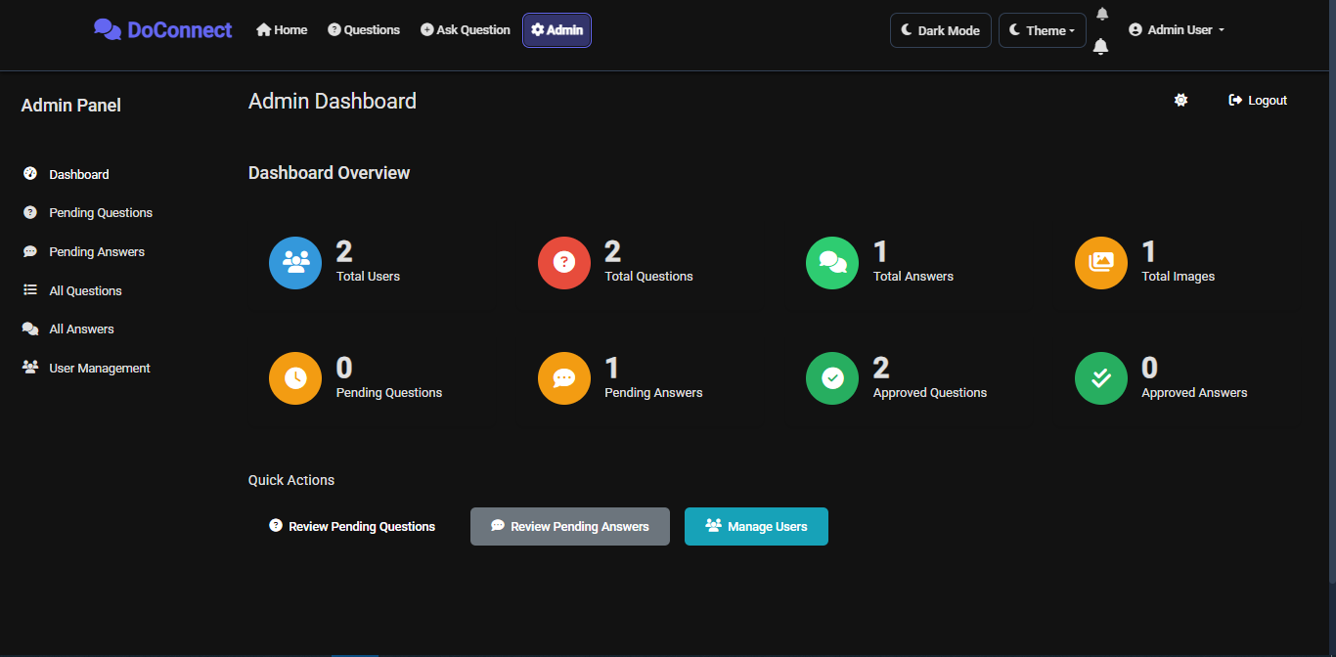
Testing
- Backend unit tests with xUnit
- Frontend tests with Jasmine/Karma
- Integration tests for API endpoints and authentication
- Coverage and test results screenshots included
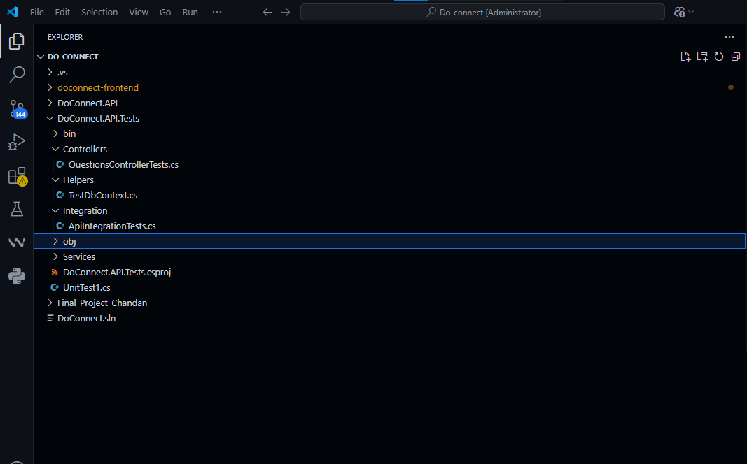

Future Enhancements
- Advanced search (Elasticsearch)
- Email notifications
- Reputation system
- Question tagging
- Mobile app development
- AI-powered content suggestions
- Video upload support
- Multi-language support
- Machine learning for moderation
- Real-time collaboration
- API rate limiting and caching
- Microservices architecture

👥 Team Members
- Developer: CHANDAN A S
- Duration: 1 WEEK
- Instructor: PATIL MAM

📞 Support
- Email: helloworld.chandan@gmail.com
- GitHub Issues: [Repository Issues Link]

License
This project is developed for educational purposes as part of a capstone project.
© 2025 DoConnect — All Rights Reserved.

