Run Manual Logger Powershell Script as a service

1. Put pi-config directory inside the PI DA Server.
2. Run nssm in command line: nssm install YourServiceName
3. Set the informations:

* Path: Powershell path
* Startup directory: Your script directory
* Options: .\service.ps1

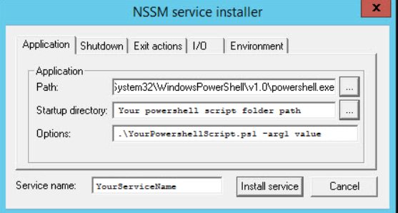

1. Share **pi-config\inputs** directory to everyone.
2. Add **ipconfig** to windows environment variables.