
Website: http://magehit.com Contact: sale@magehit.com
New Products Guide
Version 1.0.0 – May 2017

Integrate template of New Products extension with your theme. Before going to the configuration, You can please read the file
guide_put_code_into_template to integrate with current your theme.
- Configuration
Go to Magehit Extension -> Newproducts to configure the extension:
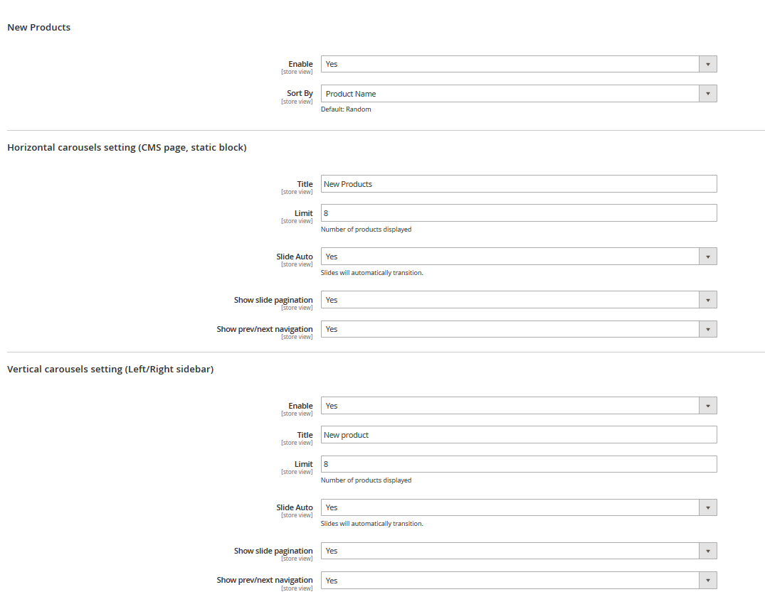

+ Tab : New Products
- In the Enable field, select Yes to enable the module.
- In the Sort By field, choose option to sort new products.

+ Tab : Horizontal carousels setting (CMS page, static block)
- In the Title field, you can put title that will display in top slider.
- In the Limit field, you can put max length item in slider.
- In the Slide Auto field, you can choose yes/no to apply auto transition slider.
- In the Show slide pagination field, you can choose yes/no to show list pagination in bootom slider.
- In the Show prev/next navigation field, you can choose yes/no to display previours/next button on slider.

+ Tab : Vertical carousels setting (Left/Right sidebar)
- In the Enable field, you can choose yes/no to display vertical slider in left or right column (not display layout in 1 column).
- In the Title field, you can put title that will display in top slider.
- In the Limit field, you can put max length item in slider.
- In the Slide Auto field, you can choose yes/no to apply auto transition slider.
- In the Show slide pagination field, you can choose yes/no to show list pagination in bootom slider.
- In the Show prev/next navigation field, you can choose yes/no to display previours/next button on slider.

And clear cache when you set new products or setting config.

- Set new product
You can set new product in backend.
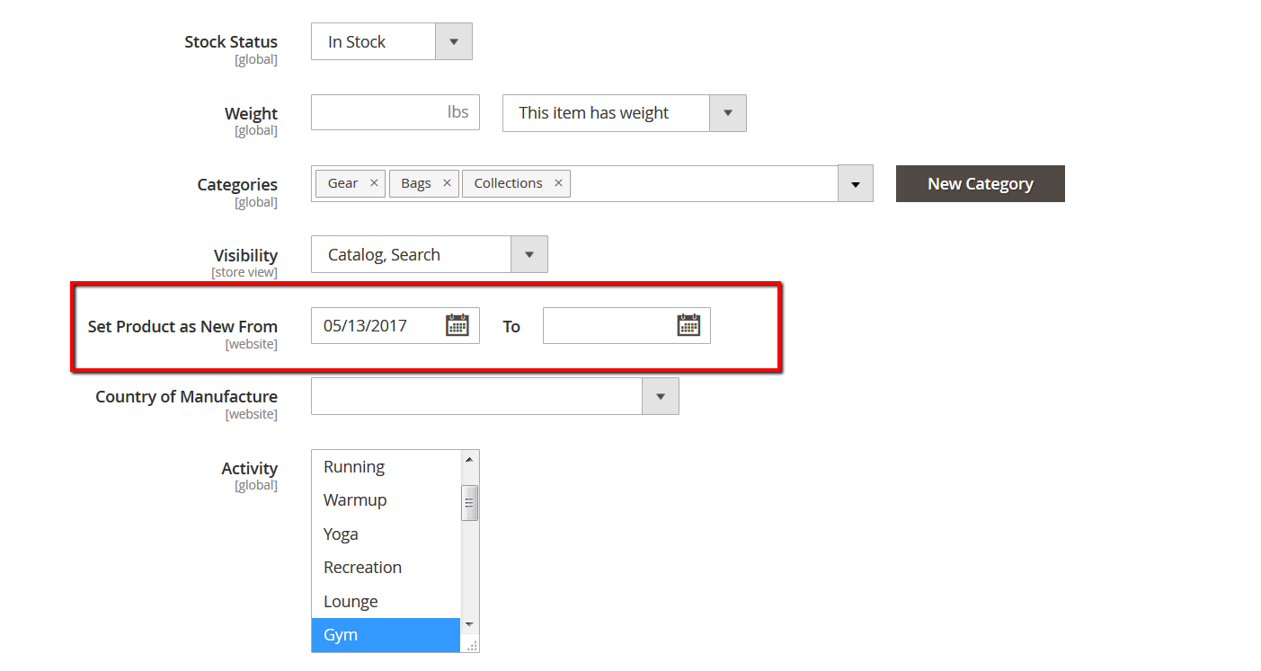

- Some pictures will be displayed at frontend :
- - Home Page :
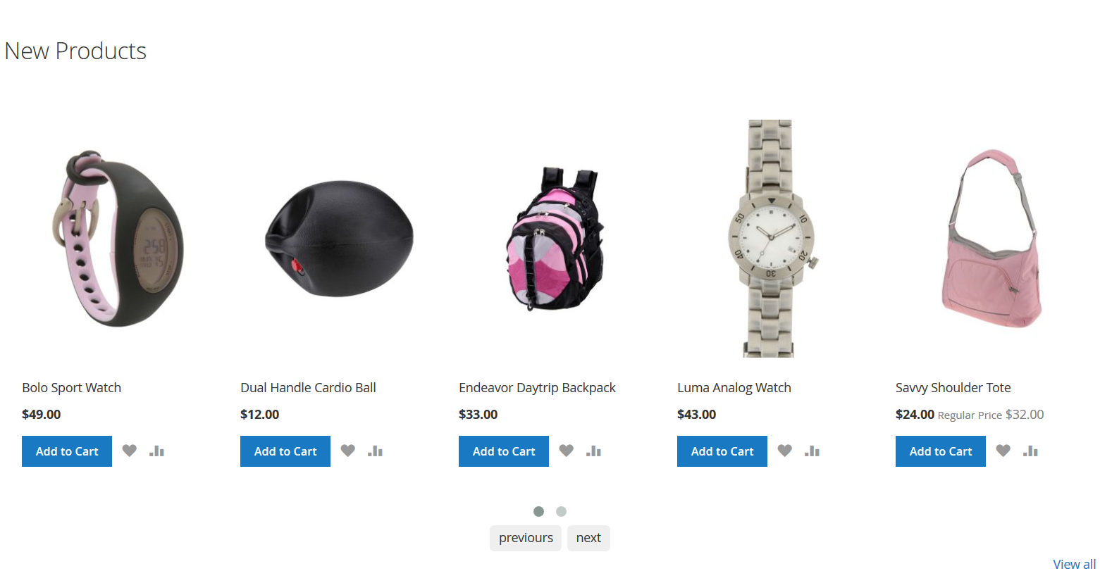

- List All Page :
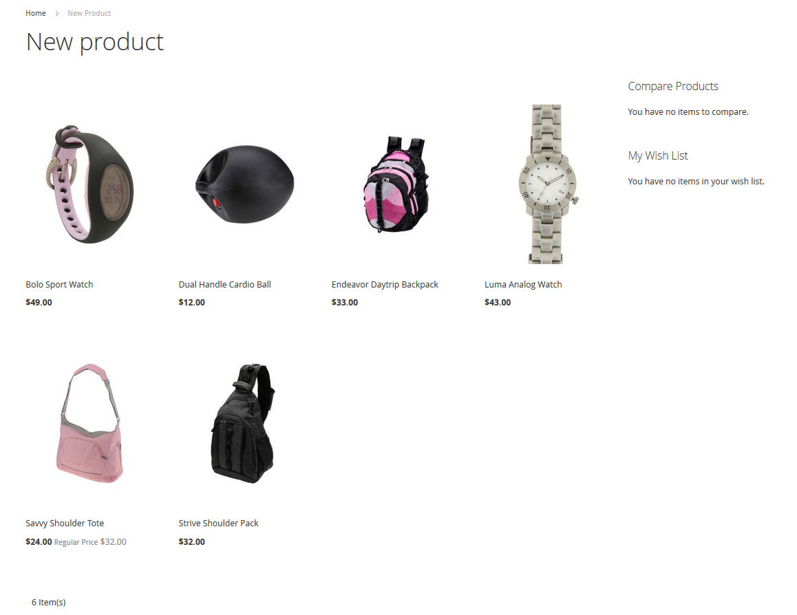
- Vertical slider :
