Ledger and Slate Interface Companion
  - Design direction for the HATCH upgrade
Version 1.0 | November 2, 2026 | THE STRUTHIO CONCERN
We are designing Ledger & Slate around shared work with an AI collaborator. The human and Slate should be able to use the same capabilities, change the same working records, and inspect each other's revisions. The interface should make that collaboration visible through editable documents, contextual commands, and a complete settings registry.
Use this companion alongside the HATCH engineering plan. Carry these interface requirements into the active checkpoint while preserving the existing command registry, Engineering Kernel, working copies, and evidence. This document records design direction; it does not close an implementation or acceptance milestone.

Owner requirements
- Keep a bottom-left Struthio or Hatch launcher for installed programs and capabilities. Open their focused instruments or supported full application views in the center workspace.
- Keep top dropdown menus with the familiar responsibilities of File, Edit, View, Options, and Help, using names distinctive to Ledger.
- Develop right-click as an adaptive visual form of commands that can also be typed. Its submenus should reflect context and likely next actions.
- Organize the left cabinet around office filing and alphabetization. Keep Trash separate and expose external transfers through Import and Export.
- Place machine monitors and the ordered operations queue in the right column. Keep per-operation priority control.
- Use graphite shades, highlight yellow, and eraser pink. Writing should appear directly on highlighted parts of the work. Actions should appear as pink ink rather than conventional buttons or web links.
- Expose all genuine Ledger and Slate settings in a registry-style hierarchy in the left column. Both the human and Slate must be able to read and change them.

Choices still under discussion
The exact launcher name, the replacement menu labels, the blinking X behavior, the priority slider labels, and the mechanism for switching the left column between Cabinet and Settings remain design choices. Examples in this companion illustrate those choices; they are not new capability claims.

Desktop surfaces and menu responsibilities
Give each surface a clear job. Multiple surfaces can invoke the same registered command, while their organization serves different needs. Keep the top menus predictable, use right-click for context, and use the launcher to open capabilities.
Surface | Responsibility
Bottom-left launcher | List installed capabilities with readiness and running state. Open the chosen instrument or application view.
Ledger head | Provide stable dropdown groups for managing, editing, arranging, configuring, and understanding the active work.
Right-click menu | Offer valid contextual commands and a short group of predicted next actions. Retain access to other eligible commands.
Left column | Show the logical filing cabinet or the complete settings hierarchy. Keep transfer sections and Trash distinct.
Center workspace | Present the shared document, calculation, investigation, settings page, or application view.
Right column | Show CPU and memory state, Slate activity, and the ordered operations queue with priority controls.

Candidate names for the Ledger head
Renaming is required; these particular words are a proposal. Keep familiar commands such as Save, Undo, Copy, and Paste within their dropdowns, and preserve their keyboard behavior.
Existing group | Candidate | Preserved function
File | Work | New, open, save, import, export, and close work
Edit | Revise | Undo, redo, selection, cut, copy, paste, find, and replace
View | Arrange | Panels, tabs, zoom, and workspace arrangement
Options | Rules | Preferences, defaults, and operating behavior
Help | Guide | Instructions, examples, and explanations

Earlier proposals this direction supersedes
The launcher belongs at the bottom left. Do not merge it with the adaptive right-click menu or make an upper-left Root button their shared entrance. Root remains an optional name, not a requirement. The launcher now has a capability-catalogue role, expanding the earlier five-command Hatch design.
CPU and other monitors belong in the right column. Capability launches belong in the launcher rather than appearing as new roots in the filing tree. Global settings can also be reached through Rules, opening their existing left-column view.

Color and editing language
Treat the three functional colors as a consistent vocabulary. Use shape, position, labels, and keyboard focus alongside color so the meaning remains clear.
Color family | Meaning | Visible treatment
Graphite shades | Information and structure | Ordinary text, document surfaces, tree guides, status, and unavailable actions
Highlight yellow | Writing or attention | Highlighted writable passages and values; a margin mark beside an unresolved issue
Eraser pink | Action | Underlined command words, actionable marks, menu choices, and draggable controls

Remove conventional input-box borders, raised button shapes, and browser-link styling from Ledger-owned surfaces. Preserve reliable text selection, insertion, undo, focus, and accessible control semantics underneath the visual treatment. A writable passage may receive focus by clicking; its yellow color identifies writing rather than an action command.
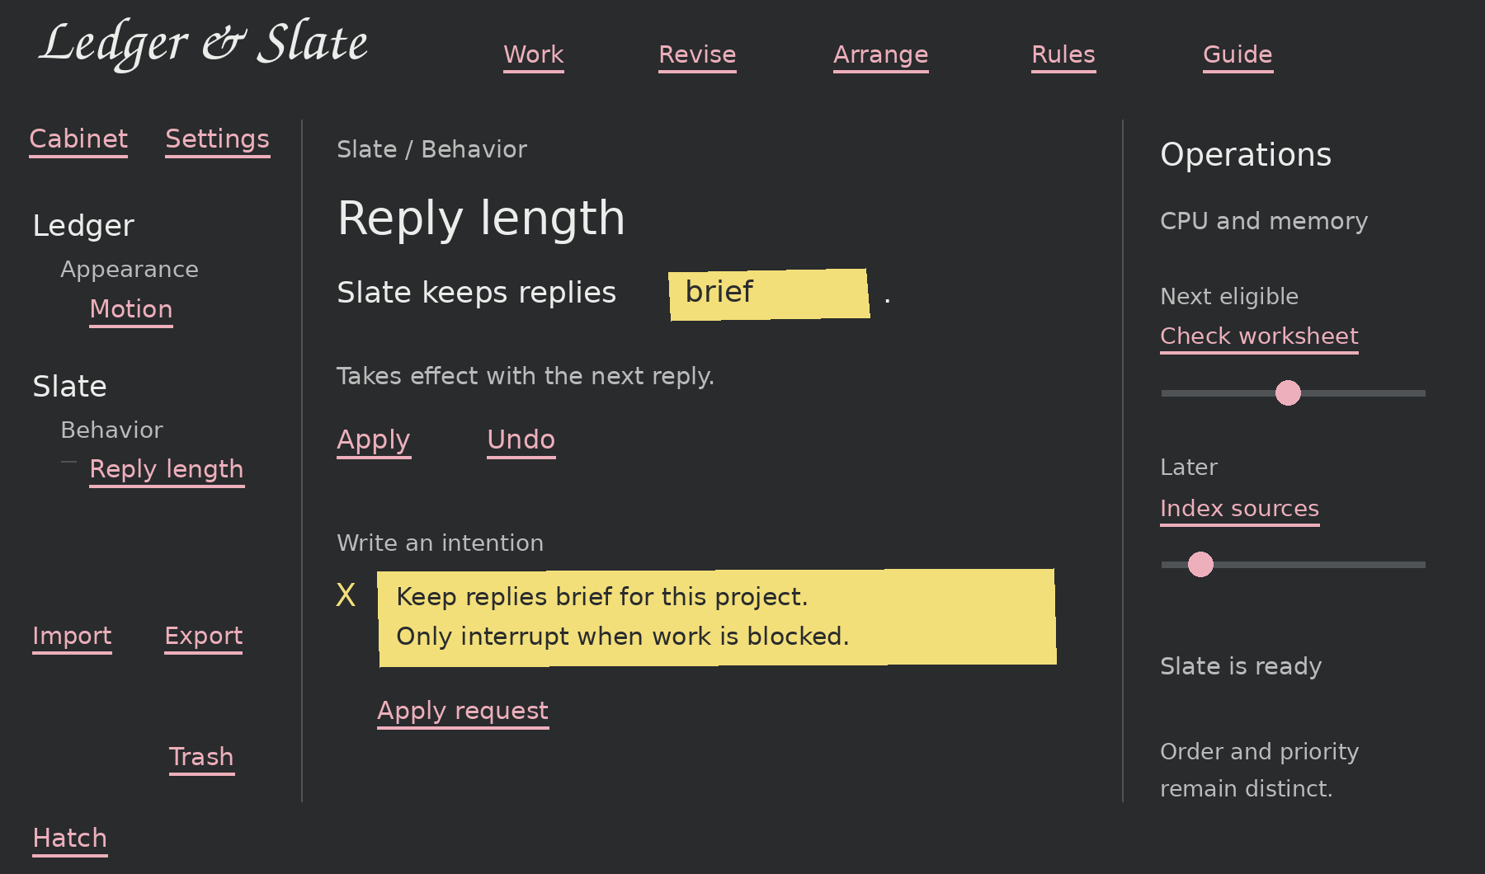
Concept layout showing placement and color roles. Menu names and sample settings remain proposals. This is a schematic, not a program screenshot.

Writing marker and identity
The owner proposed a decorative blinking X to mark a place to type. Evaluate an X beside the active passage while retaining precise insertion during editing. Reserve its meaning consistently and provide a quiet motion setting. Keep cursive for the Ledger & Slate wordmark and restrained incidental text. The Struthio is the preferred launcher mark; an egg is optional and unnecessary to the concept.

Commands and shared work

One command system
Top menus, right-click, typed staC commands, and Slate should resolve to the same registered operations. The visual interface may prepare parameters and explain an operation, but it must preserve the existing execution route, ownership, grants, and receipts. Avoid a separate dispatcher or an unrestricted shell runner for the new interface.
Use the selected record, its revision, the active capability, and actual readiness to construct context. Slate should read the relevant structured work rather than infer authoritative state from a screenshot. Display names and predictive ordering must not change operation identities.

Adaptive right-click
Build the eligible command set first. Then rank a few likely next actions using the active selection, work state, unsatisfied prerequisites, and available capabilities. Keep a complete eligible command tree accessible. Predictions propose actions; they do not execute them.
Recompute when the menu opens and hold the menu steady while the owner chooses. Submenus can be dynamic without moving targets beneath the pointer. If prediction is unavailable, the menu must still offer useful deterministic context commands. A command hint can optionally reveal the equivalent staC form.
For example, a changed input can suggest Recalculate, an unsupported assumption can suggest inspecting its source, and a checked result can offer supported comparison or reuse. Only advertise operations actually available for that record and environment.

Intent written into the work
Allow the owner to write an intention in a highlighted passage of an idea, investigation, or settings page. Slate can propose a structured change near the affected material. Keep the target and scope visible. If the wording has several materially different meanings, ask a concise question; otherwise continue within the request and show the resulting change.
A conversation transcript can remain available. It should not become a mandatory intermediary between the owner and an editable worksheet, document, or instrument. The center workspace is where the work develops.

Human and Slate revisions
Both actors operate on the same working record and its revision history. Save an edit as a new revision, keep earlier evidence, and mark only dependent calculations or conclusions as needing another check. Preserve unsaved buffers and handle revision conflicts explicitly. Keep master-file overwrite protections already established in Ledger.
Returning from a supported full application view must reconcile its saved output with the same working record. Do not create competing human and AI copies that silently diverge.

The filing cabinet and external transfers
The left cabinet represents how the owner organizes work. Its visible hierarchy must not mirror an operating system filesystem. Physical paths remain available as record details when needed.

Filing rules
Use the office model of cabinets, drawers, folders, and records without requiring every branch to contain four empty levels. Alphabetize siblings using an explicit consistent rule. A proposed default is case-insensitive natural ordering, so numbered names remain readable. The exact sorting policy belongs in the settings registry.
For example, the Concern cabinet could hold an ARC-1 drawer with a Power Supply folder containing calculations, drawings, notes, and sources. Ideas, inquiries, investigations, and results should belong to identifiable work. Reconcile the older overlapping views while preserving their existing records and destinations.
Give each record a stable identity. A useful reference in another folder should point to that record rather than move its master or create a competing owner. Keep search and alternate filters as views of those identities. Adding a capability must not automatically add another cabinet root.

Import and Export
Place transfers in separate sections outside the ordinary cabinet hierarchy. Determine direction from the device capability and the declared transfer role. Do not expose a second raw device-directory tree as the primary experience.
External item | Direction in this design | Behavior
Printer | Export | Select a document or result and send a print output.
CD-ROM | Import | Read selected material into the controlled working area.
USB import pill | Import | Inspect and copy selected incoming content.
USB export pill | Export | Choose and package outgoing content explicitly.

A USB device may support either role, but its pill role must be explicit for the current transfer. Import and Export describe actions and direction; they do not imply automatic synchronization. Preserve the existing copy-in and export boundaries.

Trash and settings placement
Keep Trash pinned at the bottom-right of the left panel, separate from the tree and unaffected by tree scrolling. Restoring or deleting a record must preserve its clear identity and scope.
The owner requires the settings hierarchy in the left column. A proposed Cabinet and Settings view switch gives both views their own structure and remembered selection. The final switch design remains open; avoid mixing every settings key into the filing cabinet.

The shared settings registry
Expose every genuine Ledger and Slate setting through one discoverable registry. Generate the human editor and Slate's settings tools from the same definitions. The owner must have access to advanced settings as well as everyday preferences.

Registry structure
Use Ledger and Slate as distinct roots. Illustrative Ledger groups include Appearance, Cabinet, Workspace, Storage, and Integrations. Illustrative Slate groups include Behavior, Models, Memory, Tools, and Operations. Derive the final groups and entries from the actual application settings inventory; these names do not establish existing implementations.
Information | Required purpose
Stable name and explanation | Identify the setting independently of its display label and explain what it changes.
Type and supported values | Define numbers, choices, text, and structured values with meaningful validation.
Default and stored value | Show the baseline and the value saved at the selected scope.
Effective value and scope | Show the value actually in use and any global, project, or session override.
Application behavior | Declare immediate, next-use, model-reload, or session-restart application.
Revision and history | Record who changed the setting, the prior value, and a reversible revision.
Dependencies and effects | Explain related settings and any work affected by a change.

Editing and delegation
Select a key on the left and show its explanation and yellow-highlighted editable value on the page. Pink actions can apply, restore a default, inspect detail, and undo. Preserve a detailed key view for people who want registry-style control. Detect invalid values and explain the actual constraint rather than silently substituting a different value.
A request such as "Make Slate's replies brief for this project" should identify the setting and scope, use the same change operation as the page, and read back the effective result. A normal settings request should not produce a parade of approval dialogs. Existing effect and privilege boundaries continue to apply.
Save a change requiring reload as pending until it actually takes effect. Distinguish stored and effective values. Preserve concurrent edits and report a conflict rather than overwriting a newer revision. Keep Undo and restoration visible and meaningful.
CPU usage and similar observations are status, not settings. Credentials should be represented through credential controls and references; displaying the configuration must not require placing raw secrets into model prompts.

Operations and capability integration

The right column
Move CPU, memory, and other machine monitors into the right column with Slate activity and the operations queue. Keep their actual state distinct from a requested setting. A permanent Slate On or Off switch is no longer an owner requirement. A Ready, Working, Waiting, or unavailable status is a proposal; detailed model controls can remain in the relevant capability.

Queue order and priority
Show operations vertically with the next eligible operation at the top and later operations below it. Dragging changes the order of eligible queued work. If prerequisites block an item, explain why it cannot run next. Preserve accessible alternatives to dragging.
Give each operation a slider for its supported running priority. Queue order determines whose turn comes next; process priority controls how a running operation competes for CPU. The interface must read back the actual applied value and show a refusal or unsupported state honestly. Do not imply that one CPU slider also controls GPU, memory, or I/O behavior.
The owner suggested Now, Soon, or Later as possible labels. Those words can imply start timing. Gentle to Focused is an alternative for the running-priority slider. Final labels and their exact behavior need owner review; preserve the two distinct controls while that choice is open.
The inspected UI correction notes report Nice sliders already present and treat lifecycle scheduling as a separate acceptance task [4]. Inspect the active implementation before adding controls or claiming live operating-system effects. Preserve the existing STOP behavior for owned jobs and process trees.

The capability launcher
List installed and enabled capabilities with readiness and running state. Resolve the owner's use of active without requiring a program to be running before it can be launched. Keep future reference methods distinct from completed callable instruments. Use the canonical catalogue as the source of available operations.
A focused capability can expose an instrument panel in the center. A complete application can use its supported full view. External applications may retain their own controls; qualify each integration rather than assuming every application can be embedded or completely restyled. Human and Slate outputs must return to the same working record.

Leaving the environment
Retain a compact launcher footer for Return to Debian, Log Out, Restart Computer, and Shut Down Computer. Return to Debian should leave the machine on and regain the intended terminal environment. Implement this against the actual session launcher and test that an automatic restart policy does not immediately reopen Ledger. Distinguish exiting Ledger from logging out or powering off.

Implementation alongside the HATCH upgrade
Use the active checkpoint in the other HATCH window. Inventory the current source, settings, navigation builders, and operation registry before editing. Reconcile work already landed there with this companion. Preserve stable IDs, records, grants, receipts, and user expansion and selection preferences.

First slice the settings foundation
Inventory genuine Ledger and Slate settings and their current stores. Define stable setting names, types, defaults, scopes, effects, application rules, and history. Adapt existing configuration rather than creating an unrelated second store. Add shared read, change, effective-value, and restore operations through existing authority.
Deliver one real settings hierarchy and a highlighted editor. Demonstrate a direct edit and a Slate-requested edit reaching the same stored and effective value, with Undo. Treat example keys from the conversation sketch as illustrative until bound to actual configuration.

Second slice the navigator model
Continue the typed node model recommended in the Navigator review [2]. Keep stable ID, parent, role, target, scope, and provider. Adapt existing records and shortcuts into the cabinet view. Keep settings, transfers, and Trash distinct. Populate the review with two projects, an unassigned item, a source, a working copy, and an inquiry or investigation.

Third slice the interaction language
Apply graphite, yellow, and pink to Ledger-owned controls. Start with the working settings page and one genuine editable document. Preserve keyboard and touch behavior while removing conventional visual boxes. Connect the launcher and top menus to their distinct roles. Add valid contextual commands before predictive ranking.

Fourth slice operations and native handoff
Place monitors and the queue in the right column. Verify queue reordering, priority readback, dependency handling, and owned STOP behavior. Qualify one supported native application handoff and its save or recheck path. Keep unresolved native or owner-host cases explicitly open.

Bounded verification and checkpointing
Use focused checks for each changed boundary and inspect the affected actual screens. Save a resumable checkpoint after each slice. Do not rerun every historical suite or launch a long model trial merely for labels, colors, or tree placement. Use a bounded real model case when the changed boundary is natural-language setting selection.
This is a companion workstream within HATCH, not a replacement campaign or a request to finish all slices in one pass. Existing HATCH and integrated acceptance criteria remain in force. Offscreen screenshots and this document do not close native application, exact-model, or ThinkPad acceptance gates.

Review cases and remaining decisions
Review behavior using a populated application. Capture only the changed screens and receipts needed to establish the boundary. Keep owner review of wording and appearance separate from claims that the underlying operation passed.
Case | What the reviewer must observe
Launch a capability | The bottom-left launcher opens a ready instrument in the center and reports genuine unavailability.
Open top dropdowns | The groups retain their familiar functions under the candidate Ledger labels; monitors remain on the right.
Use adaptive right-click | Suggestions match the selected record, the full eligible tree remains reachable, and an open menu stays steady.
Edit highlighted work | Text entry, selection, undo, keyboard focus, and touch work without conventional box chrome.
Browse the cabinet | Siblings sort consistently; shared references keep one identity; existing work and selections survive migration.
Use transfers and Trash | Printer, CD-ROM, and pill roles have correct directions; Trash remains outside tree scrolling.
Edit settings two ways | Human and Slate changes reach the same setting, scope, and history; Undo restores the prior value.
Inspect effective settings | Invalid values, overrides, pending reloads, and concurrent changes are visible and handled honestly.
Control operations | Queue order and running priority have separate real effects; dependency waits and applied priority are visible.
Save and leave | Shared working revisions reopen correctly; Return to Debian and owned STOP preserve their intended boundaries.

Decisions to settle through the next screen review
Choose the launcher name and simplified Struthio mark; select the final top-menu words; review the X marker during real typing; choose slider labels; and choose the Cabinet and Settings switch. The owner has established the responsibilities, colors, and access requirements. Those open presentation details should not be silently treated as accepted.

Reference checkpoints
[1] HATCH CAMPAIGN (1).docx. HATCH master plan v1.0; use its existing implementation and acceptance boundaries.
[2] Ledger_Slate_Navigator_Review_01.txt. Explains the three navigation builders, mixed roles, and proposed typed node model.
[3] Ledger_Slate_HATCH_Discovery_01_Notes.txt. Describes saved inquiry revisions, dependencies, and the initial navigator consolidation.
[4] Ledger_Slate_UI_Correction_02_and_HATCH_Next_Steps.txt. Reports preserved Nice sliders and separate lifecycle and native acceptance tasks.

