STRUTHIO
ESP32-S3 DEDICATED HANDHELD
Manual for the C port of STRUTHIO ARCADE 1.8.0 on Prototype A0
WHAT THIS MANUAL DESCRIBES
The handheld software as it exists in handheld/ on branch claude/handheld-core-port: the C simulation, the two-button input layer, the C port of the browser renderer, the asset pack, the ESP-IDF firmware, the host tools that prove each of them, and the hardware they run on.
The browser build (JavaScript, STRUTHIO ARCADE 1.8.0) is no longer the thing being planned. It is the reference the C port is checked against: its sources are hashed, its games are recorded, and its frames are captured. Nothing in the handheld runs JavaScript.

STATE OF THE PORT IN ONE PARAGRAPH
The C core reproduces the browser simulation bit for bit: 75,144 recorded ticks across five traces give the same SHA-256 state digest on every tick. The C scene builder produces the browser's exact draw list on every one of those ticks. The C panel renderer draws the browser's picture at 320 x 480 from an 8.3 MB asset pack, within 24.9-30.3 dB of the browser frame. The firmware is written around all of it and type-checks against a stand-in for the ESP-IDF headers. It has not yet been built with the real toolchain or run on the board.
C PORT MANUAL / v0.7 / 2026-10-01
Supersedes the v0.4 prototype path. The game now runs as portable C, proven against the browser build tick for tick; the browser renderer is ported and measured; the firmware is written. v0.7 adds the A1 hardware: a portable arcade in the spirit of the 1990s LCD handhelds. What remains needs the board.

1. Status: what is proven and what is not
Every claim in this manual is one of three kinds. Proven means a check in handheld/run_tests.sh demonstrates it on every run. Measured means a number was taken on the host and is reported as such. Not yet means it needs the physical board, parts or the ESP-IDF toolchain.
Area | Status | Evidence
Simulation (physics, AI, jousts, eggs, rings, rounds, lives, scoring) | Proven bit-exact | host/replay: per-tick SHA-256, digest chain and final digest equal the browser on 5 traces, 75,144 ticks
Input normalizer (flap queue, 100 ms chord, 8-tick flap buffer) | Proven bit-exact | the same replay checks every input frame
Rulebook constants | Proven | core/struthio_rules.h is generated from rules.mjs; the core static_asserts against it
Scene builder (every quad the browser draws) | Proven equal | host/scene_check: instance-list hash equals the browser on all 75,144 ticks
Rasterizer, materials, post (float reference) | Measured | host/raster_check vs WebGPU at 768 x 1152: 35.7-50.6 dB over 18 frames
Device panel renderer + asset pack | Measured | host/panel_check: game picture 24.9-30.3 dB, HUD 43.2 dB; two-core band split identical to one pass
Decomposed ambience used by the device | Proven | host/amb_test: worst difference 0.00000 against the shader formula
Wing buttons (debounce, chord timing, DART trials, service hold) | Host-tested | firmware/host_test; DART trial report on the bots' press timelines
Firmware (tasks, 60 Hz loop, frames, NVS, watchdog, service mode) | Type-checked only | make -C firmware/host_test compile against an ESP-IDF header shim
idf.py build, flashing, on-device replay | Not yet | toolchain download blocked in the build environment
Panel, power and audio drivers for the Waveshare 3.5B | Not yet | firmware/main/board_waveshare_35b.c is a stub
Renderer speed on the ESP32-S3 | Not yet | 8-10 ms per frame on one x86 core; the device figure comes from the boot log
Fit, switch feel, battery, speaker, USB-C extension | Not yet | needs prints and parts (CAD unchanged from v0.4)

A0 PASS CONDITION (UNCHANGED)
POWER ON -> STRUTHIO STARTS -> A PLAYABLE ROUND IS COMPLETED USING ONLY THE TWO PHYSICAL BUTTONS.

2. Architecture of the C port
The port keeps the game and replaces the platform. The simulation and the input normalizer are translated line for line; the renderer is translated stage by stage and fed from baked assets; everything specific to the board sits behind one adapter file. Each layer is portable C11 that builds and is tested on a desktop.
Layer | Files | What it is
Simulation core | core/struthio_sim.c, struthio_core.h, struthio_tower.c (generated), struthio_rules.h (generated) | The 1.8.0 game: state, physics, AI, jousts, eggs, rings, rounds, events. No heap, no floats in state.
Digests | core/struthio_digest.c | Canonical JSON and SHA-256, byte-identical to the browser's digest(). Validation only.
Input normalizer | core/struthio_input.c | The browser InputNormalizer, wing path: flap queue, chord rewrite, flap buffer.
Replay | core/struthio_replay.c | Plays a golden trace through the normalizer and the sim; used on the host and in service mode.
Wing buttons | firmware/main/struthio_buttons.c | GPIO samples -> debounced presses with raw-edge times -> normalizer; DART trials; service hold.
Scene builder | render/struthio_scene.c, struthio_scene_data.c (generated) | Port of scene.mjs, ring effects, bird animation, camera and session feel: the browser's quad list.
Reference rasterizer | render/struthio_raster.c | Float port of the WebGPU sprite pass and post pass, used to prove the materials.
Panel renderer | render/struthio_panel.c | The device renderer: 320 x 480 in 16-line bands, HUD layers, lookup-table post.
Asset pack | render/struthio_pak.c, host/make_pak.c | Textures and HUD at panel density in one file, mapped from flash.
Greybox renderer | render/struthio_greybox.c | Simple fallback picture when no asset pack is flashed; used by service mode.
Firmware | firmware/main/main.c, service.c | Tasks, 60 Hz clock, frame hand-off, NVS, watchdog, service mode.
Board adapter | firmware/main/board_waveshare_35b.c, board.h | Panel, power, backlight, audio. The one file finished on the bench.

Runtime topology
POWER ON -> ROM -> 2nd-stage bootloader -> app_main()
wing GPIO17/18 (pull-up, active low) -> NVS: best score, DART trial
board_power_init, board_display_init
both wings held 650 ms within the 800 ms boot guard? -> SERVICE MODE (never returns)
board_audio_init, backlight, map asset pack (falls back to greybox if absent)
new_run(): seed from esp_random(), st_start_run()
core 0: wings 1 kHz debounce -> normalizer
core 1: game 60 Hz normalizer frame -> st_step -> events -> scene + HUD (every tick)
-> frame slot published every 2nd tick
core 0: render <=30 fps even 16-line bands -> panel as each band finishes
core 1: render1 with render: odd bands of the same frame (below game priority)

Tasks and priorities
Task | Core | Priority | Rate | Rule
wings | 0 | 10 | 1 kHz | Samples both switches; never blocks.
game | 1 | 9 | 60 Hz fixed | Rational microsecond schedule (exactly 60 ticks/s on average); on a stall longer than 4 ticks it resynchronises instead of bursting. Watchdog-registered.
render | 0 | 5 | <= 30 fps | Takes the newest published frame; may drop frames; never slows the game. Writes NVS.
render1 | 1 | 4 | with render | Renders the odd bands of the frame render hands it.

Frames are handed over through three slots in PSRAM (each holds a quad list, the HUD model and the frame parameters). The game task always writes a slot that is neither the newest published one nor the one being drawn, so neither side ever waits for the other.

3. Playing: the two wing buttons
Normal power-on goes straight into a run. There is no menu, no START button and no touch input.
Action | Buttons | Notes
Flap left / right | press that wing | Flaps at once; the chord window adds no latency to the first press.
Steer | hold a wing | Continuous horizontal control while the switch is down.
Straight-up flap | both wings within 100 ms | The opposite wing inside 100 ms rewrites the pending flap to STRAIGHT, exactly as the browser does.
DART (trial C, default) | hold both wings 200 ms | Dives toward the side the bird faces. Trials A and B can be selected in service mode.
New run after GAME OVER | hold both wings | Accepted one second after GAME OVER; a single flap cannot skip the result screen.
Service mode | hold both wings while powering on | Hidden diagnostics; power-cycle to play.

Why DART is trial C
The browser fires DART with a downward flick, which two buttons cannot make. Three gestures were implemented and replayed against the golden bots' millisecond press timelines, counting darts the bots never asked for:
Trial | Gesture | Unwanted darts per minute | Why
A HOLD | one wing held 230 ms | 69-78 | Steering is holding a wing.
B TAP-HOLD | release, re-press within 220 ms, hold 60 ms | 40-49 | Flapping while steering is a quick re-press.
C BOTH-HOLD | both wings held 200 ms | 0.3-2.0 | Uses the one idle gesture: both wings held after the straight-up chord.

STILL A DECISION FOR A HUMAN THUMB
C is the default because it is the only trial that does not collide with normal play on recorded inputs. It is locked only after real play on real switches (bring-up step 7).

4. The simulation core
core/ is a platform port of the 1.8.0 simulation: every stage runs in the same order with the same integer arithmetic. A tick is one call:
st_state_t s; st_events_t ev;
st_state_init(&s, seed); // ATTRACT shell, empty world, 11 lives
st_start_run(&s, &ev); // PLAY shell, tower built
for (;;) {
st_input_t in = st_norm_frame(&norm, st_can_accept_buffered_flap(&s));
st_step(&s, &in, &ev); // one deterministic 60 Hz tick; events carry serials
}

Property | Value
Logical scene | 256 x 384 px, 256 integer subpixels per pixel, wrap 65,536 subpixels
Tick | 60 Hz fixed
State | st_state_t, 2,388 bytes, no pointers, no floats; copied whole for snapshots
Actors / events | up to 24 actors, 96 events per tick
Tower | 43 platforms, 10 ring sets of 6 (generated from tower.mjs)
Cost | 0.9-2.0 µs per tick on x86-64; about 60 µs with the per-tick SHA-256. The ESP32-S3 figure comes from service mode.

Where the JavaScript semantics were preserved
Trap | How the C core handles it
Integer width | Explicit int32_t state, int64_t intermediates where JavaScript Number was wider.
Truncating division, modulo | The authority's trunc/mod helpers ported as helpers; no raw % on signed values.
RNG | xorshift32 ported exactly; one changed bit would fail the replay within a few ticks.
Event order | Same step sequence as step.mjs; events and their serials are part of each tick's digest.
Floating point | The only doubles are the tower's altitude-band comparisons, which the authority also does in IEEE double.
Constants | struthio_rules.h is generated from rules.mjs; the core static_asserts its own constants against it.

Port authority
docs/PORT_AUTHORITY.md lists the SHA-256 of every browser source the core is a port of (rules, fixed, rng, canonical, sha256, state, world, physics, ai, tower, step, game, input, session, camera). tools/port_authority.mjs --check fails if any of them changes, until the change is ported and the goldens re-recorded. Against the 1.6.0 snapshot v0.4 used, only step.mjs differs: since 1.7.0, rising straight up always wins a joust. That is why the port follows 1.8.0.

5. Input: from switch to input frame
1. The wings task samples GPIO17 and GPIO18 at 1 kHz (FreeRTOS tick 1 ms).
2. Each switch is debounced independently: 8 ms stable. The debounced press keeps the time of its raw edge, so the chord window measures real thumb timing, not debounce delay.
3. A press becomes a wing "pointer" in the normalizer: it queues a directional flap at once (4-deep queue).
4. The opposite wing within 100 ms rewrites the pending flap to STRAIGHT, or queues a STRAIGHT chord if the flap already fired. The chord depends only on press times.
5. Every 60 Hz tick the game task takes one input frame: held state for steering, at most one flap, chord and DART edges. A flap that cannot fire yet waits up to 8 ticks, gated like the browser session.
6. After a death or GAME OVER the normalizer is cleaned up exactly as the browser session does.
The v0.4 mapper differed from the browser on three points (one queued flap, a chord that needed the first wing still held, no flap buffer). v0.5 replaced it with an exact port; the replay proves the frames equal.

6. Graphics: the browser's picture in C
v0.4 planned a "deliberately small" renderer that would not emulate WebGPU. The port went the other way: the browser renderer is translated stage by stage, and each stage is measured against what Chromium actually renders, captured headless with the real WebGPU renderer and DOM HUD.
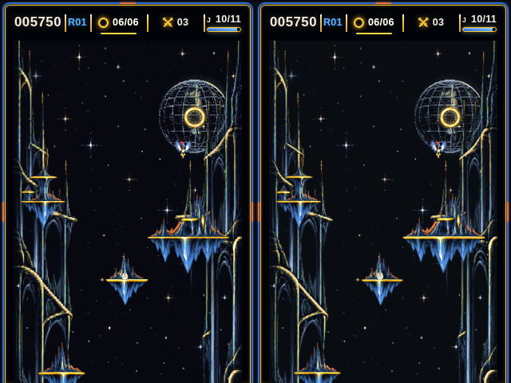
FIGURE 1 - The C panel renderer (left) and the browser (right) at the same tick of the mortal trace. 320 x 480, as on the panel.

The pipeline
Stage | Browser source | C | Proof
Scene: sprites, islands, rings, props, popups, banners, menu as instanced quads | render/scene.mjs, ring-fx, bird-animation, camera, session feel | struthio_scene.c | equal draw list on all 75,144 ticks
Sprite pass: depth, premultiplied blend, materials | WGSL in renderer.mjs | struthio_raster.c | 35.7-50.6 dB vs WebGPU at 3x
Post: tone, Arcade grade, bloom, scanlines, vignette | WGSL post pass | st_raster_post | quality 0 and 2 compared
HUD bar, toasts, page frame | DOM + CSS | captured layers, composed by struthio_panel.c | 43.2 dB vs the DOM render
Device picture | the canvas in a 320 x 480 window | struthio_panel.c + asset pack | 24.9-30.3 dB (below)

What the panel shows
In a 320 x 480 window the arcade page lays its 768 x 1152 canvas out at 286 x 429 at (17, 51), with the HUD bar above and the frame around it. The handheld reproduces that page, with the wing buttons in place of the touch deck. The browser shows the canvas with nearest-pixel scaling, which drops thin lines, stars and glyph strokes. The handheld instead targets the full canvas area-filtered to 286 x 429: textures are prefiltered to that density offline, so the device reads about one texel per pixel.

The panel renderer
- Draws straight into 16-line bands (30 per frame); there is no framebuffer. Each band is cleared, the quads that touch it are drawn with a 16-bit depth test and premultiplied blending, then post, then the HUD.
- Post at quality 0: tone (exposure 1.8, white 1.6) per channel through a 256-entry table, then the Arcade grade through a 65,536-entry RGB565 table.
- The world plates carry the ambience per texel (lit, star coverage, glint weights). Per plate row and per frame terms are computed once, so no transcendental function runs per pixel except the twinkle of actual star texels.
- The turning moon reads a per-texel latitude/longitude table and a filtered longitude map: no trigonometry per pixel.
- The HUD model ports hud.mjs and its CSS: toast fade 160 ms, gold-ring pulse 1.2 s to brightness 1.35, bar fade-in 140 ms.
- Bands go out in RGB565, byte-swapped for the panel. Even bands are drawn on core 0 and odd bands on core 1; the host check proves the split frame is identical to one pass.

The asset pack
host/make_pak builds build/assets/struthio.pak (8.3 MB) from the browser's exported textures and the HUD capture. idf.py flash writes it to the assets partition; the firmware maps it and reads textures through the flash cache. It is never copied to RAM.
Entry | Size | Format
world_rear, world_near | 286 x 858 each | RGB565 + ambience bytes (lit, star coverage, moon-disk flag / alpha, glint weights)
bird_ink6, bird_ink1/2/3 | 572 x 429 each | RGB565 + 8-bit alpha; player and rival inks pre-applied
atlas | 763 x 763 | RGB565 + 8-bit alpha; island palette pre-applied
atlas_hi | 512 x 568 | full-resolution glyph and swatch strip (drawn magnified)
globe_map, globe_lut | 384 x 192, disk box | the moon's longitude map and per-texel row/longitude
chrome | 320 x 480 | the page frame, RGB565
427 HUD layers | 613 KB | run-length coded premultiplied RGBA; round toasts coded against a base toast

Measured against the browser
Check | Result
Game picture vs the browser frame area-filtered to 286 x 429, nearest sampling (default), 18 frames | 24.9-30.3 dB
Same, bilinear sampling (BILINEAR=1, 4 reads per pixel) | 28.2-31.2 dB
For scale: the browser's own nearest-pixel display vs the same reference | 27-29 dB
HUD from the pack vs the DOM HUD, after RGB565 | 43.2 dB
Host time per 320 x 480 frame (one x86 core) | 8-10 ms

The remaining differences sit on sprite edges, where a pixel's footprint straddles texels; flat areas match.
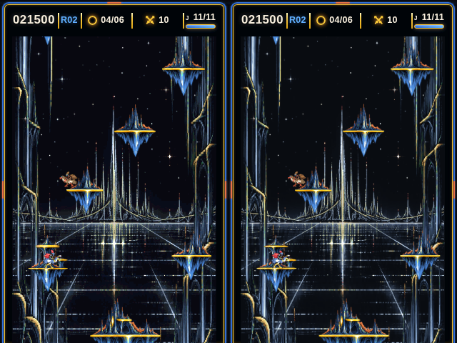
FIGURE 2 - C panel (left) and browser (right), climb trace tick 6000.

Not reproduced on the device
- Bloom, halo, scanlines and vignette (quality 1-2). The reference rasterizer has them; the device runs quality 0 to keep frame time.
- The islands' 0-4% brightness pulse on the music beat.
- Text is Chromium's greyscale anti-aliasing, captured with --disable-lcd-text; the HUD is a set of captured layers, not a font renderer.

7. Firmware

Boot sequence
1. Configure GPIO17/18 as pulled-up inputs; initialise NVS (erased and re-initialised if its format changed).
2. Load the DART trial (dart, default C) and the best score (best).
3. Allocate the greybox framebuffer and a DMA band; initialise power and the panel.
4. Boot guard: for 800 ms, if both wings have been held 650 ms, enter service mode.
5. Reset the input state (presses during the guard are discarded), initialise audio, backlight on.
6. Map the asset pack. With a working panel and a valid pack the panel renderer runs; otherwise the greybox renderer.
7. Start a run with a seed from the hardware RNG and start the tasks. No splash, no menu.

Memory
Item | Size | Where
Frame slots (quad list 4,096 x 80 B + HUD model + parameters) x 3 | ~984 KB | PSRAM
Post lookup tables | 130 KB | internal RAM (PSRAM fallback)
Band workspaces x 2 (colour, depth, HUD row) | 2 x 35 KB | internal RAM
Band line buffers x 2 (16 x 320 RGB565) | 2 x 10 KB | internal DMA RAM
Game state, scene state | 2.4 KB + 17 KB | internal RAM
Asset pack | 8.3 MB | flash, memory-mapped

Flash partitions (16 MB)
Name | Type | Offset | Size | Use
nvs | data / nvs | 0x9000 | 24 KB | best score, DART trial
phy_init | data / phy | 0xF000 | 4 KB | RF calibration
factory | app | 0x10000 | 4 MB | firmware, embedded climb.trace for service mode
assets | data / 0x40 | after factory | 11 MB | the asset pack (8.3 MB used)

Persistence and recovery
- NVS holds two values: best (high score) and dart (DART trial). Writes happen in the render task, never inside a game tick.
- Power-off ends the run; there is no checkpoint.
- Task watchdog: 3 s, panic and reboot. A hung game or render task returns the toy to a fresh run.

Service mode
Hold both wings while powering on. The screen and the USB log show:
- build, reset reason, free PSRAM and internal heap;
- live wing states, debounced press counts, darts fired, the active DART trial;
- on-device golden replay: the embedded climb.trace (10,011 ticks) through the C core with every tick's SHA-256 checked against the browser, then again without digests to time the bare simulation (both include a one-tick yield every 256 ticks, so they over-report slightly);
- a panel benchmark: full 320 x 480 presents, ms per frame.
LEFT tap cycles the DART trial (A, B, C, off; saved). RIGHT tap re-runs the replay and benchmark. Power-cycle to play.

8. Building, testing and flashing

On a desktop (no board needed)
handheld/run_tests.sh # every check that does not need the board
make -C handheld/host test # bit-exact replay of the five goldens
make -C handheld/host scene # scene builder vs the browser draw lists
make -C handheld/host pak # build/assets/struthio.pak
make -C handheld/firmware/host_test run # button tests + DART report
make -C handheld/firmware/host_test compile # type-check the firmware

Needs Node 22 and a C compiler. The graphics comparisons need the browser references in handheld/build/reference (not committed: they are large). Produce them with headless Chromium:
node handheld/tools/reference/capture.mjs --frames --textures # WebGPU via SwiftShader
node handheld/tools/reference/hud_capture.mjs # DOM HUD layers

run_tests.sh runs the scene, rasterizer, HUD and panel comparisons and builds the pack when those references exist, and says SKIP when they do not.

On the board
make -C handheld/host pak # the asset pack
cd handheld/firmware
idf.py set-target esp32s3
idf.py build flash monitor # app + asset pack to the assets partition

ESP-IDF 5.5 or newer (Waveshare's requirement for this board). sdkconfig.defaults sets 16 MB flash, the custom partition table, octal PSRAM at 80 MHz, 240 MHz CPU, 1 kHz FreeRTOS tick, the 3 s task watchdog and the USB Serial/JTAG console. Without the pack in flash the build warns and the firmware runs the greybox renderer.
NOT YET BUILT WITH THE REAL TOOLCHAIN
The build environment could not download ESP-IDF. make -C host_test compile type-checks every firmware source against a stand-in for the IDF headers. That catches mistakes in this code, not mismatches with the real SDK. The first idf.py build may need small fixes.

9. How the port is verified
The rule from v0.4 stands: do not judge the port by whether a bird appears to move similarly. Each layer is compared with the browser on recorded data, and a mismatch is a bug until explained.

Golden traces
tools/golden_export.mjs runs the unmodified browser Game and InputNormalizer headless while a bot presses two virtual wing buttons with millisecond timing. Each tick stores the presses, the frame the normalizer produced and the first 64 bits of the tick's SHA-256 state digest (STRGOLD1 format). The C side replays the same presses through its own normalizer and simulation, serialises its state to the same canonical JSON, hashes it and must match on every tick.
Trace | Ticks | Covers
climb | 10,011 | three round clears, gold ring, jousts, eggs, darts, chords (test shield on)
mortal | 14,143 | real lives: 12 deaths, an extra life, GAME OVER
duel | 20,000 | joust losses, frequent darts and chords
late | 10,990 | rounds 9-11 (8-rival cap, top tiers, short egg timers)
raw | 20,000 | frames straight into the sim: chord during cooldown, side-less darts

Mutation check: deliberately breaking gravity, ring slack, an AI branch, the egg-landing margin or the chord window each fails within a few hundred ticks. One mutation is not caught: the straight-up joust threshold moved from 24 to 25 subpixels, because no trace hits that exact boundary.

Everything run_tests.sh checks
Check | Proves
Port authority --check | the browser sources are the ones the port follows
Regenerated tower, rules, scene data | generated C matches the arcade sources
Golden re-export --check | the goldens still come from the browser byte for byte
host/replay | bit-exact simulation and normalizer on 75,144 ticks
host/amb_test | the device's decomposed ambience equals the shader
host/scene_check | the C draw list equals the browser's on every tick
host/raster_check | C rasterizer vs WebGPU frames, quality 0 and 2, >= 30 dB
make_pak, panel_check --hud, panel_check | pack builds; HUD and game picture vs the browser; two-core split identical
firmware/host_test run | buttons: debounce, chord, DART trials, service hold
firmware/host_test compile | firmware type-checks against the IDF shim

10. Hardware: the A0 bench prototype
A0 proves the electronics and the two-button game on the bench. Its locks are unchanged from v0.4, and the software was written around them. Section 11 turns A0 into a finished-looking handheld.
Item | A0 choice | Status
Carrier | Waveshare ESP32-S3-Touch-LCD-3.5B, portrait: ESP32-S3R8 240 MHz, 8 MB PSRAM, 16 MB flash, 320 x 480 AXS15231B QSPI, AXP2101, ES8311 + NS4150B | LOCKED FOR A0
Left wing | GPIO17 (header pin 16), switch to GND, pull-up, active low | LOCKED FOR A0
Right wing | GPIO18 (header pin 18), switch to GND, pull-up, active low | LOCKED FOR A0
Switch | Omron B3F-4050, 12 x 12 mm projected plunger, 7.3 mm, 1.27 N (B3F-4055 firmer alternative) | FEEL TEST REQUIRED
Speaker | 8 ohm, ~1 W, ~28 mm mono; low gain on first power-up | TO TEST
USB-C | short full-data male-to-female extension through the bottom of the shell | PART NOT CHOSEN
Battery | protected LiPo; CAD reference cavity ~36 x 52 x 6.2 mm | DEFERRED
Shell envelope | 88 x 128 x 25 mm (shrink target 85 x 125 x 23 mm) | LOCKED FOR FIT TEST

GPIO17/18 are published as free GPIOs and sit next to each other on the header. GPIO0, 3, 45 and 46 are strapping pins and GPIO19/20 are native USB, so none of those are used for the wings. No extra wire is needed for DART: trial C uses the same two switches.

Minimal BOM
Qty | Part | Requirement
1 | Main carrier | Waveshare ESP32-S3-Touch-LCD-3.5B
2 | Wing switch | Omron B3F-4050 candidate
2 | Small switch PCB | ~18 x 18 mm perfboard or simple daughterboard
1 | Speaker | 8 ohm, ~1 W, ~28 mm
1 | Battery | defer final lock
1 | USB-C extension | short male-to-female, full data + power
1 | Button harness | 3 wires: GPIO17, GPIO18, GND
4 | Case screws | M2-class
1 set | Printed shell | A0 front + rear + 2 wing caps

Enclosure CAD (unchanged from v0.4)
cad/struthio_a0_enclosure.scad is the parametric source; cad/stl/ holds the front shell, rear shell and mirrored wing caps, each watertight. The carrier is rotated portrait, which puts its USB-C inside the shell; hence the extension. SWITCH_PCB_PLANE_Z shims the switch plane after the first cap print.
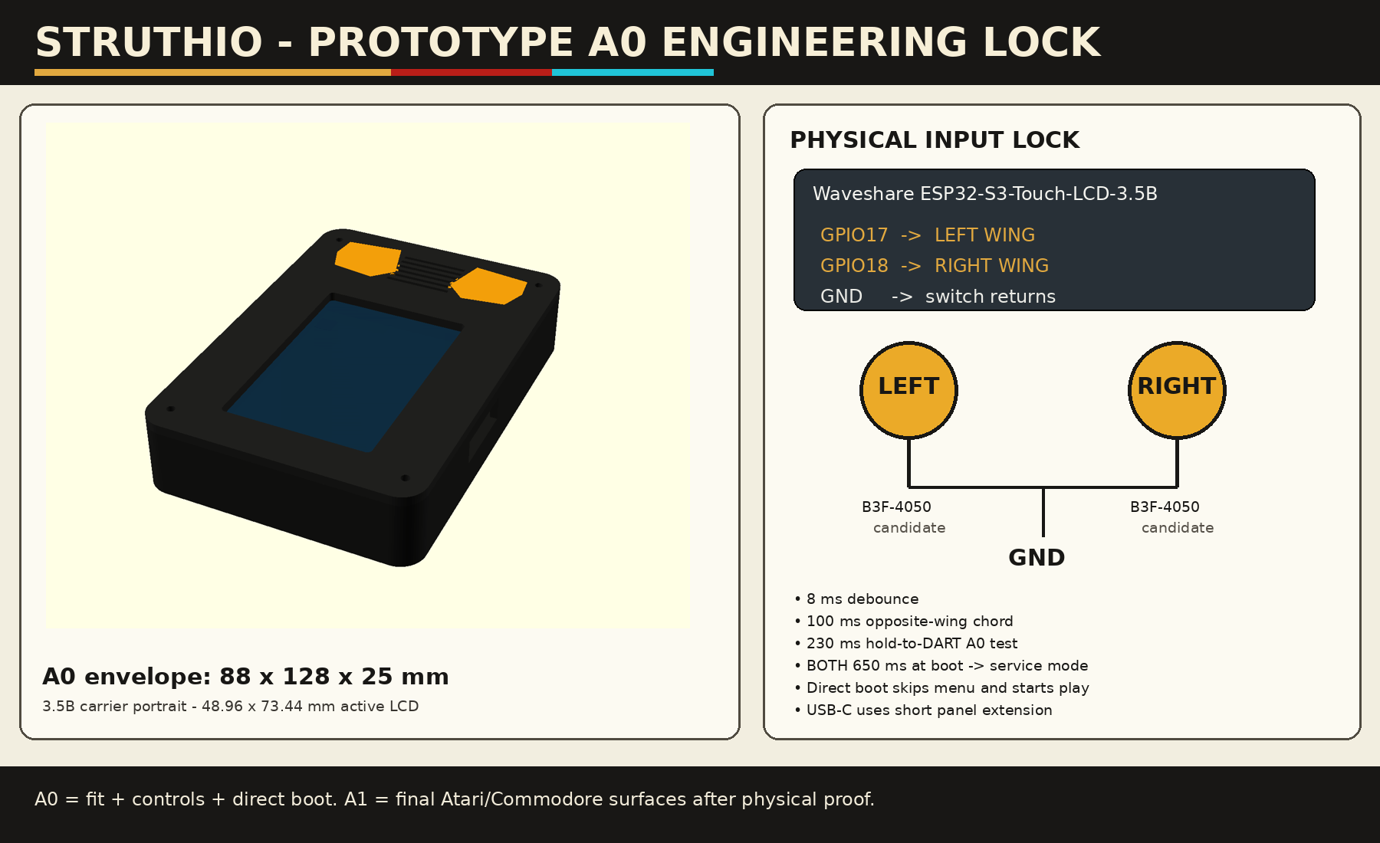
FIGURE 3 - Prototype A0 engineering lock (v0.4 CAD): 88 x 128 x 25 mm envelope, portrait carrier, two wing controls. Its 230 ms hold-to-DART note is the v0.4 trial A; the default is now trial C (section 3).

11. A1: a portable arcade
STRUTHIO was always meant to feel like the dedicated LCD games of the early 1990s, the Tiger Electronics handhelds and their cousins: one game per device, switch it on and play, a chunky plastic body, big action buttons, a row of small pill buttons for the housekeeping, full-colour art printed all over the face, a battery door held by a screw, an ALL CLEAR pinhole and a folded instruction sheet in the box. A1 takes the proven A0 electronics and gives them that object.
THE PLASTIC IDEA: A PORTABLE ARCADE
The face reads like an arcade cabinet shrunk into the hand. Marquee on top (the STRUTHIO logo from the game's box art), the screen in a raised bezel below it, then the control deck: a pill row, two big wing buttons on round pads, a slotted speaker, all printed over the box-art battle scene, and a "PORTABLE ARCADE" tagline band at the bottom.
The vertical, tapered body follows the portrait handhelds of the period, which suits STRUTHIO's portrait screen.

INSPIRED BY, NOT COPIED FROM
A1 borrows the genre, not anyone's marks: no Tiger, Konami or other company names, logos, typography or recognisable trade dress on the shell, labels, leaflet or packaging. STRUTHIO's own box art, logo and palette carry the look.

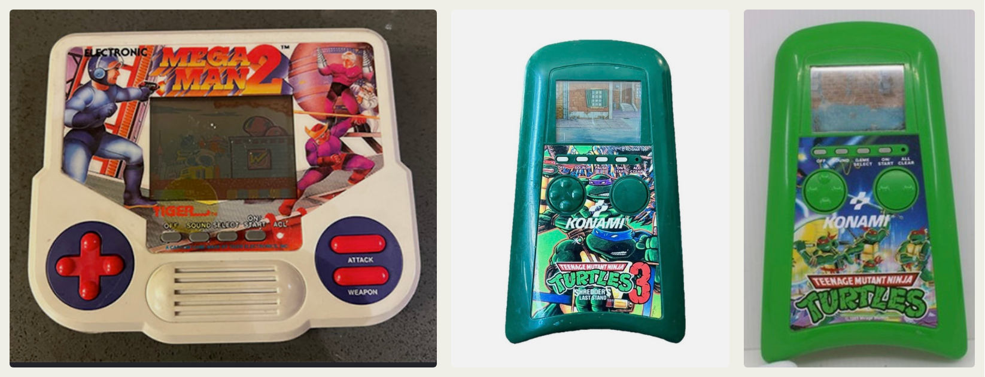
FIGURE 4 - Reference units supplied for A1 (third-party products, shown for reference only): a landscape 1990s LCD handheld with full-face art, pill row and slotted grille, and two vertical tapered handhelds with the screen on top and the controls on an art panel below.

What A1 takes from the reference units
Seen on the references | STRUTHIO A1 | Status
One game; switch on and you are playing | Power-on starts a run; no menu, no START needed | Done in firmware
Vertical tapered body, screen at the top, controls below | 88 mm wide at the top, 82 mm at the bottom, 158 x 25 mm; crowned top, scooped bottom | Proposal; grows A0's 128 mm by 30 mm
Full-face printed art overlay | Marquee logo, box-art scene behind the control deck, tagline band | Proposal; art from hero-art.webp
Screen in a raised frame | Raised bezel with a gold rim around a clear lens | Proposal
Pill row: OFF, SOUND, PAUSE / SELECT, ON/START, ALL CLEAR | OFF, SOUND, PAUSE, ON/START pills and an ALL CLEAR pinhole, labels printed under them | Proposal; GPIO and firmware not done
Big round button pads, hard caps on rubber domes | The A0 wing caps on round pads; B3F tactile (A0) or a rubber-dome variant | Feel test
Slotted speaker grille in a raised oval | Raised oval with four slots over the 28 mm speaker | Proposal; audio not wired yet
Reflective LCD, no backlight, very long battery life | Backlit 320 x 480 IPS: STRUTHIO's real picture; shorter battery life | Deliberate difference
Cells behind a door held by a small screw | Battery door with one captive screw; LiPo inside, or an AA pack option | Proposal
Auto power-off | Sleep after idle at GAME OVER or PAUSE; a wing press wakes it | Proposal; firmware not done
Solid, bright single-colour plastic | Deep navy shell with gold caps; a bright colourway is a later option | Proposal
Folded instruction sheet | Player's instruction sheet, Appendix C | Drafted

Measure the reference units before locking A1 (see "Reference-unit study" below). Every number in this chapter is a STRUTHIO proposal, not a measurement of another company's product.
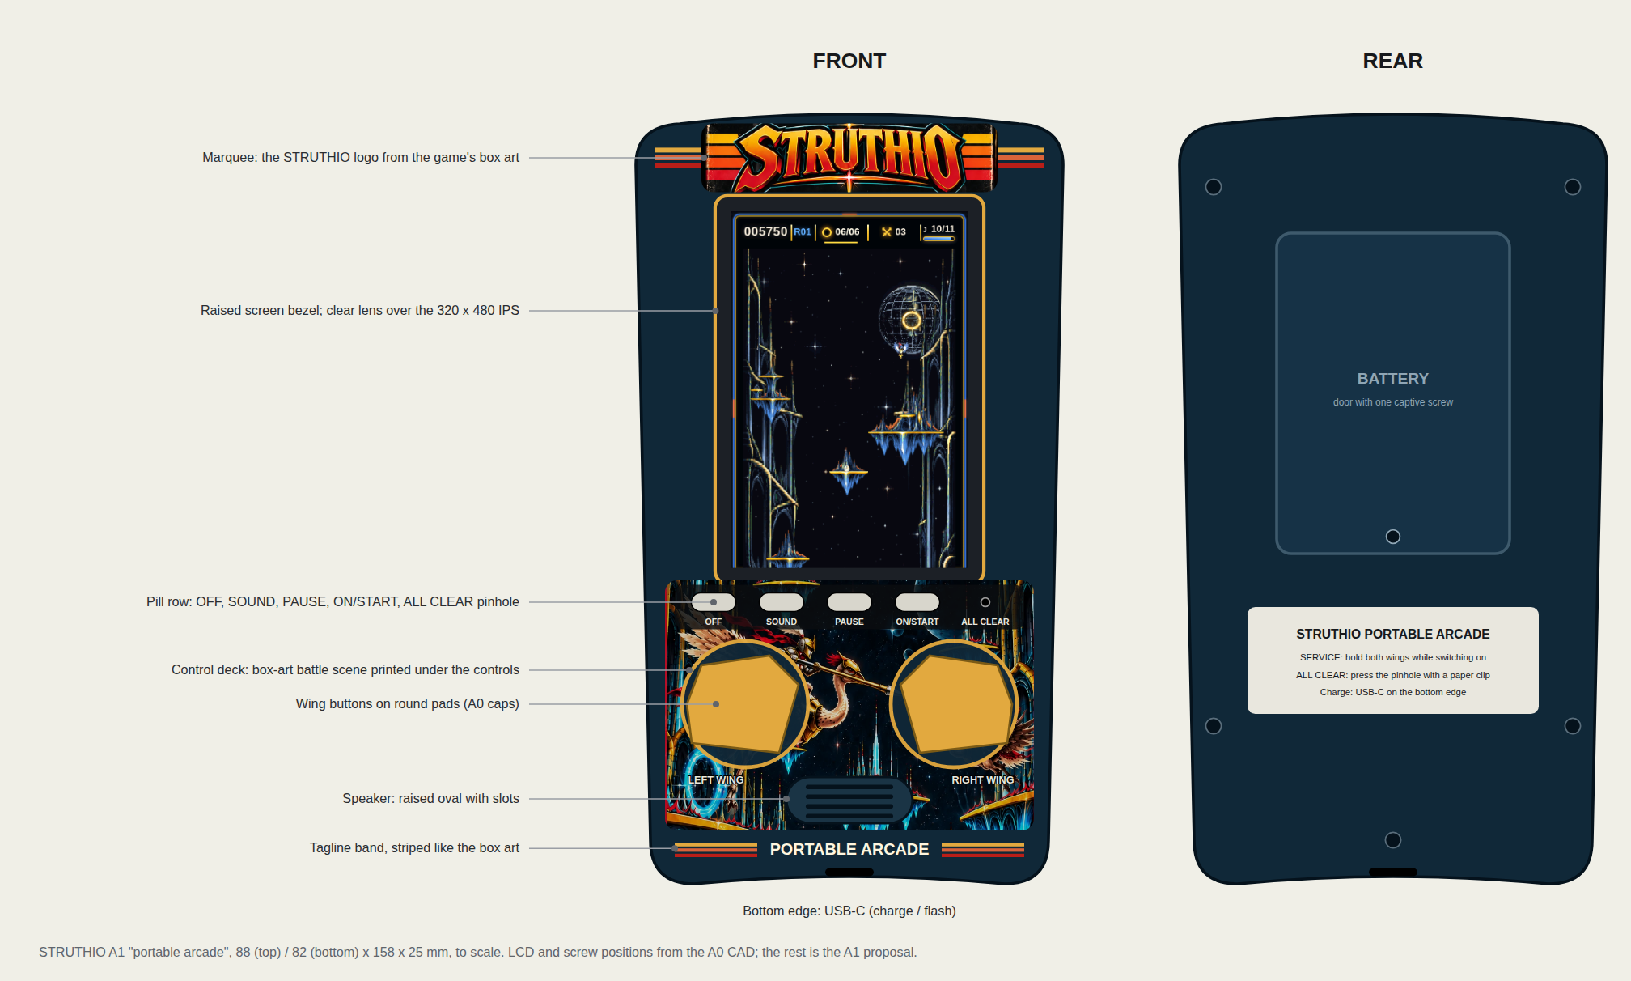
FIGURE 5 - A1 "portable arcade", front and rear, to scale. The screen shows a real frame from the C panel renderer; the overlay uses the game's own box art. LCD and screw positions come from the A0 CAD; the rest is the A1 proposal (source: cad/a1/make_layout.py).

The front face
Coordinates are mm from the A0 face centre, y up, as in the A0 OpenSCAD model. The A1 body extends A0's -64 to +64 to -88 to +70: 6 mm more for the marquee, 24 mm more for the control deck.
Zone | Position | Notes
Marquee | y +54.5 to +68.6; logo 61 mm wide, stripes across the full width | STRUTHIO logo from the box art; gold / red stripes either side
Screen bezel | raised frame 55.4 x 79.8 mm around the screen, gold rim | Lens recessed in the bezel
Screen window | 48.96 x 73.44 mm active area centred at y +13.78 | Opening 0.55 mm inside the active area on each side (A0 rule)
Control deck art | x -38 to +38, y -25.5 to -77 | Box-art battle scene printed on the overlay
Pill row | y -30: OFF x -28, SOUND x -14, PAUSE x 0, ON/START x +14; ALL CLEAR pinhole x +28 | Pills 9.2 x 3.8 mm on a dark strip, labels underneath
Wing buttons | x -21.5 and +21.5, y -51 on 26 mm round pads | The A0 caps, lowered 3.5 mm from A0's -47.5 to clear the pill row
Speaker | raised oval 26 x 9.5 mm centred at y -70.75 | Four slots over the 28 mm speaker
Tagline band | y -80 | "PORTABLE ARCADE" between striped bars
USB-C | bottom edge | The A0 extension opening: charging and flashing

Buttons
The wing buttons decide whether STRUTHIO feels like a toy or like a dev board. Build both constructions and choose by thumb, in the same sessions as the DART test:
 | A Tactile (A0) | B Rubber dome (1990s feel)
Mechanism | Omron B3F-4050 under a printed cap | Hard cap on a silicone dome; a carbon pill shorts gold interdigitated pads on a small PCB
Feel | Crisp click, short travel | Soft, quiet, longer travel: the 1990s handheld feel
Parts | Off-the-shelf switch, perfboard | Custom button PCB (ENIG pads) and a dome sheet that also carries the pills
Electrical | Clean contact, short bounce | Contact resistance of tens to hundreds of ohms and a slower make: re-check the 8 ms debounce and the internal pull-up
Risk | Clicky, less toy-like | Feel varies with dome choice; needs a PCB spin

The pill row, as on the references:
Pill | Does | Hardware | Firmware
OFF | Saves and switches the device off | One GPIO | Asks the AXP2101 to power down (not written yet)
SOUND | Speaker on / off, remembered | One GPIO | Mute flag in NVS (not written yet)
PAUSE | Stops and resumes play | One GPIO | Drives the sim's existing PAUSE state (not written yet)
ON/START | Switches on; the run starts by itself | Plunger onto the board's PWR key | None: power-on already starts a run
ALL CLEAR | Hard reset, with a paper clip | Pinhole, recessed ~3 mm, onto the board's RESET key | None: the board restarts into a new run

- Pill GPIOs (3): choose from the expansion header after the schematic check, never GPIO0, 3, 45, 46 (strapping) or 19, 20 (USB). Prefer pins that can wake the chip from deep sleep (the ESP32-S3 RTC-capable GPIOs; confirm in the datasheet). GPIO17/18, the wings, are in that group.
- PWR and RESET keys are on the board: the ON/START plunger and the ALL CLEAR pin must reach them from the front. Their positions come from the vendor drawing; if a key sits too far from its pill, wire a small switch in parallel instead (check the schematic first).
- BOOT stays behind the battery door: only needed for recovery flashing.

Power: batteries the Tiger way
Tiger games ran for a long time on a few cells because a reflective LCD draws almost nothing. STRUTHIO's backlit IPS panel and 240 MHz dual-core renderer draw far more, so battery life is the one place A1 cannot match the originals. Two ways to power it:
 | A Internal LiPo (recommended) | B AA pack (heritage option)
Cells | One protected 1-cell LiPo, ~36 x 52 x 6.2 mm cavity | 3 x AA in a holder (NiMH or alkaline)
Connection | The board's battery connector; the AXP2101 charges it from USB-C | A 5 V boost module into the board's 5 V input (USB-C path, or a 5 V header pin if the schematic confirms one)
Charging | USB-C, cells stay inside | None: swap cells, like the originals
Door | Battery door with one captive screw hides the cell | Battery door with one captive screw; spring contacts
Depth | Fits the 25 mm A0 envelope | AA cells are 14.5 mm thick: needs a deeper rear or a rear bulge; check before choosing

POWER SAFETY
Never connect AA, NiMH or any non-lithium pack to the board's LiPo connector: its charger would try to charge it.
Do not feed the boost output and a USB cable at the same time unless the two are joined through a power-path or ideal-diode circuit.
Use only a protected LiPo, and check polarity on the connector before plugging it in (the A0 rule).

Battery life is measured, not guessed. Hours = usable watt-hours / measured watts. Example only: a 1,000 mAh LiPo holds about 3.7 Wh, so at 1 W it would last roughly 3.5 hours. Measure the real draw in play, at idle and with the backlight at each level (bring-up step 11) before choosing a cell or promising a runtime.
Auto power-off (proposal): after two minutes untouched on GAME OVER or PAUSE, turn the backlight off and put the ESP32-S3 into deep sleep with either wing as the wake source; the AXP2101 PWR long press stays the full off. This needs firmware that is not written yet.

Screen window and bezel overlay
- A clear 1.0-1.5 mm acrylic or polycarbonate lens sits in a recess in the front shell, the way the originals framed their LCDs.
- The bezel art is printed on the back of the lens or on a thin sheet behind it (second-surface print), so play cannot rub it off.
- Keep at least 0.4 mm between the lens and the display glass and never clamp the glass (A0 rule).
- The IPS panel is bright; a matte or anti-glare lens is an option if reflections bother players. Test both under room light.

Shell, finish and labels
Item | A1 proposal
Material | Print in PETG or ASA for strength (PLA for fit checks only); the originals were moulded ABS
Walls and closure | A0 values: 2.4 mm walls, 3 mm front plate, 4 x M2 screws with heat-set inserts
Finish | Sand, prime, matte graphite paint; or print in a graphite filament and leave it
Colours | Deep navy shell (STRUTHIO navy #102838), gold wing caps and bezel rim, light grey pills; the overlay carries the box-art colours. A bright single-colour shell, as on the references, is a later colourway
Front overlay | One full-face printed overlay (marquee, deck art, pill labels, tagline) under a clear protective film, cut around the screen bezel, pills, pads and grille
Rear label | Vinyl label plate: "STRUTHIO PORTABLE ARCADE", SERVICE: hold both wings while switching on, ALL CLEAR: press the pinhole, Charge: USB-C
Battery door | Separate printed part, one captive M2 screw, a hook at the far end

Reference-unit study
One afternoon with real 1990s handhelds settles most A1 questions. For each reference unit, record in docs/A1_REFERENCE_UNITS.md:
- outer width, height, depth and corner radius; weight with cells;
- action-button cap size, travel and force (a kitchen scale and a ruler are enough), and how the dome feels;
- pill button size and spacing; screen window inset and lens thickness;
- battery door design, screw type, cell type and count;
- grille hole size and pattern; label placement on the back.
Compare with 88 x 128 x 25 mm and the A0 button positions; adjust the A1 CAD only from these measurements.

A1 changes to the electronics
Change | What it needs | Status
Rubber-dome wing buttons (option B) | 2-button PCB with gold interdigitated pads, GPIO17/18/GND harness unchanged | Design after the feel test
OFF, SOUND and PAUSE pills | 3 free GPIOs, 3 small switches or domes, firmware | Pins TBD from the schematic
ON/START pill | Printed plunger to the board PWR key | Position from the vendor drawing
ALL CLEAR pinhole | Pin onto the board RESET key, or a parallel switch | Position from the vendor drawing
Taller body (158 mm) | New A1 CAD; the extra deck space can also take the battery or AA holder | CAD not drawn yet
AA pack (option B) | 3 x AA holder, 5 V boost module, power-path if USB stays connected | Only if the depth allows
Low-battery warning | AXP2101 battery level to a HUD icon | Firmware proposal

A1 BOM additions (candidates, not locked)
Qty | Part | Requirement
1 | Lens | 1.0-1.5 mm clear acrylic or polycarbonate, cut to the window recess
1 | Face overlay | Full-colour printed film with a clear protective laminate, die- or knife-cut
3 | Pill switches | 6 x 6 mm tactile switches, or domes on the same sheet (OFF, SOUND, PAUSE)
1 set | Rubber domes + button PCB | Option B wing buttons
1 | Battery door | Printed, with one captive M2 screw
1 | AA holder + 5 V boost | Option B power only
1 set | Labels | Rear label plate and pill labels, vinyl

A1 acceptance tests (in addition to section 12)
Test | Method | Pass
Button feel | 3 players, 10 minutes each, A and B wing buttons | A clear preference; no missed or double flaps
Pills | OFF, SOUND, PAUSE, ON/START 50 presses each; ALL CLEAR 10 | Every press acts once; ALL CLEAR always restarts into a new run
Battery door | 20 open / close cycles | Screw holds; door does not rattle
Drop | Five drops from 1 m onto carpet | No rattles, cracks or loose parts; the game still plays
Runtime | Play from full until the low-battery warning | Measured hours recorded; meets the number chosen for A1
Lens | Room light and window light | Picture readable; no glare complaint, or anti-glare lens chosen

If STRUTHIO is ever sold or given as a toy, the applicable toy-safety rules apply (for example EN 71 in Europe and ASTM F963 in the United States, which among other things cover battery compartments and small parts), as do lithium-battery rules. That is outside A1, which is a prototype for adults to test.

12. Bring-up on the board
Before the board arrives, handheld/run_tests.sh must pass. Then, in this order, so faults stay separable:
1. Record the board revision. Flash and run Waveshare's own ESP-IDF example unchanged.
2. Move the example's panel (AXS15231B over QSPI), power (AXP2101, backlight) and later audio init into firmware/main/board_waveshare_35b.c. board_display_lines() must accept 16-line bands, high byte first.
3. idf.py build flash monitor without the asset pack first. The game runs on the greybox renderer.
4. Hold both wings at power-on. Record GOLDEN PASS, sim µs per tick, digest µs per tick and the panel ms per frame.
5. Confirm GPIO17/18 read high idle and low pressed with the display active (service mode shows live states and counts).
6. make -C handheld/host pak, flash again with the pack. Read scene and render µs in the log every 300 frames: the first device measurement of the C renderer.
7. Play. Confirm the 100 ms chord and thumb-test DART trial C, then A and B. Lock one only after real play.
8. If 16-line bands misbehave on the AXS15231B, try larger bands or full-frame writes and record which works.
9. Wire the audio (ES8311 + NS4150B) at low gain with the 8-ohm speaker.
10. Print the front shell only; test the LCD opening and board width. Then one wing cap; tune SWITCH_PCB_PLANE_Z. Then the rear shell.
11. Battery last: polarity, charge, low-battery and shutdown behaviour before enclosing the cell. Measure the current in play, at idle and at each backlight level: the A1 runtime comes from these numbers.

If the renderer is too slow
The frame budget at 30 fps is 33 ms over two cores, and the scene builder runs in the game task every tick. In order of cost to fidelity:
- Check that the post tables and band workspaces landed in internal RAM: the tables fall back to PSRAM silently when internal RAM is short.
- Profile the scene builder: it keeps double precision so its draw list equals the browser's, and the ESP32-S3 has no double-precision FPU. A float build is possible if the draw list stays within tolerance.
- Profile flash-cache misses on the textures; move the hottest (birds) to PSRAM.
- Last resort: render at 20 fps. The simulation stays at 60 Hz either way.

Acceptance tests
Test | Method | Pass
Cold boot | power-cycle 20 times | 20/20 reach a live run without touch, menu or debug
Input bounce | tap each switch 100 times | no phantom double flaps; logged presses match
Chord | 50 two-button chords at varied timing | straight-up at the 100 ms window, no lag on the first press
DART | repeated sessions with the chosen trial | no recurring accidental DART
Simulation | service-mode golden replay | GOLDEN PASS on the device
Frame pacing | worst visible scene, 10 minutes | no tearing; 30 fps held or a lower target chosen; zero missed game deadlines
Persistence | set a high score, power off/on | the score returns
Watchdog | inject a task hang | the device resets into a new run
Soak | 30-60 minutes of play | no crash, corruption or thermal problem

13. Known deviations from the browser
Every intentional difference is named here rather than left to drift.
Deviation | Why
DART is a held two-wing gesture (trial C), not a downward flick | two buttons cannot flick; pending a thumb test
GAME OVER needs both wings held to start a new run | a stray flap from the last fight must not skip the result
No title / attract screen: power-on starts a run | appliance behaviour; the menu shows only on GAME OVER
Picture is the area-filtered canvas, not nearest-pixel | keeps thin detail at 286 x 429
Post at quality 0 (no bloom, scanlines, vignette) | frame time on the device
No island music pulse (0-4%) | no music yet; small effect
Display at <= 30 fps, simulation at 60 Hz | panel bandwidth and render time; to be measured
Audio: not yet implemented (cue hook only) | needs the board
A1 adds OFF, SOUND and PAUSE pills, ALL CLEAR and auto power-off, which the browser does not have | the handheld's own housekeeping, 1990s style

Risk register
Risk | Impact | Mitigation / trigger
Renderer too slow on the ESP32-S3 | High | measured at bring-up step 6; see section 12 for the order of fixes
QSPI panel bandwidth | High | bands go out as they finish; try band sizes and full-frame writes; 30 fps target
First real idf.py build finds SDK mismatches | Medium | small, local fixes; the shim only type-checks
DART gesture under a real thumb | High | trials A/B/C switchable in service mode without a rebuild
Flash-cache contention between textures and the panel DMA | Medium | move hot textures to PSRAM
Simulation drift after a browser update | High | port authority --check and the goldens fail until ported
Enclosure built too early | Medium | no final shell until the bare-board prototype passes A0
Battery life far below the 1990s originals | Medium | measure first; auto-off, backlight levels, LiPo size; say so on the box
AA option does not fit the 25 mm depth | Medium | rear bulge or LiPo only; decided from the depth check
Rubber-dome feel or bounce unsuitable | Medium | keep the B3F tactile construction
Look too close to another company's product | Medium | STRUTHIO art and palette only; no third-party marks or trade dress

14. Next work and open decisions
1. Bring up the board (section 12) and record the first device numbers: µs per tick, scene µs, render ms, panel ms.
2. Lock the DART gesture after a thumb test.
3. Lock 30 fps or a higher rate from the measurements.
4. Audio: one embedded music stream and pre-rendered SFX cues through the ES8311; audio never touches the game state.
5. Battery, then the full A0 shell.
6. A1 (section 11): reference-unit study, A1 CAD for the 158 mm portable-arcade body, wing-button feel test (tactile vs rubber dome), pill GPIOs, OFF / SOUND / PAUSE / auto-off firmware, print-ready face overlay from the box art, battery door, then the A1 print.
Open decisions: whether retail boot shows a sub-second mark or nothing; USB-only updates or a hidden OTA path; the shell shrink from 88 x 128 x 25 mm toward 85 x 125 x 23 mm after the fit print.

15. Repository map
handheld/
core/ C11 simulation, normalizer, digests, replay (portable, no heap)
render/ scene builder, reference rasterizer, panel renderer, pack loader, greybox
firmware/ ESP-IDF app (main.c, service.c, buttons, board adapter), host tests, IDF shim
host/ replay, scene/raster/panel checks, amb_test, make_pak
tools/ golden exporter, generators, port authority, browser reference capture, this manual
golden/ five browser-recorded traces
cad/ A0 enclosure (OpenSCAD source, STLs, renders); a1/: portable-arcade layout drawing
docs/ this manual, graphics port, validation report, bring-up, wiring, BOM, port authority
run_tests.sh

This manual is generated: python3 handheld/tools/manual/build_manual.py STRUTHIO_ESP32_HANDHELD_v0.4.docx (the v0.4 manual supplies the page design and the industrial-design figures).

References
- Waveshare ESP32-S3-Touch-LCD-3.5B: https://docs.waveshare.com/ESP32-S3-Touch-LCD-3.5B
- Waveshare 3.5B resources, schematics, drawings, examples: https://docs.waveshare.com/ESP32-S3-Touch-LCD-3.5B/Resources-And-Documents
- Espressif ESP32-S3 datasheet (strapping pins, USB pins): https://documentation.espressif.com/esp32_s3_datasheet_en.pdf
- Espressif ESP32-S3 hardware design guidelines: https://docs.espressif.com/projects/esp-hardware-design-guidelines/en/latest/esp32s3/
- Omron B3F tactile switch datasheet: https://components.omron.com/us-en/datasheet_pdf/A070-E1.pdf
- NS4150B amplifier reference: https://dl.espressif.com/dl/schematics/NS4150B.pdf

Appendix A. Industrial design direction (carried from v0.3)
Concept visualisations for planning, not fabrication authority. Geometry in sections 10 and 11 is the engineering authority.
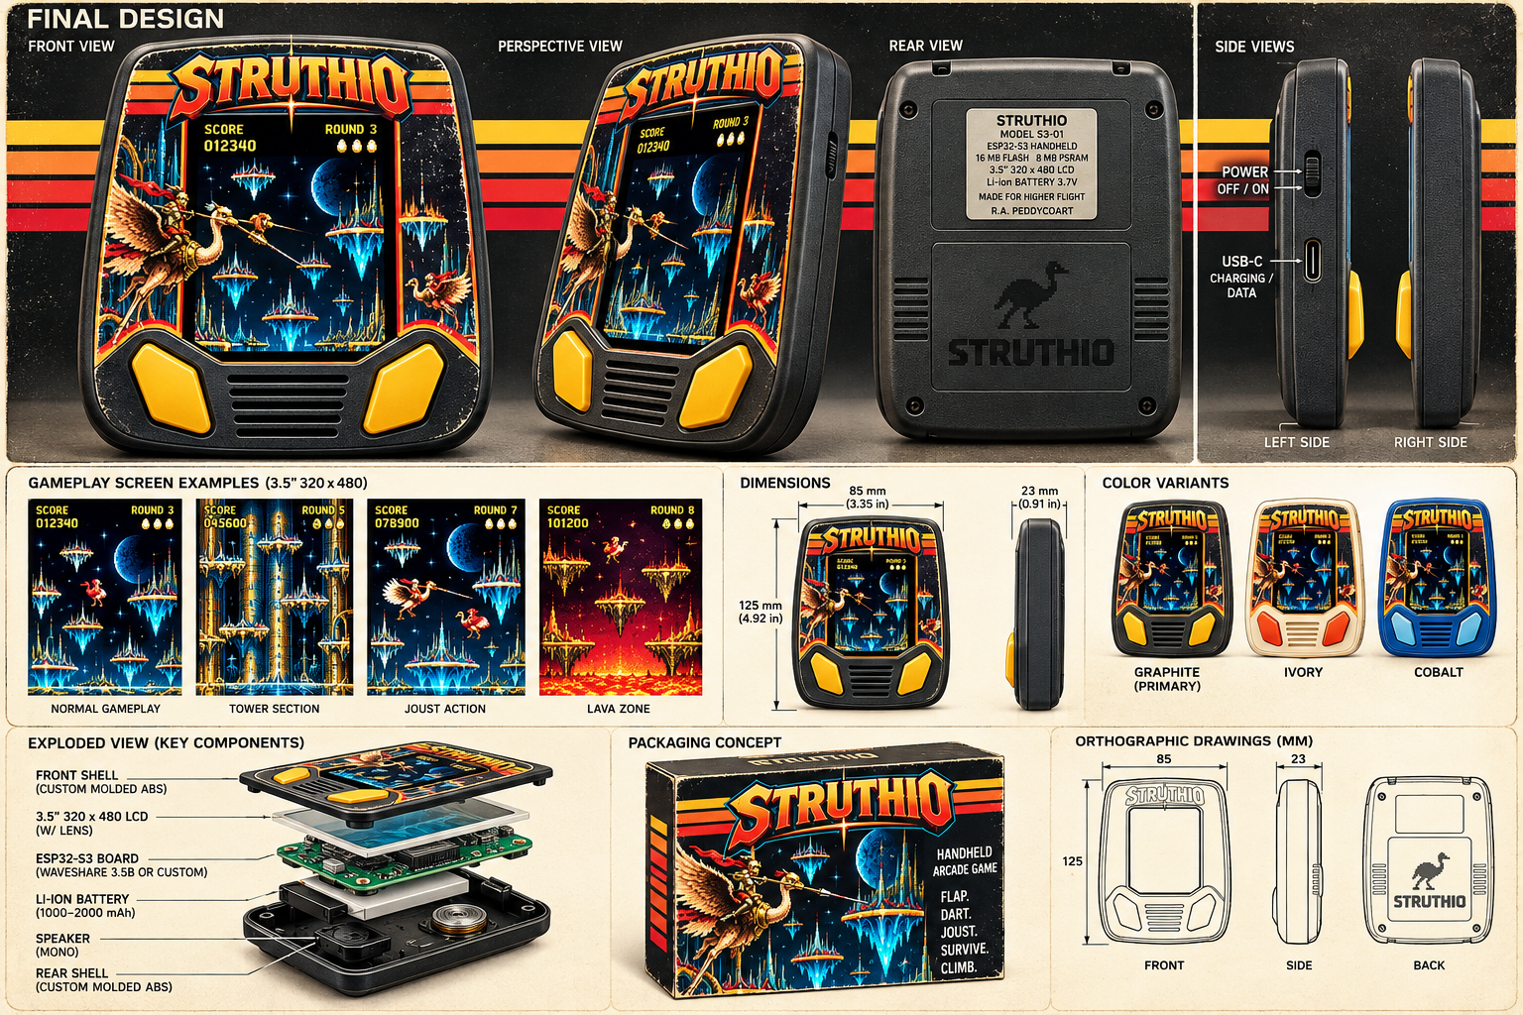
FIGURE A - Preferred product direction: graphite shell, warm retro stripes, two dominant wing controls, portrait display.
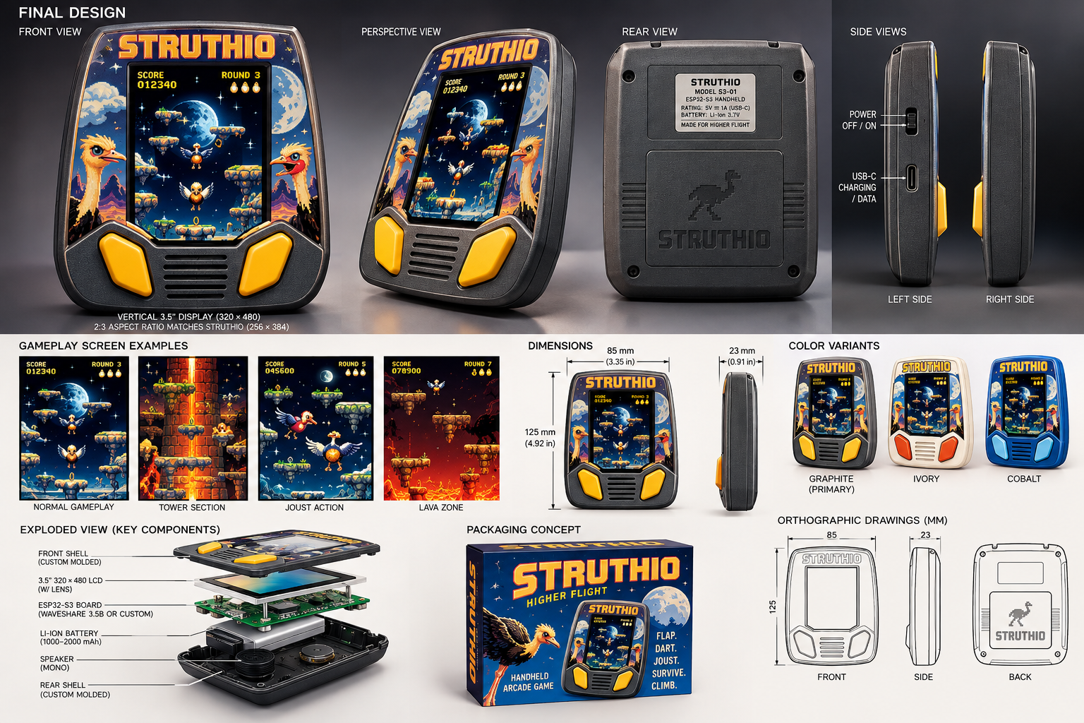
FIGURE B - Integrated final-design board: front, perspective, rear, side, packaging and exploded assembly.
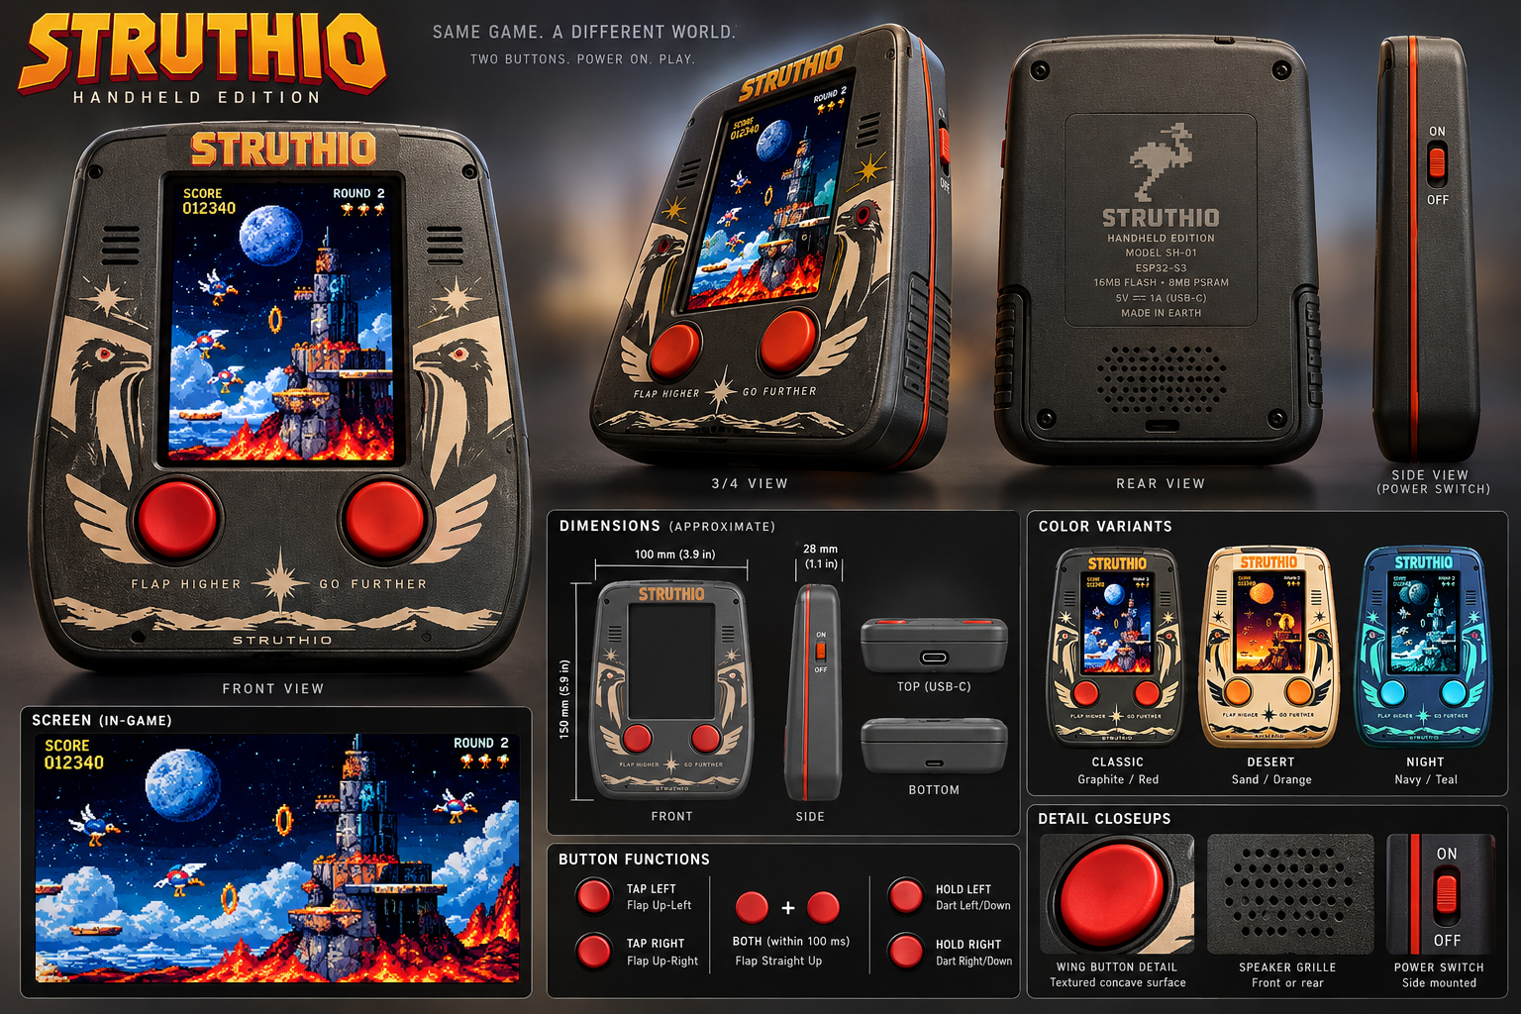
FIGURE C - Heritage handheld direction: two buttons first, the game screen second, everything else hidden.

Appendix B. Change history
Version | Date | Change
v0.1-v0.2 | 2026-09 | Prototype path from STRUTHIO ARCADE 1.6.0; industrial design boards.
v0.3 | 2026-09-28 | CAD and ESP32-S3 engineering kickoff.
v0.4 | 2026-09-28 | A0 enclosure files, GPIO17/18 wing lock, host-tested input scaffold.
v0.5 | 2026-10-01 | Simulation ported to C, bit-exact with 1.8.0 on 75,144 ticks; exact normalizer; DART trials measured; firmware on the core.
v0.6 | 2026-10-01 | Browser renderer ported (scene builder equal on every tick; materials and post measured vs WebGPU; HUD captured); asset pack; two-core panel renderer; firmware renders the browser picture. Manual rewritten for the C port.
v0.7 | 2026-10-01 | Hardware chapter for A1, a 1990s-style "portable arcade" handheld: reference units, layout drawing with the game's box art, buttons, power and battery door, screen window, shell and labels, reference-unit study, A1 BOM and tests; player's instruction sheet (Appendix C).

Appendix C. Player's instruction sheet (draft)
The folded sheet that goes in the box, in the 1990s style: short, friendly, nothing a player does not need. Rules are taken from the game itself (STRUTHIO ARCADE 1.8.0, as ported).
STRUTHIO PORTABLE ARCADE - HOW TO PLAY
TURN ON. Press ON/START. The game starts by itself. OFF switches it off.
FLY. Press the LEFT WING or the RIGHT WING to flap that way. Hold a wing to steer.
STRAIGHT UP. Press both wings together.
DART. Hold both wings down to dive the way you are facing.
JOUST. Meet a rival with your lance higher than theirs to knock them off. Rising straight up always wins. Lances level? You both bounce.
EGGS. A beaten rival leaves an egg. Grab it before it hatches: 250, 500, 750, then 1,000 points for each egg in a row.
RINGS. Fly through the six rings (500 points each). When all six are yours, the gold ring opens at the moon: reach it to clear the round.
LIVES. You start with 11 jousts. Extra ones at 30,000 points and every 100,000 after. Keep out of the lava.
GAME OVER. Hold both wings to play again.

BUTTONS AND CARE
SOUND turns the speaker on and off. PAUSE stops the game; press again to go on. ALL CLEAR (the little hole) restarts the game: press it gently with the end of a paper clip.
Charge with a USB-C cable at the bottom. If the game ever stops responding, press ALL CLEAR.
Keep away from water. Do not open the battery door except to change batteries.

OFF, SOUND, PAUSE, ALL CLEAR, the battery door and the charging line depend on A1 choices still open; edit the sheet when they are locked.

