Computational Physics

Exam 1 Report

Part 1: Algorithms

Using a recursion algorithm to compute ex that is as follows:

$$S_{n+1}=1+\frac{xS_{n}}{n}$$

I developed a program to estimate ex to n number of terms. I then plotted the resulting sum for each term versus the number of terms. The results of the program were very satisfactory, as the recursion formula allowed for high precision in estimation while utilizing very little computational power.

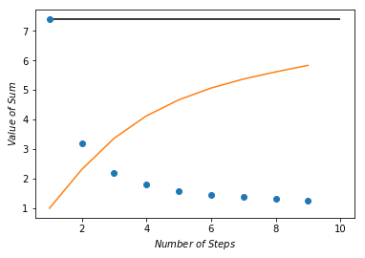

Figure 1: A plot of the sum versus the number of terms estimated at e2. The black line represents the actual value of e2. The orange curve is the plot of the sum after addition of previous term to sum, and the blue dots are the fractional error (e2/sum).

Question posed: Does the algorithm converge quickly or slowly?

Looking at figure 1, I would say the algorithm converges rather quickly.

Part 2: Random Process:

I utilized an example program written in lecture to write a program that simulates radioactive decay. I then plotted the number of remaining nuclei versus the time elapsed.

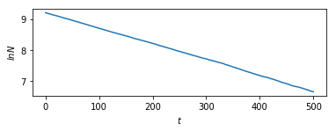

Figure 2: A plot of the natural log of the number of nuclei remaining (N) versus the time elapsed (t).

Question posed: How does your simulation show that the decay is exponential-like and not a power law such as N=βt−α ?

My simulation shows that the decay is exponential-like because the plot of ln(N) vs. t is a straight line. If it were not, it would indicate that the decay could potentially be a power law function.