# Composition services

## The composition infrastructure

While it is true that the composition (see also Inversion of Control or Dependency Injection) provides an abstraction level which, in the beginning, may be hard to understand with respect to the way it works, in the end it makes the application easier to keep under control, more extensible, more maintainable, and, very important, easier to unit test.

The infrastructure for composition includes:

* The interface IConventionsRegistrar, which is the contract for registering composition conventions.
* The interface IConventionsBuilder, which is the contract for defining conventions using a fluent API.
* The interface ICompositionContainer, which is the contract for components providing composition hosting.
* The class CompositionContainerBuilderBase, which provides a base implementation for builders of composition containers.

How the composition infrastructure works:

1. All the convention registrars are collected (simply all the classes implementing IConventionRegistrar) and then they are invoked to register the conventions.
2. The composition container builder registers the log manager, the configuration manager, and the platform manager with factory export providers.
3. The composition container builder registers all application services [link] according to their metadata provided by the [AppServiceContract] attribute.
4. The composition container is built using the provided conventions.
5. And last, the composition container registers itself as the service exporting ICompositionContainer.

Recommendations:

* There is no restriction about the number of convention registrars per assembly nor what those registrars should register. However, to keep the things under control, a registrar should not register conventions for components outside the scope of the assembly where it is defined and, also, it is recommended to have one registrar per assembly.
* For components participating in composition, if possible, import the required services in the constructor. By using this approach it is clearly defined what is required for the component to function properly and also specific checks may be performed at the constructor level regarding imported services. However, if there are a lot of dependencies, the constructor may not be very appropriate due to an ugly signature, therefore in this case it is acceptable to use either property import or a combination of them.
* Prefer conventions over attributes. The code becomes clearer and more concise, and the dependencies on specific IoC containers will diminish.

See exposing application services [link] for more details about how to use in practice the composition.

## Alternative container implementation

Kephas provides a default composition container based on the portable MEF implementation. If a custom implementation is required for other IoC containers, please take care of the following:

* The composition container should export itself as a shared service for the ICompositionContainer contact, so that services requiring the composition container get this service injected. Accessing ambient services (like AmbientServices.Instance.CompositionContainer [link]) makes unit testing very hard.
* Use a composition container builder derived from the one provided as base, to have access to all the features it provides, including the registration of application services.

# Application services

Application services are services discovered and registered with the composition container at application level.

Steps for defining an application service:

1. Define the application service contract and configure it using the [AppServiceContract] or [SharedAppServiceContract] attributes (Allow multiple: yes/no).
2. Implement one or more application services based on the contract defined in the step above. Note: for contracts not allowing multiple service implementations, it is a recommended practice to decorate the service implementation with the [OverridePriority] attribute.
3. Consume the service.

Note: To mark application services as shared use the [SharedAppServiceContract] attribute.

Note: Kephas registers automatically application services with the composition container, so no composition registrars are required in this case.

Note: Because the sharing scope is defined at the service contract level, there is no need to set it at the implementation level. Otherwise it’s even counterproductive and confusing, making hard to identify possible bugs.

Note: in most cases the definition and discovery of application services should be sufficient, and no other conventions registrar for other kind of components should be required.

## Override priorities

An override priority is used for services not allowing multiple implementations at the same time, to ensure a deterministic identification of the desired service. The override priority attribute is applied on the service implementation.

Kephas exposes its default services either with a lowest override priority (for example for null services), or with a low priority (the rest of them), to allow an uncomplicated override, because when an override priority is not provided, the normal value is used in this case.

Example:

/// <summary>

/// Application service for processing requests.

/// </summary>

[SharedAppServiceContract]

public interface IRequestProcessor : IAsyncRequestProcessor

{

/// <summary>

/// Processes the specified request.

/// </summary>

/// <param name="request">The request.</param>

/// <returns>The response.</returns>

IResponse Process(IRequest request);

}

/// <summary>

/// Provides the default implementation of the <see cref="IRequestProcessor"/> application service contract.

/// </summary>

[OverridePriority(Priority.Low)]

public class DefaultRequestProcessor : IRequestProcessor

{

//...

}

## Multiple services with the same contract

If the application service contract should allow multiple registered service implementations, set the AllowMultiple option to true in the contract declaration.

Example:

[AppServiceContract(AllowMultiple = true)]

Note: generic application service contracts allow multiple registrations by default, because it is expected that multiple services will be defined with different actual generic type parameters.

## Composition constructor

If an application service has only one constructor, this constructor is used for composition. If multiple constructors are defined, the constructor annotated with [CompositionConstructor] is used.

## Composition metadata

Application services may indicate metadata attributes that they use. The following conventions are applied:

* The attributes must implement IMetadataValue<TValue>. The Value property will provide the value of the metadata key.
* The attribute type without the “Attribute” suffix will be the metadata key.
* When declaring the contract, the supported metadata attributes must be declared.
* The attributes are applied to the service implementations.

Example:

/// <summary>

/// Application service for request processing interception.

/// </summary>

/// <typeparam name="TRequest">The type of the request.</typeparam>

[AppServiceContract(AllowMultiple = true, MetadataAttributes = new[] { typeof(ProcessingPriorityAttribute) })]

public interface IRequestFilter<TRequest> : IRequestFilter

{

}

## Generic application service contracts

When exposing generic application service contracts, Kephas will export the parts using the generic interface, unless a ContractType is specified in the metadata.

Example of generic export contract type:

/// <summary>

/// Application service for handling requests.

/// </summary>

/// <typeparam name="TRequest">The type of the request.</typeparam>

[AppServiceContract]

public interface IRequestHandler<TRequest> : IRequestHandler

{

}

In this example, the request handlers are exporting using the generic IRequestHandler contract type.

Example of the non-generic export contract type:

/// <summary>

/// Application service for request processing interception.

/// </summary>

public interface IRequestProcessingFilter

{

}

/// <summary>

/// Application service for request processing interception.

/// </summary>

/// <typeparam name="TRequest">The type of the request.</typeparam>

[AppServiceContract(AllowMultiple = true,

MetadataAttributes = new[] { typeof(ProcessingPriorityAttribute) },

ContractType = typeof(IRequestProcessingFilter))]

public interface IRequestProcessingFilter<TRequest> : IRequestProcessingFilter

where TRequest : IRequest

{

}

In this second example, the request processing filters are exported using the non-generic IRequestProcessingFilter contract type, so that all of them can be collected by the composition using the non-generic contract, and later decisions may be taken based on the generic type metadata.

Additional to the metadata collected by using the MetadataAttributes declaration, Kephas collects also from the service implementations the actual generic types and adds them to the existing composition metadata. The following rules are applies:

* The actual generic parameter is the metadata value.
* The adjusted name of the generic parameter is the metadata key. The adjusted name is obtained by stripping the leading “T”, if specified, and appending “Type”, if not already there.

# The Kephas Model

## Model element contracts

* INamedElement
* IModelDimension
* IModelDimensionElement
* IModelProjection
* IModelSpace
* IModelElement
* IAttribute
* IClassifier
* IProperty

## Model dimensions

* AppLayer
* Module
* Scope
* Aspect

## Model projections

## Model element names

The root mode space

## Factories

Factory namespace

IModelSpaceProvider: shared application service contract for providing a model space.

IElementFactory: shared application service contract for creating elements of the model.

Base factory abstract class: ElementFactoryBase.

* TryGetElementConstructorInfo: Based on the provided native element, tries to create a structure for creating the model element. If null is returned, the factory cannot create an element.
* CreateElement: creates an element based on the provided constructor information.

ModelDimensionFactory: factory for model dimensions.

## Configuring elements

Configuration namespace

Once an element is created, using registered configurators the element can be configured.

IElementConfigurator: shared application service contract for configuring an element.

* TNativeElement: the native type used for configuration.
* TRealConfigurator: the real configurator type.

IConfigurableElement

## Model elements

* NamedElementBase
* ModelElementBase
* ModelDimension

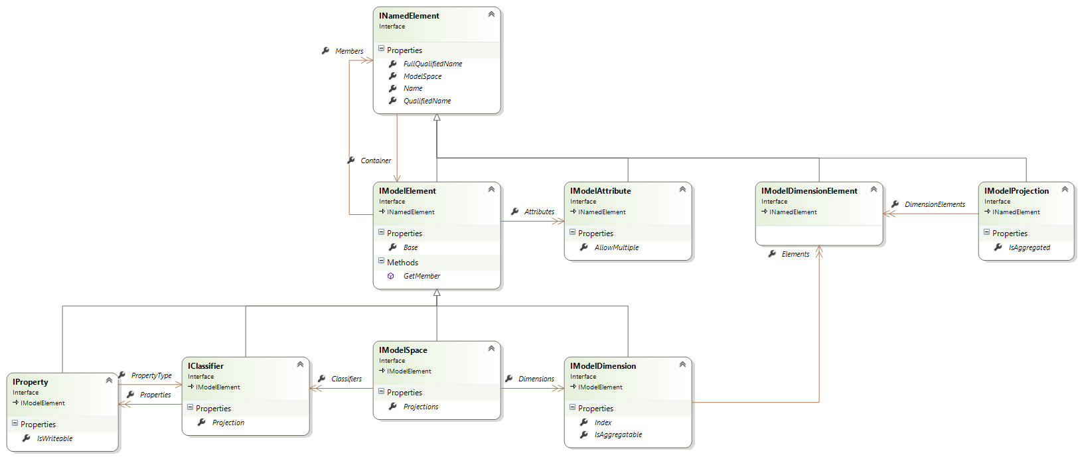

### INamedElement

This is the minimal interface a model element must implement.

**Container**: provides a reference to the container model element. Except the model space, all the elements have a container.

**Name**: the friendly name of the element. This is the name provided by the

**QualifiedName**: the name of the element unique within its container’s members. This name is used to build the full name.

Some elements have the qualified name the same as their name, but others will use a discriminator prefix to avoid name collisions. For example, attributes use the "@" discriminator, dimensions use "^", and projections use ":".

**FullQualifiedName**: the fully qualified name, starting from the root model space. The full name is built up of qualified names separated by "/". Examples:

|  |  |
| --- | --- |
| Full name | Meaning |
| / | The root model space. |
| /^AppLayer | The AppLayer dimension. |
| /:Primitives:Kephas:Core:Main:Global/String | The String classifier within the :Primitives:Kephas:Core:Main:Global projection. |
| /:MyModel:MyCompany:Contacts:Main:Domain/Contact/Name | The Name member of the Contact classifier within the :MyModel:MyCompany:Contacts:Main:Domain projection. |
| /:MyModel:MyCompany:Contacts:Main:Domain/Contact/Name/@Required | the Required attribute of the Name member of the Contact classifier within the :MyModel:MyCompany:Contacts:Main:Domain projection. |