

**CSC302 Net-Centric Computing**

TAY KIAT LOONG

U1621514E

**ASSIGNMENT 2**

**Fruit Shop Web Application**

**Introduction**

This assignment requires us to create an application that includes form inputs, form validation and form processing at server side. HTML is used to write out the texts and include the necessary input widgets. CSS is then used to style and organize the webpage. Javascript allowed for client-side validation, input checking with regular expression and alert messages. PHP is then used at server side to validate further and update the input values in the for submissions.

Approach to these new concepts

Firstly, the manual was read and important elements of the web application is recorded down. A wireframe is then drawn roughly to show the organization of the elements instead of directly writing out code immediately. I then went straight to pure HTML first keeping needed <div> and names in mind.

During the process of the writing, code comments are inserted too to make sure we do not miss out or forget what the code snippets are doing especially during the regular expressions code which is the most confusing to me.

HTML has tags which help specify element types which means that I can indicate if the specified item is an input or a anchor link and more. I firstly created the HTML file alone to make sure that all the needed input boxes, radio buttons, submit buttons are present with all the <div> tags in place.

CSS is then used to style the web application. This time, in HTML, giving classes, names and id to elements as drawn in the wireframe. CSS grids was implemented since it allows for more flexibility in the organization and it can help with responsiveness of the web application with neater code. After the styling, I moved on to the javascript code writing.

Javascript is the used at client side to check on every key up which I chose to embed in the HTML. Functions are then written to calculate the total cost of the fruits and present it in the blurred textbox which I had changed the height to show more information. I also took into consideration the possibility of no username being entered, no fruits being ordered, a summary before page submission, the possibility of wrong input of non-digits input. After the input at the client side is confirmed, then we will submit the page via process.php file.

PHP is then used to process the submitted posts in server side. This is also where the calculations will be done to process the total cost of the fruits. This assignment requires us to update the latest total number of fruits all the users has input. For example, for first submission of form, A ordered 1 apple, 2 banana and 3 oranges. For second submission, B ordered 2 apples, 1 banana and 0 oranges. This means that the order.txt(where we store the information), has 3 apples, 3 bananas and 3 oranges net. This is will stored in order.txt.

The files required for the web application are:

* Index.html
* netcentass2.js
* netcentass2.css
* process.php
* order.txt

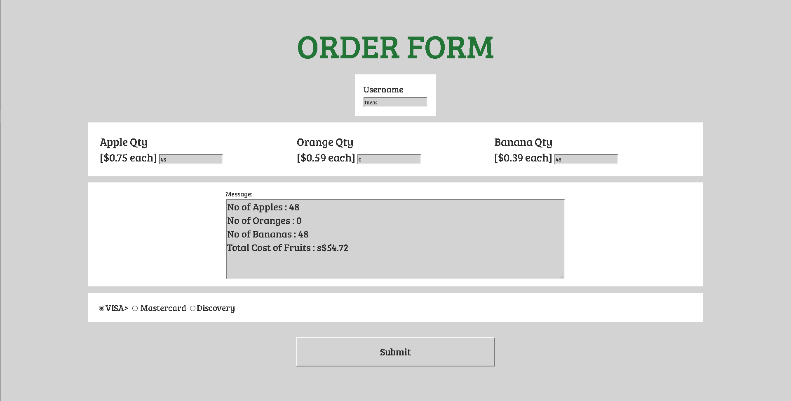

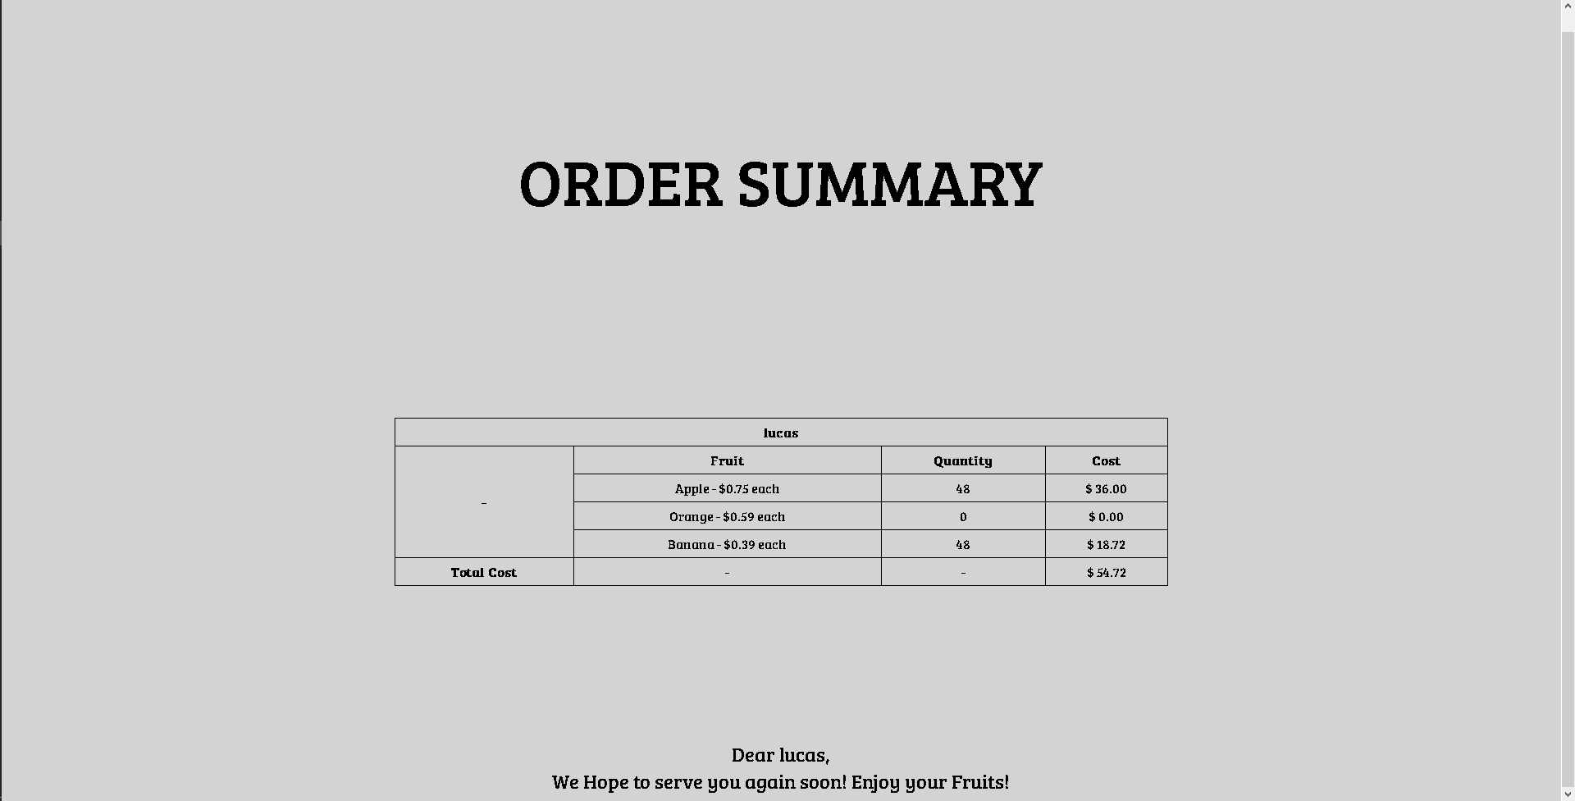

The source code :

**Index.html**

<!DOCTYPE html>

<html lang="en">

<head>

    <meta charset="UTF-8">

        <!--

font-family: 'Black Han Sans', sans-serif;

font-family: 'Gamja Flower', cursive;

font-family: 'Bree Serif', serif;

-->

<link href="https://fonts.googleapis.com/css?family=Black+Han+Sans|Bree+Serif|Gamja+Flower" rel="stylesheet">

    <script type="text/javascript" src="netcentass2.js"></script>

    <title>Order Form</title>

    <link rel="stylesheet" type="text/css" href="netcentass2.css">

</head>

<body>

    <form action="process.php" method="post">

            <div class="titleOfPage">ORDER FORM</div>

            <div class="wrapper">

                <div class="usernameWrapper">

                    <label class="labelfruits" for="inputUsername">Username<br></label>

                    <input id="usernameText" type="text" name="inputUsername" required >

                </div>

                <!--This is for selection of the qty of fruits-->

                <div class="quantityWrapper">

                    <div class="Apple">

                        <label class="labelfruits" for="noApples">Apple Qty <br>[$0.75 each]</label>

                        <input id="AppleQtyText" type="text" name="noApples" value="0" onkeyup="checkQty('apple');" onblur="checkIfNonZero('Apple');">

                    </div>

                    <div class="Orange">

                        <label class="labelfruits" for="noOranges">Orange Qty <br>[$0.59 each]</label>

                        <input id="OrangeQtyText" type="text" name="noOranges" value="0" onkeyup="checkQty('orange');" onblur="checkIfNonZero('Orange');">

                    </div>

                    <div class="Banana">

                        <label class="labelfruits" for="noBananas">Banana Qty <br>[$0.39 each]</label>

                        <input id="BananaQtyText" type="text" name="noBananas" value="0" onkeyup="checkQty('banana');" onblur="checkIfNonZero('Banana');">

                    </div>

                </div>

                <!--

                    This is to output price andit is not for any input

                    blur this so this value displayed cannot be edited

                -->

                <div class="outputWrapper">

                    <div></div>

                    <div class="containerOutput">

                        <label class="labelfruits" for="outputPrice" >Message:</label>

                        <textarea id="outputPriceText" type="text" name="outputPrice" onfocus="blur();" cols="60" rows="20"> </textarea>

                    </div>

                    <div></div>

                </div>

                <div class="paymentoptionsWrapper">

                    <!--This is part for the payment method-->

                    <input id="modeV" type="radio" name="payment" value="VISA" checked="true">VISA>

                    <input id="modeM" type="radio" name="payment" value="Mastercard">   Mastercard

                    <input id="modeD" type="radio" name="payment" value="Discovery">Discovery

                </div>

                <div class="submitWrapper">

                    <div></div>

                    <input id="submitButton" type="submit" value="Submit" name="submit" onclick="onSubmitButtonPressed();">

                    <div></div>

                </div>

            </div>

    </form>

</body>

</html>

**Netcentass2.css**

*{

    background-color: #d3d3d3;

    color: #2f2f2f;

    font-family: 'Bree Serif', serif;

}

.titleOfPage{

    font-size: 5em;

    text-align: center;

    color: #237537

}

form{

    margin-left:10%;

    margin-right: 10%;

    margin-top: 3%;

}

.wrapper{

    display: grid;

    padding: 1em;

    grid-template-columns: 1fr;

    grid-gap: 1em;

}

.usernameWrapper{

    background-color: #ffffff;

    padding: 1em;

    margin-left: auto;

    font-size: 1.3em;

    margin-right: auto;

}

.quantityWrapper{

    display: grid;

    background-color: #ffffff;

    padding:1em;

    grid-template-columns: 1fr 1fr 1fr;

    font-size: 1.7em;

}

.Apple , .Banana , .Orange{

    background-color: #ffffff;

}

.labelfruits{

    background-color: #ffffff;

}

.outputWrapper{

    background-color: #ffffff;

    padding: 1em;

    display: grid;

    grid-template-columns: 1fr 2fr 1fr;

}

.outputWrapper>div{ /*Select all div where outputwrapper is the parent*/

    background-color: #ffffff;

}

.containerOutput{

    margin-left: auto;

    margin-right: auto;

}

#outputPriceText{

    font-size: 1.5em;

    height: 8em;

}

.paymentoptionsWrapper{

    background-color: #ffffff;

    padding: 1em;

    font-size: 1.3em;

}

.submitWrapper{

    display: grid;

    grid-template-columns: 1fr 1fr 1fr;

    margin: 20px;

}

#submitButton{

    height: 3em;

    color: #282828;

    font-size: 1.5em;

}

**Netcentass2.js**

/*Initialization*/

var outputText = document.getElementById("outputPriceText"); // Textbox of username

function checkIfNonZero(fruit){

    var qty = 0;

    switch (fruit){

        // Depending on fruits, we want to get the quantity of that specific input

        //So i used the switch case control flow here

        case 'Apple':

            qty=document.getElementById("AppleQtyText").value;

            break;

        case 'Banana':

            qty=document.getElementById('BananaQtyText').value;

            break;

        case 'Orange' :

            qty=document.getElementById('OrangeQtyText').value;

            break;

        default:

            alert("ERROR! NO SUCH FRUIT 1");

    }

    //If quantity is 0 or is backspaced with no input

    if ( qty == 0 || qty==null){

        var textbox = fruit + "QtyText";

        //alert(textbox);

        document.getElementById(textbox).value="0"; // Add back the default value of 0

    }

    /*

    var ok = qty.search(/^[0-9]*$/);    // Make sure it is just digits

    if (ok != 0){

        output("Quantity field only accepts numbers");

    }else{

        output("")

    }

    */

}

/*Event handler when submit button is clicked*/

/*On key up to check qty*/

function checkQty(fruit){

    //Initialization

    var submitbutton = document.getElementById("submitButton"); // Get the submit button object

    var qtyB = document.getElementById("BananaQtyText").value;

    var qtyO = document.getElementById("OrangeQtyText").value;

    var qtyA = document.getElementById("AppleQtyText").value;

    // Regex to check that the inputs are purely integers since no decimal point should be allowed

    var okB = qtyB.search(/^[0-9]*$/);

    var okO = qtyO.search(/^[0-9]*$/);

    var okA = qtyA.search(/^[0-9]*$/);

    if (okB != 0 || qtyB < 0 || okA != 0 || qtyA < 0 ||okO != 0 || qtyO < 0){

        //Anything that does not fit in the described regex will come here

        submitbutton.disabled = true;   // The submit button wil be disabled

        output("");                     //Clear outputTextBox

        output("NaN\n\nQuantity field only accepts digits"); // Display Error Message

    }else

    //IF NO FRUITS WERE BOUGHT

    if (qtyA == 0 && qtyB == 0 && qtyO ==0){

        output("");

        submitbutton.disabled = false;  //Submit buton will still be pressable

    }

    else{

        displayTotalCost(qtyA, qtyB, qtyO); // If nothing goes wrong, then display total cost of items

        submitbutton.disabled = false;      //Make sure submit button is pressable

    }

}

function displayTotalCost(a,b,o){

    totalCost = a*0.75+b*0.39+o*0.59;

    //output("\nNo of Apples : " + a+"\n\nNo of Oranges : " + o+"\n\nNo of Bananas : " + b+"\n\nTotal Cost of Fruits : s$" + (totalCost.toFixed(2)) +"\n\n");

    //toFixed(2) allows us to write floating point values to 2 dp

    var outputMessage = "No of Apples : " + a+"\nNo of Oranges : " + o+"\nNo of Bananas : " + b+"\nTotal Cost of Fruits : s$" + totalCost.toFixed(2)+"\n";

    output(outputMessage); // Print the outputMessage

}

function output(outputvalue){

    var outputText = document.getElementById("outputPriceText");

    //alert("This is no ok"); // DEBUGGING PIRPOSE

    outputText.value = outputvalue; //Display message into the otputtextbox

}

/*WHEN THE SUBMIT BUTTON IS PRESSED */

function onSubmitButtonPressed(){

    //vairable initialization

    var totalQty=0;

    var paymentMode="";

    /*Get the textboxes object */

    bQtyTextBox = document.getElementById("BananaQtyText");

    oQtyTextBox = document.getElementById("OrangeQtyText");

    aQtyTextBox = document.getElementById("AppleQtyText");

    usernameTextBox = document.getElementById("usernameText");

    totalQty= bQtyTextBox.value + oQtyTextBox.value + aQtyTextBox.value; // Calculate the total quantity of all the fruits

    if(totalQty == 0){              // Check if any number of fruits is added

        alert("There are no fruits being added!");  //This is the reason why we still allow the buttpon to be pressable

    }

    else{

        //Initialize variables of radiobuttons

        var payBy = "";

        var visa = document.getElementById("modeV");

        var discovery = document.getElementById("modeD");

        var mastercard = document.getElementById("modeM");

        //Finding out which radiobutton has been checked

        if (visa.checked){

                payBy = visa.value;

        }

        else if(discovery.checked){

            payBy=discovery.value;

        }

        else{

            payBy = mastercard.value;

        }

        totalCost = aQtyTextBox.value*0.75+bQtyTextBox.value*0.39+oQtyTextBox.value*0.59; // Calculate the total cost of all the fruits

        var outputMessage = "No of Apples : " + aQtyTextBox.value+"\nNo of Oranges : " + oQtyTextBox.value+"\nNo of Bananas : " + bQtyTextBox.value+"\nTotal Cost of Fruits : s$" + totalCost.toFixed(2)+"\n\n Payment By : "+ payBy;

        alert("Dear \n"+ usernameTextBox.value + "\n\n"+outputMessage); // Inform user about the order list

    }

}

**Process.php**

<!DOCTYPE html>

<html lang="en">

<head>

    <!--

font-family: 'Black Han Sans', sans-serif;

font-family: 'Gamja Flower', cursive;

font-family: 'Bree Serif', serif;

-->

<link href="https://fonts.googleapis.com/css?family=Black+Han+Sans|Bree+Serif|Gamja+Flower" rel="stylesheet">

    <meta charset="UTF-8">

    <title>Form Submitted</title>

    <style>

        *{

            margin-top: 5%;

            background-color:#d3d3d3;

            font-family: 'Bree Serif', serif;

        }

        table{

            margin-left : auto;

            margin-right: auto;

            margin-top: 0;

        }

        table, th, td {

     border: 1px solid black;

        border-collapse: collapse;

        }

        th, td {

        padding: 5px;

            text-align:center;

        }

        #TitleOfOrderSummary{

            font-size:5em;

            text-align: center;

            margin-top: 0;

        }

</style>

</head>

<body>

        <?php

        //INITIALIZATIONS

            //Get Quantity of fruits

            $qtyO= $_POST["noOranges"] ;

            $qtyB=$_POST["noBananas"];

            $qtyA=$_POST["noApples"];

            //Calculate total cost of each fruit category

            $totalCostOrange = ($qtyO * 0.59);

            $totalCostBanana = ($qtyB * 0.39);

            $totalCostApple = ($qtyA * 0.75);

            //Calculate Total cost of all fruits

            $totalCostOfFruits = $totalCostApple + $totalCostBanana + $totalCostOrange;

    ?>

    <div id="TitleOfOrderSummary">ORDER SUMMARY</div><br><br>

    <table class="summary" style="width :50%;">

        <tr >

            <th colspan="4">

                <?php printf("%s",$_POST["inputUsername"]); ?>

            </th>

        </tr>

        <tr>

            <th rowspan="4";>-</th>

            <th>Fruit</th>

            <th>Quantity</th>

            <th>Cost</th>

        </tr>

        <tr>

            <td>Apple - $0.75 each</td>

            <td><?php printf("%d",$qtyA); ?></td>

            <td><?php printf("$ %.2f",$totalCostApple) ?></td>

        </tr>

        <tr>

            <td>Orange - $0.59 each</td>

            <td><?php printf("%d",$qtyO); ?></td>

            <td><?php printf("$ %.2f",$totalCostOrange) ?></td>

        </tr>

        <tr>

            <td>Banana - $0.39 each</td>

            <td><?php printf("%d",$qtyB); ?></td>

            <td><?php printf("$ %.2f",$totalCostBanana) ?></td>

        </tr>

        <tr>

            <th>Total Cost</th>

            <td>-</td>

            <td>-</td>

            <td><?php printf("$ %.2f",$totalCostOfFruits) ?></td>

        </tr>

    </table>

<?php

    //define file path

    $filePath = "order.txt";

    if(file_exists($filePath)){ // Check if file at filepath exists

        $orderfptr = fopen($filePath,'r') or exit("Unable to open file!");     // READ the content inside after opening

        if(flock($orderfptr, LOCK_SH))  //Since we allow multiple users to read the file, we set flock as LOCK_SH (shared)

        {

        // Get the content of the file and store into $ordersContent

        $ordersContent = fread($orderfptr,filesize($filePath)+1);

        //int preg_match ( string $pattern , string $subject [, array &$matches [, int $flags = 0 [, int $offset = 0 ]]] )

        //With regex, we attempt to find the pattern in the content in ordersContent and use the grouping to store the result as an array

        //WHERE recoreddxxxxx[0] is the string and recordedxxxxx[1] is the digits or the quantity

        preg_match("/Total number of apples: (\d+)/", $ordersContent, $recordedAppleNumber);

        preg_match("/Total number of oranges: (\d+)/", $ordersContent, $recordedOrangeNumber);

        preg_match("/Total number of bananas: (\d+)/", $ordersContent, $recordedBananaNumber);

        /* For Debugging */

        //printf("%d\n",intval($recordedAppleNumber[1]));

        //printf("%d\n",intval($recordedBananaNumber[1]));

        //printf("%d\n",intval($recordedOrangeNumber[1]));

        //Get latest number for each fruit

        $newAppleNumber = $qtyA + (int) $recordedAppleNumber[1];

        $newOrangeNumber = $qtyO+ (int)$recordedOrangeNumber[1];

        $newBananaNumber = $qtyB + (int)$recordedBananaNumber[1];

        //write back into order.txt with fwrite

        /*

        Total number of apples: 0

        Total number of oranges: 0

        Total number of bananas: 0

        */

        }

        else{

            echo "Error locking file1!";

        }

        //NOT FORGETTING TO CLSE FILE

        fclose($orderfptr);

        //NOW ON THE WRITING INTO FILE

        $orderfptr = fopen($filePath,'w') or exit("Unable to open file!"); // OPEN THE SAME FILE WITH THE INTENTIONG TO WRITE

        if(flock($orderfptr, LOCK_EX)) //Prevent other from accessing the file  // Check that the lock is exclusive and no other user is writing into it

        {                                                                           //If it is exclusive then write with fwrite

            //Write content as per the lab manual

            fwrite($orderfptr,"Total number of apples: $newAppleNumber\n");

            fwrite($orderfptr,"Total number of oranges: $newOrangeNumber\n");

            fwrite($orderfptr,"Total number of bananas: $newBananaNumber\n");

            flock($fptr, LOCK_UN); //release lock since the writing has been done so others can write into this too

        }

        else

                 echo "Error locking file2!";       // FOR DEBUGGING PURPOSE

        // CLOSE THE FILE AFTER COMPLETING

        fclose($orderfptr);

    }

?>

</body>

</html>

**Order.txt**

**Total number of apples: 32**

**Total number of oranges: 47**

**Total number of bananas: 32**