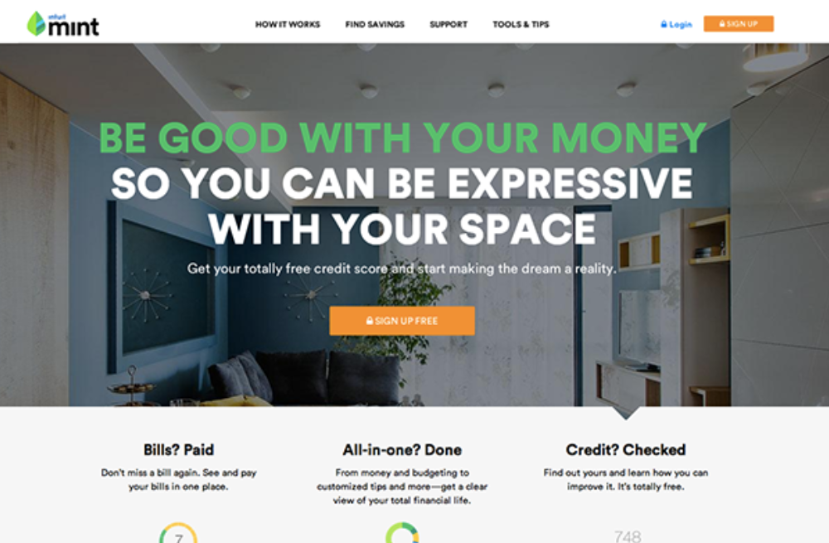

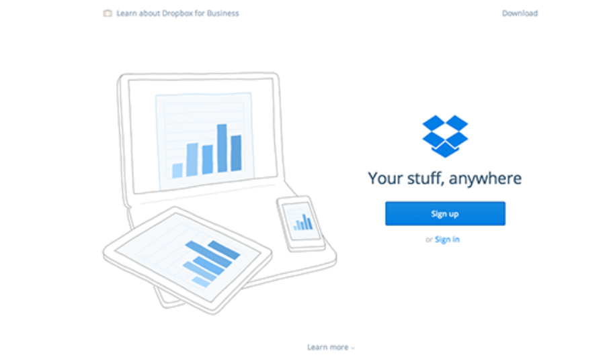

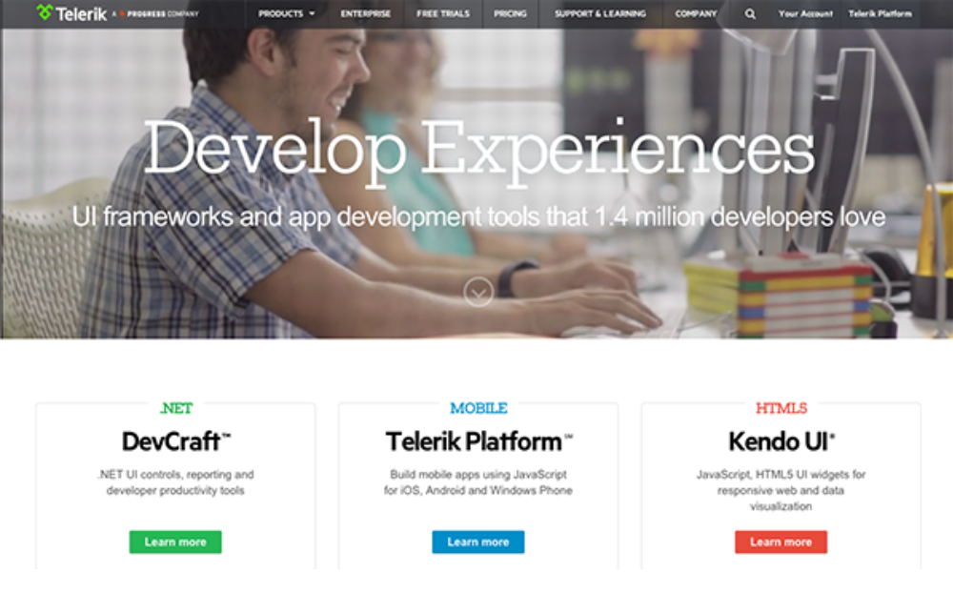







**GOAL**

* Static Home page
* Consists of 2 pages. 1 home page and 1 still under construction page
* No JavaScript and Database
* 1 Navbar with 3 menu items and 2 buttons (login and sign up)
* Main content has 1 center displayed image and 3 cards
* 1 Footer with Links to social media (facebook, Instagram, etc) and additional info like copywrite etc

**NAVBAR**

|  |  |  |
| --- | --- | --- |
| Item | Position | Notes |
| Main Icon | Left | When clicked, go to home page |
|  |  |  |
|  |  |  |
|  |  |  |