Instructions for Using the Image Zooming Gallery Enhancement   
Script on Premium sites.

This script allows the user to easily create good looking image zooming galleries which contain both portrait and landscape image orientations. This script accomplishes this by measuring the thumbnail div and automatically centering and resizing the image so the images center focal point is displayed.

Example: <http://enhanced-gallery.yp-sites.com/gallery-1>

Setting It Up

Step 1:

Upload the “jquery.galleryEnhancement.v2-min.js” to the GFX folder then copy and paste the below script and CSS into the header of your template.

<script type="text/javascript" src="gfx/jquery.galleryEnhancement.v2-min.js"></script>

<style>

/* new image zooming gallery CSS */

.zooming-gallery-thumb {  
width:250px; /* controls width of thumbnail */  
height:175px; /* controls height of thumbnail */  
margin-right: 15px; /* margin of the thumbnail */  
overflow:hidden;  
border:4px solid #d5d5d5;  
position:relative;  
cursor:pointer;   
}

/* image zooming gallery CSS in master reset */

#Zoom_gallery_list ul {  
margin-left:0px;  
padding-left:0px;  
}

#Zoom_gallery_list ul li {  
 float: left;  
 margin-bottom: 5px;  
 margin-right: 15px !important;  
}

#Zoom_gallery_list ul li a img {  
 border: 0px solid #C7C7C7 !important;  
 padding: 0px !important;  
}

#Zoom_gallery_list ul li div {  
padding:0px !important;  
}

</style>

Step 2:

Create your new Gallery and change the “Items Per Row” to 100. This is an important step.

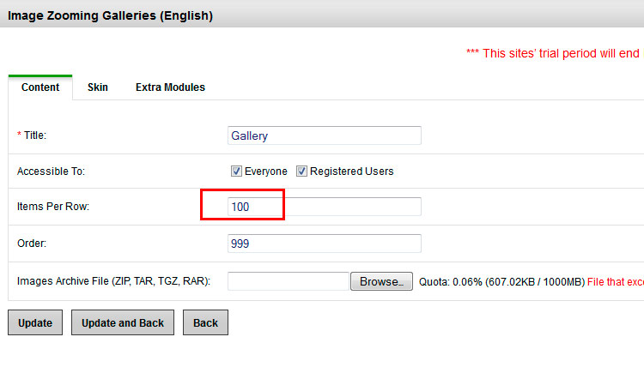

Step 3:

No more steps, it’s that simple!

Tips and Tricks

Resizing Thumbnails:

When a normal Image Zooming Gallery is used Webs Planet sets the width of the thumbnail based on the number of items per row. This script removes that inline styling so the width and height can be determined by the CSS in the “Extra Header Data”. Modify the width and height of the “.zooming-gallery-thumb” class to change the width and height of your thumbnail.

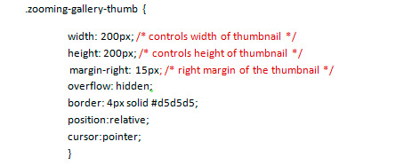

Note: This script works best if the .zooming-gallery-thumb div has the same width and height, or if it is more landscape in orientation. This is because the CSS used in the image zooming gallery is not accessible to users of creator templates and a thumbnail image width of 100% in the master CSS prevents the use of portrait orientation.