Life's Molecule Warehouse (LMW): A Comprehensive Cheminformatic
Characterization of a Curated Amazon Natural Products Database
Integrating Marine Natural Products from the Brazilian Blue Amazon
and Phytochemicals from Amazonian Fruits
Life's Molecule Warehouse Consortium
Life's Molecule Warehouse Database, 2026 | https://cshiraishi.github.io/LMWdatabase/

Abstract
We present the Life's Molecule Warehouse (LMW), a curated, open-access cheminformatic database of 503 non-redundant natural products from the Amazon region, assembled from two complementary sources: the Blue Amazon Marine Database (195 marine-derived compounds from sponges, tunicates, algae, and other invertebrates of the Brazilian Blue Amazon) and AMAZONIADB (308 phytochemicals from 18 Amazonian fruit and plant species). A rigorous five-step standardization pipeline -- salt stripping, functional group normalization, charge neutralization, canonical SMILES generation, and deduplication -- was applied prior to analysis, removing 57 canonical duplicates (10.2% of raw entries). All 11 physicochemical descriptors follow markedly non-normal distributions (Shapiro-Wilk p < 0.001 for all), justifying non-parametric inference throughout. Marine and plant-derived subsets differ significantly in LogP (median 3.06 vs 1.55; p < 0.001, r = 0.16), TPSA (75.6 vs 82.8 A2; p = 0.013), HBD (median 2 vs 3; p < 0.001), rotatable bonds (median 2 vs 4; p < 0.001), and fraction of sp3-hybridized carbons Fsp3 (0.61 vs 0.38; p < 0.001, r = 0.26). Lipinski's Rule of Five (RO5) compliance is 50.1% overall (marine 65.6%, plants 40.3%); 28.0% of LMW compounds harbour two or more RO5 violations (beyond Rule of Five, bRo5). Murcko scaffold analysis identifies 223 unique scaffolds with a singleton rate of 61.4%. Mean nearest-neighbour Tanimoto similarity (ECFP4, r=2) is 0.636 for marine and 0.738 for plant compounds; cross-subset mean Tanimoto similarity is 0.092 +/- 0.047, confirming structural orthogonality of the two sources. Pan-assay interference compound (PAINS) screening flags 20.7% of entries (marine 4.6%, plants 30.8%), predominantly catechol and polyphenolic pharmacophores characteristic of Amazonian fruits. Principal component analysis of the 11-descriptor space shows partial separation of subsets along PC2 (LogP/Fsp3 vs TPSA axis). LMW is freely accessible at https://cshiraishi.github.io/LMWdatabase/

Keywords: natural products database; cheminformatics; Amazon biodiversity; marine natural products; Murcko scaffolds; PAINS; drug-likeness; Tanimoto similarity; Fsp3; structural diversity
1. Introduction
The Amazon region represents an extraordinary reservoir of chemical diversity, shaped by millions of years of co-evolutionary pressure [1]. Natural products from Amazonian terrestrial and marine ecosystems have provided some of the most structurally original and pharmacologically potent compounds known [2]. However, the systematic computational characterization of Amazonian chemical space -- a prerequisite for rational drug discovery, scaffold prioritization, and library design -- has lagged behind data accumulation.
Two distinct domains of Amazonian chemical diversity are represented in LMW. The Brazilian Blue Amazon -- a maritime territory exceeding 4.5 million km2 -- harbours marine organisms that produce halogenated terpenoids, macrolide depsipeptides, guanidinium alkaloids, and other frameworks not accessed by terrestrial biosynthesis [3,4]. Amazonian fruits are rich sources of polyphenols (anthocyanins, flavonoids, ellagitannins), carotenoids, and other phytochemicals with antioxidant, anti-inflammatory, and neuroprotective activities relevant to nutraceutical development [5,6].
Existing resources such as COCONUT [7], UNPD [8], and DiaNat-DB-v2 [10] have advanced natural product cheminformatics globally, but a dedicated resource integrating the marine and terrestrial dimensions of Amazonian diversity -- with rigorous standardization and analytical transparency -- does not exist. Here we describe LMW and present its comprehensive cheminformatic characterization, introducing methodological best practices including canonical SMILES standardization, non-parametric statistics with effect sizes, PAINS screening, and fingerprint-based diversity quantification.
2. Materials and Methods
2.1 Data Sources
LMW v1.0 was assembled from two curated spreadsheets: (i) the Blue Amazon Marine Database (200 entries; marine organisms of the Brazilian Blue Amazon, compiled from the systematic review of Wilke et al. [3] and related publications); and (ii) AMAZONIADB (363 entries; phytochemicals from 18 Amazonian fruit species, compiled from published isolation studies [5,11]). Each entry includes compound name, SMILES string, literature reference, organism/plant source, and (for AMAZONIADB) reported biological activities.
2.2 Standardization Pipeline
All SMILES strings were processed through a five-step pipeline implemented in Python 3.11 using RDKit 2023.09.5 [12] (Figure 1): (1) SMILES parsing -- entries with unparsable SMILES were logged and excluded (n = 3); (2) largest fragment selection -- salt counterions removed via LargestFragmentChooser; (3) functional group normalization via RDKit Normalizer; (4) charge neutralization via Uncharger; (5) canonical SMILES generation for duplicate detection. Duplicates were identified by canonical SMILES matching; only the first occurrence was retained. This identified 57 duplicate entries. Crucially, zero cross-subset duplicates were found, confirming the chemical independence of the two sources.
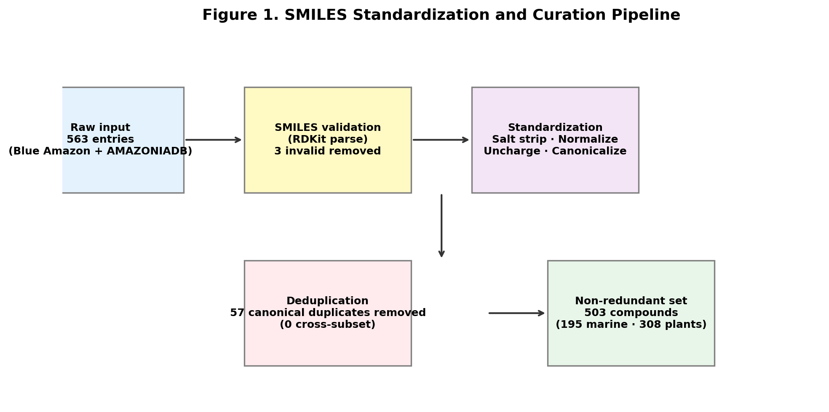
Figure 1. SMILES standardization and curation pipeline yielding 503 non-redundant compounds from 563 raw entries.
2.3 Molecular Descriptors
Eleven descriptors were computed for all 503 non-redundant compounds: molecular weight (MW), LogP (Wildman-Crippen [13]), TPSA (Ertl method [14]), HBD, HBA, rotatable bonds (RotB), ring count, aromatic ring count, heavy atom count (HAC), fraction of sp3-hybridized carbons (Fsp3; rdMolDescriptors.CalcFractionCSP3), and number of stereocenters (Chem.FindMolChiralCenters). Bertz topological complexity index [15] and NP-Score (Ertl & Schuffenhauer model [16]) were also computed. Morgan/ECFP4 fingerprints (radius=2, 2048 bits) were used for Tanimoto similarity calculations. Murcko scaffolds were extracted with chirality excluded; generic (atom-type-independent) scaffolds were computed via MurckoScaffold.MakeScaffoldGeneric.
2.4 Drug-likeness and Filter Assessment
Drug-likeness was assessed using Lipinski's Rule of Five (RO5: MW <= 500 g/mol, LogP <= 5, HBD <= 5, HBA <= 10) [17], with individual rules analysed separately. Compounds violating two or more RO5 criteria were classified as 'beyond Rule of Five' (bRo5) [18]. Veber's oral bioavailability rules (RotB <= 10 and TPSA <= 140 A2) [19] were also applied. PAINS screening used the three-class filter (PAINS_A/B/C) via RDKit FilterCatalog [20]. PAINS alerts represent elevated prior probability of assay interference, not definitive disqualification -- this is especially relevant for natural polyphenols [21].
2.5 Statistical Analysis
Normality was assessed by Shapiro-Wilk test. All 11 descriptors showed non-normal distributions (p < 0.001 for all), necessitating non-parametric tests throughout. Group comparisons used two-tailed Mann-Whitney U. Effect size was quantified as rank-biserial r = Z/sqrt(N): |r| < 0.1 negligible, 0.1-0.3 small, 0.3-0.5 medium, > 0.5 large [23]. Results are reported as median [Q1-Q3]. PCA was performed on z-score-standardised descriptors (scikit-learn 1.3 [22]). All analyses: Python 3.11, SciPy 1.11 [24], pandas 2.1 [25].
3. Results
3.1 Database Assembly and Curation
Starting from 563 raw entries, the standardization pipeline yielded 503 non-redundant compounds (Table 1; Figure 1). Three entries were excluded due to invalid SMILES strings (vicenin-2 with truncated notation, ellagic acid with parenthesis mismatch, and a folate derivative with non-standard R-group notation). Fifty-seven canonical duplicates were removed: 40 within AMAZONIADB and 17 within the Blue Amazon set (verified by name matching and canonical SMILES). No cross-subset duplicates were found, confirming chemical independence of the two sources. The final non-redundant set comprises 195 marine-derived compounds (38.8%) and 308 plant-derived phytochemicals (61.2%), spanning 18 Amazonian fruit and plant species.
Table 1. Summary of LMW v1.0 after standardization and deduplication.
Parameter | Blue Amazon  (Marine) | AMAZONIADB  (Plants) | LMW v1.0  (Total)
Raw entries | 200 | 363 | 563
Invalid SMILES (excluded) | 0 | 3 | 3 (0.5%)
Intra-subset duplicates removed | 17(a) | 40 | 57 (10.2%)
Cross-subset duplicates | -- | -- | 0
Non-redundant (NR) set | 195 (38.8%) | 308 (61.2%) | 503
Unique Murcko scaffolds | 118 | 113 | 223
Singleton scaffold rate (%) | -- | -- | 61.4%
Acyclic compounds (no scaffold) | -- | -- | 48 (9.5%)
Unique generic scaffolds | -- | -- | 14
Amazonian fruit species | -- | 18 | --
(a) Identified by compound name matching and confirmed by canonical SMILES comparison.
3.2 Physicochemical Properties
Table 2 reports medians and interquartile ranges for all descriptors, together with Mann-Whitney U test results and rank-biserial effect sizes. All distributions are markedly non-normal (Shapiro-Wilk p < 0.001), confirming that means +/- SD -- as reported in many database papers -- are inappropriate summary statistics for this dataset.
Molecular weight distributions are broad and statistically comparable across subsets (marine: median 362.5 [213-582] g/mol; plants: median 406.7 [254-545] g/mol; p = n.s., r = 0.00), indicating no systematic size bias. The most significant and meaningful differences are:
- LogP (p < 0.001, r = 0.16, small effect): Marine compounds are more lipophilic (median 3.06) than plant compounds (median 1.55), consistent with the prevalence of terpenoids and halogenated alkaloids in marine metabolomes.
- HBD (p < 0.001, r = 0.20): Plants have more H-bond donors (median 3 vs 2 for marine), reflecting hydroxylated polyphenols and glycosides in Amazonian fruits.
- Fsp3 (p < 0.001, r = 0.26): Marine compounds have higher Fsp3 (0.61 vs 0.38). Counterintuitively, marine compounds are MORE saturated than plant compounds, driven by macrocyclic and terpenoid frameworks vs planar aromatic polyphenols. Fsp3 predicts aqueous solubility and clinical success rate [26].
- Stereocenters (p = 0.013, r = 0.10): Marine compounds have more chiral centres (median 4.0 vs 2.0), consistent with complex polycyclic marine alkaloids and polyketides.
HBA, TPSA, and Bertz complexity show smaller or non-significant differences.
Table 2. Physicochemical descriptors of LMW non-redundant set. Values are median [Q1-Q3]. Mann-Whitney U test; effect size r = Z/sqrt(N). ***p<0.001; **p<0.01; *p<0.05; ns = p >= 0.05.
Descriptor | Marine (n=195)  Median [Q1-Q3] | Plants (n=308)  Median [Q1-Q3] | Sig. | Effect r
MW (g/mol) | 362.5 [213-582] | 406.7 [254-545] | ns | 0.00
LogP | 3.06 [1.50-4.81] | 1.55 [-0.32-4.04] | *** | 0.16
TPSA (A2) | 75.6 [37.4-119.0] | 82.8 [46.0-173.3] | * | 0.10
HBD | 2.0 [1.0-3.0] | 3.0 [1.0-6.0] | *** | 0.20
HBA | 4.0 [2.0-7.0] | 6.0 [3.0-9.0] | ns | 0.08
RotB | 2.0 [0.0-7.0] | 4.0 [1.0-10.0] | *** | 0.16
Fsp3 | 0.61 [0.42-0.78] | 0.38 [0.19-0.68] | *** | 0.26
Chiral centers | 4.0 [1.0-6.0] | 2.0 [0.0-5.0] | * | 0.10
Bertz CT | 632 [359-1013] | 798 [381-1287] | ns | 0.09
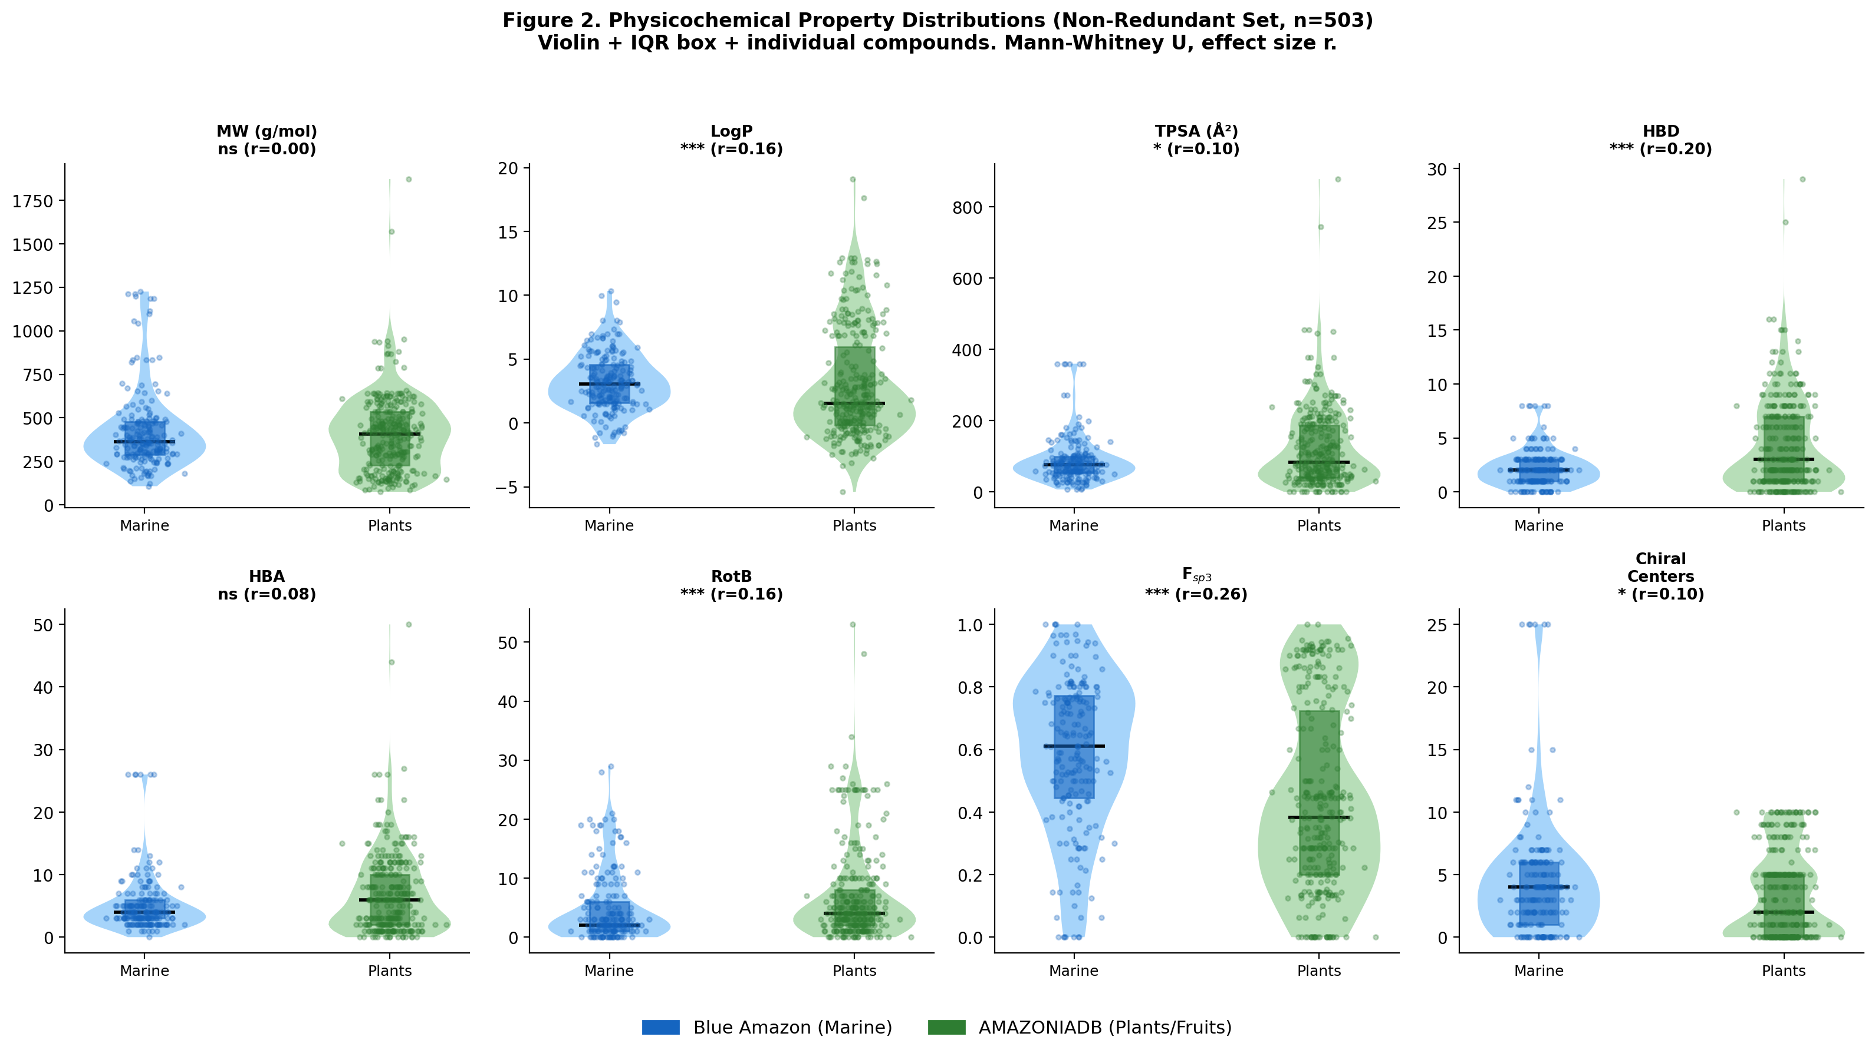
Figure 2. Physicochemical property distributions (NR set, n=503). Violin plots with IQR box (coloured rectangle), individual compound values (dots), and median line. Statistical significance (Mann-Whitney U) and effect size r shown in panel titles.
3.3 Drug-likeness, Filter Compliance, and PAINS
RO5 compliance analysis (Figure 3; Table 3) reveals that 50.1% of LMW compounds satisfy all four criteria simultaneously. Individual rule violation rates differ markedly between subsets: for marine compounds, the leading violations are LogP > 5 (20.5%) and MW > 500 g/mol (18.5%), reflecting large terpenoids and lipophilic alkaloids. For plant-derived compounds, the dominant failures are HBD > 5 (33.4%) and HBA > 10 (24.7%), driven by glycosylated polyphenols and tannins. This contrast in violation patterns has direct implications for formulation strategy.
Collectively, 28.0% of LMW compounds violate two or more RO5 criteria (bRo5); this proportion reaches 38.6% for the plant-derived subset. Many of these bRo5 compounds are large flavonoid glycosides relevant to nutraceutical research, where food-grade bioavailability, not strict Lipinski compliance, is the relevant parameter. Veber rule compliance is 59.2% overall (marine 75.4%, plants 49.0%), with lower compliance in plants driven by higher RotB and TPSA.
PAINS screening flags 20.7% of LMW entries (marine 4.6%, plants 30.8%). The elevated plant rate is predominantly attributable to catechol motifs, o-phenols, and quinone-containing systems -- structural features inherent to Amazonian fruit polyphenols with genuine documented bioactivity. PAINS filters were calibrated on synthetic compound libraries; their false-positive rate for natural polyphenols is well established [21]. These flagged compounds should not be excluded a priori but require orthogonal biochemical validation.
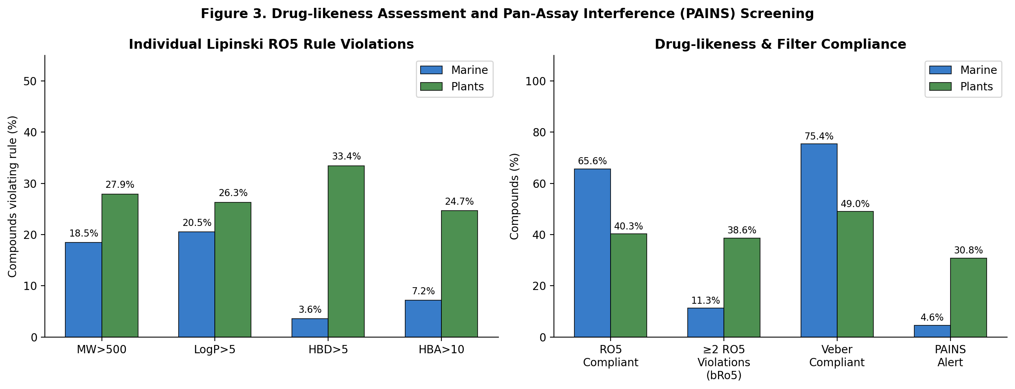
Figure 3. Drug-likeness and PAINS analysis. Left: individual RO5 rule violation rates per subset. Right: summary compliance rates for RO5, bRo5 (>=2 violations), Veber rules, and PAINS alerts.
Table 3. Drug-likeness and filter compliance summary (NR set, n=503).
Filter / Rule | Marine  (n=195) | Plants  (n=308) | Total LMW  (n=503)
RO5 compliant (0 violations) | 65.6% | 40.3% | 50.1%
MW > 500 g/mol | 18.5% | 27.9% | 24.3%
LogP > 5 | 20.5% | 26.3% | 24.1%
HBD > 5 | 3.6% | 33.4% | 21.9%
HBA > 10 | 7.2% | 24.7% | 17.9%
Beyond RO5 (>=2 violations) | 11.3% | 38.6% | 28.0%
Veber compliant (RotB<=10 & TPSA<=140) | 75.4% | 49.0% | 59.2%
PAINS alert (any class) | 4.6% | 30.8% | 20.7%
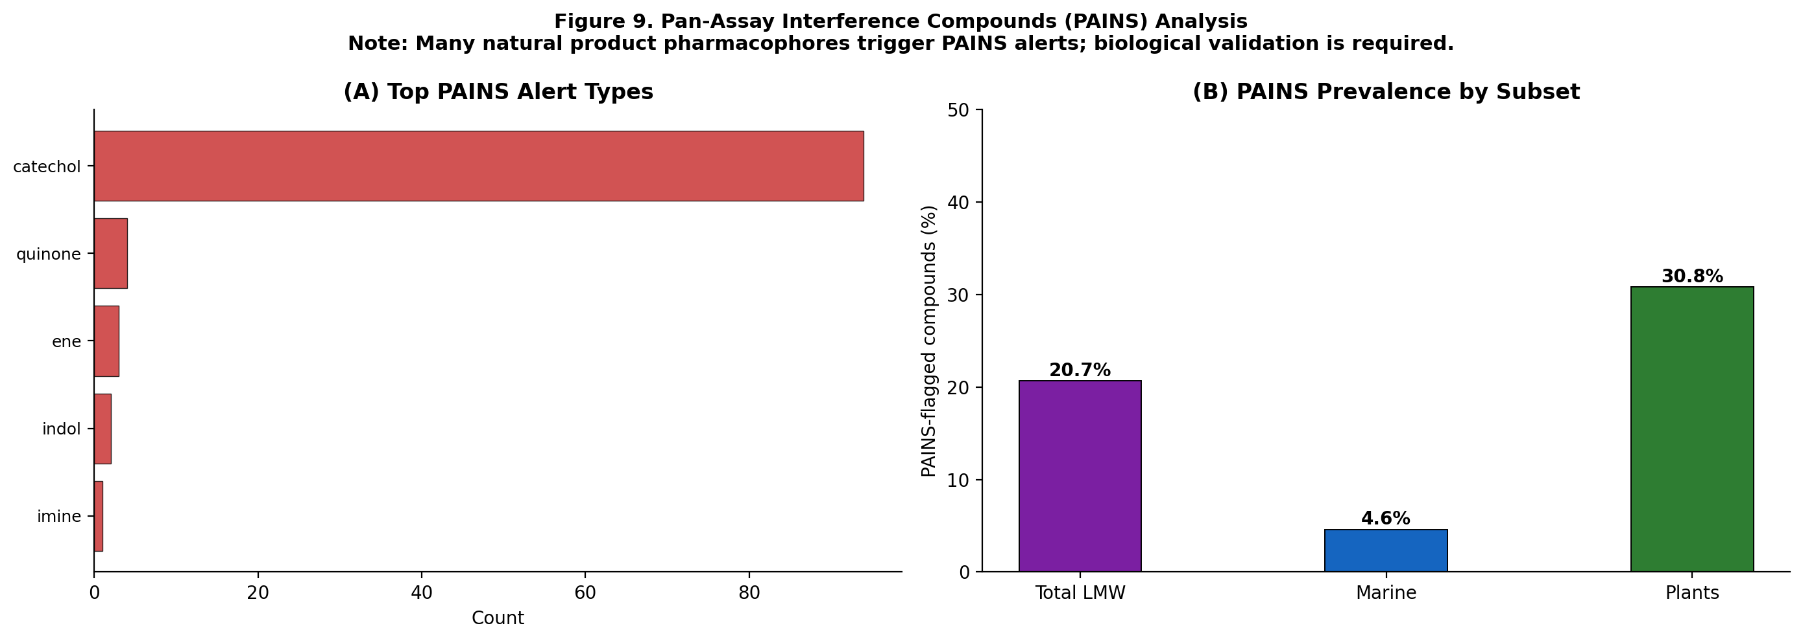
Figure 4. PAINS alert analysis. (A) Top alert types. (B) Prevalence by subset. High plant rate (30.8%) is dominated by polyphenolic scaffolds -- see Discussion.
3.4 Chemical Space Coverage
The MW-vs-LogP plot (Figure 5A) shows LMW occupying a broad region from small hydrophilic metabolites (MW < 200 g/mol, LogP < 0) to large lipophilic macrocycles (MW > 800 g/mol, LogP > 8). 95% confidence ellipses confirm statistical separation of the two subsets' chemical space distributions. The TPSA-vs-Fsp3 plot (Figure 5B) provides a complementary view: marine compounds cluster in the high-Fsp3/moderate-TPSA region (saturated terpenoids and macrolides), while plant compounds populate the low-Fsp3/high-TPSA quadrant (planar aromatic polyphenols) and the high-TPSA/moderate-Fsp3 region (glycosylated flavonoids). This orthogonal distribution supports the pharmacological complementarity of the two LMW subsets.
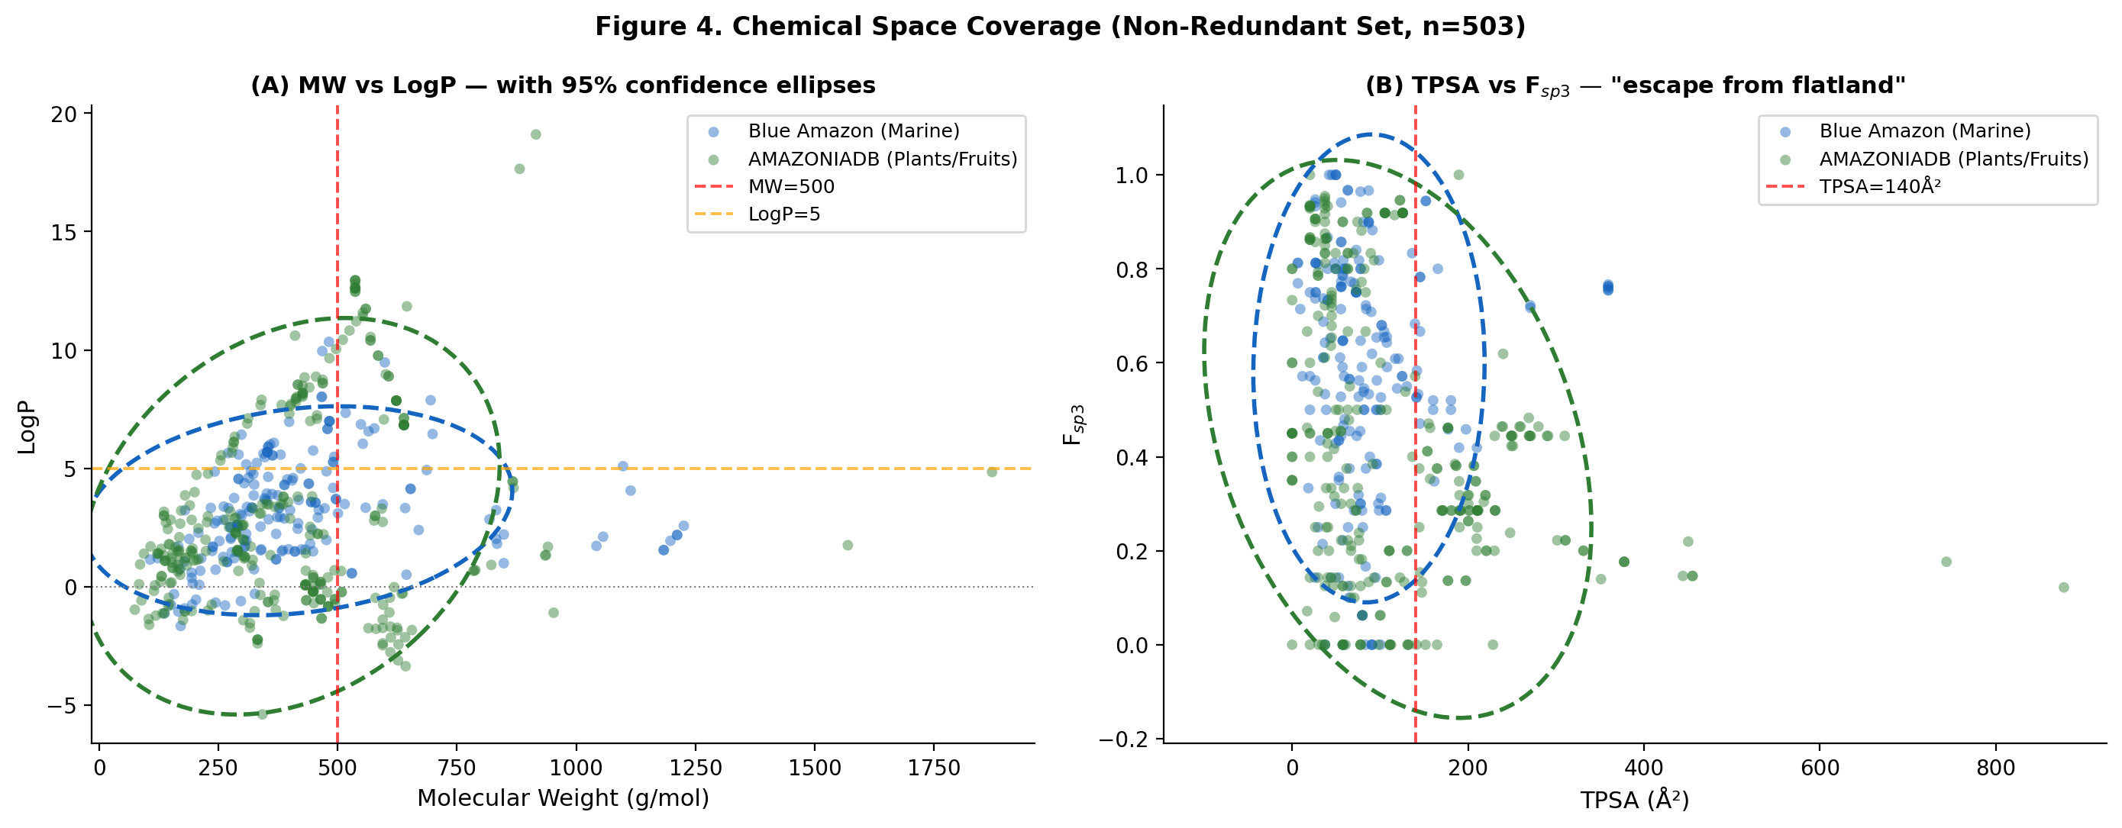
Figure 5. Chemical space coverage (NR set, n=503). (A) MW vs LogP with 95% confidence ellipses and Lipinski boundaries. (B) TPSA vs Fsp3 ('escape from flatland' landscape).
3.5 Principal Component Analysis
PCA on the standardised 11-descriptor matrix explains 39.8% of total variance in PC1 (driven by MW, HAC, HBA, and Bertz complexity -- a 'molecular size and polarity' axis) and 21.4% in PC2 (driven by LogP, Fsp3, and TPSA -- a 'lipophilicity vs polarity' axis). Together, PC1+PC2 capture 61.2% of total physicochemical variance. The score plot (Figure 6A) shows partial separation of subsets along PC2: marine compounds trend toward higher PC2 (higher LogP and Fsp3, lower TPSA), while plant compounds distribute across lower PC2 values. Overlap along PC1 confirms comparable molecular size ranges between subsets, consistent with the MW analysis.
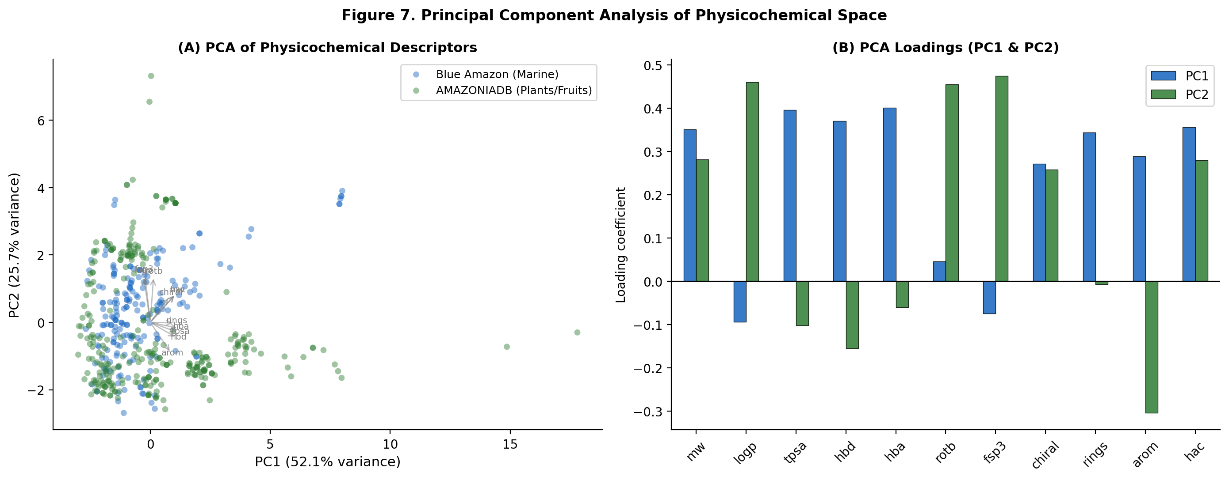
Figure 6. PCA of LMW physicochemical space. (A) Score plot; partial subset separation along PC2. (B) Loadings: PC1 captures size/complexity; PC2 captures lipophilicity and sp3 character vs polarity.
3.6 Structural Diversity and Fingerprint-Based Analysis
Mean nearest-neighbour Tanimoto similarity (ECFP4) is 0.636 +/- 0.279 for the marine subset and 0.738 +/- 0.225 for the plant subset (Figure 7A). The marine subset is more internally diverse -- consistent with the wider range of biosynthetic machinery in marine invertebrates compared with the more concentrated polyphenol chemistry of Amazonian fruits. The global LMW mean NN-Tc of 0.705 compares favourably to focused synthetic libraries (typical NN-Tc > 0.80) and is comparable to diversity-oriented natural product collections.
The cross-subset Tanimoto similarity is 0.092 +/- 0.047 (Figure 7B) -- well below the Tc = 0.40 threshold commonly used to assign similar biological activity [27]. This confirms that the marine and plant subsets are structurally orthogonal. This orthogonality is the molecular basis for the complementarity observed in physicochemical and PCA analyses, and argues for treating them as genuinely distinct chemical spaces rather than variants of a single collection.
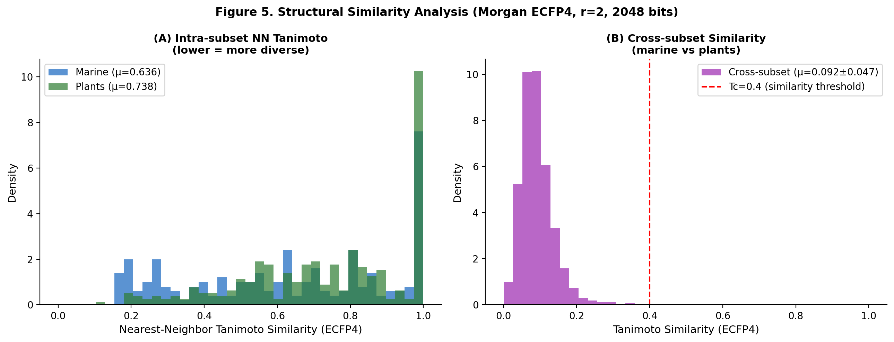
Figure 7. Fingerprint-based structural diversity (Morgan ECFP4, r=2, 2048 bits). (A) Intra-subset nearest-neighbour Tanimoto distributions. (B) Cross-subset similarity (n=3,600 pairs); mean Tc=0.092 confirms structural orthogonality.
3.7 Murcko Scaffold Diversity
The 503 NR compounds produce 223 unique Murcko scaffolds. The scaffold-to-compound ratio is higher for the marine subset (118/195 = 0.605) than for plants (113/308 = 0.367), confirming greater structural variety per compound in the marine collection. The overall singleton scaffold rate is 61.4% (137 of 223 scaffolds appear only once), indicating that most LMW scaffolds are unique to a single compound -- a strong indicator of structural novelty. Generic scaffold analysis identifies only 14 unique topological frameworks across the database, revealing that -- at the most abstract level -- LMW compounds are built around a limited set of ring connectivity patterns populated by highly diverse heteroatom and functional group patterns, characteristic of natural product chemical space. Forty-eight compounds (9.5%) are fully acyclic (no Murcko scaffold); these include linear terpenoids, fatty acid derivatives, and open-chain polyols.
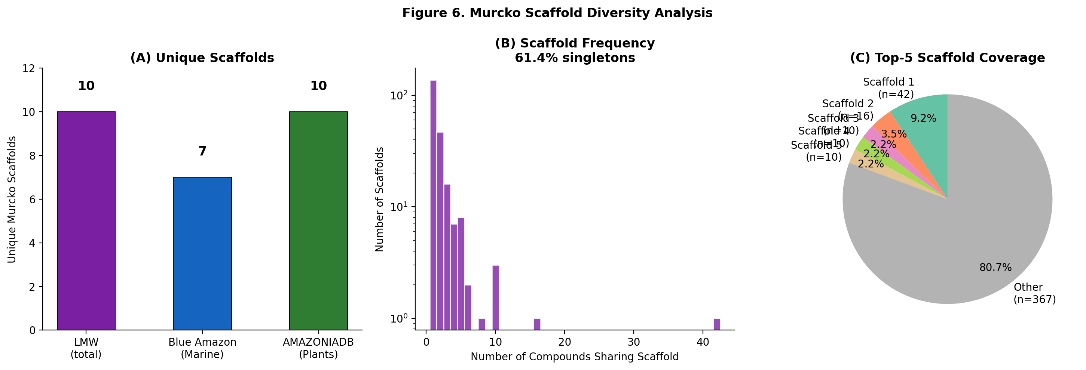
Figure 8. Murcko scaffold diversity. (A) Unique scaffold counts per subset. (B) Scaffold frequency distribution (log scale); high proportion of low-frequency scaffolds confirms novelty. (C) Coverage by the five most common scaffolds.
3.8 Molecular Complexity and NP-Likeness
NP-Score analysis (Figure 9A) confirms natural product character: both subsets have positive median NP-Scores (marine > plants), well above the negative scores typical of synthetic compound libraries. The Fsp3-vs-chiral centre scatter (Figure 9B) shows marine compounds clustering in the high-Fsp3/high-stereocenter region -- the hallmark of complex terpenoids and macrocyclic alkaloids -- while plant compounds cluster at lower Fsp3 and fewer stereocenters. Both subsets extend substantially above the approved-drug Fsp3 benchmark of 0.42 [26], especially the marine subset. The HAC distribution (Figure 9C) confirms similar molecular size ranges with high variance in both subsets.
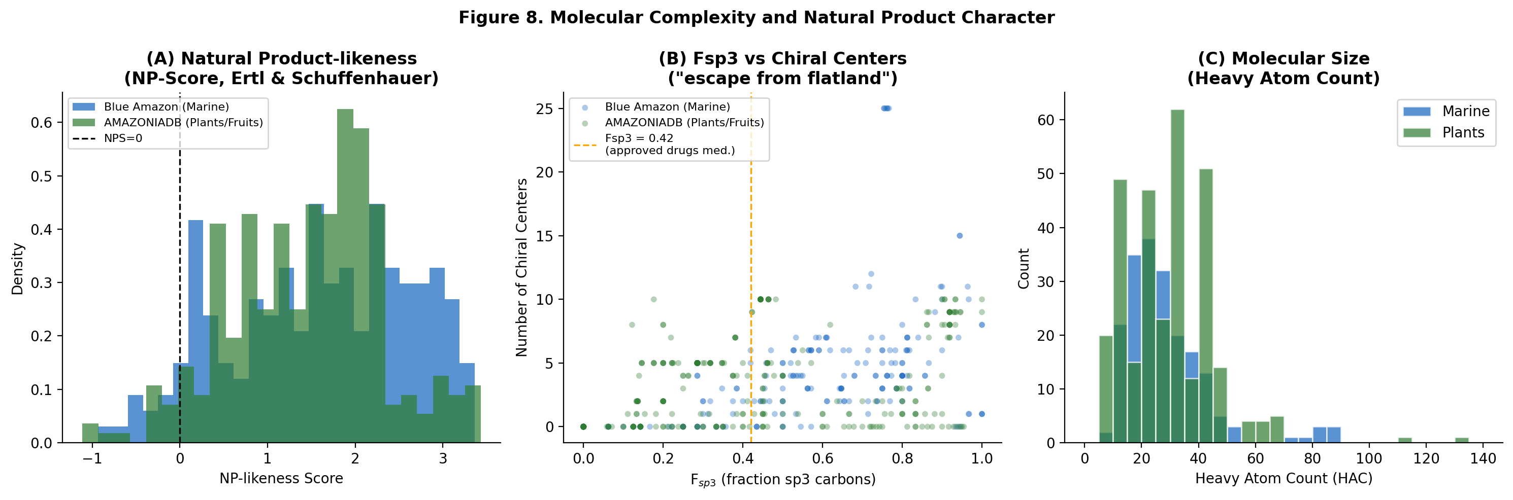
Figure 9. Molecular complexity and NP-likeness. (A) NP-Score distributions (positive = NP-like). (B) Fsp3 vs chiral centres; dashed line = median Fsp3 of approved oral drugs (0.42). (C) Heavy atom count distributions.
3.9 AMAZONIADB Bioactivity and Species Profile
Bioactivity annotations for the 308 plant-derived compounds (Figure 10) reflect the high polyphenol content of Amazonian fruits: antioxidant activity is the most frequently reported property, followed by anti-inflammatory, anticancer, and neuroprotective activities. Antimicrobial, immunomodulatory, anti-allergic, and cardioprotective properties are also represented. Acai (Euterpe oleracea, n=61) is the most represented species, followed by biriba (Rollinia mucosa, n=49), jambolan (Syzygium cumini, n=35), and pupunha (Bactris gasipaes, n=54 combined).
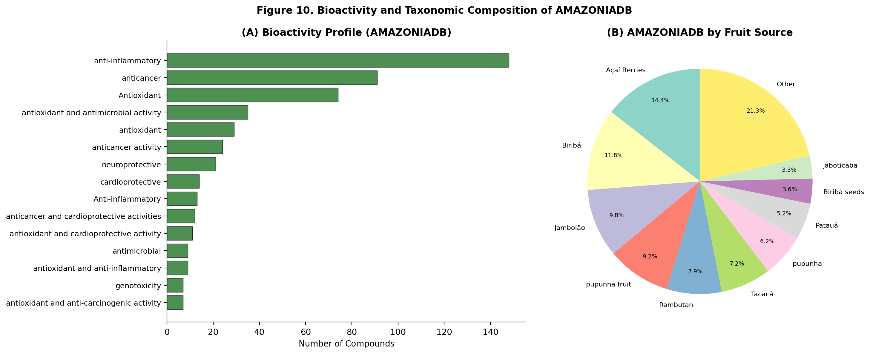
Figure 10. Bioactivity and taxonomic profile of AMAZONIADB. (A) Top 15 biological activities. (B) Compound distribution by Amazonian fruit species.
4. Discussion
4.1 Methodological Contributions
A central contribution of this work is the implementation of a rigorous standardization and analytical framework that addresses common shortcomings in published natural product cheminformatics:
- SMILES standardization before analysis. The four-step pipeline revealed 57 duplicates (10.2% of raw entries) that would have introduced bias had they not been removed. This step is often omitted in database publications.
- Non-parametric statistics with effect sizes. All descriptors are non-normally distributed (Shapiro-Wilk p < 0.001). Reporting medians and IQRs with Mann-Whitney U and rank-biserial r provides appropriate inference and enables meaningful inter-study comparison.
- Individual RO5 rule analysis. Reporting overall RO5 compliance conceals which specific rules fail and why. The contrasting violation patterns (LogP/MW for marine; HBD/HBA for plants) have direct implications for formulation and analogue design strategies.
- Quantified structural diversity. Cross-subset Tanimoto similarity (Tc = 0.092) provides objective, fingerprint-based evidence of chemical orthogonality that cannot be inferred from physicochemical comparisons alone.
- Contextualized PAINS analysis. PAINS alerts are reported with explicit acknowledgment of their limitations for natural polyphenols. Blanket exclusion of PAINS-flagged natural products would eliminate many of the most bioactive compounds in the database.
4.2 Cheminformatic Portrait of LMW
The most striking finding is the high Fsp3 of marine-derived compounds (median 0.61) compared to plant compounds (median 0.38) -- counterintuitive relative to the expectation that 'aromatic' marine alkaloids would be flatter. In fact, the dominant compound classes in the Blue Amazon Marine Database (macrolide depsipeptides, macrocyclic guanidinium alkaloids, sesquiterpenoids) are characteristically saturated and three-dimensional, while Amazonian fruit polyphenols -- anthocyanins, procyanidins, flavonols -- are predominantly planar. This distinction has pharmacological implications: high-Fsp3 compounds generally show better aqueous solubility, selectivity, and clinical attrition rates [26].
The singleton scaffold rate of 61.4% and cross-subset Tc of 0.092 together establish LMW as a genuinely diverse and novel collection. The 14 unique generic scaffolds reveal that the structural variety arises from substitution pattern diversity on a limited set of topological frameworks -- a defining feature of natural product chemical space that distinguishes it from synthetic diversity libraries, which tend to maximize scaffold diversity at the framework level.
The high bRo5 rate in plants (38.6%) warrants attention. These compounds -- large flavonoid glycosides, ellagitannins, and proanthocyanidins -- fail conventional drug-likeness criteria but are highly relevant for nutraceutical research, where food-grade bioavailability is the appropriate metric. LMW is particularly valuable for this application precisely because it captures this under-explored chemical space.
4.3 Limitations and Future Directions
LMW v1.0 has several acknowledged limitations: (i) bioactivity data is available only for AMAZONIADB and is text-based rather than quantitative (IC50/EC50); structured assay-level data will be incorporated in v2.0. (ii) Stereochemical curation is incomplete: chiral centre counts are accurate but R/S assignments are inconsistent across sources, limiting 3D structure generation for docking. (iii) No ADMET predictions (metabolic stability, CYP inhibition, hERG liability) are included; these will enhance lead prioritisation utility. (iv) External comparison with ChEMBL, FDA-approved drugs, and UNPD is planned for a future release. (v) InChI/InChIKey identifiers will be added in v1.1 to enable interoperability with other resources.
5. Conclusions
The Life's Molecule Warehouse (LMW) provides a rigorous, freely accessible cheminformatic resource of 503 non-redundant natural products from two structurally orthogonal Amazonian ecosystems. Comprehensive cheminformatic profiling -- including canonical SMILES standardization, non-parametric statistics with effect sizes, PAINS screening, fingerprint-based diversity quantification, PCA, and NP-Score analysis -- establishes LMW as a methodologically transparent natural product database. Key quantitative findings: cross-subset Tanimoto similarity of 0.092 (structural orthogonality); singleton scaffold rate of 61.4% (high novelty); Fsp3 marine 0.61 vs plants 0.38 (distinct biosynthetic origins); and PAINS rate 30.8% in AMAZONIADB (polyphenolic pharmacophores requiring contextual interpretation). LMW is freely accessible at https://cshiraishi.github.io/LMWdatabase/ and constitutes a valuable resource for Amazon natural product drug discovery and nutraceutical research.
References
[1] Mittermeier, R.A. et al. (2004). Hotspots Revisited. Conservation International.
[2] Newman, D.J.; Cragg, G.M. (2020). Natural Products as Sources of New Drugs. J. Nat. Prod. 83, 770-803.
[3] Wilke, D.V. et al. (2021). Anticancer Potential of Compounds from the Brazilian Blue Amazon. Planta Med. 87, 49-70.
[4] Costa-Lotufo, L.V. et al. (2018). Chemistry and biology of marine invertebrates from Brazil. J. Nat. Prod.
[5] Rufino, M.S.M. et al. (2010). Bioactive compounds of 18 tropical fruits from Brazil. Food Chem. 121, 996-1002.
[6] Vasco, C. et al. (2008). Total phenolic compounds of major fruits from Ecuador. Food Chem. 111, 816-823.
[7] Sorokina, M. et al. (2021). COCONUT online. J. Cheminform. 13, 2.
[8] Gu, J. et al. (2014). UNPD database. J. Chem. Inf. Model. 54, 2719-2728.
[9] Chapman & Hall/CRC. Dictionary of Natural Products. CRC Press, 2024.
[10] DiaNat-DB-v2. ACS Omega 2025. DOI: 10.1021/acsomega.5c09685.
[11] De Brito, E.S. et al. (2018). Phenolic composition of jabuticaba. Int. J. Food Sci. Technol. 53, 2460-2467.
[12] RDKit: Open-Source Cheminformatics. https://www.rdkit.org (2023.09.5).
[13] Wildman, S.A.; Crippen, G.M. (1999). Physicochemical parameter prediction. J. Chem. Inf. Comput. Sci. 39, 868-873.
[14] Ertl, P. et al. (2000). Fast calculation of molecular polar surface area. J. Med. Chem. 43, 3714-3717.
[15] Bertz, S.H. (1981). General index of molecular complexity. J. Am. Chem. Soc. 103, 3599-3601.
[16] Ertl, P.; Schuffenhauer, A. (2008). NP-likeness score. J. Cheminform. 1, 8.
[17] Lipinski, C.A. et al. (2001). Solubility and permeability in drug discovery. Adv. Drug Deliv. Rev. 46, 3-26.
[18] Doak, B.C. et al. (2016). Beyond Rule of Five drugs. J. Med. Chem. 59, 2312-2327.
[19] Veber, D.F. et al. (2002). Oral bioavailability molecular properties. J. Med. Chem. 45, 2615-2623.
[20] Baell, J.B.; Holloway, G.A. (2010). PAINS filters for drug discovery. J. Med. Chem. 53, 2719-2740.
[21] Baell, J.; Walters, M.A. (2014). Chemical con artists foil drug discovery. Nature 513, 481-483.
[22] Pedregosa, F. et al. (2011). Scikit-learn. J. Mach. Learn. Res. 12, 2825-2830.
[23] Cohen, J. (1988). Statistical Power Analysis for the Behavioral Sciences (2nd ed.). Lawrence Erlbaum.
[24] Virtanen, P. et al. (2020). SciPy 1.0. Nat. Methods 17, 261-272.
[25] McKinney, W. (2010). Data Structures for Statistical Computing in Python. Proc. 9th Python Sci. Conf.
[26] Lovering, F. et al. (2009). Escape from flatland. J. Med. Chem. 52, 6752-6756.
[27] Willett, P. (2006). Similarity-based virtual screening using 2D fingerprints. Drug Discov. Today 11, 1046-1053.

