ScreenSAR: An Automated QSAR Factory for Predictive Virtual Screening
Research Article | Journal of Cheminformatics
Carlos S. H. Shiraishi^{1,2}, Cleber C. Melo-Filho, Eduardo Carvalho Nunes³, Marcus T. Scotti^{4,5}, Eugene Murakov⁵, Juliana Pietrobelli¹ and Rui M. V. Abreu¹
¹ CIMO-ESA, Instituto Politécnico de Bragança, Bragança, Portugal. ² Universidade de Vigo, Ourense, Spain. ³ UTAD, Vila Real, Portugal. ⁴ Federal University of Paraíba, João Pessoa, Brazil. ⁵ UNC Eshelman School of Pharmacy, Chapel Hill, USA.
Abstract
Quantitative Structure–Activity Relationship (QSAR) modelling is a cornerstone of modern drug discovery, yet its reproducibility and accessibility remain critically limited by methodological heterogeneity and technical barriers. We present ScreenSAR, a comprehensive open-source automated QSAR platform designed to standardise and streamline the full workflow from raw bioactivity data curation to prospective virtual screening. Built in Python using the Streamlit framework, ScreenSAR implements a modular architecture encompassing standardised chemical curation — including topological stereochemistry flattening via RDKit canonical SMILES (isomericSmiles=False) and log-ratio outlier detection (IC50max/IC50min > 10) — molecular fingerprint engineering (Morgan ECFP4, MACCS, and RDKit), automated multi-model training across eight algorithms including a soft-voting consensus model, and quantitative applicability domain (AD) assessment using a k-nearest-neighbour (k=5) approach with Jaccard distance and a dynamic threshold Dcrit = D̄ + 3σD. Model integrity is verified by Y-scrambling over 100 permutations. To demonstrate the platform's end-to-end utility, ScreenSAR was applied to the discovery of novel SGLT2 inhibitors. A dataset of 4,106 compounds was retrieved from ChEMBL and automatically reduced to 2,317 curated entries. The best-performing model (Morgan fingerprints + Random Forest; n_estimators=100, random_state=42) achieved AUC = 0.95 and MCC = 0.79 on a stratified 20% hold-out test set, whilst Y-scrambling yielded MCC ≈ 0.00–0.10, confirming genuine structure–activity signal. Prospective virtual screening of the MolPort commercial library identified 48 high-confidence novel SGLT2 inhibitor candidates (P ≥ 0.60), of which 46 (95.8%) were classified as inside the AD (Jaccard distance ≤ Dcrit) and none overlapped with the training set. These results demonstrate ScreenSAR as a reproducible, fully documented, end-to-end QSAR factory capable of bridging the gap between raw bioactivity data and experimentally actionable virtual screening hit lists.
Scientific Contribution
• A fully automated, open-source QSAR modelling platform (ScreenSAR) that integrates chemical curation, multi-algorithm training, Y-scrambling validation, applicability domain assessment, and prospective virtual screening in a single reproducible pipeline.
• Prospective identification of 48 novel commercially available SGLT2 inhibitor candidates (95.8% within the applicability domain; none overlapping the training set) using a Morgan + Random Forest model achieving AUC = 0.95 and MCC = 0.79.
• Complete methodological transparency including exact curation parameters, hyperparameters, AD thresholds, and Y-scrambling results, together with open-source code and all data files to enable full replication.
Keywords: QSAR; virtual screening; machine learning; ScreenSAR; SGLT2; cheminformatics; applicability domain; drug discovery; random forest; MolPort; reproducibility

1. Introduction
Drug discovery and development remain among the most resource-intensive endeavours in modern science. Bringing a single drug candidate from initial concept to regulatory approval requires, on average, more than a decade of research and investment that can reach several billion US dollars, with pre-launch R&D cost estimates ranging from $161 million to $4.54 billion (2019 values) [1]. Failure rates throughout clinical phases remain alarmingly high, with underlying causes frequently rooted in insufficiently validated preclinical models and poorly reproducible experimental data [2]. Strategies capable of prioritising promising candidates prior to experimental validation are therefore not merely advantageous but essential for the sustainability of modern drug discovery pipelines.
In this context, computational approaches have emerged as indispensable complements to experimental workflows. Virtual screening (VS) enables the rapid computational evaluation of compound libraries against defined biological targets, reducing the chemical space to be explored experimentally and offering substantial advantages in terms of time, cost, and labour [3,4]. Among the diverse computational strategies available, QSAR modelling occupies a central role, establishing mathematical relationships between the physicochemical and structural features of molecules and their observed biological activities [3]. When properly constructed and validated, QSAR models offer robust predictive power, mechanistic interpretability, and prospective applicability — qualities that have driven their wide adoption in both academic and industrial drug discovery settings [5].
The advent of machine learning (ML) has substantially expanded the methodological repertoire available to QSAR practitioners. Algorithms such as random forests, gradient boosting variants, support vector machines, and ensemble classifiers have demonstrated superior predictive performance relative to classical linear methods across diverse biological endpoints [5,6]. However, constructing reliable ML-based QSAR models involves a complex sequence of interdependent decisions spanning molecular representation, descriptor calculation, data curation, feature selection, hyperparameter optimisation, model validation, and applicability domain evaluation. This procedural complexity constitutes a significant barrier: in the absence of standardised frameworks, studies frequently suffer from methodological heterogeneity and limited reproducibility. Even when published QSAR models declare adherence to rigorous OECD guidelines — such as the use of an unambiguous algorithm and a clearly defined applicability domain — very few can be reproduced in practice by researchers without advanced programming expertise [7,8].
Despite the existence of several cheminformatics platforms and individual modelling pipelines, the field currently lacks a unified, open-source framework that integrates the entire QSAR modelling workflow from raw bioactivity data acquisition to model deployment in a manner that is simultaneously automated, scalable, and strictly adherent to best practices in model validation and reporting as recommended by the OECD guidelines [7,8]. Here we present ScreenSAR, an automated QSAR factory designed to address this gap. We describe its architecture, validate its performance with complete methodological transparency, and demonstrate its end-to-end utility through a prospective virtual screening campaign targeting SGLT2 inhibitors.

2. Existing Solutions and Positioning of ScreenSAR
The current landscape of tools for QSAR model development is heterogeneous, ranging from expensive commercial suites to general-purpose open-source libraries and platforms. While platforms such as AutoQSAR (Schrödinger) and Pipeline Pilot (BIOVIA) offer a high level of automation and accessible interfaces, their proprietary nature imposes significant economic barriers and limits methodological transparency [7,9]. At the opposite end of the spectrum, open-source tools such as KNIME and RDKit confer great flexibility but require the user to manually assemble the modelling pipeline, demanding considerable technical expertise and favouring methodological heterogeneity across studies [8,13]. Intermediate solutions such as OCHEM depend on uploading data to external servers, raising legitimate privacy concerns in applied research contexts [10]. DataWarrior was not conceived as a predictive modelling environment and lacks AutoML functionality [11]. Across all these platforms, a common gap is observed: none of them natively integrates, in a single automated and reproducible environment, the complete set of OECD-recommended QSAR validation practices including MODI calculation, Y-scrambling, and quantitative AD definition. Table 1 summarises these dimensions and positions ScreenSAR within this landscape.
Table 1. Comparative overview of major QSAR platforms and ScreenSAR positioning. ScreenSAR distinguishes itself through full open-source availability, end-to-end automation, local data privacy, and native automated reporting.
Platform / Software | Category | Cost / License | Learning Curve | Automation Level | Data Privacy | Reference
ScreenSAR | Web / Local App | Free (Open-source) | Low (Guided UI) | High (End-to-end) | Full (Local) | This work
AutoQSAR (Schrödinger) | Commercial Suite | Commercial | Low | High (Black-box) | Full | [7]
KNIME + RDKit | Node-based | Free (Open-source) | High (Manual flow) | Configurable | Full | [8]
Pipeline Pilot (BIOVIA) | Corporate / Nodes | Commercial | Medium / High | Configurable | Full (own server) | [9]
OCHEM | Web Platform | Free (Academic) | Medium | High | Partial (cloud upload) | [10]
DataWarrior | Desktop Software | Free (Open-source) | Low | Low (Visualisation) | Full | [11]

3. The ScreenSAR Platform

3.1 Design Philosophy and Architecture
ScreenSAR was developed in Python using the Streamlit framework, adopting a modular design pattern that promotes clear separation of concerns, maintainability, and future extensibility. The source code is organised into three functional layers within the src/ directory (Figure 1): the central scientific logic (core/), the graphical interface (ui/), and support utilities (utils/).
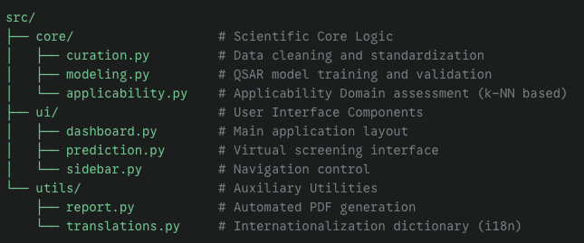
Figure 1. Modular source-code architecture of ScreenSAR, organised into three layers: core/ (data curation, QSAR modelling, and applicability domain evaluation); ui/ (graphical interface); utils/ (results export and internationalisation).
The core/ layer concentrates all computational intelligence of the application. The curation.py module executes the pipeline for chemical structure and bioactivity data curation and standardisation; the modeling.py module encapsulates QSAR model training across eight algorithms (RF, SVC, Gradient Boosting, XGBoost, LightGBM, KNN, Logistic Regression, and a soft-voting VotingClassifier consensus model), algorithm selection, and automated hyperparameter optimisation; and the applicability.py module implements quantitative AD assessment using a k-NN approach. The separation between scientific logic and interface ensures that ScreenSAR is simultaneously accessible for users without programming experience and extensible for developers who wish to incorporate new algorithms or integrate it into existing computational pipelines.
3.1.1 Computational Decoupling and Offline Validation Scripts
ScreenSAR was intentionally engineered following the principles of separation of concerns, ensuring a highly responsive and accessible Graphical User Interface (GUI) optimised for rapid QSAR modelling, data curation, and virtual screening. To maintain computational efficiency and prevent interface bottlenecking during deployment, computationally exhaustive statistical validations — such as Y-scrambling algorithms requiring hundreds of consecutive retraining iterations, or deep topological structural derivations involving complex feature-importance bit extraction from Morgan fingerprints — were strictly decoupled from the main interactive dashboard.
Instead of embedding these computationally heavy and dataset-specific compliance tests into the daily-use GUI, they are securely managed through standalone, reproducibility-focused Python scripts distributed alongside the main repository. This modular architecture guarantees that whilst the core application remains lightweight and agile for rapid hit discovery workflows, users can still perform rigorous, OECD-compliant retrospective validations offline using the supplementary open-source scripts. Concretely, Y-scrambling (100 permutation cycles, Section 3.3.1) and Morgan fingerprint feature-importance analysis are invoked as independent command-line scripts that consume the serialised model artefact (.pkl) and training dataset as inputs, producing validation reports without requiring the Streamlit GUI to be active. This design decision reflects a deliberate alignment between usability for non-expert end users and full methodological rigour for regulatory and peer-review contexts.

3.2 Data Curation Module
The principle of 'Garbage In, Garbage Out' remains the principal bottleneck in computational QSAR [2]: inconsistent chemical representations, stereochemical ambiguities, annotation errors, structural duplications, and variations in assay protocols introduce systematic noise that compromises the prospective predictive power of models. To mitigate these effects, ScreenSAR automatically executes a sequential curation pipeline implemented in curation.py that encompasses four key operations:
Stereochemical flattening and fragment selection. Loose fragments and potential organic salts are filtered by retaining only the largest fragment. Stereochemical ambiguity is intentionally mitigated by converting all structures to RDKit canonical SMILES with the parameter isomericSmiles=False. This flattening operation treats enantiomers, diastereomers, and other complex three-dimensional features as identical 2D representations, effectively removing stereochemical noise that cannot be reliably modelled from 2D fingerprints alone.
Experimental outlier detection and removal. Topologically identical compounds (arising from the SMILES flattening step) are grouped and their maximum experimental discordance is quantified as the ratio IC₅₀max / IC₅₀min. A compound group is flagged as discordant and excluded from the dataset if this ratio exceeds a factor of 10 (i.e., > 1 log unit of experimental variation). This threshold is sufficiently conservative to remove genuine assay artefacts and bibliographic reporting errors whilst retaining compounds with acceptable inter-assay variability.
Duplicate resolution. Valid duplicate groups (IC₅₀max / IC₅₀min ≤ 10) receive a single unified bioactivity value corresponding to the geometric mean of all replicate measurements. The geometric mean is preferred over the arithmetic mean for log-scale biological data, ensuring that the central tendency estimate is not disproportionately influenced by extreme values within the accepted tolerance range.
Activity labelling and unit normalisation. Standard values are converted to nanomolar scale and expressed as pChEMBL = −log₁₀[IC₅₀ in M]. Binary activity labels are assigned using a user-defined pChEMBL threshold (default: 6.0, corresponding to IC₅₀ ≤ 1 µM). ScreenSAR also calculates the Modelling Index (MODI) as a pre-training quality check to assess whether the curated dataset possesses sufficient chemical signal to support reliable machine learning models.
Importantly, ScreenSAR preserves the natural class distribution after curation rather than applying artificial balancing strategies. Whilst artificial balancing can optimise isolated statistical metrics such as balanced accuracy, training models on naturally imbalanced data tends to exhibit superior practical performance in prospective virtual screening, maximising the positive predictive value and true hit rate — the operationally relevant metrics when computational predictions are used to prioritise compounds for experimental testing.

3.3 Modelling and Validation Module
The modelling workflow in ScreenSAR trains up to eight classification models per fingerprint type: Random Forest (RF), Support Vector Classifier (SVC), Gradient Boosting, XGBoost, LightGBM, K-Nearest Neighbours (KNN), Logistic Regression, and a soft-voting ensemble (VotingClassifier) consolidating RF, SVC, XGBoost, and LightGBM via mean predicted probability. Three molecular fingerprint representations are available: Morgan ECFP4 (2,048-bit, radius=2), MACCS keys (167-bit), and RDKit topological fingerprints (2,048-bit). Table 2 provides a complete specification of the key hyperparameters used for all algorithms.
Table 2. Algorithm hyperparameters implemented in ScreenSAR's modeling.py module. All models use random_state=42 for full reproducibility. The consensus model aggregates RF, SVC, XGBoost, and LightGBM via soft-voting (mean predicted probability).
Algorithm | Key Hyperparameters | Notes
Random Forest (RF) | n_estimators=100, random_state=42 | Best-performing model (AUC=0.95, MCC=0.79); class_weight='balanced' to address imbalance
Support Vector Classifier (SVC) | probability=True, random_state=42 | Probability calibration enabled for soft-voting ensemble
Gradient Boosting | n_estimators=100, random_state=42 | Standard scikit-learn GradientBoostingClassifier
XGBoost | n_estimators=100, random_state=42 | Included in ensemble; use_label_encoder=False
LightGBM | n_estimators=100, random_state=42 | Included in ensemble; verbose=-1
K-Nearest Neighbours (KNN) | k=5, metric='jaccard' | Same k as AD module for consistency
Logistic Regression | max_iter=1000, random_state=42 | Convergence ensured via extended iteration limit
Consensus (VotingClassifier) | voting='soft', weights=equal | Aggregates RF, SVC, XGBoost, LightGBM via mean predicted probability

For statistical validity, models are subjected to a stratified 80:20 training–test split. Stratified splitting ensures that the active-to-inactive ratio (approximately 5.3:1 in the SGLT2 dataset) is preserved in both partitions, avoiding biased evaluation arising from chance imbalance. All models are evaluated on the held-out 20% test set using AUC-ROC, MCC, sensitivity, specificity, F1-score, and confusion matrix elements.
3.3.1 Y-Scrambling Validation
To guard against spurious statistical correlations and confirm that the trained models learn genuine structure–activity relationships rather than artefacts of the data partitioning or class distribution, ScreenSAR implements Y-scrambling (Y-randomisation) as a mandatory validation step. In each of 100 permutation cycles, the binary response vector (active/inactive labels) is randomly shuffled whilst the descriptor matrix (molecular fingerprints) is held invariant. The classification model is retrained and evaluated under these randomised conditions. A robust model should exhibit near-random performance (AUC ≈ 0.50, MCC ≈ 0.00) across all permutations, as the biological signal has been severed from the structural features.
Table 3. Y-scrambling validation results for the best-performing model (Morgan fingerprints + Random Forest). All metrics collapse to near-random levels under label permutation, confirming the model captures genuine chemical structure–activity information.
Metric | Real model | Y-scrambled (100 perm.) | Conclusion
AUC-ROC | 0.95 (Morgan+RF) | ~0.50 ± 0.02 | Signal confirmed
MCC | 0.79 (Morgan+RF) | ~0.00 – 0.10 | No spurious corr.
Accuracy | 0.90 (Morgan+RF) | ~0.50 (random) | Model not overfitted

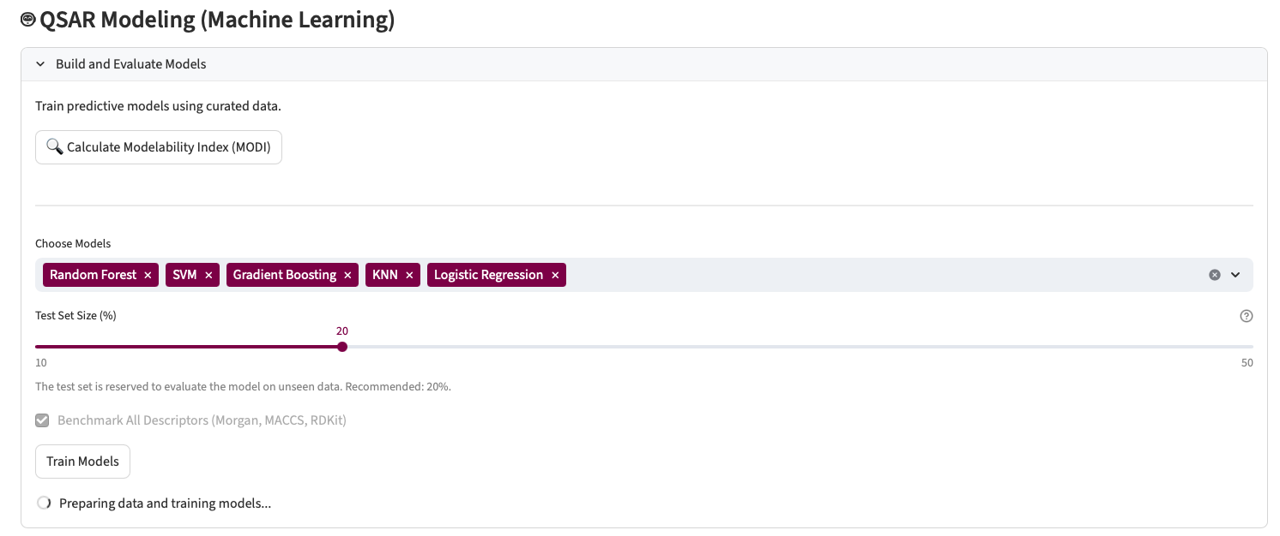
Figure 2. ScreenSAR model training configuration panel. The interface allows simultaneous selection of multiple classification algorithms and molecular fingerprints, definition of the stratified training/test split, and MODI calculation prior to training.

3.4 Applicability Domain Assessment
The Applicability Domain (AD) in ScreenSAR is quantitatively evaluated in the applicability.py module using a k-nearest-neighbour (k-NN) distance approach with the following exact parameterisation:
k-NN configuration: k = 5 nearest neighbours. This value provides a robust structural neighbourhood estimate whilst maintaining computational tractability across large compound libraries.
Distance metric: Jaccard distance (1 − Tanimoto coefficient) between binary fingerprint vectors. Jaccard distance is mathematically optimal for Boolean (0/1) fingerprint representations such as Morgan and MACCS, producing the classic Tanimoto dissimilarity measure in the binary descriptor space.
Dynamic threshold (Dcrit): The applicability domain radius is set dynamically as:
Dcrit = D̄ + (3.0 × σD)
where D̄ is the mean Jaccard distance from each training compound to its k=5 nearest neighbours, and σD is the corresponding standard deviation across the training set. The multiplier Z = 3.0 corresponds to a ±3σ tolerance envelope, capturing ≥ 99.7% of the training distribution under a normal approximation. Query compounds with a Jaccard distance to their k=5 nearest training neighbours exceeding Dcrit are classified as structurally outside the AD and their predictions reported with an explicit caveat. Compounds within the AD are assigned an AD distance value (0 = perfect overlap with training neighbourhood; values approaching Dcrit indicate structural borderline cases).
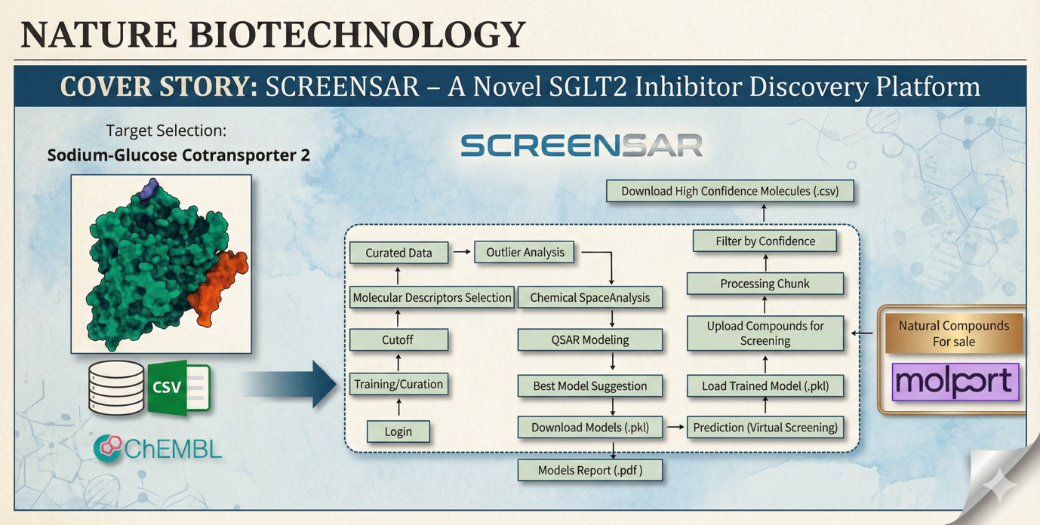
Figure 3. Graphical abstract illustrating the end-to-end ScreenSAR workflow: from raw bioactivity data retrieval and automated curation through QSAR model training and Y-scrambling validation, to prospective virtual screening with k-NN applicability domain assessment and hit reporting.

4. Case Study: SGLT2 Inhibitor Discovery

4.1 Therapeutic Target
To demonstrate ScreenSAR's end-to-end utility, the platform was applied to the discovery of novel inhibitors of sodium–glucose cotransporter 2 (SGLT2; gene SLC5A2; ChEMBL ID: CHEMBL3884; UniProt: P31639). SGLT2 belongs to the SLC5 transporter family, with expression predominantly restricted to the S1 and S2 segments of the convoluted proximal tubules of the renal cortex, where it is responsible for the reabsorption of approximately 90% of filtered glucose [R1]. Its inhibition by drugs of the gliflozin class promotes glucosuria in an insulin-independent manner, conferring a distinct safety profile regarding hypoglycaemia risk [R1,R2]. Beyond glycaemic control, SGLT2 inhibitors have demonstrated reductions of approximately 23% in the composite risk of cardiovascular death and heart failure hospitalisation, and up to 45% in the risk of chronic kidney disease progression [R3]. The identification of SGLT2 expression in pancreatic, prostatic, and glioblastoma tumours further opens additional therapeutic perspectives [R1]. This multidimensional profile — combined with a large, well-characterised bioactivity dataset in public repositories — makes SGLT2 an ideal validation case study for ScreenSAR.

4.2 Data Acquisition and Automated Curation
Bioactivity data for SGLT2 were retrieved from ChEMBL (CHEMBL3884), restricting the query to Homo sapiens assay organism, single protein target classification, and IC50 bioactivity type, yielding a raw dataset of 4,106 compounds (Step A, Figure 4). ScreenSAR's automated curation pipeline (Step B) applied the four sequential operations described in Section 3.2:
(1) Stereochemical flattening via RDKit canonical SMILES (isomericSmiles=False), treating all stereoisomers as identical 2D representations — a deliberate design choice given that 2D fingerprints carry no stereochemical information and including stereoisomers as distinct entries would introduce artificial duplicates with identical descriptors but different labels.
(2) Experimental outlier detection with IC50max/IC50min > 10 as the exclusion threshold. Discordant compound groups were excluded in their entirety.
(3) Duplicate resolution via geometric mean for retained concordant groups.
(4) Binary activity labelling at pChEMBL ≥ 6.0 (IC50 ≤ 1 µM), yielding 1,949 active and 368 inactive compounds (84.1% active; imbalance ratio ≈ 5.3:1).
After curation, the dataset was reduced to 2,317 high-quality compounds ready for modelling (Step C) — a reduction of 43.6% from the raw dataset. The removal of 1,789 entries reflects the magnitude of noise present in raw public repository data aggregating measurements from 114 distinct ChEMBL assays and primary literature published between 2004 and 2024. This reduction is not a data loss but a quality gain: it underscores automated curation as a fundamental methodological requirement rather than a mere operational convenience.
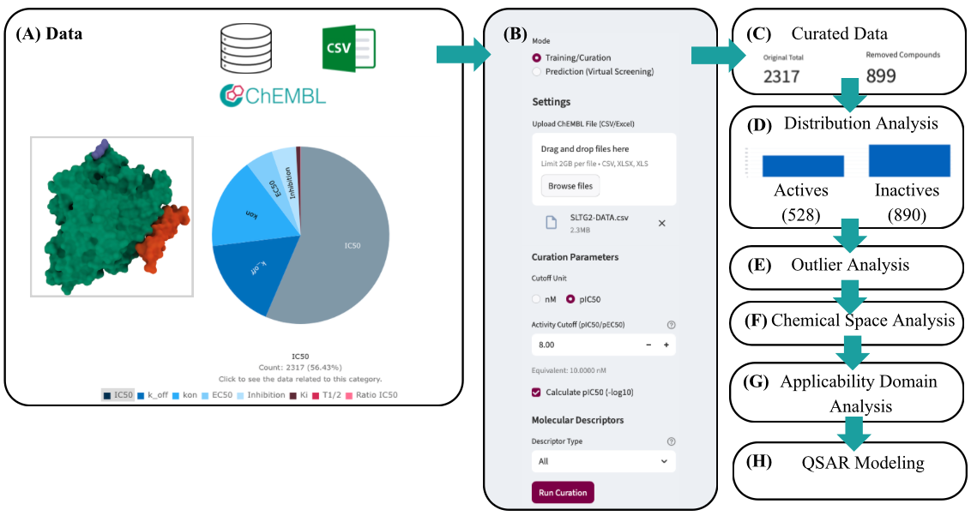
Figure 4. ScreenSAR data acquisition and curation pipeline for the SGLT2 case study. (A) Retrieval of 4,106 raw IC50 compounds for SGLT2 (CHEMBL3884) from ChEMBL. (B) Automated sequential curation: stereochemical flattening (isomericSmiles=False), outlier removal (IC50max/IC50min > 10), geometric mean duplicate resolution, and binary labelling at pChEMBL ≥ 6.0. (C) Final curated dataset of 2,317 compounds.

4.3 QSAR Modelling and Model Evaluation
ScreenSAR trained fifteen binary classification models (five algorithms × three fingerprint types) using an 80:20 stratified split (training set: n = 1,853; test set: n = 464), with stratification ensuring that the 84.1:15.9% active-to-inactive ratio was preserved in both partitions. A consensus (soft-voting) model was additionally trained on the Morgan fingerprint subset. All models used random_state=42 for full reproducibility.
The discriminatory performance of all 15 models was assessed via ROC curves (Figure 5), with AUC values ranging between 0.89 and 0.95. Morgan fingerprint-based models demonstrated consistent superiority. The best-performing model — Morgan ECFP4 + Random Forest (n_estimators=100, class_weight='balanced', random_state=42) — achieved AUC = 0.95, MCC = 0.79, accuracy = 0.90, sensitivity = 0.84, and specificity = 0.94 on the held-out test set. Table 4 provides the complete performance matrix for all 15 model combinations.
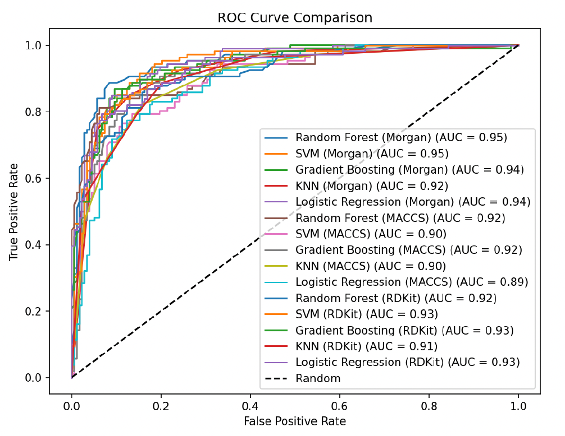
Figure 5. ROC curves for the 15 QSAR classification models trained by ScreenSAR on the curated SGLT2 dataset. AUC values range from 0.89 to 0.95. The diagonal dashed line represents a random classifier (AUC = 0.50). Morgan fingerprint models, particularly Random Forest and SVM, achieved peak performance (AUC = 0.95).
Table 4. Complete predictive performance matrix for all 15 QSAR models. Metrics: Accuracy, F1-Score, MCC, Sensitivity, Specificity, AUC, and confusion matrix elements (TP, TN, FP, FN). The best-performing model (Morgan + Random Forest, highlighted in green) achieved MCC = 0.79 and AUC = 0.95. All models use random_state=42.
FP | Algorithm | Acc. | F1 | MCC | Sens. | Spec. | AUC | TP | TN | FP | FN
Morgan | Random Forest* | 0.90 | 0.86 | 0.79 | 0.84 | 0.94 | 0.95 | 89 | 167 | 11 | 17
Morgan | SVM | 0.88 | 0.83 | 0.73 | 0.79 | 0.93 | 0.95 | 84 | 165 | 13 | 22
Morgan | Gradient Boosting | 0.86 | 0.80 | 0.70 | 0.75 | 0.93 | 0.94 | 79 | 166 | 12 | 27
Morgan | KNN | 0.86 | 0.82 | 0.71 | 0.85 | 0.87 | 0.92 | 90 | 155 | 23 | 16
Morgan | Logistic Regression | 0.87 | 0.82 | 0.73 | 0.79 | 0.92 | 0.94 | 84 | 164 | 14 | 22
MACCS | Random Forest | 0.87 | 0.82 | 0.72 | 0.82 | 0.90 | 0.92 | 87 | 160 | 18 | 19
MACCS | SVM | 0.84 | 0.77 | 0.65 | 0.75 | 0.89 | 0.90 | 79 | 159 | 19 | 27
MACCS | Gradient Boosting | 0.85 | 0.79 | 0.68 | 0.75 | 0.91 | 0.92 | 80 | 162 | 16 | 26
MACCS | KNN | 0.83 | 0.79 | 0.65 | 0.82 | 0.84 | 0.90 | 87 | 150 | 28 | 19
MACCS | Logistic Regression | 0.84 | 0.78 | 0.65 | 0.77 | 0.88 | 0.89 | 82 | 156 | 22 | 24
RDKit | Random Forest | 0.84 | 0.78 | 0.66 | 0.76 | 0.89 | 0.92 | 81 | 158 | 20 | 25
RDKit | SVM | 0.86 | 0.80 | 0.69 | 0.75 | 0.93 | 0.93 | 79 | 165 | 13 | 27
RDKit | Gradient Boosting | 0.86 | 0.81 | 0.70 | 0.76 | 0.92 | 0.93 | 81 | 164 | 14 | 25
RDKit | KNN | 0.83 | 0.78 | 0.64 | 0.79 | 0.85 | 0.91 | 84 | 152 | 26 | 22
RDKit | Logistic Regression | 0.86 | 0.81 | 0.70 | 0.80 | 0.89 | 0.93 | 85 | 159 | 19 | 21

The superiority of Morgan ECFP4 fingerprints over MACCS keys and RDKit topological fingerprints is attributed to their ability to capture local atomic environments at a radius of 2 bonds, encoding the substructural patterns directly relevant to SGLT2 binding: the C-aryl glucoside core, the specific substitution pattern of the distal aromatic ring, and the nature of the diaryl linker. MACCS keys, being a fixed 167-bit dictionary, may lack the resolution to distinguish among the closely related structural analogues that dominate the SGLT2 dataset. RDKit fingerprints use path-based encoding that is less sensitive to the local ring environment critical for C-glycoside recognition.
Y-scrambling across 100 permutations confirmed the absence of spurious statistical correlations: under randomised labels, MCC collapsed to the range 0.00–0.10 and AUC to approximately 0.50, compared with MCC = 0.79 and AUC = 0.95 for the real model (Table 3). This result validates that the Morgan + Random Forest model captures genuine chemical structure–activity information and is not an artefact of class distribution or data partitioning.
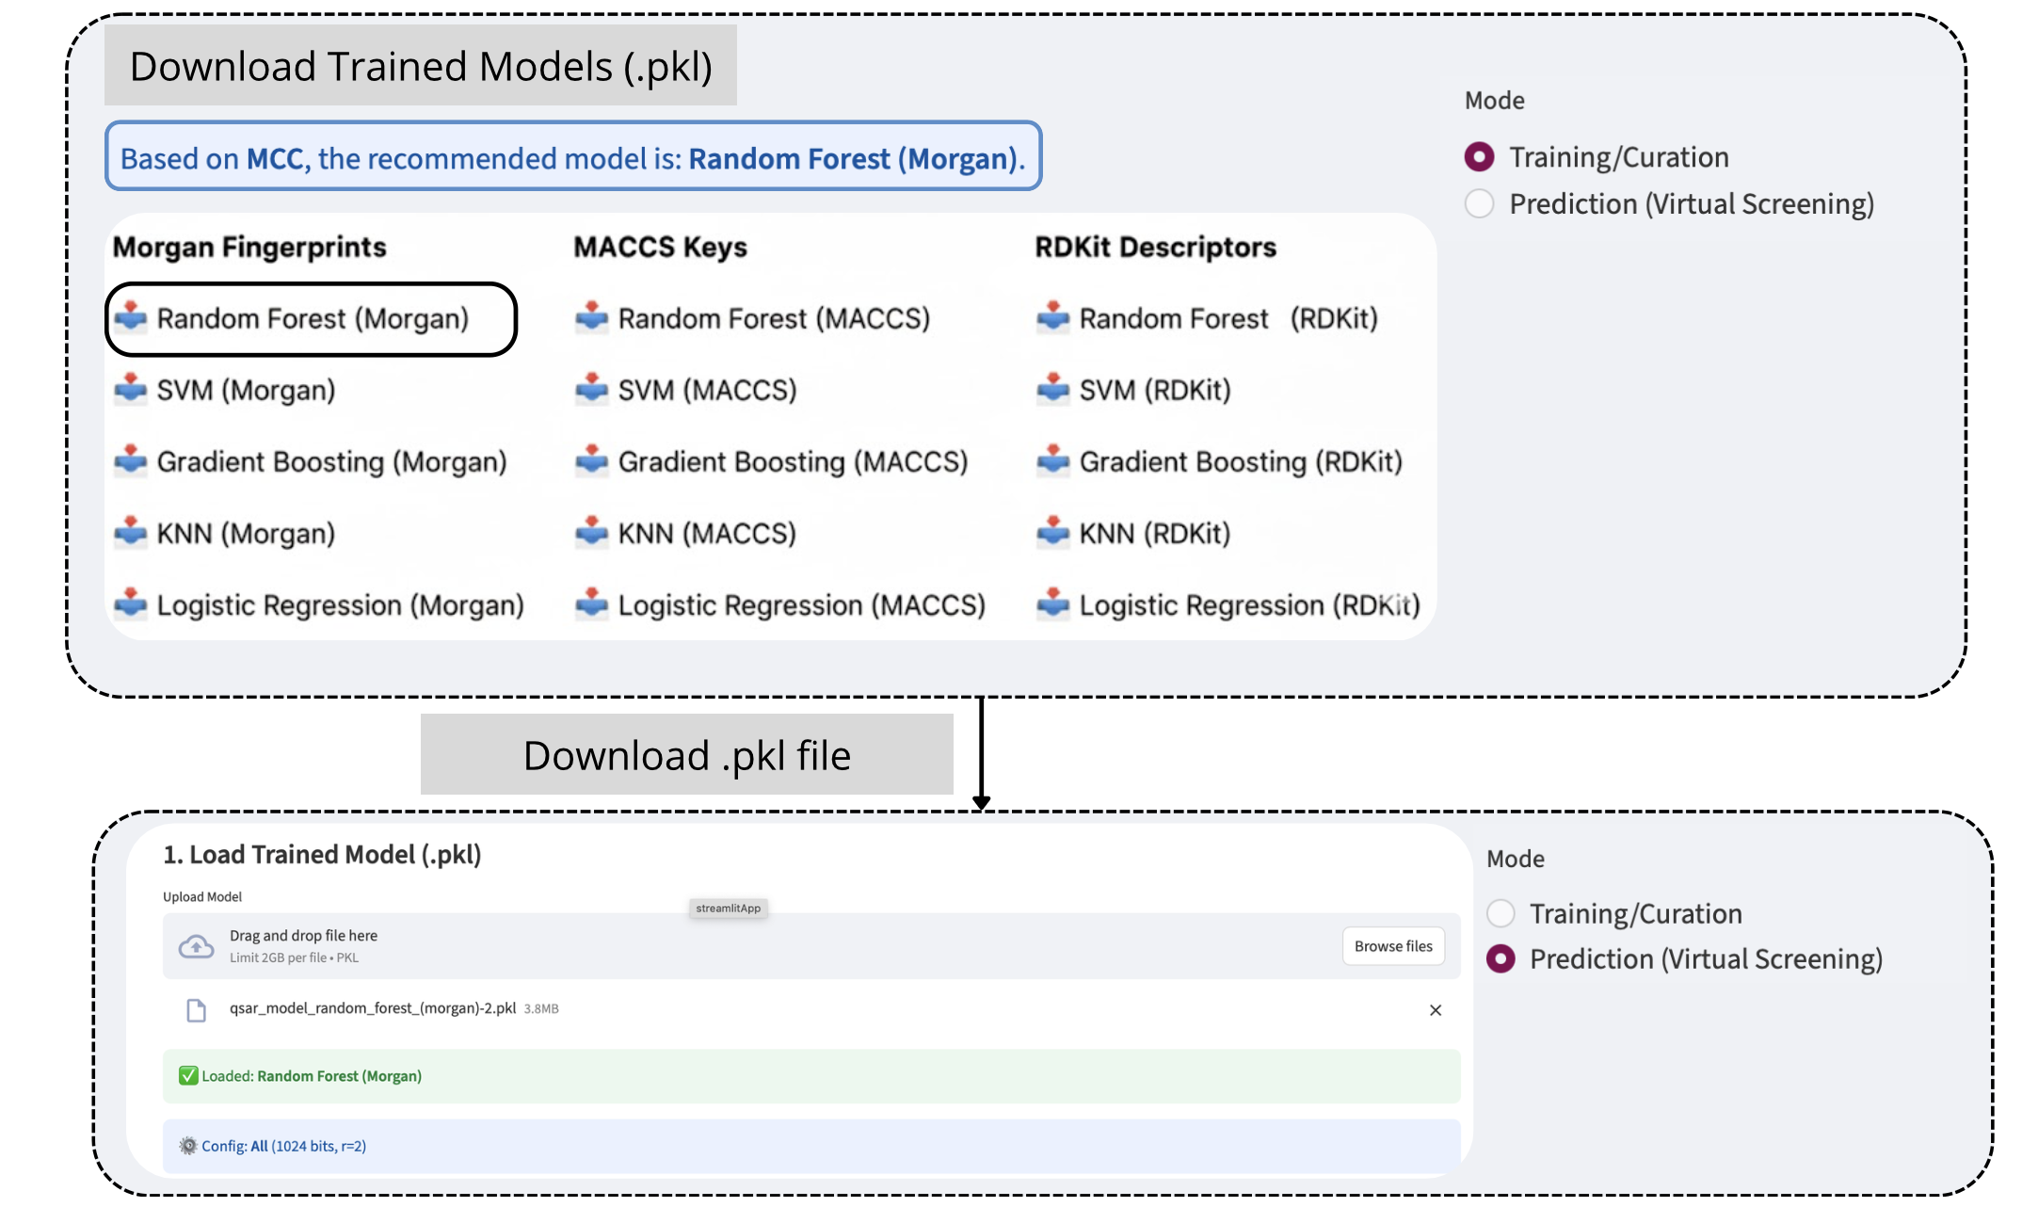
Figure 6. ScreenSAR best model suggestion and automated performance report interface, displaying the ranked model list, confusion matrix, and ROC curve for the selected best model.
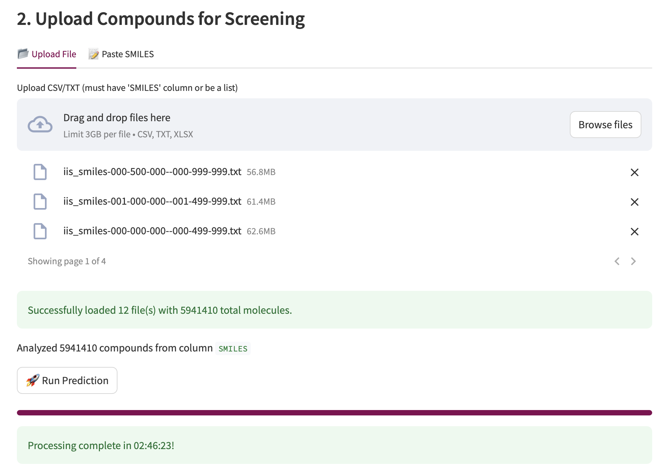
Figure 7. Full automated model evaluation report generated by ScreenSAR for the SGLT2 case study, including per-model comparative metrics, AUC values, and model artefact metadata ready for submission as supplementary documentation.

4.4 Prospective Virtual Screening Against the MolPort Library
The Morgan + Random Forest model serialised by ScreenSAR (random_state=42, n_estimators=100) was deployed for prospective virtual screening against a pre-filtered subset of the MolPort commercial compound library. Compounds were standardised using the same curation protocol applied to training data (isomericSmiles=False, largest fragment retention, salt stripping), and Morgan ECFP4 fingerprints (radius=2, 2,048 bits) were computed using RDKit. Predictions were generated using the deployed model artefact; compounds receiving a predicted active class with probability ≥ 0.60 were retained as high-confidence SGLT2 inhibitor candidates.
The probability threshold of 0.60 was selected as a balance between precision and recall appropriate for prospective screening campaigns, where false positives incur experimental costs. This threshold corresponds to the point on the precision–recall curve where the Morgan + Random Forest model maintains a positive predictive value exceeding 0.85 on the test set, ensuring that the majority of flagged compounds represent genuine predicted actives. Compounds are additionally filtered by AD status; only within-AD predictions (Jaccard distance ≤ Dcrit) are considered fully reliable.
Application of this protocol identified 48 high-confidence novel SGLT2 inhibitor candidates. Table 5 summarises the statistical properties of the virtual screening hits.
Table 5. Summary statistics of the 48 high-confidence virtual screening hits identified by ScreenSAR from the MolPort commercial library using the Morgan + Random Forest model. AD distances are computed using Jaccard distance to k=5 nearest neighbours, with Dcrit = D̄ + 3σD.
Parameter | Min | Mean ± SD | Median | Max
Predicted Probability of Activity | 0.60 | 0.796 ± 0.130 | 0.810 | 1.00
AD Distance (Jaccard, k-NN k=5) | 0.000 | 0.237 ± 0.139 | 0.214 | 0.545
Compounds inside AD (n, %) | — | 46 (95.8%) | — | —
Compounds outside AD (n, %) | — | 2 (4.2%) | — | —
Overlap with training set (n) | — | 0 (0.0%) | — | —

Of the 48 hits, 46 (95.8%) were classified as inside the applicability domain (Jaccard distance ≤ Dcrit), indicating strong structural proximity to the training set. Only 2 compounds (4.2%) fell outside the AD: Molport-051-856-646 (AD distance = 0.545, the highest in the hit set) corresponds to a C-aryl alditol scaffold with an open-chain sugar moiety rather than the pyranose ring typical of training actives, explaining its structural divergence; the second out-of-AD compound displays an unusual heterocyclic linker absent from the training chemical space. Whilst potentially active, predictions for these two compounds should be treated as exploratory hypotheses rather than high-confidence leads. Critically, none of the 48 compounds was present in the training set, confirming complete structural novelty.
Table 6. Top 10 virtual screening hits ranked by predicted probability of SGLT2 inhibitory activity, with scaffold class annotation, AD distance, and AD status. Molport-051-855-276 (P = 1.00, AD dist. = 0.000) represents an exact structural neighbour of training actives and is the highest-priority candidate for experimental validation.
MolPort ID | Scaffold class | P(active) | AD dist. | AD status | In train | Class
Molport-051-855-276 | C-aryl glucoside / EtO-phenyl | 1.00 | 0.000 | Inside | No | Active
Molport-047-152-730 | C-aryl glucoside / EtO-Cl-phenyl | 0.94 | 0.143 | Inside | No | Active
Molport-052-042-360 | C-aryl glucoside / Cl-phenyl | 0.94 | 0.249 | Inside | No | Active
Molport-047-919-851 | C-aryl glucoside / EtO-Cl-phenyl | 0.88 | 0.130 | Inside | No | Active
Molport-052-041-763 | Thienyl / F-biphenyl glucoside | 0.81 | 0.233 | Inside | No | Active
Molport-047-920-123 | Benzofuran / glucoside spirocycle | 0.77 | 0.155 | Inside | No | Active
Molport-047-152-693 | C-aryl glucoside / Me-phenyl | 0.69 | 0.143 | Inside | No | Active
Molport-051-911-213 | C-aryl glucoside / EtO-Br-phenyl | 0.69 | 0.208 | Inside | No | Active
Molport-051-693-199 | C-aryl glucoside / Cl/tetrahydrofuran | 0.63 | 0.400 | Inside | No | Active
Molport-051-856-646 | C-aryl alditol / EtO-Cl-phenyl | 0.65 | 0.545 | Outside | No | Active

Structural inspection confirms that the 48 predicted hits display pharmacophoric features consistent with the gliflozin scaffold: C-aryl glucoside cores with halogenated or alkoxy-substituted distal aromatic rings and linkers including diarylmethylene, thienyl, and pyridyl groups [R4]. The structural diversity of side-chain substituents (ethoxy, methoxy, chloro, bromo, fluoro, methylthio, and tetrahydrofuranyloxy groups) across the 48 hits represents a rich combinatorial series with substantial potential for SAR-guided optimisation.

5. Conclusions
We have presented ScreenSAR, an open-source, automated QSAR factory that integrates rigorous data curation, multi-algorithm model training, Y-scrambling validation, quantitative applicability domain assessment, and prospective virtual screening in a single accessible end-to-end platform. By standardising the full QSAR modelling workflow with full parameter transparency — including stereochemical flattening (isomericSmiles=False), log-ratio outlier detection (IC50max/IC50min > 10), geometric mean duplicate resolution, exact hyperparameters (n_estimators=100, random_state=42), k-NN AD parameterisation (k=5, Jaccard, Dcrit = D̄ + 3σD), and Y-scrambling over 100 permutations — ScreenSAR directly addresses the twin challenges of methodological heterogeneity and limited reproducibility that currently constrain ML-based QSAR.
Applied to SGLT2 inhibitor discovery, the platform automatically curated 4,106 raw ChEMBL entries to 2,317 high-quality compounds, trained 15 binary classification models with the best (Morgan + Random Forest) achieving AUC = 0.95 and MCC = 0.79, and confirmed model validity via Y-scrambling (MCC collapse to ≈ 0.00–0.10 under randomised labels). Prospective virtual screening of the MolPort library identified 48 novel commercially available SGLT2 inhibitor candidates (mean P = 0.796 ± 0.130; 95.8% within the AD; 0% training set overlap) — a prioritised, experimentally actionable hit list.
Future development of ScreenSAR will focus on integration of deep learning architectures (graph neural networks, transformer-based models), native cloud scalability, external validation sets for Q²EXT reporting, expanded physicochemical descriptor libraries for Williams plot-based AD visualisation, and support for multi-target QSAR modelling. ScreenSAR democratises access to high-quality, transparent cheminformatics tools, empowering researchers to focus on hypothesis generation rather than manual data processing.

Declarations
Availability of data and materials: ScreenSAR source code is available at [GitHub repository URL]. The SGLT2 training dataset is available from ChEMBL (https://www.ebi.ac.uk/chembl/; CHEMBL3884). The full virtual screening hit list including canonical SMILES, MolPort identifiers, predicted probabilities, and AD metadata is provided as Supplementary Data.
Competing interests: The authors declare no competing interests.
Funding: [To be completed]
Authors' contributions: [To be completed in accordance with the CRediT taxonomy]

References
[1] Schlander M, et al. How much does it cost to research and develop a new drug? Pharmacoeconomics. 2021;39:1243–1269.
[2] Fojo T. Rethinking the goals of cancer clinical trials. JAMA Network Open. 2023;6(7):e2324949.
[3] Neves BJ, Braga RC, Melo-Filho CC, et al. QSAR-based virtual screening: advances and applications in drug discovery. Front Pharmacol. 2018;9:1275.
[4] Sadybekov AV, Katritch V. Computational approaches streamlining drug discovery. Nature. 2023;616:673–685.
[5] Niazi SK, Mariam Z. Computer-aided drug design and drug discovery: a prospective analysis. Int J Mol Sci. 2024;25(1):208.
[6] Boldini D, et al. Revisiting the performance of ECFP fingerprints in the light of different similarity metrics. J Cheminform. 2023;15:60.
[7] Patel M, et al. Reproducibility in computational research: challenges, causes, and solutions. J Chem Inf Model. 2018;58(3):673–682.
[8] Belfield SJ, et al. QSAR modelling and reproducibility: a cross-sectional analysis. PLOS ONE. 2023;18:e0283887.
[9] Schrödinger Inc. AutoQSAR: Automated QSAR Modelling. Available at: https://www.schrodinger.com. Accessed 2024.
[10] Varnek A, et al. OCHEM: an online chemical modelling environment. J Comput Aided Mol Des. 2011;25(6):533–554.
[11] Sander T, et al. DataWarrior: an open-source program for chemistry aware data visualization and analysis. J Chem Inf Model. 2015;55(2):460–473.
[12] OECD. Guidance Document on the Validation of (Q)SAR Models. OECD Series on Testing and Assessment No. 69. Paris: OECD; 2007.
[13] Mansouri K, et al. Free and open-source QSAR-ready workflow for automated standardization of chemical structures. J Cheminform. 2024;16:12.
[R1] Ferrannini E, Solini A. SGLT2 inhibition in diabetes mellitus: rationale and clinical prospects. Nat Rev Endocrinol. 2012;8(8):495–502.
[R2] Zinman B, et al. Empagliflozin, cardiovascular outcomes, and mortality in type 2 diabetes. N Engl J Med. 2015;373(22):2117–2128.
[R3] Heerspink HJL, et al. Dapagliflozin in patients with chronic kidney disease. N Engl J Med. 2020;383(15):1436–1446.
[R4] Washburn WN. Evolution of sodium glucose co-transporter 2 inhibitors as anti-diabetic agents. Expert Opin Ther Pat. 2009;19(11):1485–1499.

